# Core Python: Big Picture

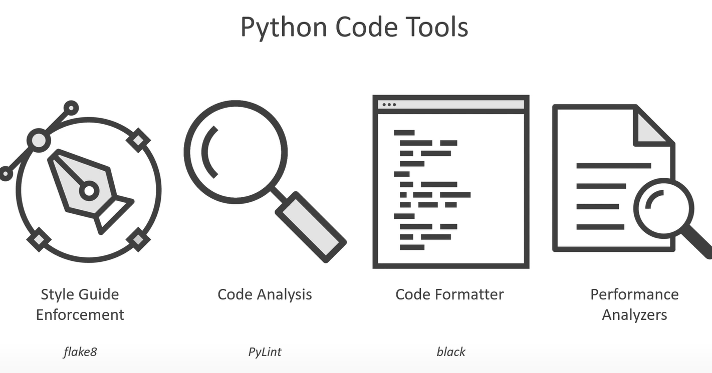

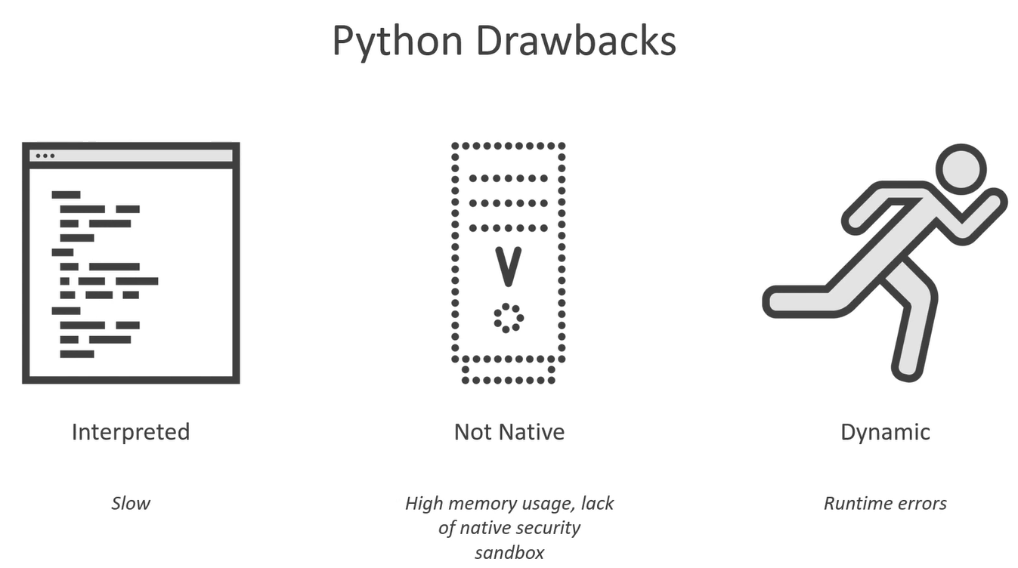

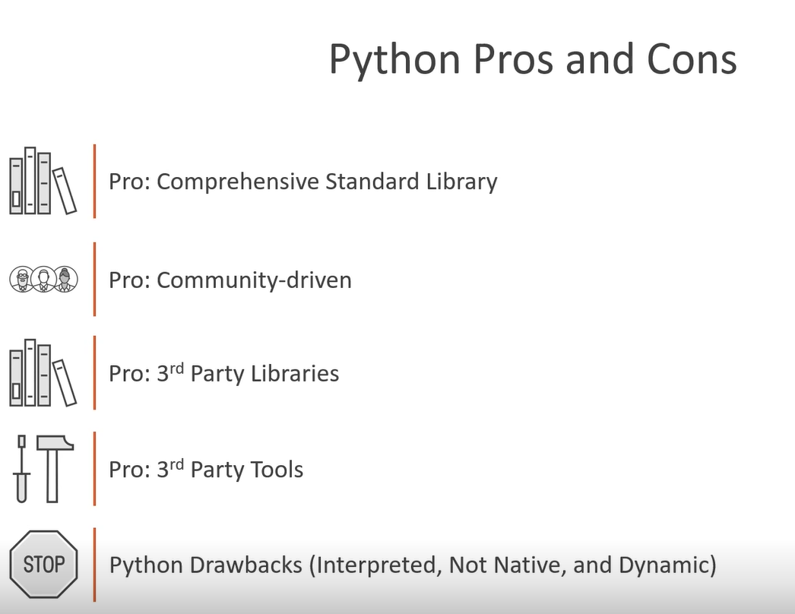

# Core Python 3.6: Getting Started

In python, a tab is equivalent to four spaces.

## Basic

### REPL

* Python terminal is called REPL -> Read Evaluate Print Loop
* The underscore in REPL (only in REPL) is bound to the result of last evaluated expression

### Zen of Python

import this prints out the zen of python

### Data Types

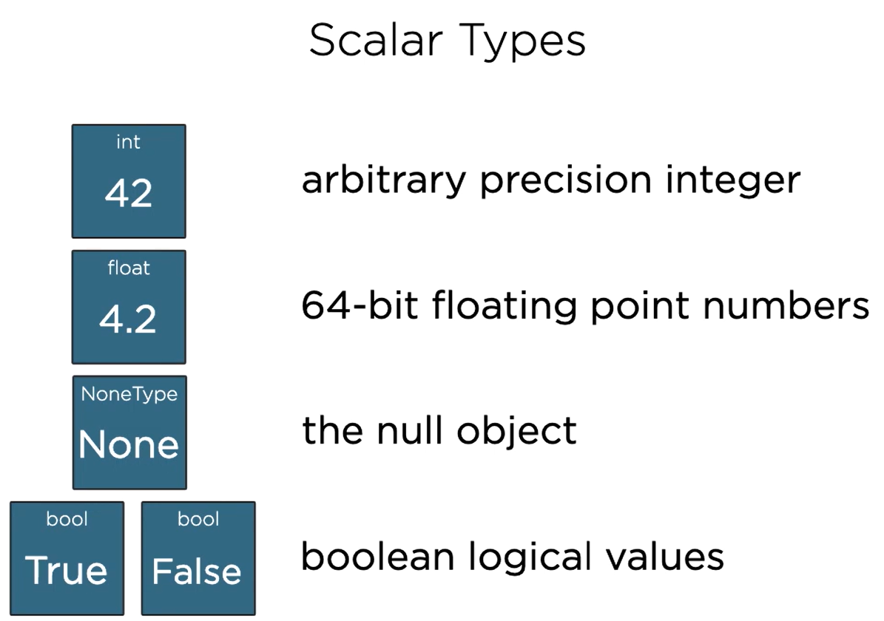

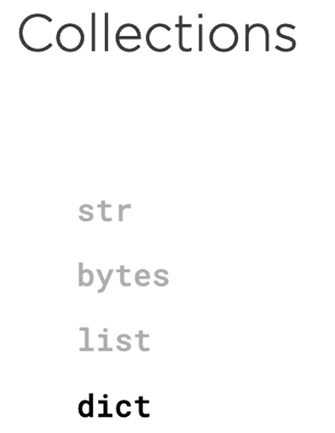

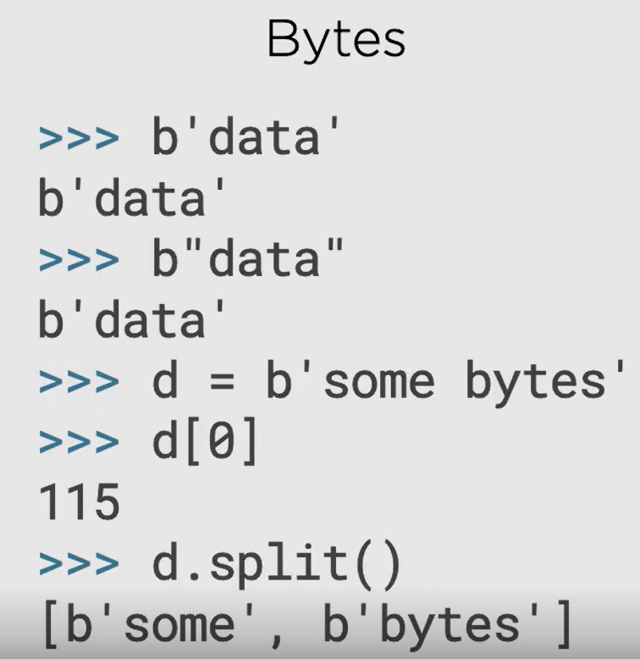

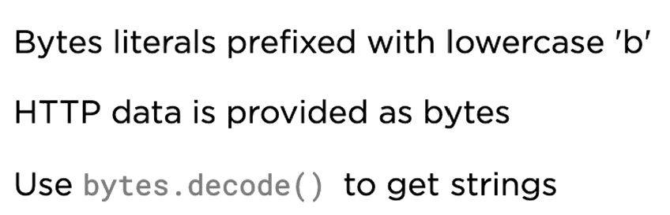

Use str.encode() to convert string to byte

Raw strings: r”<any_string>”

It means everything that we define is a pure string (escape character “\” is also treated as a character here, rather than escape character)

Useful when dealing with Windows File System

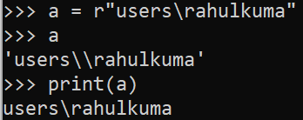

Prior to python 3.7, there is no order for entries in dictionary. However, python 3.7 and onwards, the entries are stored in insertion order.

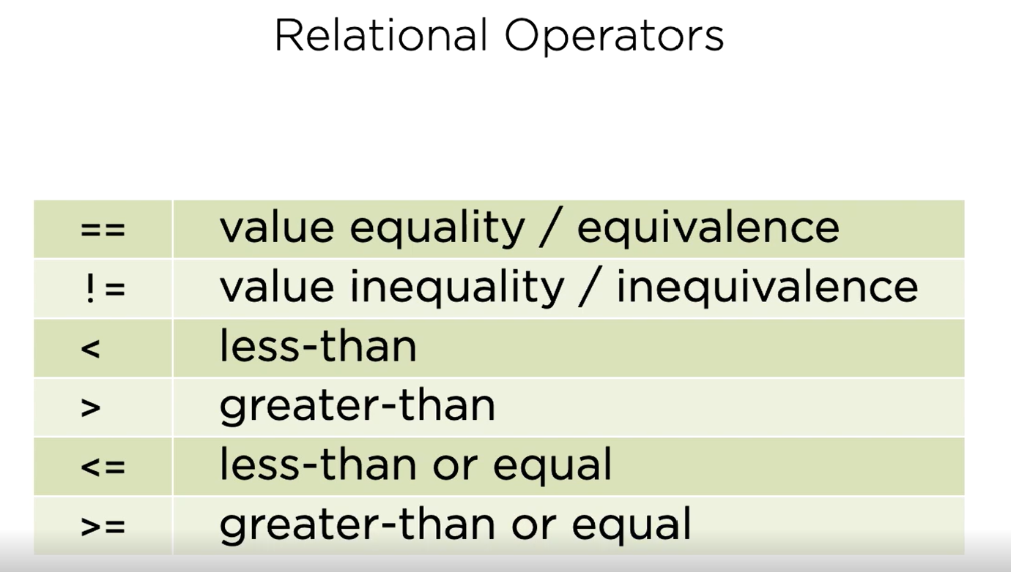

### Functions

Every function in python returns something, if there is no explicit return statement, then it returns None. Return statement without an argument also return None.

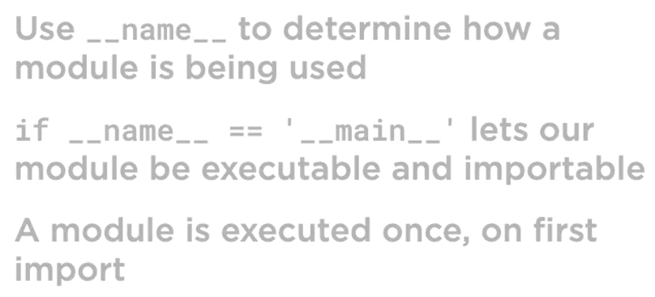

__name__ will have value:

* __main__ if a module is executed directly as a program
* module_name (name of the file without py extension) if a module is imported

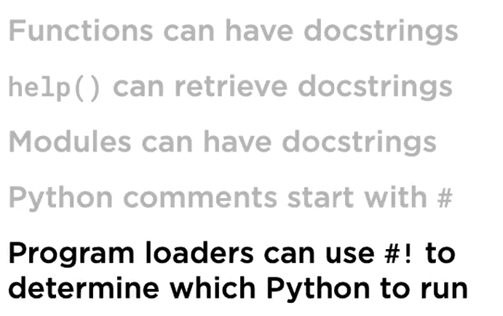

The last statement talking about #! -> this can be used as first line of the module and helps to launch the correct python interpreter on all major platforms.

## Objects and Types

### Mutable vs Immutable

Int is immutable which means

A = 1

B = A

A = 100

This will not change B because int is immutable.

X = 1000

X = 500

The picture below shows this, 1000 will be collected by garbage collector

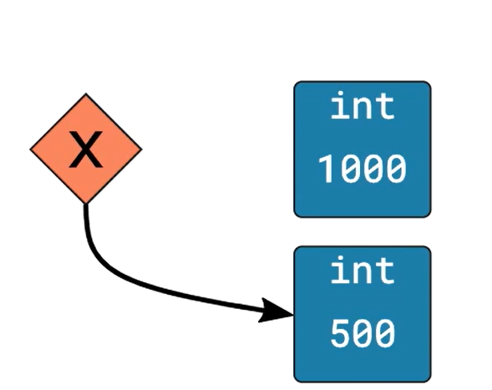

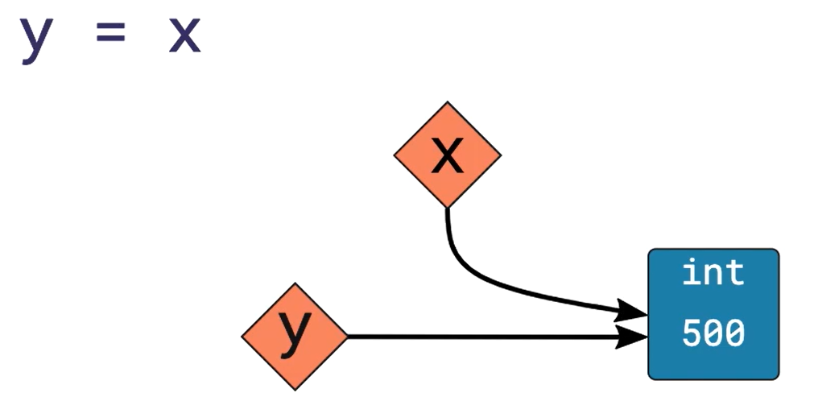

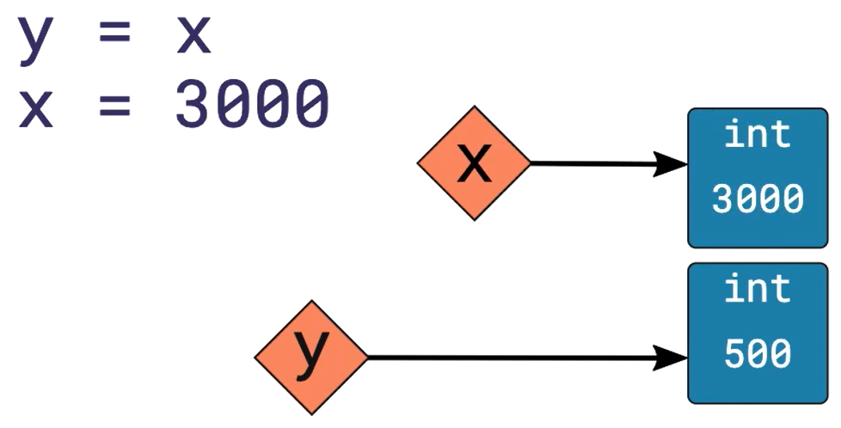

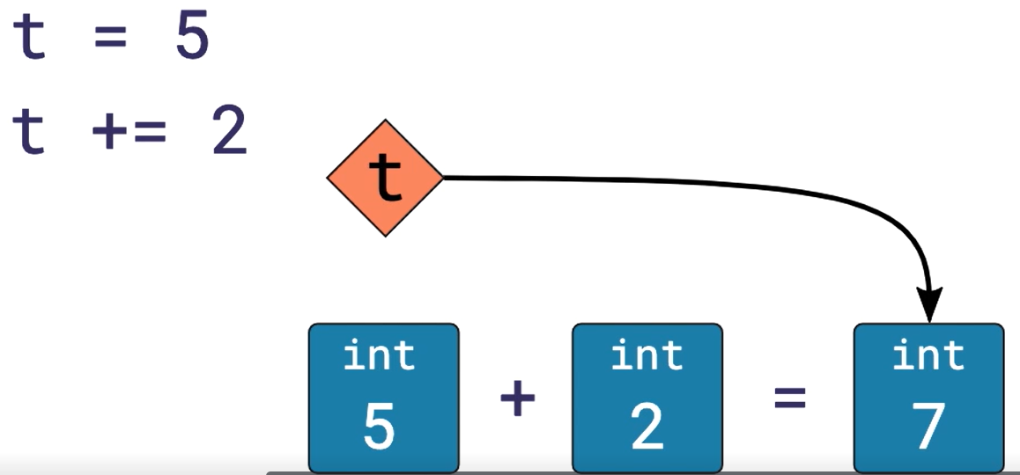

**Assignment operator only ever binds objects to names, it never copies an object by value.**

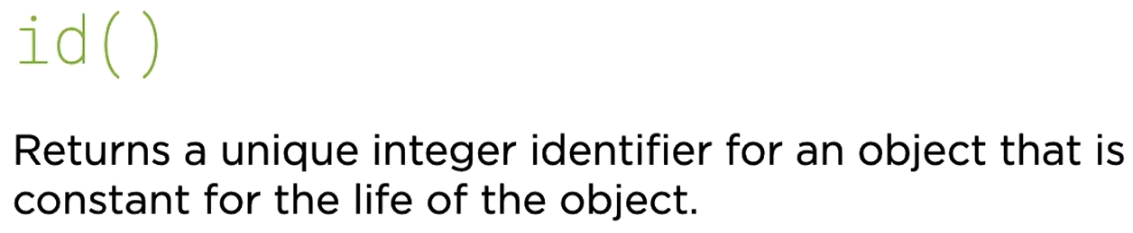

List is mutable which means

A = [1, 2, 3]

B = A

A[0] = 100

This will also change B because both of the names are pointing to the same mutable object.

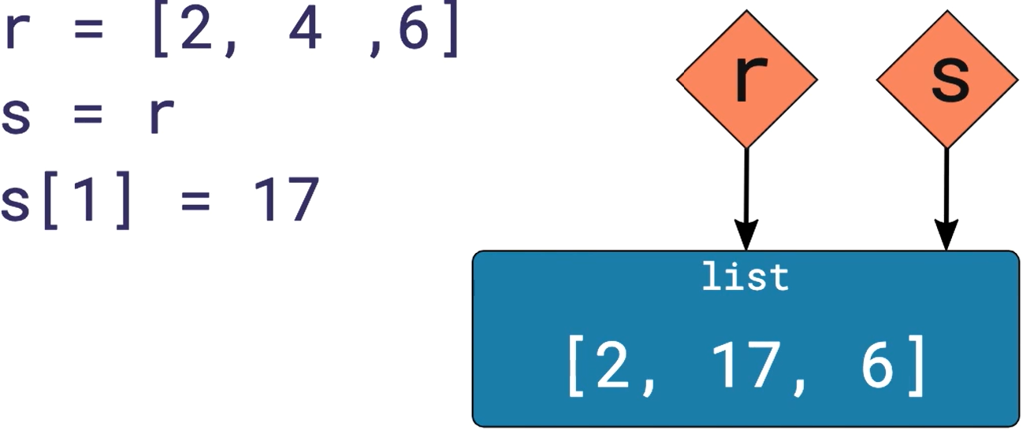

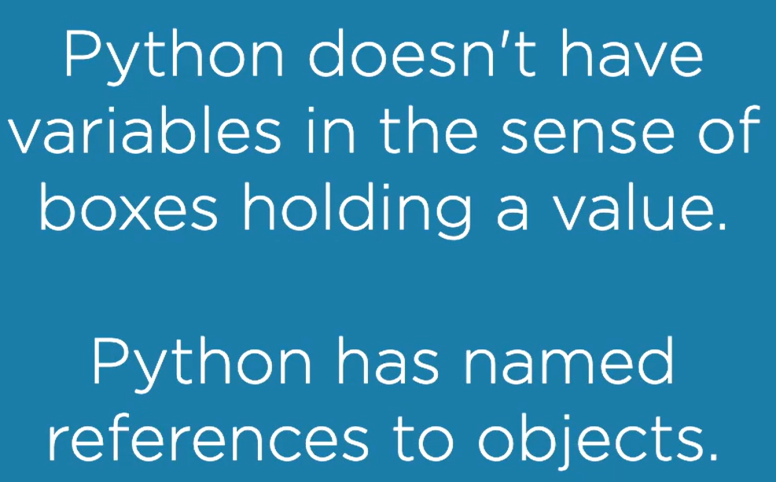

### Value vs Identity Equality

Identity equality “is” checks if two references refer to the same object. i.e., if their id are same.

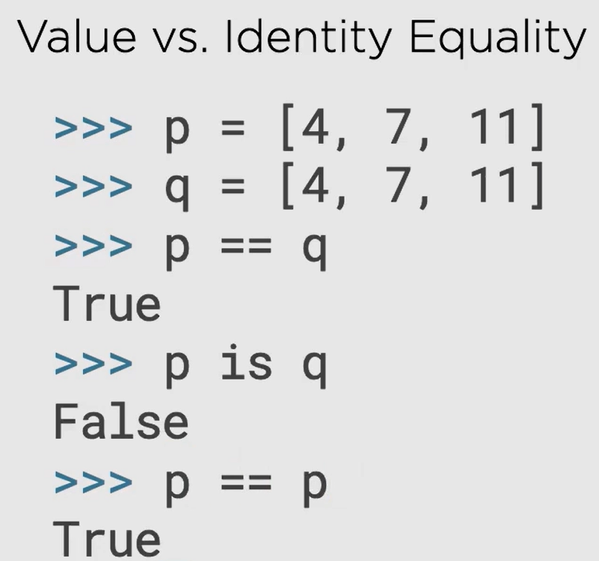

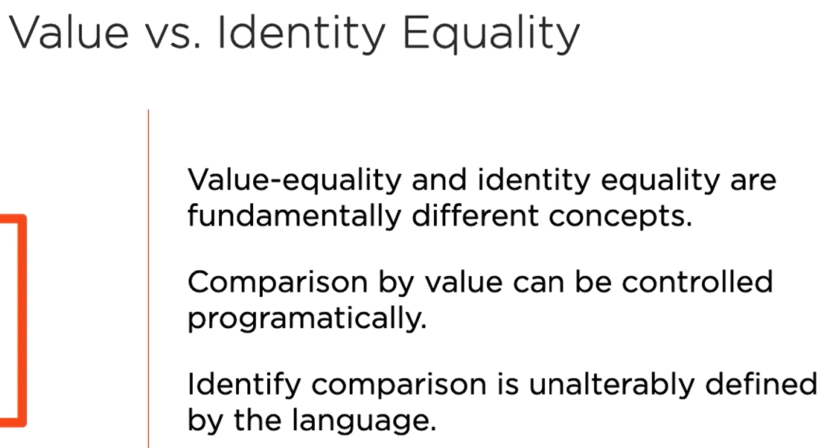

### Argument Passing

def modify(k):

k.append(39)

print(k) // [9, 15, 24, 39]

m = [9, 15, 24]

modify(m)

print(m) // [9, 15, 24, 39]

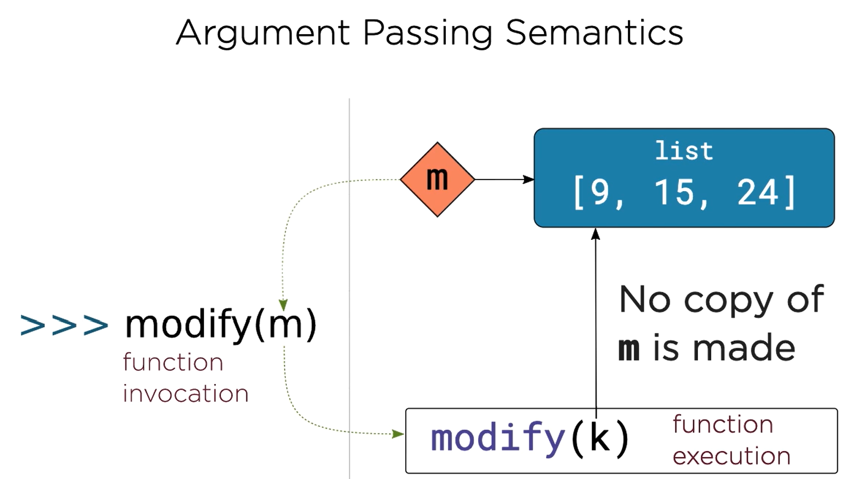

**If you want the function to modify a copy of an object, it’s the responsibility of the function to do the copying.**

def replace(g):

g = [17, 28, 45]

print(g) // [17, 28, 45]

f = [14, 23, 37]

replace(f)

print(f) // [14, 23, 37]

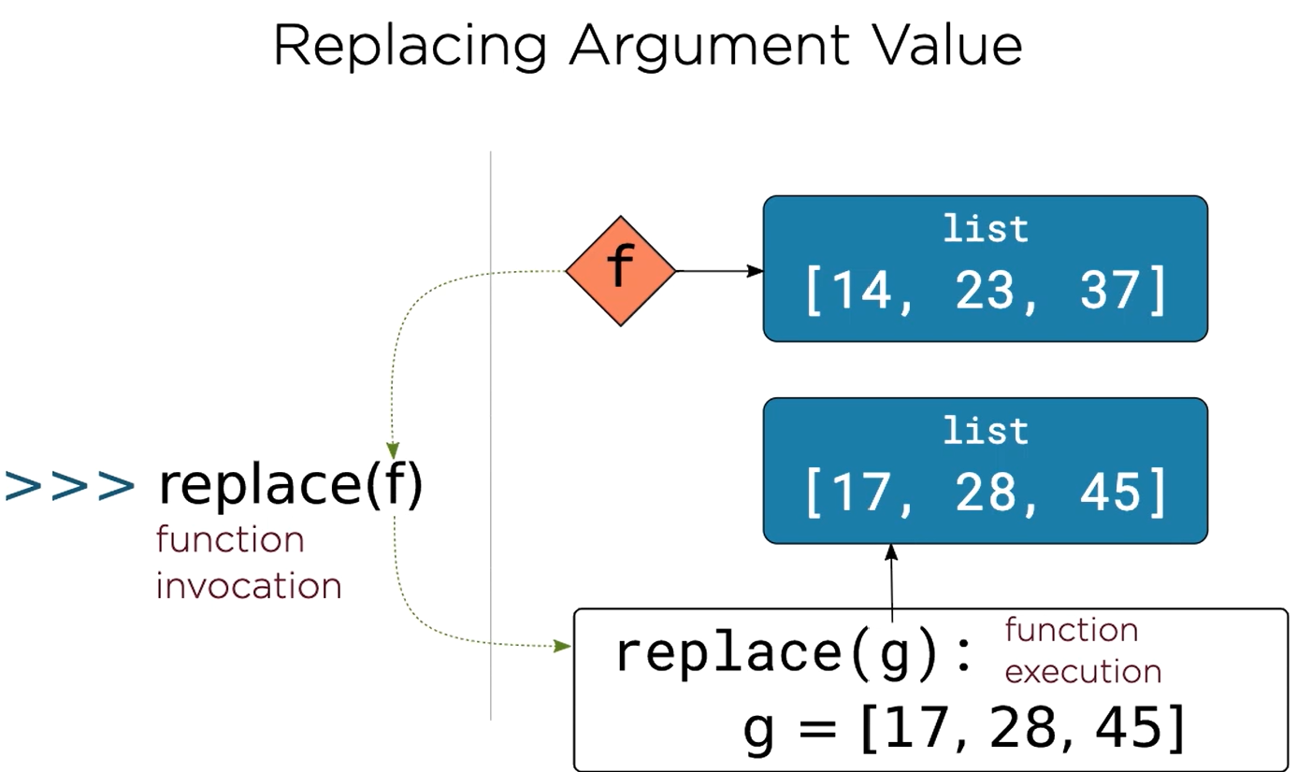

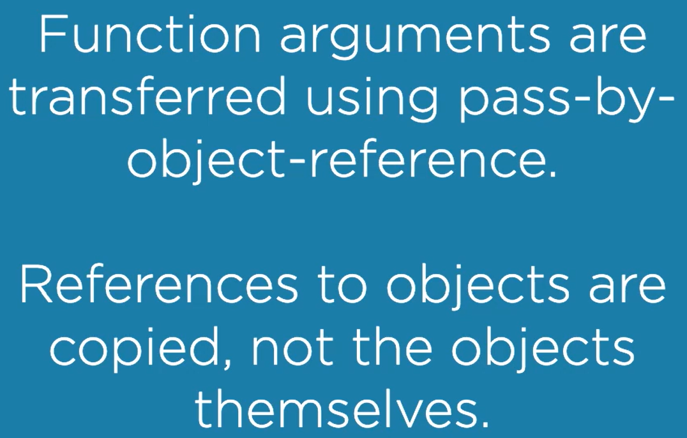

Return statement also uses pass by object reference model.

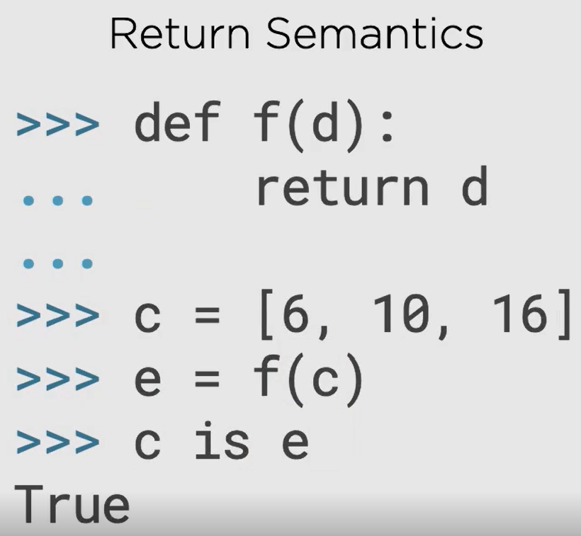

### Function Arguments

Positional arguments vs keyword arguments:

|  |  |
| --- | --- |
| **Positional Arguments** | **Keyword Arguments** |
| They are matched up in sequence with the formal arguments, i.e. by position | They are matched by name |
| Order matters | Supply them in any order |
| They come first and then keyword arguments | They come after positional arguments |
|  |  |

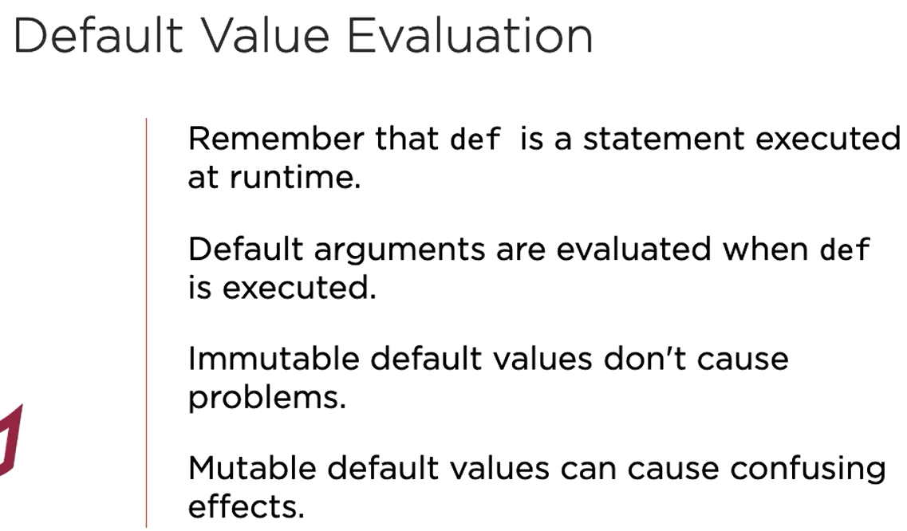

Problem example:

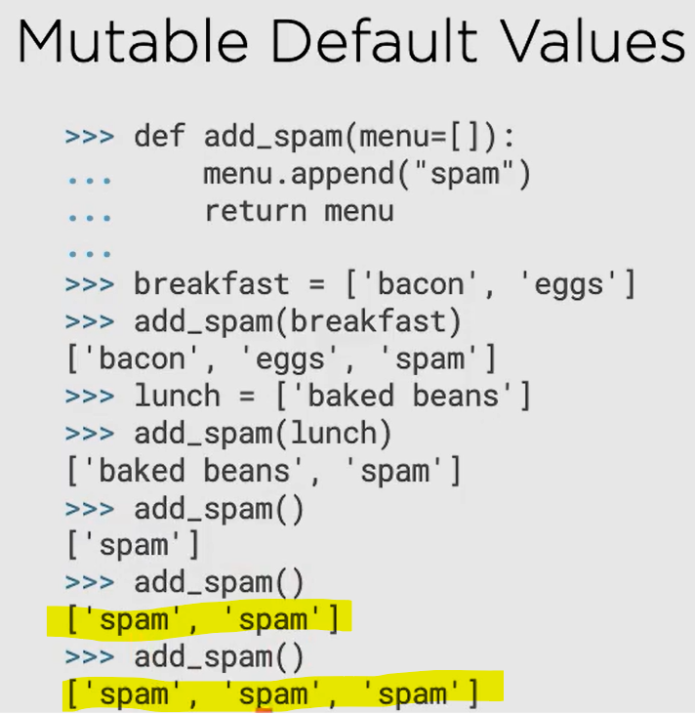

Solution:

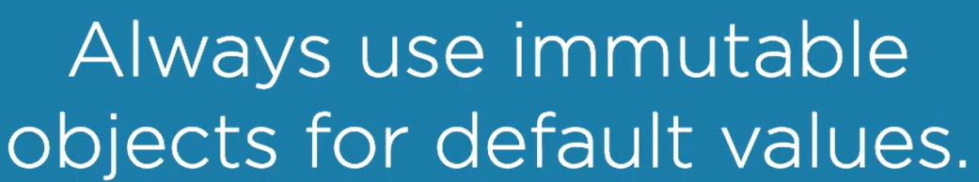

**Always use immutable objects for default values such as int, str, None**

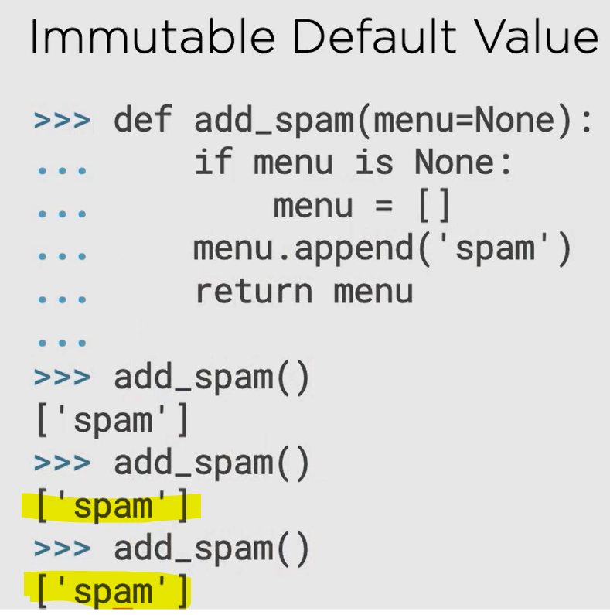

### Scopes in Python

LEGB rule

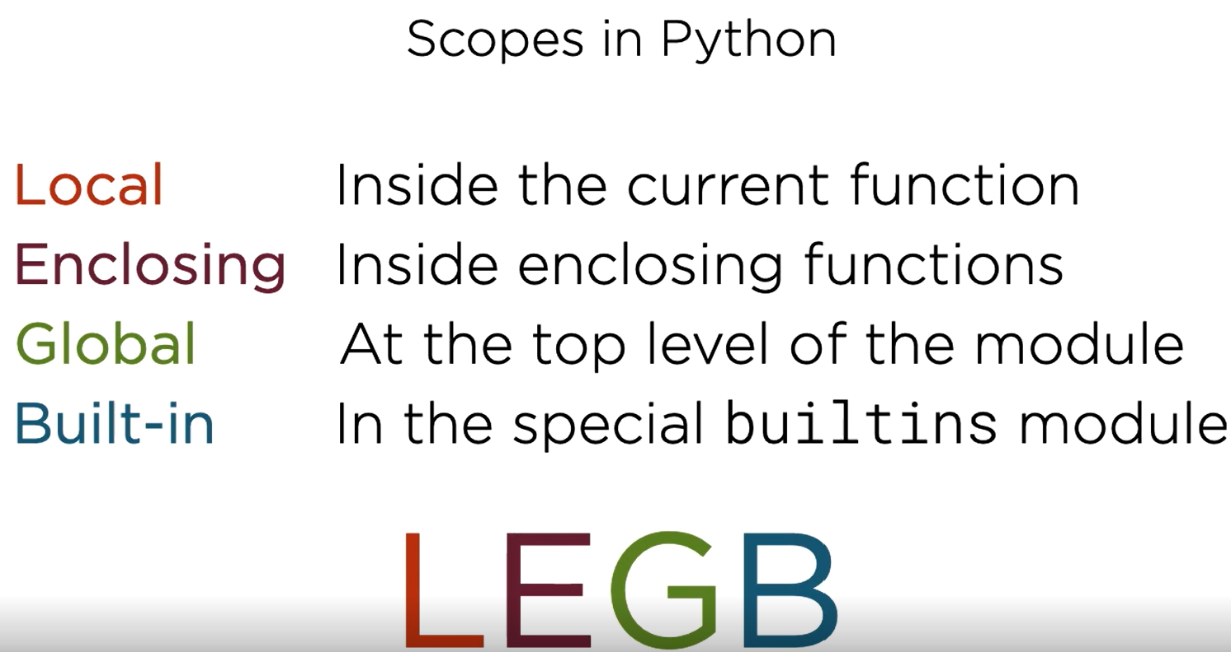

Global scope is also called module scope

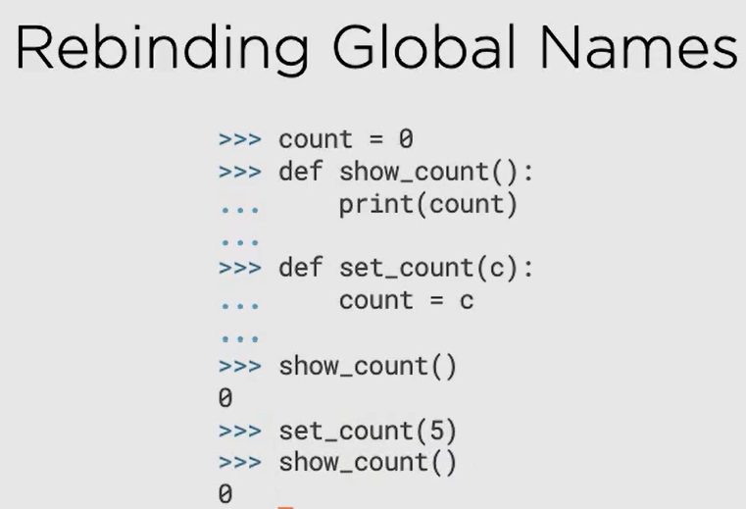

First checks if count is present in local scope (refer to the previous picture for hierarchy), not found then checks enclosing scope, not found then checks global scope, found -> print 0

The same thing happens in the second example as well, the reason 5 was lost is because 5 was in the local scope of set_count() function and got destroyed when the function completed, this 5 was not stored anywhere, the global count was 0 all this time.

Use “global” keyword to treat a local variable in the global scope.



Everything in python is an object including modules and functions.

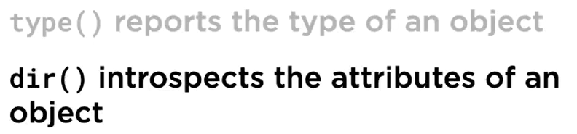

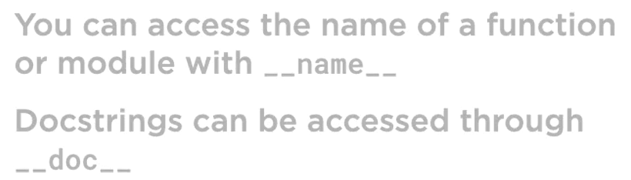

## Built-in collections

### str

Partition method expects a partition string, returns a tuple of three elements -> before partition string, partition string and after partition string

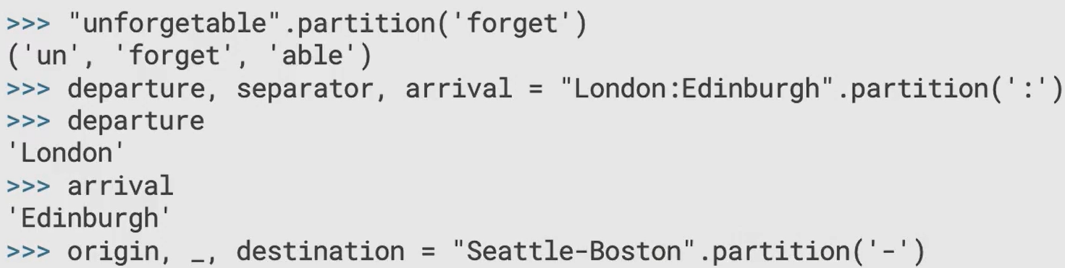

The format method

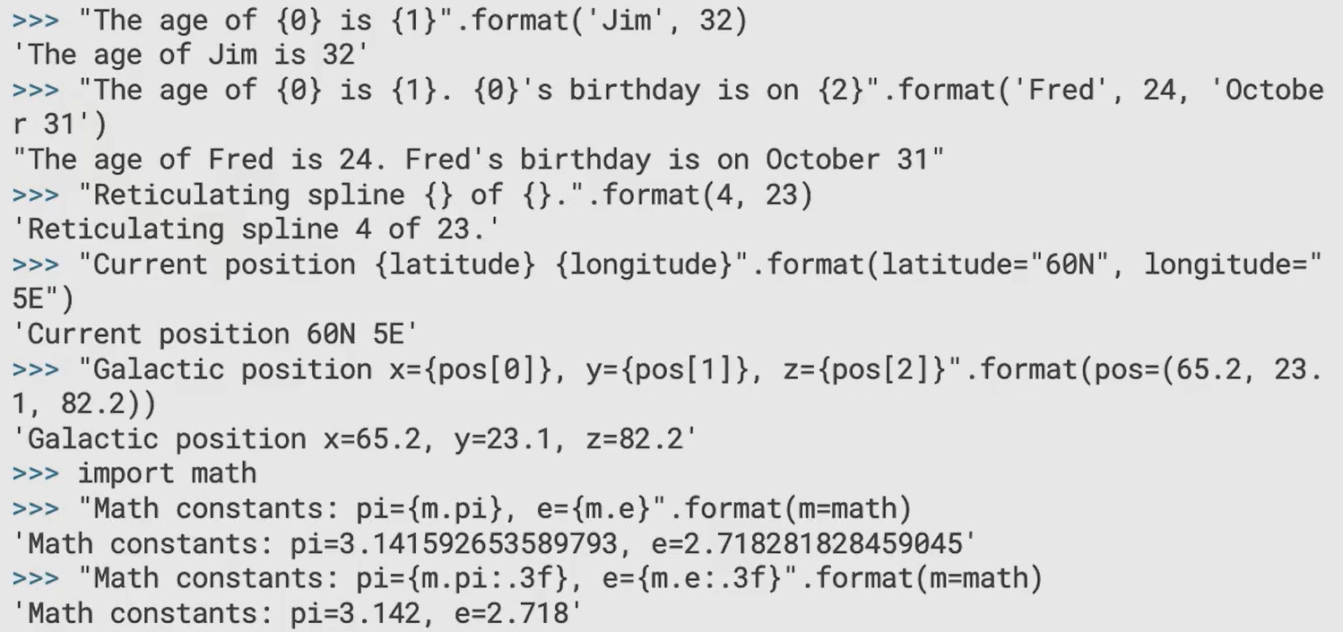

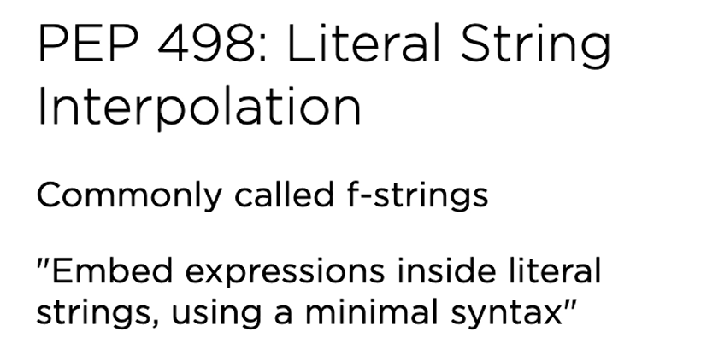

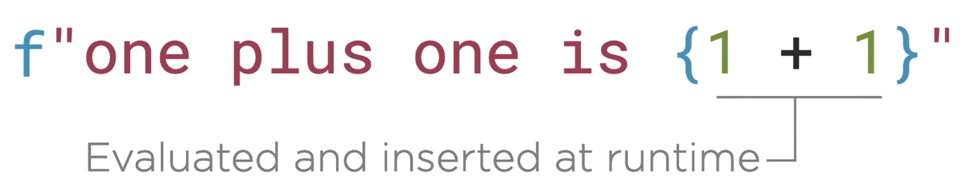

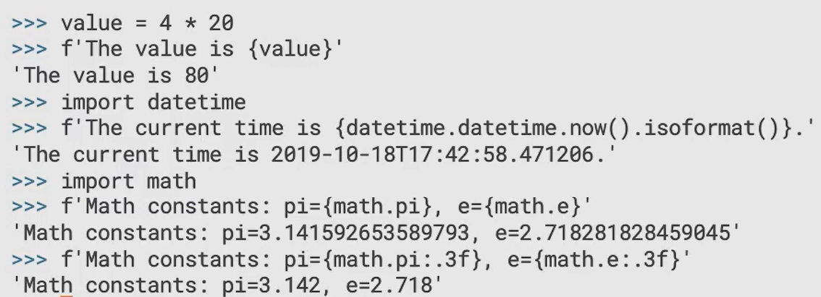

### ranges

never use this:

t = [6, 372, 8862, ….]

for i in range(len(t)):

print(t[i])

This is unpythonic, instead use this

for i in t:

print(i)

If for some reason you want the index, then use this:

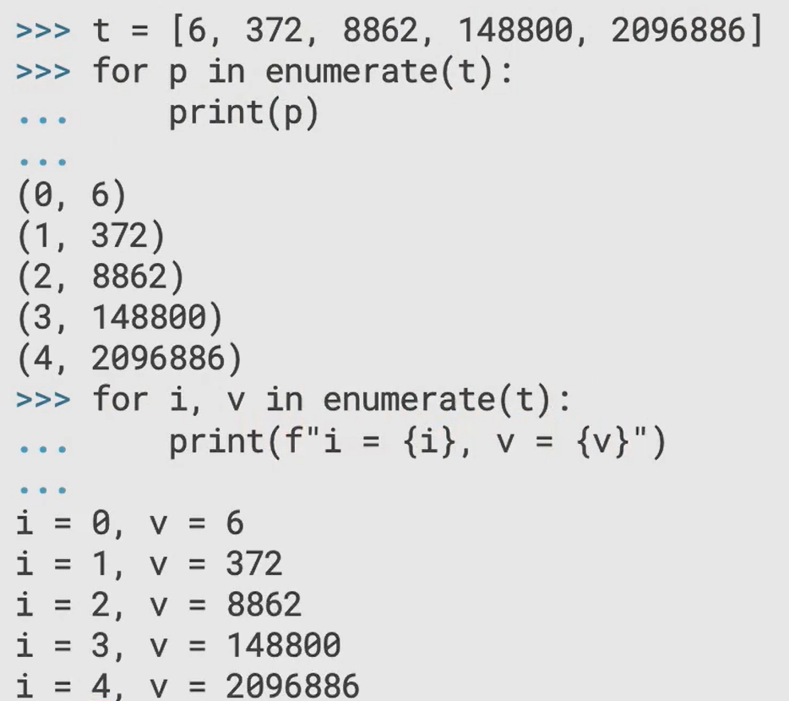

### List

How do we create a copy of a list?

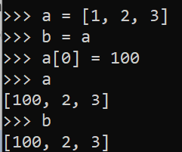

This means both A and B has been modified because they point to the same object.

Instead use the slicing technique like this

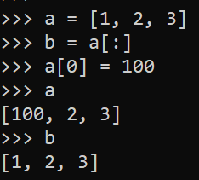

This way a new list object is created in memory which is pointed by b. So, changes in a does not reflect in b. Since int (the actual member of the list is int) is immutable that is why this behaviour is observed.

Be aware, using slicing to copy definitely creates a new object for the overall list but the members still point to the old member objects.

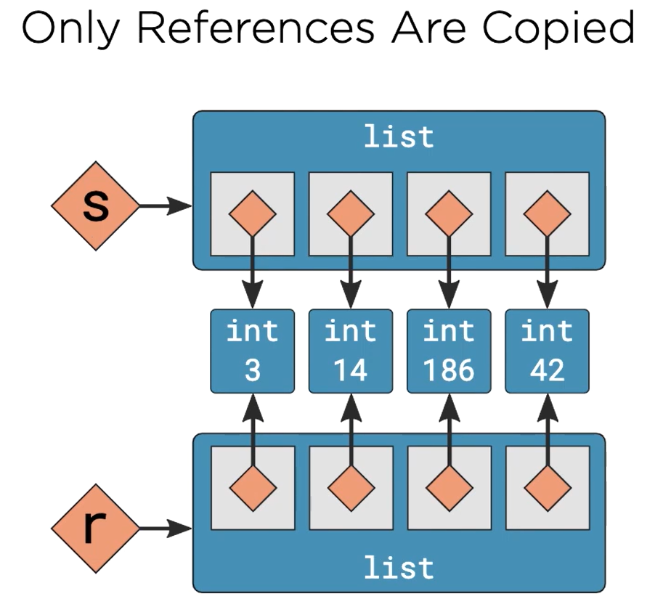

A good example:

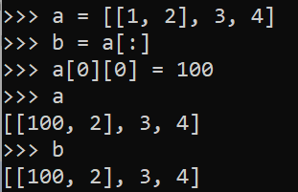

Results will be same if you use:

* b = a.copy()
* b = list(a)

This is called shallow copying.

Beware of the same issue:

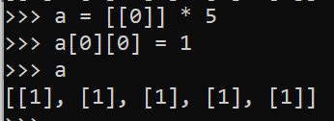

To prevent this, use deepcopy from copy module

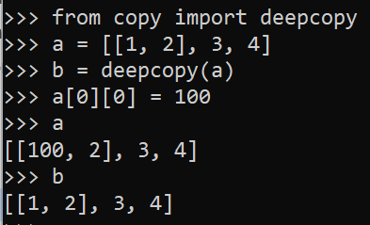

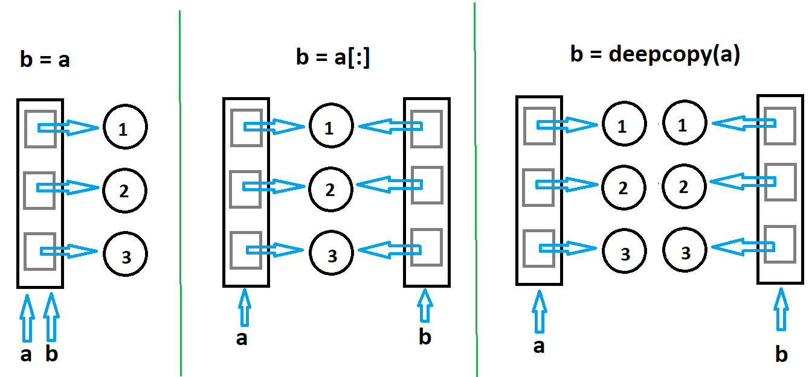

**Note: Beware of mutable objects and their behaviour while copying**

### Dict

* Copying dictionary is also shallow.
* Dictionary keys must be immutable

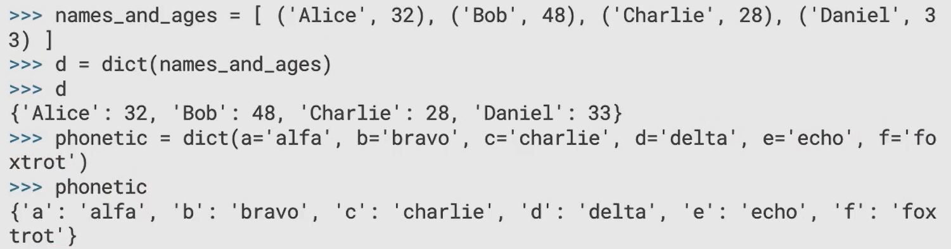

Shallow copying a dictionary

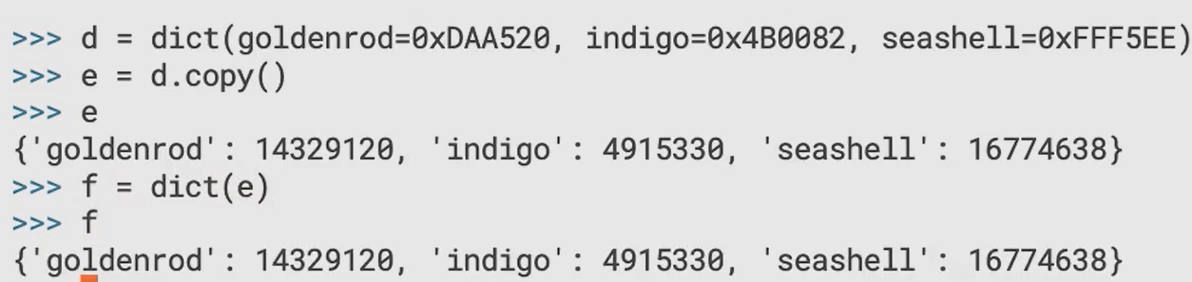

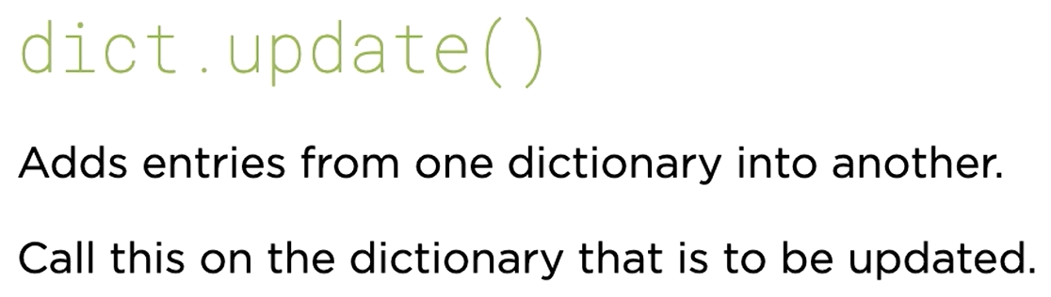

### Set

Following useful methods:

* add(): adds an element to the existing set
* update(): adds an iterable collection to the existing set
* remove(): removes an element from the set, results in key error if value is not present
* discard(): removes an element form the set, ignores of element is not present, no key error
* copy(): preforms a shallow copy
* union(): |
* intersection(): &
* difference(): -
* symmetric_difference(): ^
* issubset()
* isdisjoint()

### Protocol

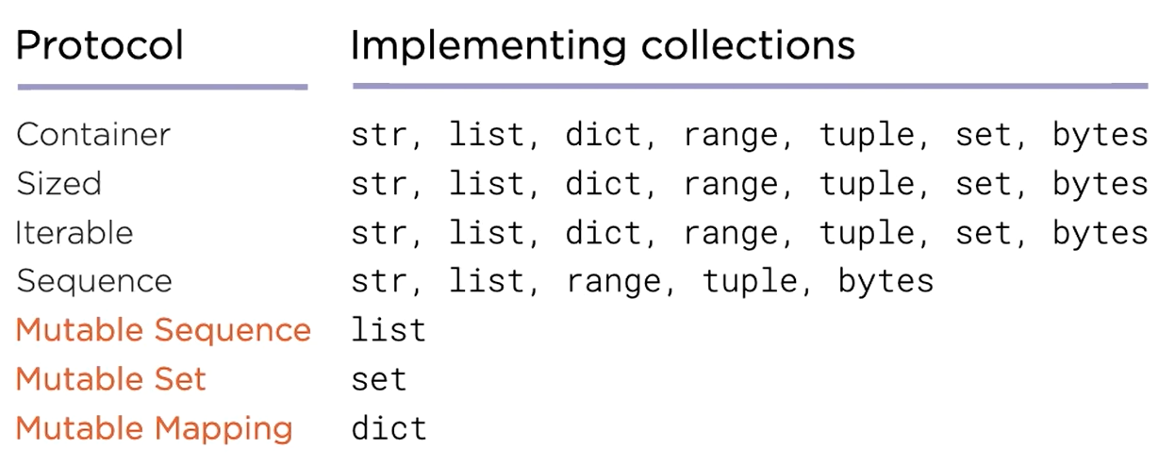

Container requires the support of **in** and **not in** operator

Sized requires the support of **len()** function

Iterable requires producing items one by one as they are requested which means they support **iter()** function to produce an iterator

Sequence requires that **item can be retrieved using squared brackets with an integer index**

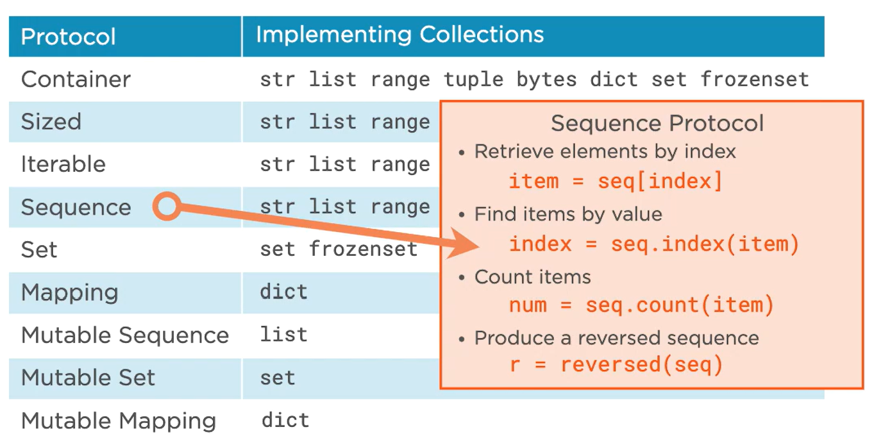

## Exceptions

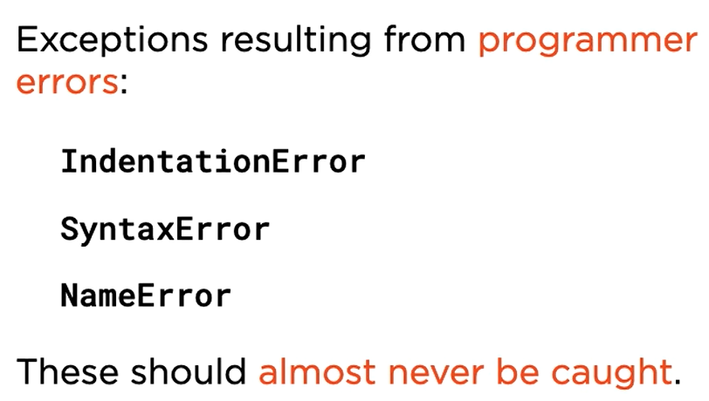

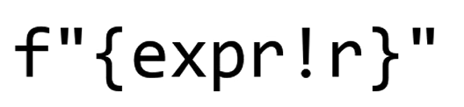

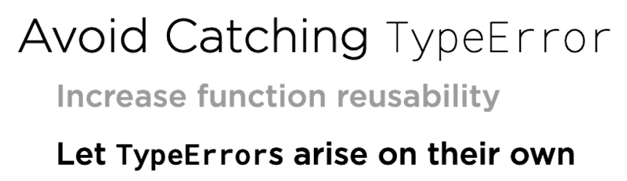

### try except

try:

# some statement

except Exception as e:

# some statement

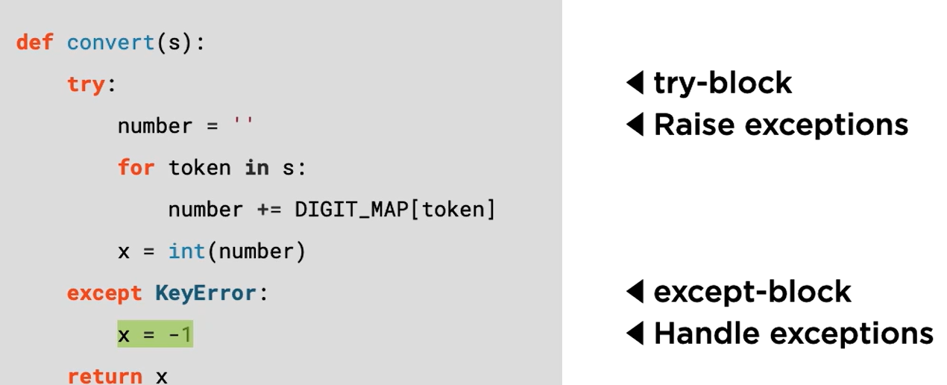

### LBYL vs EAFP

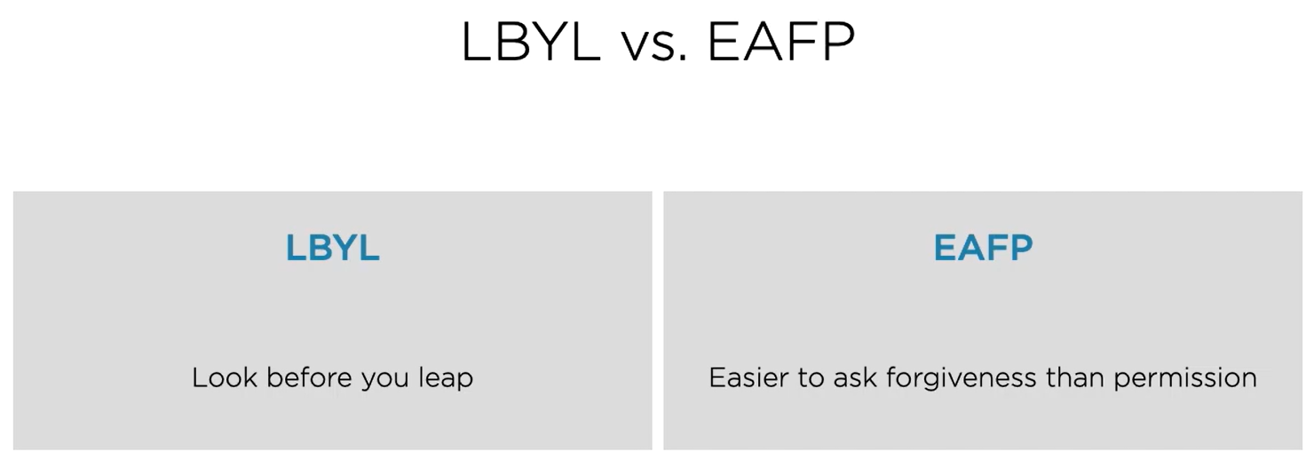

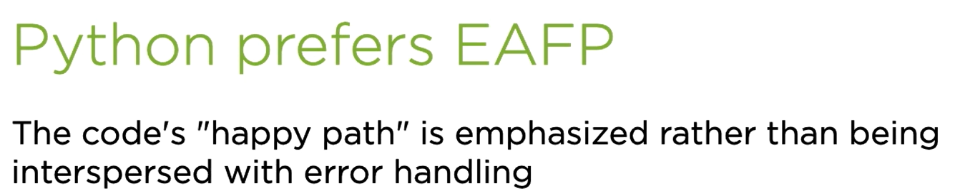

Example of LBYL vs EAFP:

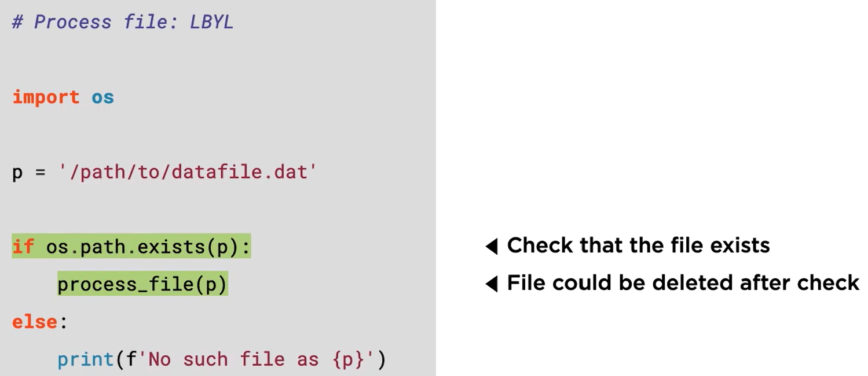

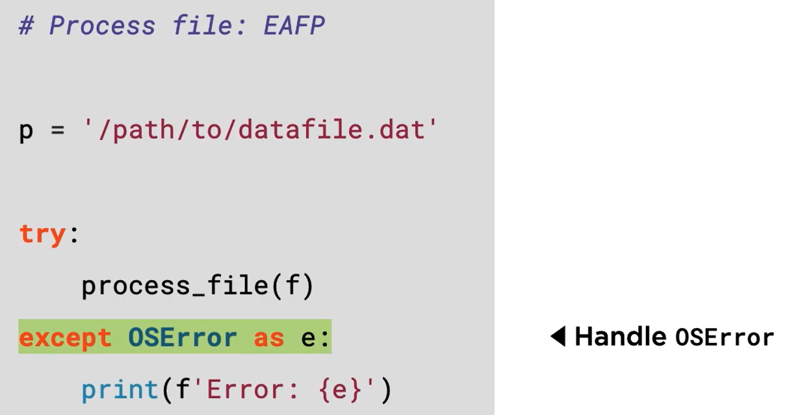

This one is preferrable.

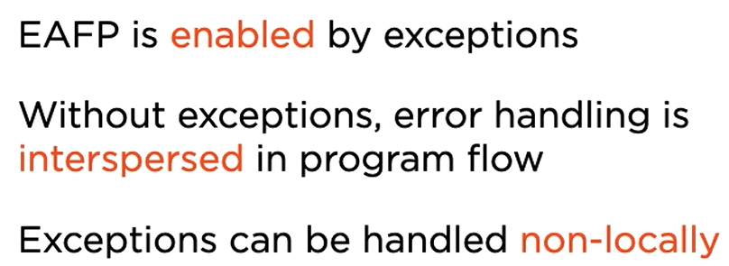

### raise

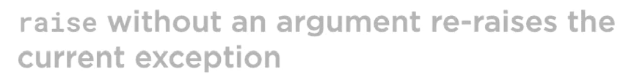

### try finally

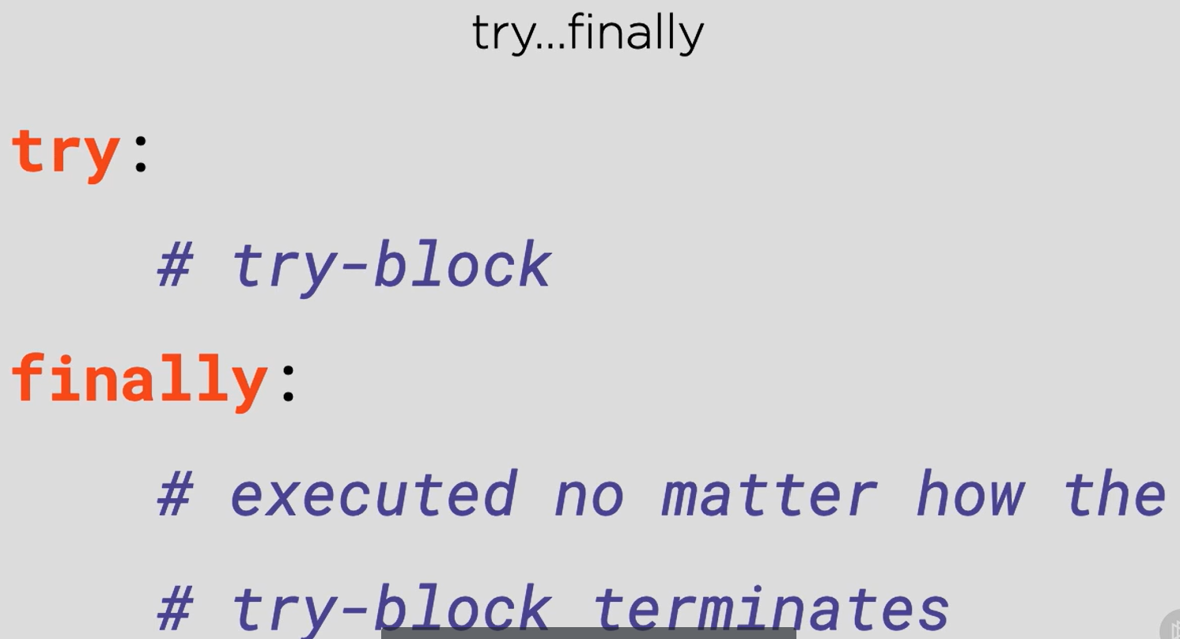

**Code in the finally block is executed whether exception leaves the try block normally by reaching the end of the block, or exceptionally by an exception being raised.**

### Platform specific code

To implement a solution capable of detecting a single key press, we will need to use OS specific modules:

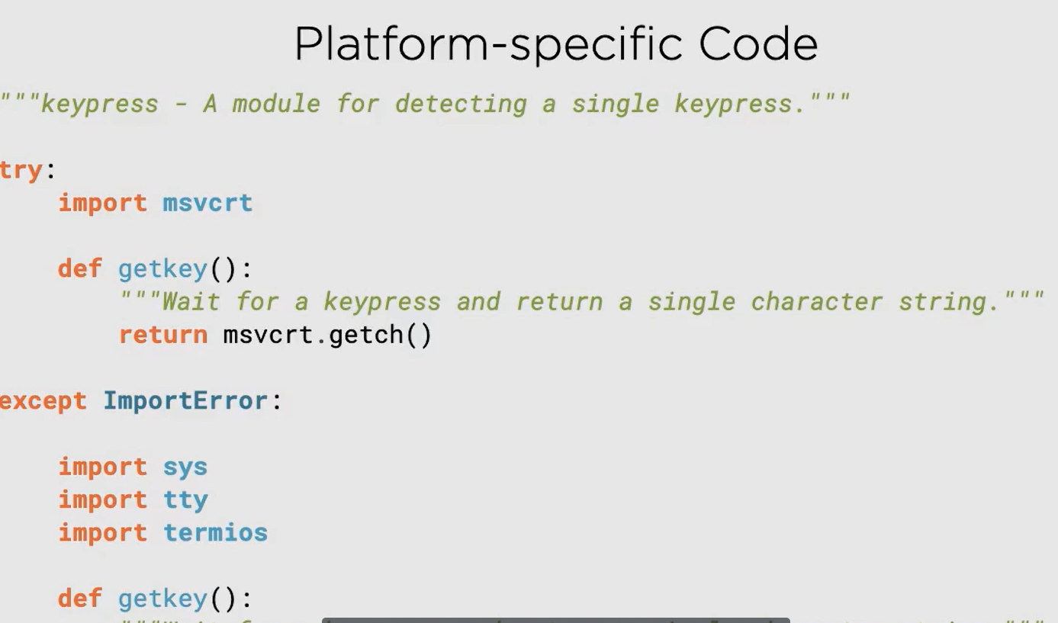

## Iteration and Iterables

### List and set comprehension

Syntax for list comprehension



Replace the outer square bracket by curly bracket and yo have the syntax for set comprehension

### Dictionary comprehension

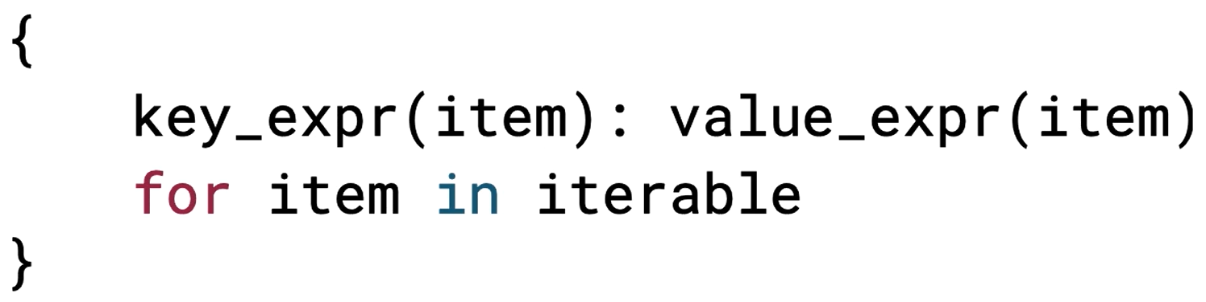

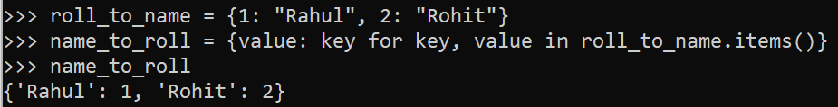

### Iteration protocols

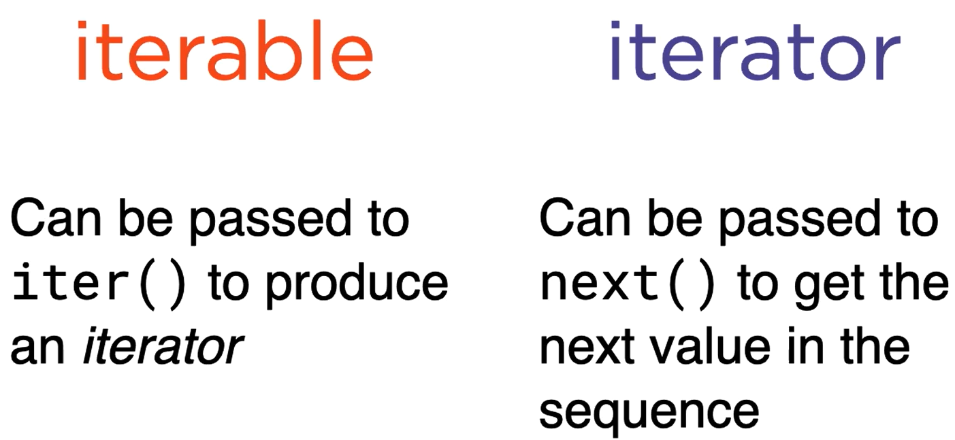

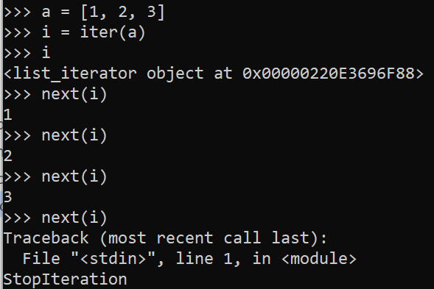

### Generator funnction

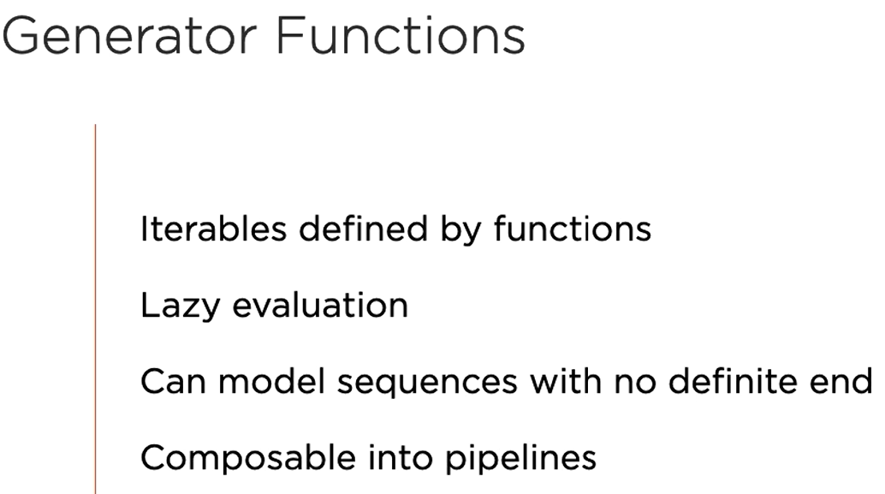

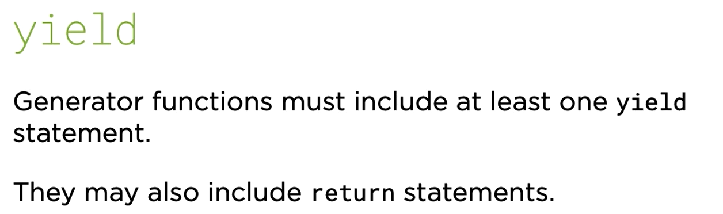

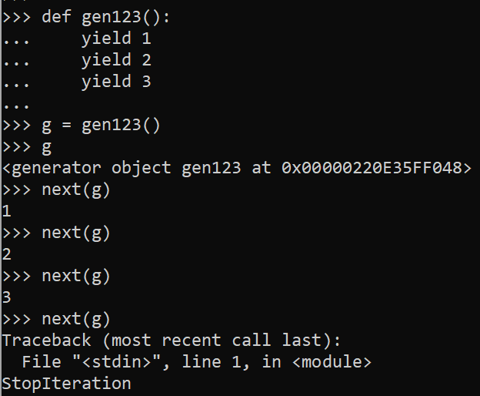

Generators are iterators and iterators are made up of iterables, so we can do something like this

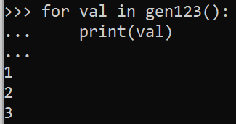

Let’s see when the yield statement gets executed

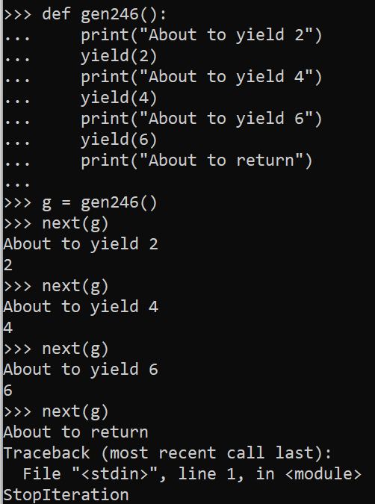

### Maintaining state in generators

Refer program generator.py

### Advantages of generator

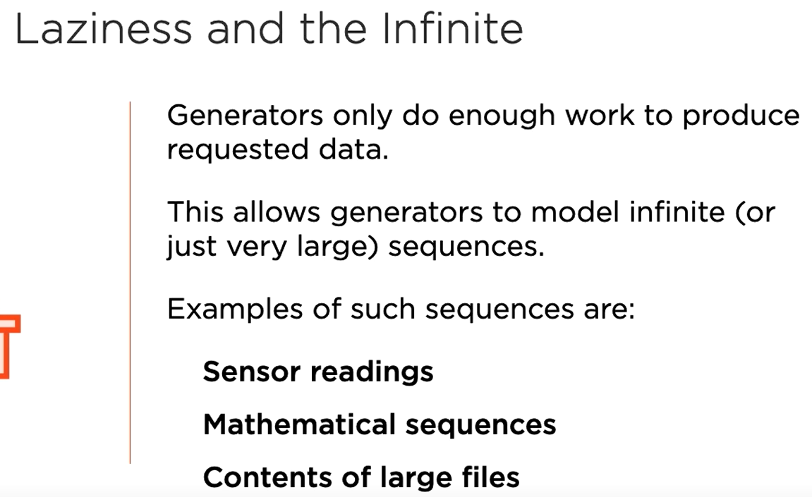

### Generator expression

* A combination of comprehension and generator function
* They are useful when you want lazy evaluation with declarative concision of comprehensions



Notice this is similar to list comprehension except the outer brackets are not square here.

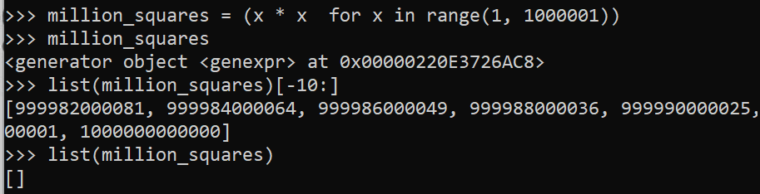

Once the generator has reached the end, it cannot yield anything. Notice the last statement in the above example.

Generators are single use objects. Each time we call a generator function, we create a new generator object.

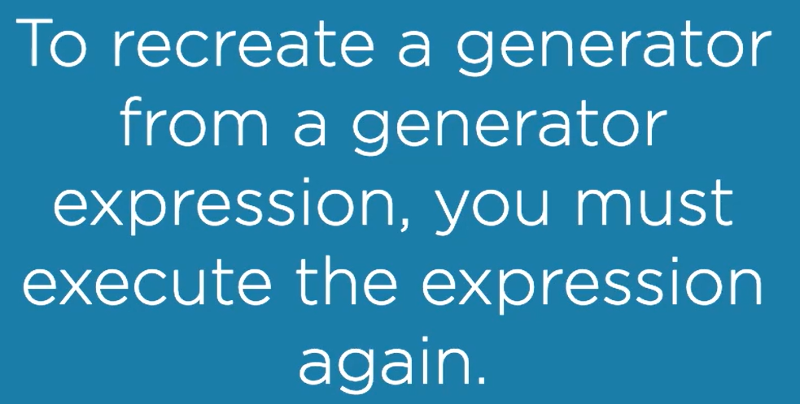

### Iteration tools

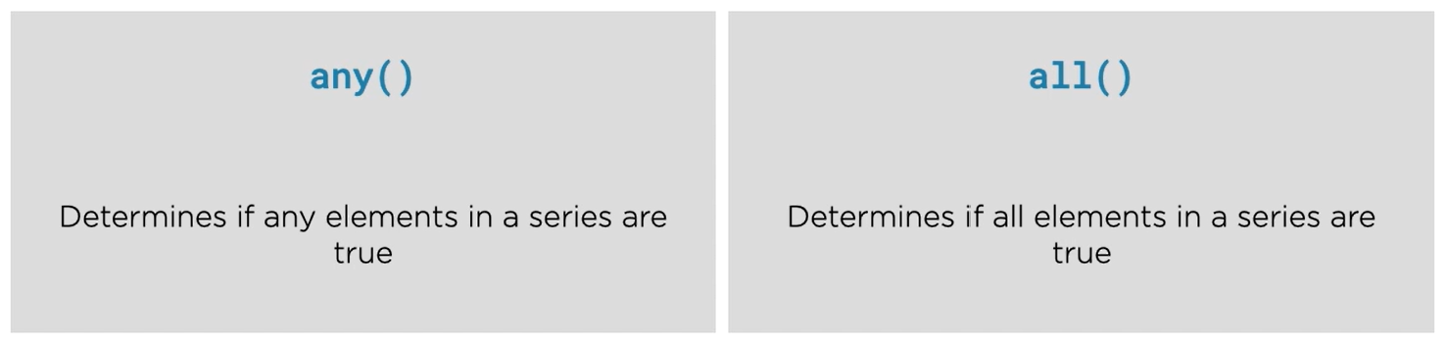

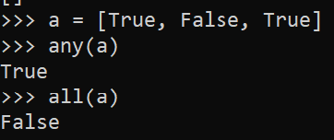

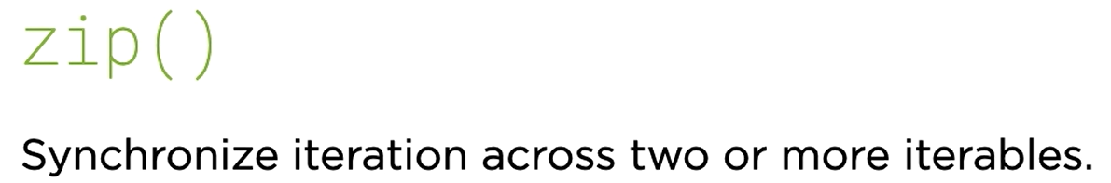

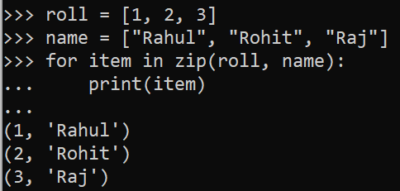

## Classes

### Instance Initializers

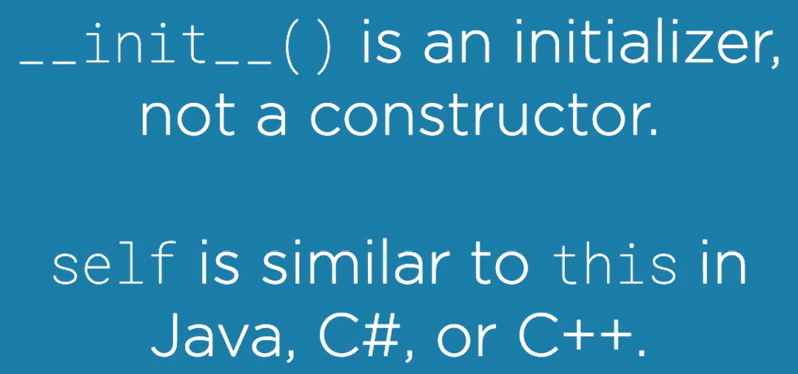

The purpose __init__() is to configure an object that already exists by the time __init__() is called.

## File IO and Resource Managements

### Opening Files

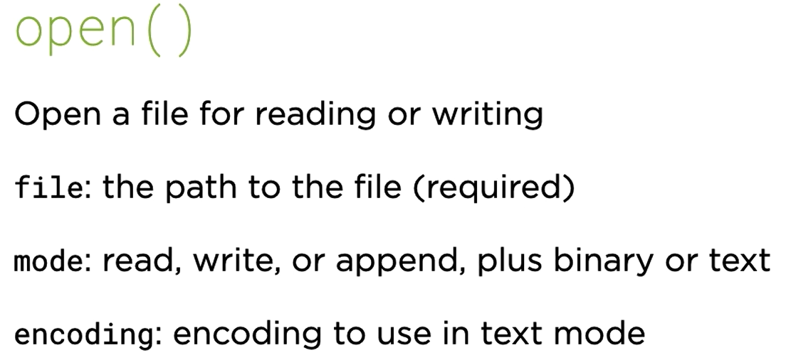

Files are stored as binary (contains a series of bytes).

Two modes to open a file in python:

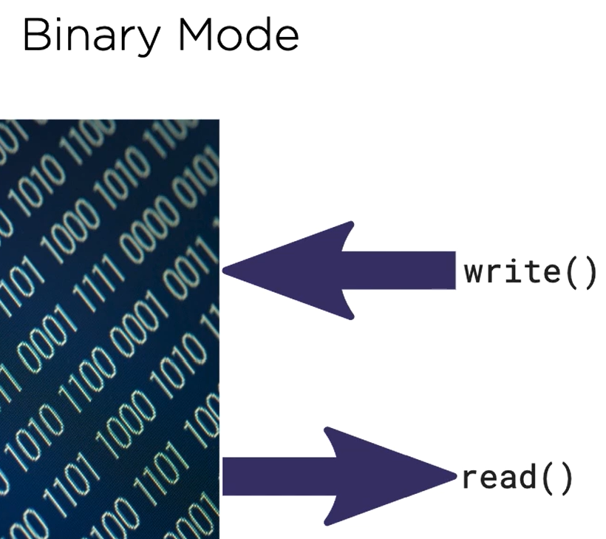

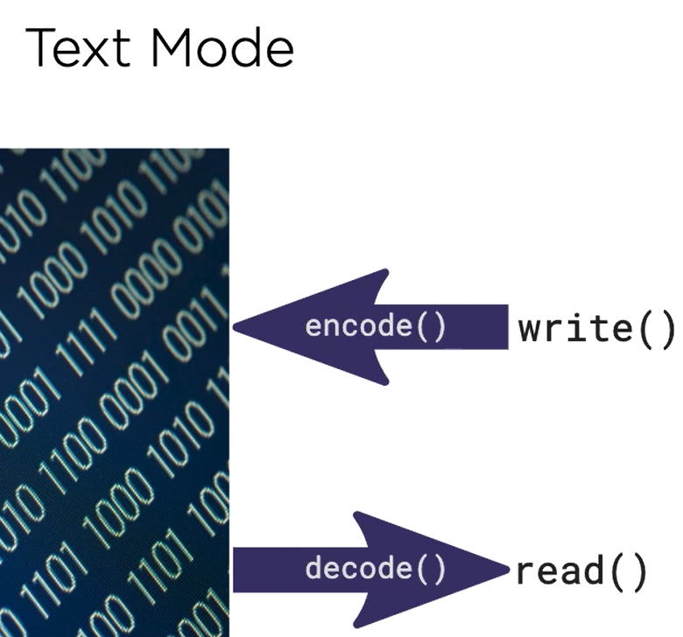

If you don’t specify an encoding, default encoding will be used:

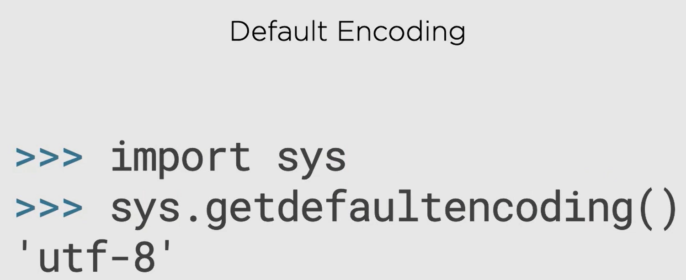

This can vary system to system.

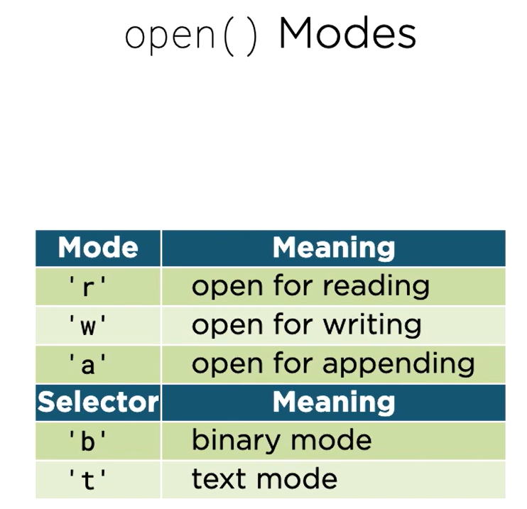

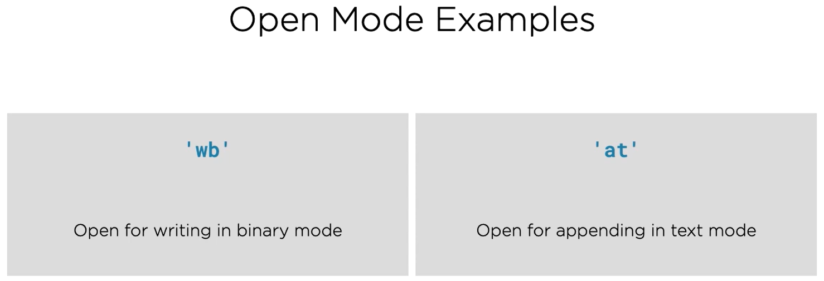

### Writing Text



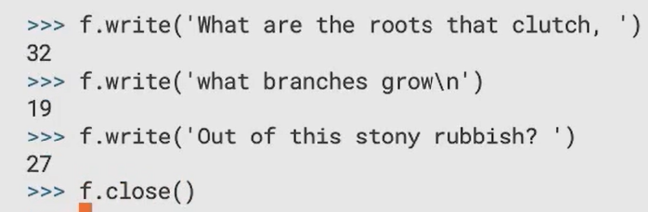

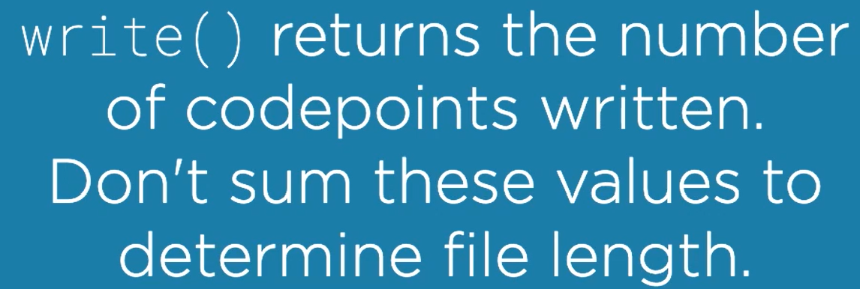

### Reading Text

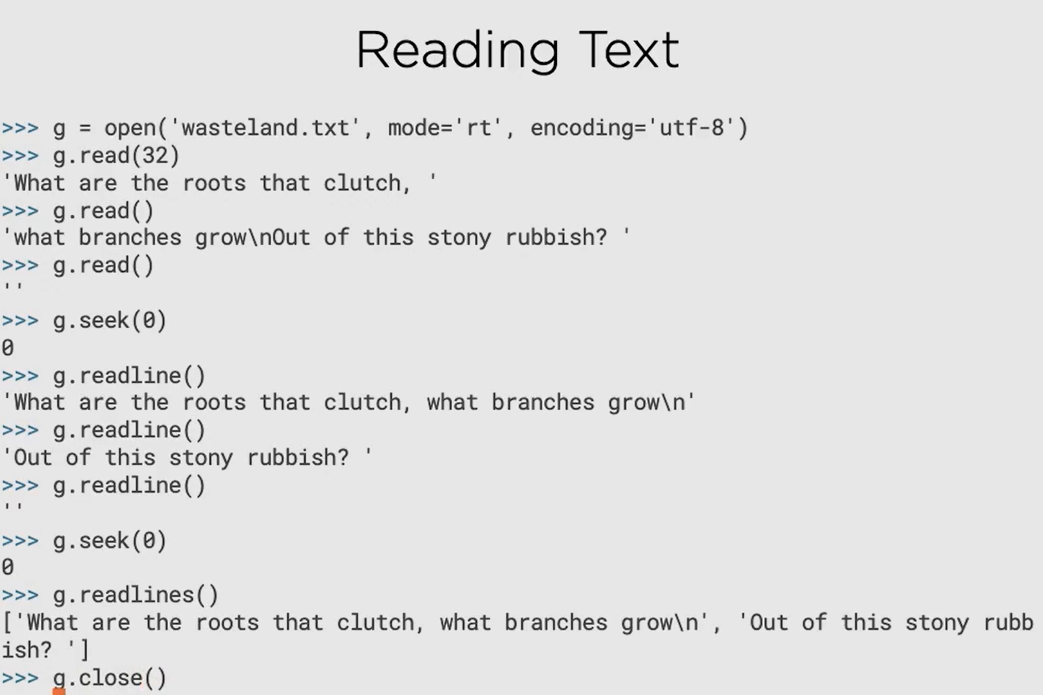

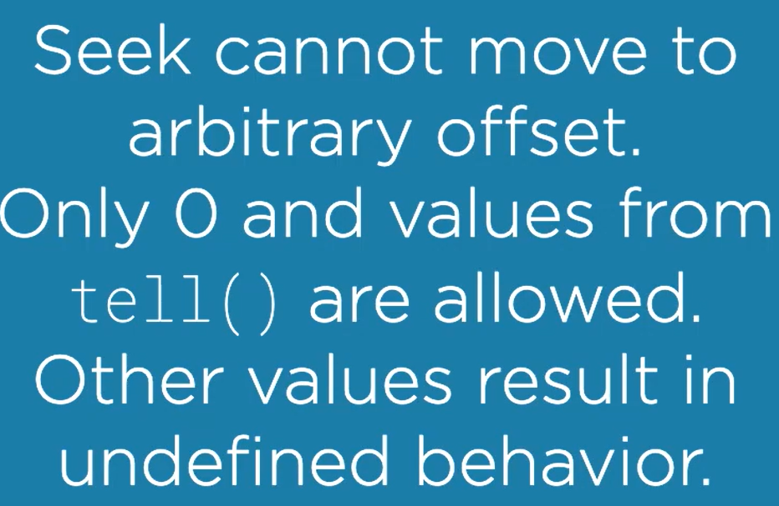

### Appending Text

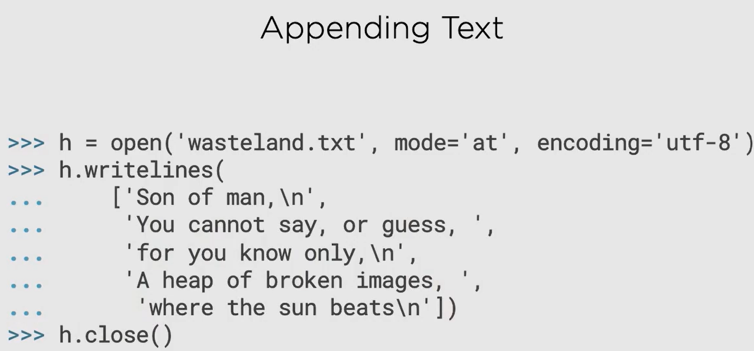

### Iterating over files

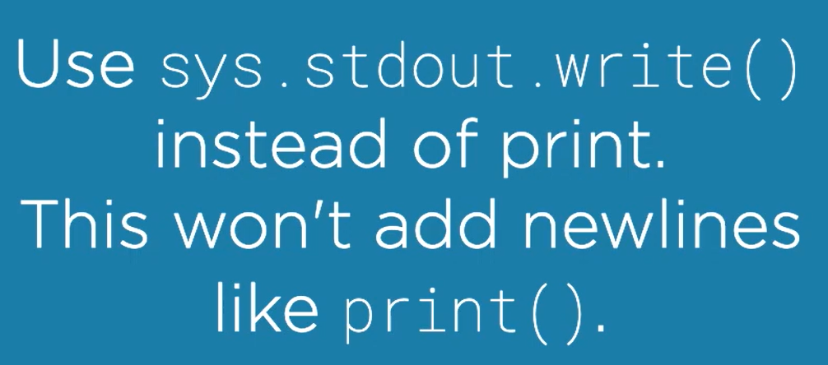

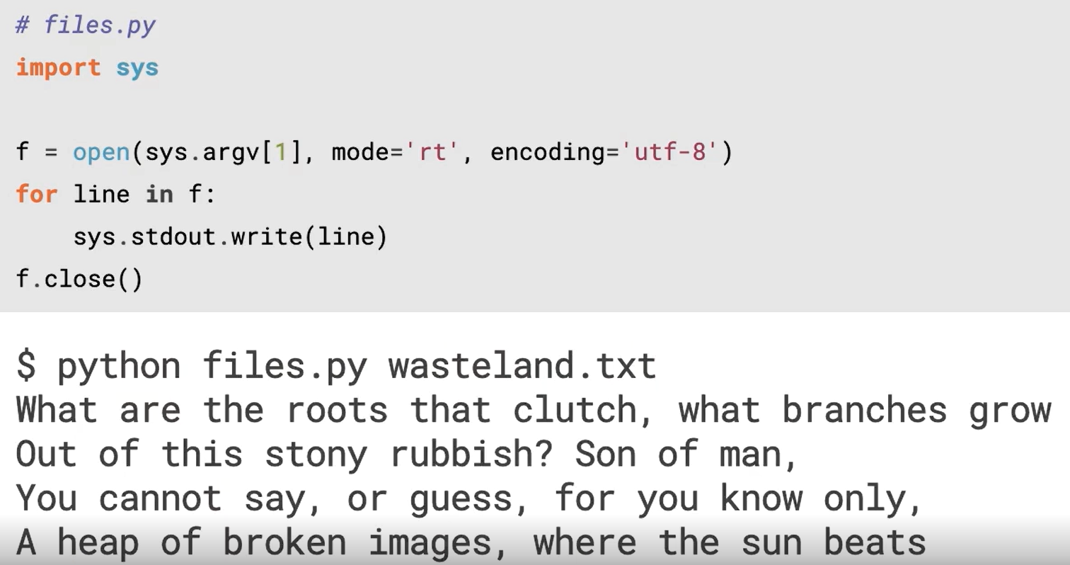

### Closing files with finally

Always put your file code in the try block, who knows what kind of error can you see. Lastly put the file.close() in the finally block to make sure it is always executed irrespective of the exception.

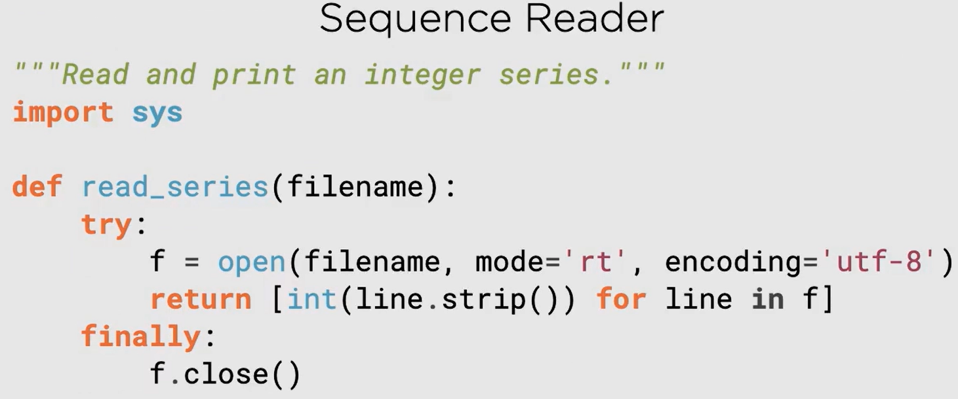

### with blocks

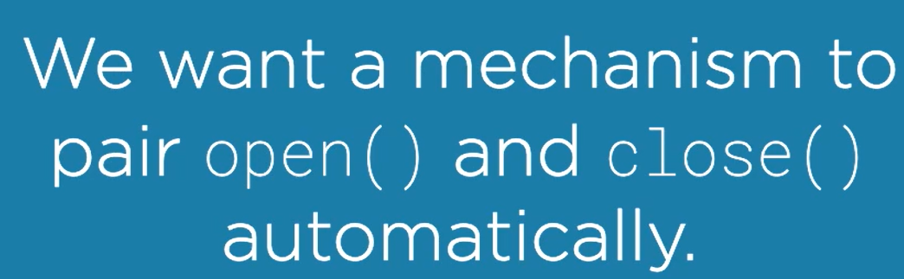

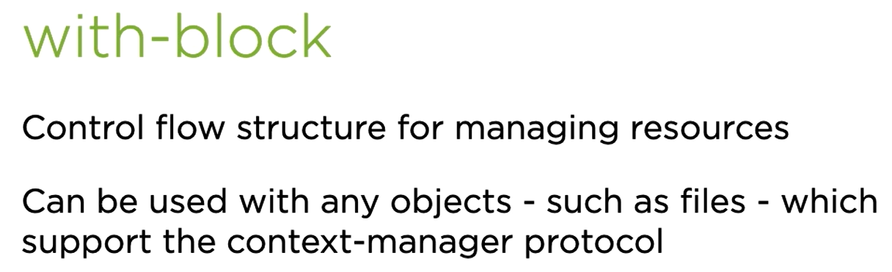

Great thing about with block is that it will automatically close the file even if there is an exception. No need of explicit close statement.

### Binary Files

Open it without any encoding.

### Context Managers

Refer fridge.py

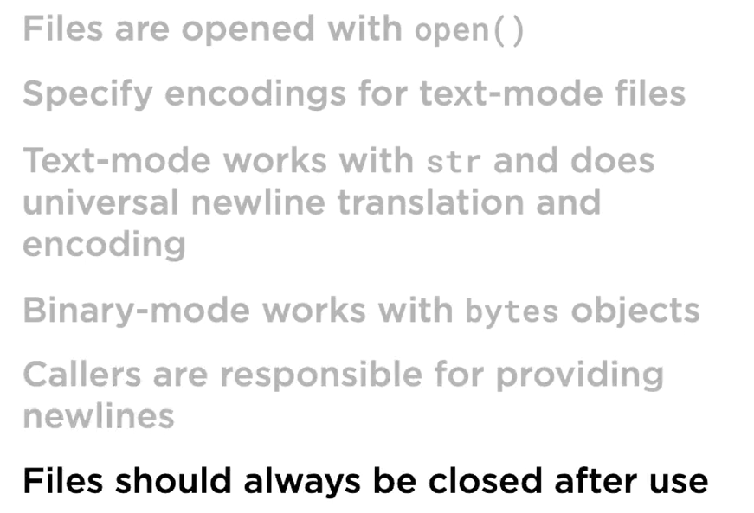

## argparse

* argparse is the recommended command-line parsing module in the Python standard library.
* Refer:
* program argparse-example.py
* <https://docs.python.org/3/howto/argparse.html>

# Core Python 3.6: Organizing Larger Programs

## Nesting Modules with Packages

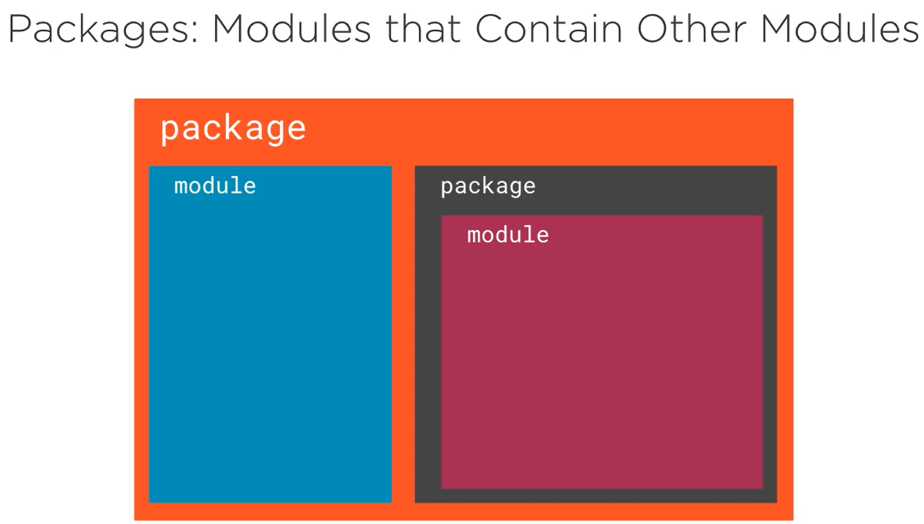

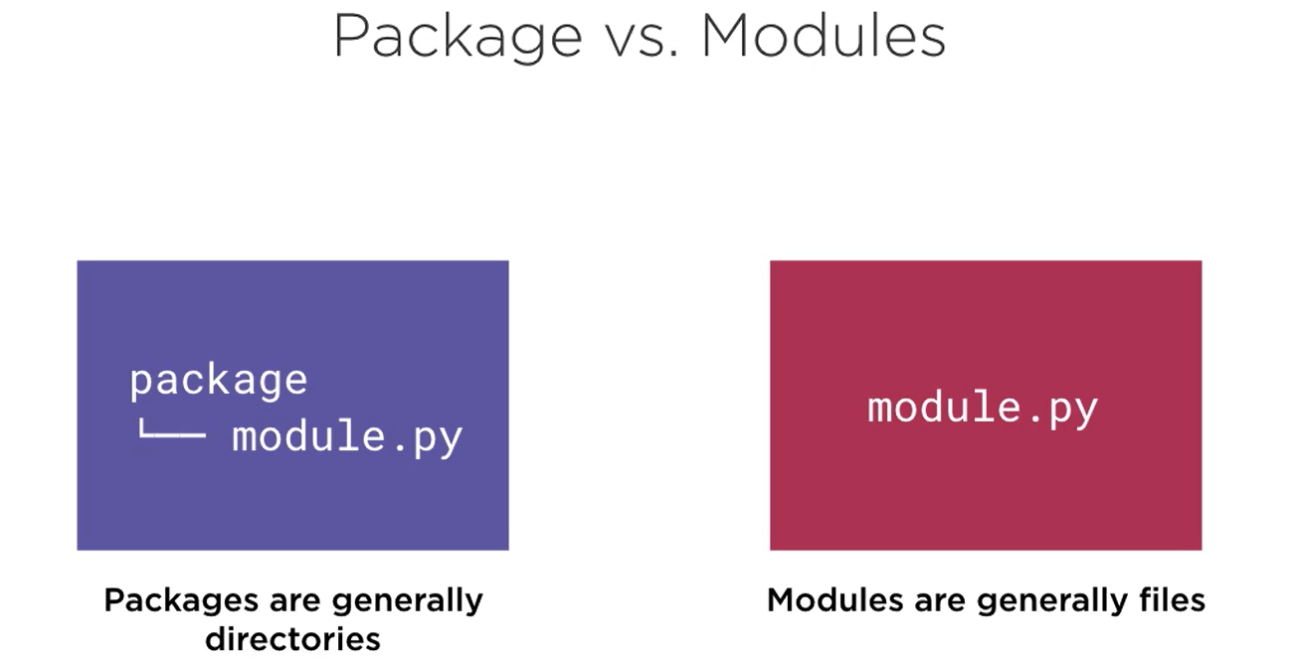

## Locating Modules

When we import any library, python looks for it in the sys.path

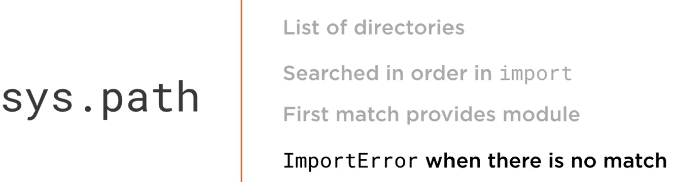

Since, sys.path is a list, we can append any path that we want to be added for imports to work without worrying about the directory that we are in.

Another way to modify path is using the environment variable PYTHONPATH

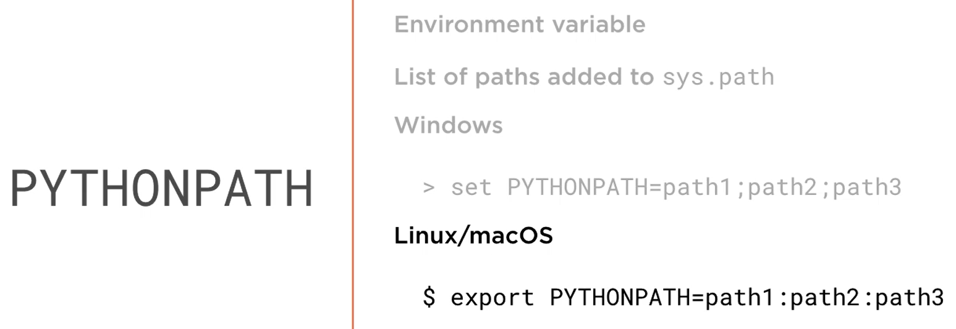

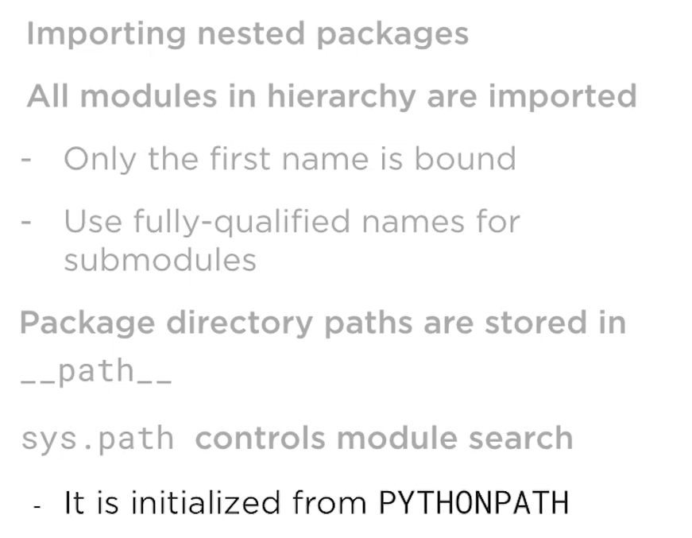

## Implementing Packages

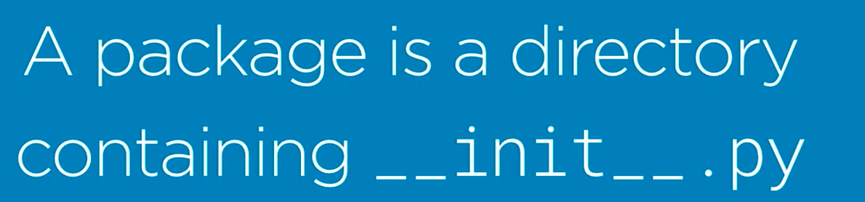

### Create a Package

Let’s try to create a package like this:

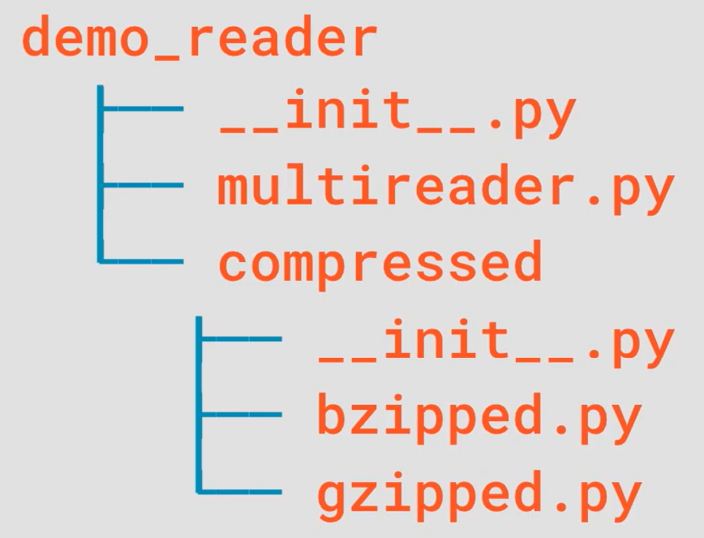

### Relative imports

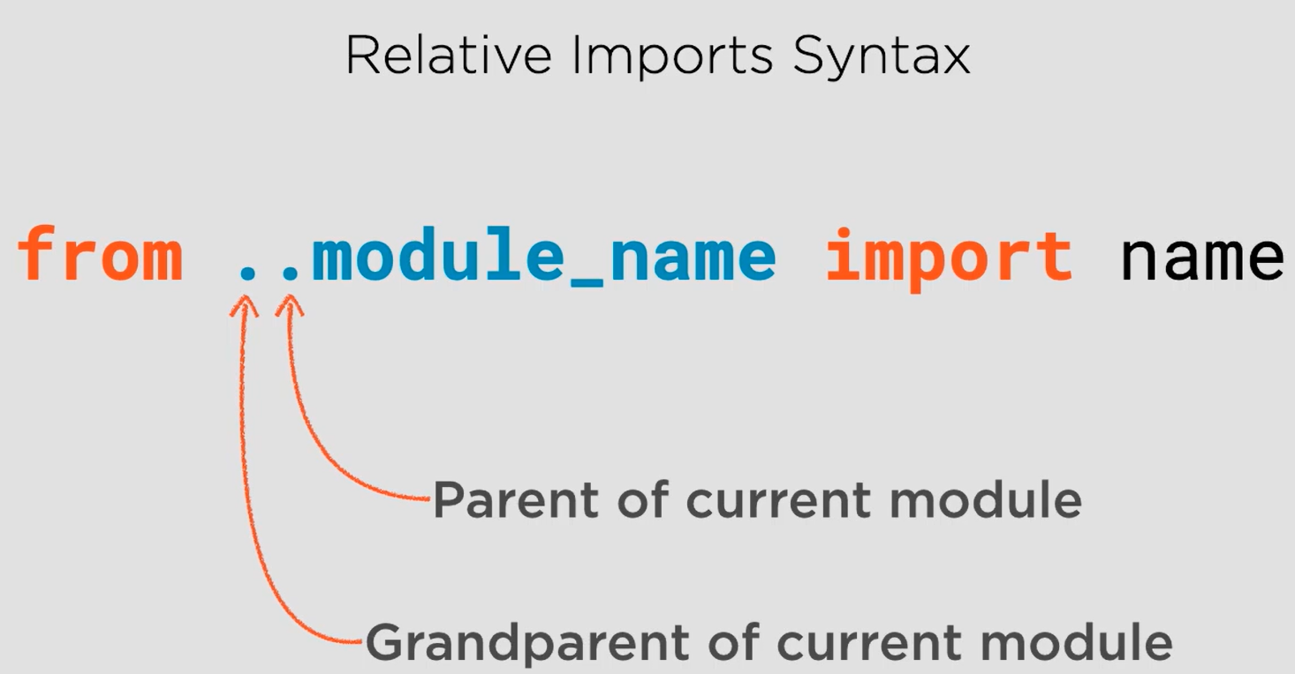

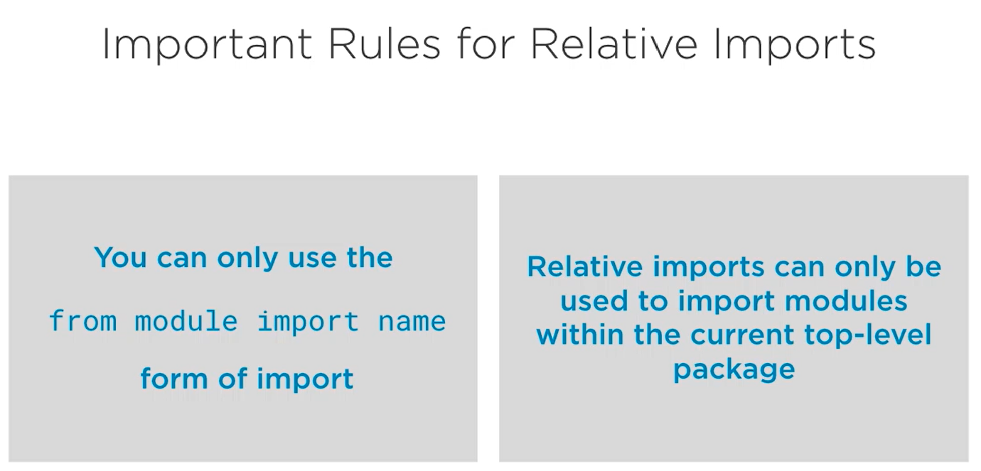

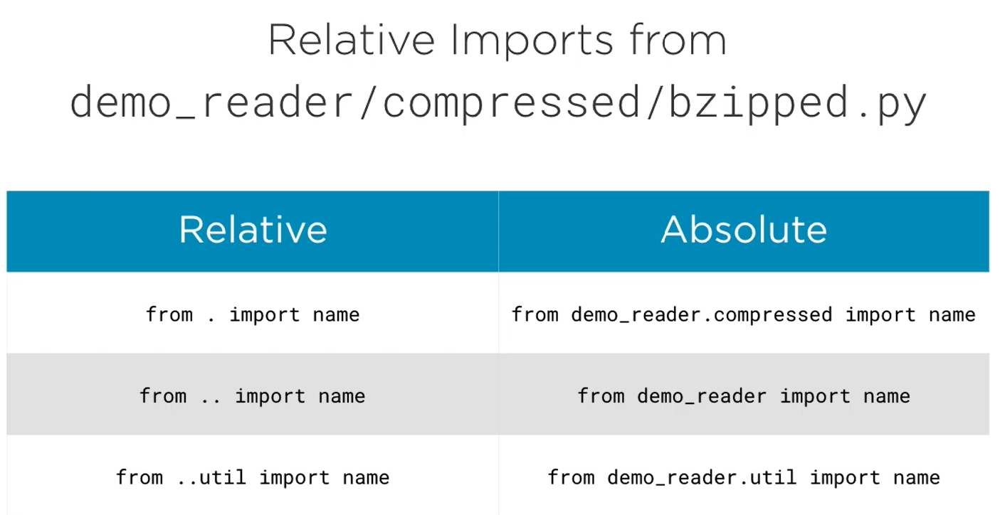

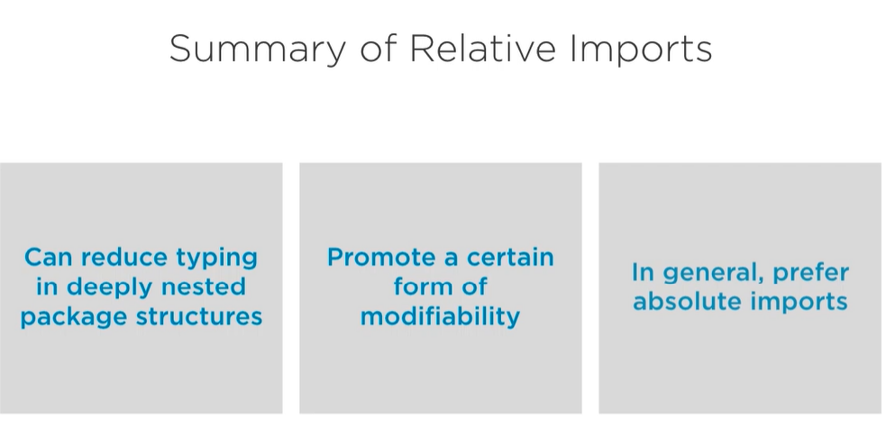

### Using __all__

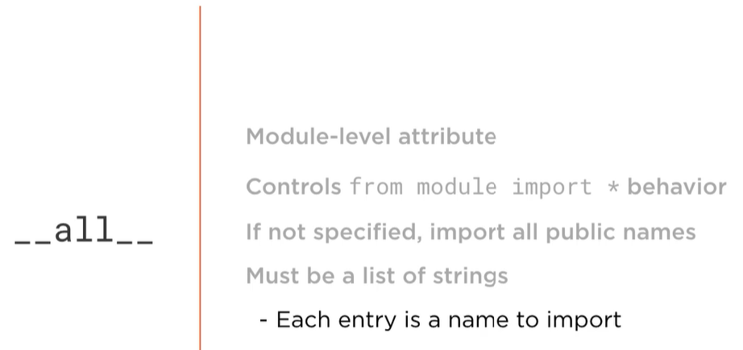

## Namespaces and Executable Packages

### Namespace Packages

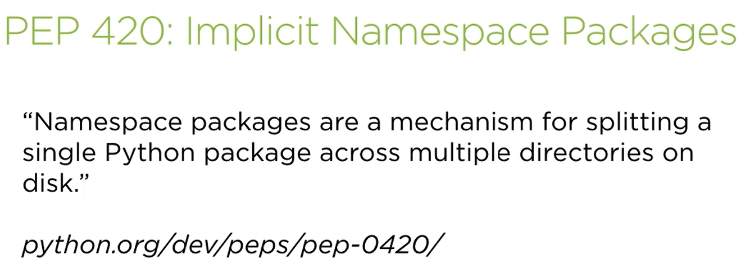

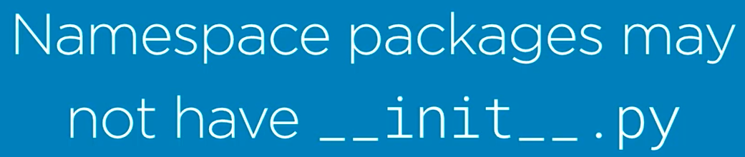

This is very important:

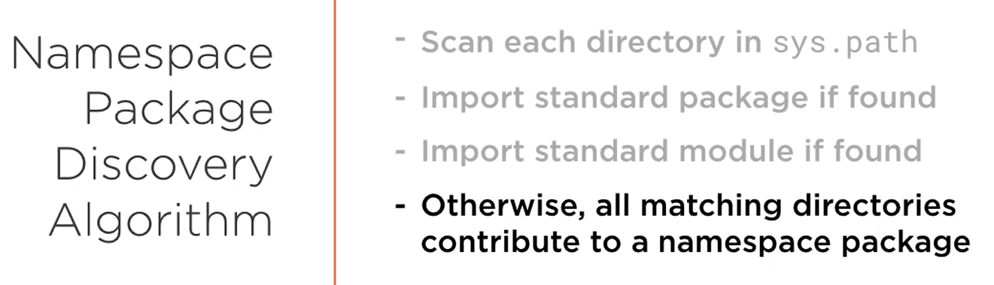

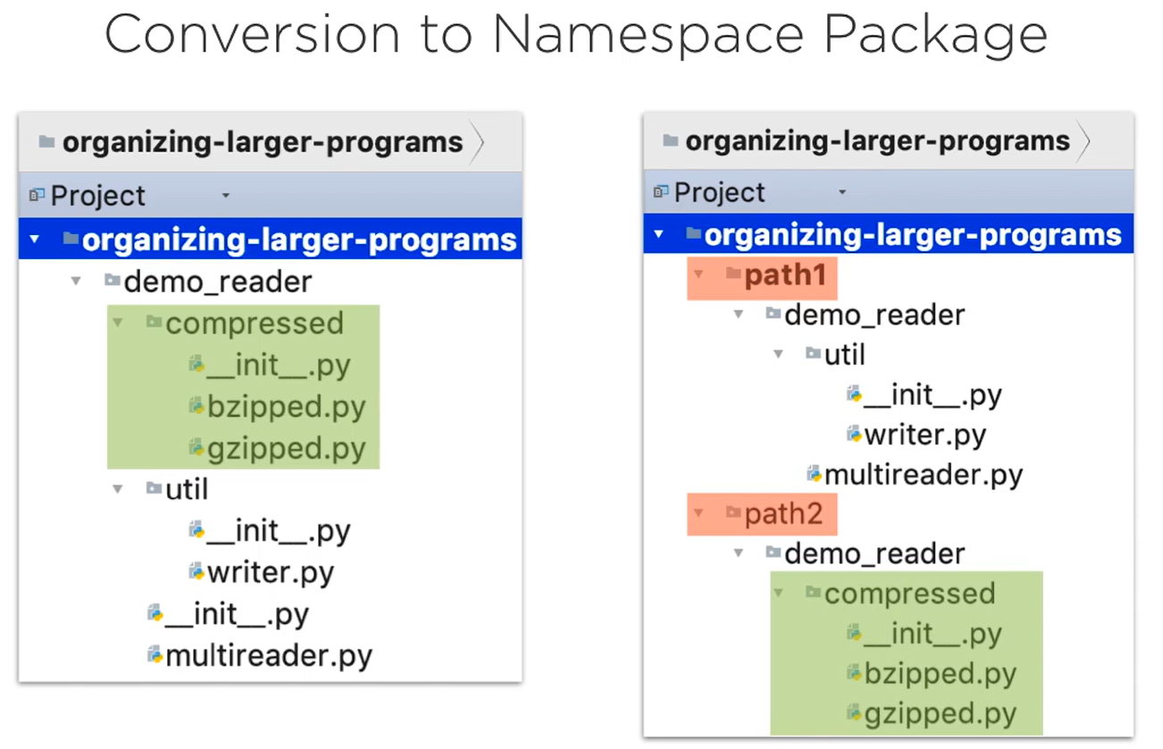

path1 and path2 must be present in the sys.path and then we can import **demo_reader**, this will act as namespace package.

Remember if you are importing a package or a module, it’s parent directory must be present inside sys.path.

For example, here is the package named **test_package** and we can see the content inside it

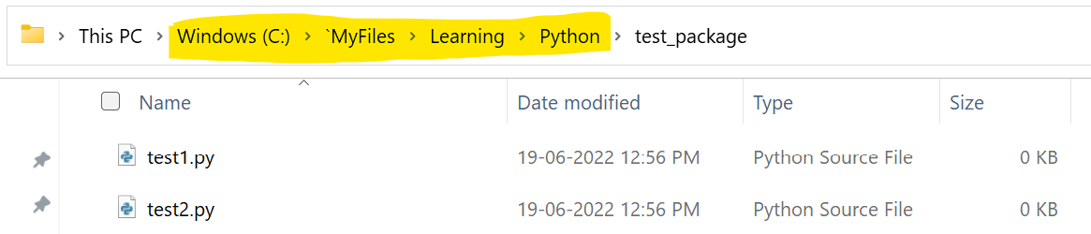

Now, we need it to add this directory to the sys.path

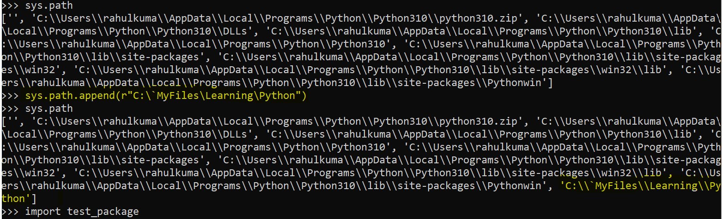

You can see that we were successful in importing test_package. We can also import modules from the same directory without any issues.

### Executable Directories

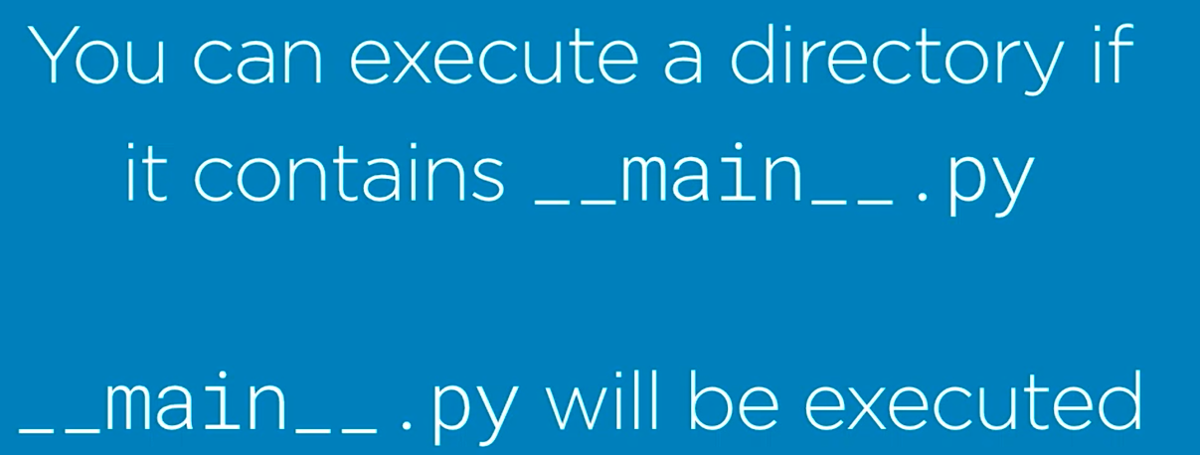

To execute the directory, run command **python <directory_name>**

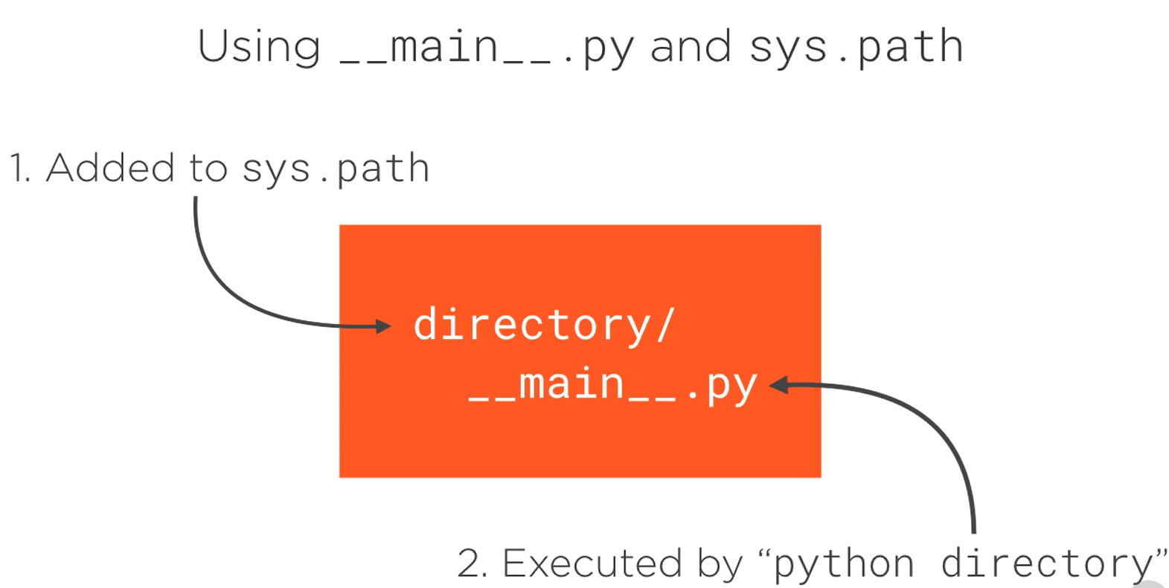

### Executable Zip Files



And the rest remains same

To execute the zipped directory, run command **python <directory_name>.zip**

### Executable Packages

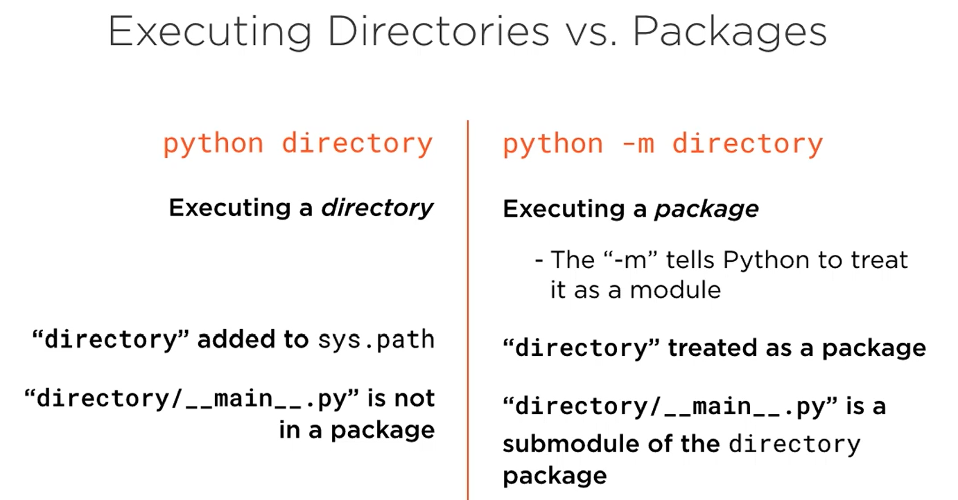

__init__.py vs __main__.py

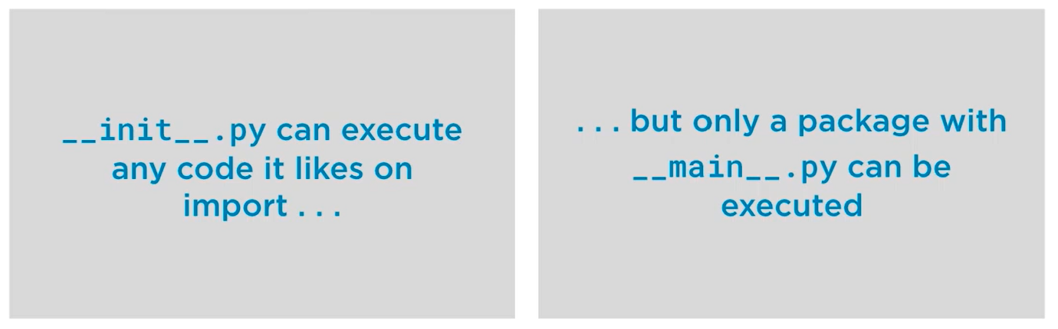

## Recommended Package Layout

### Python Project Structure

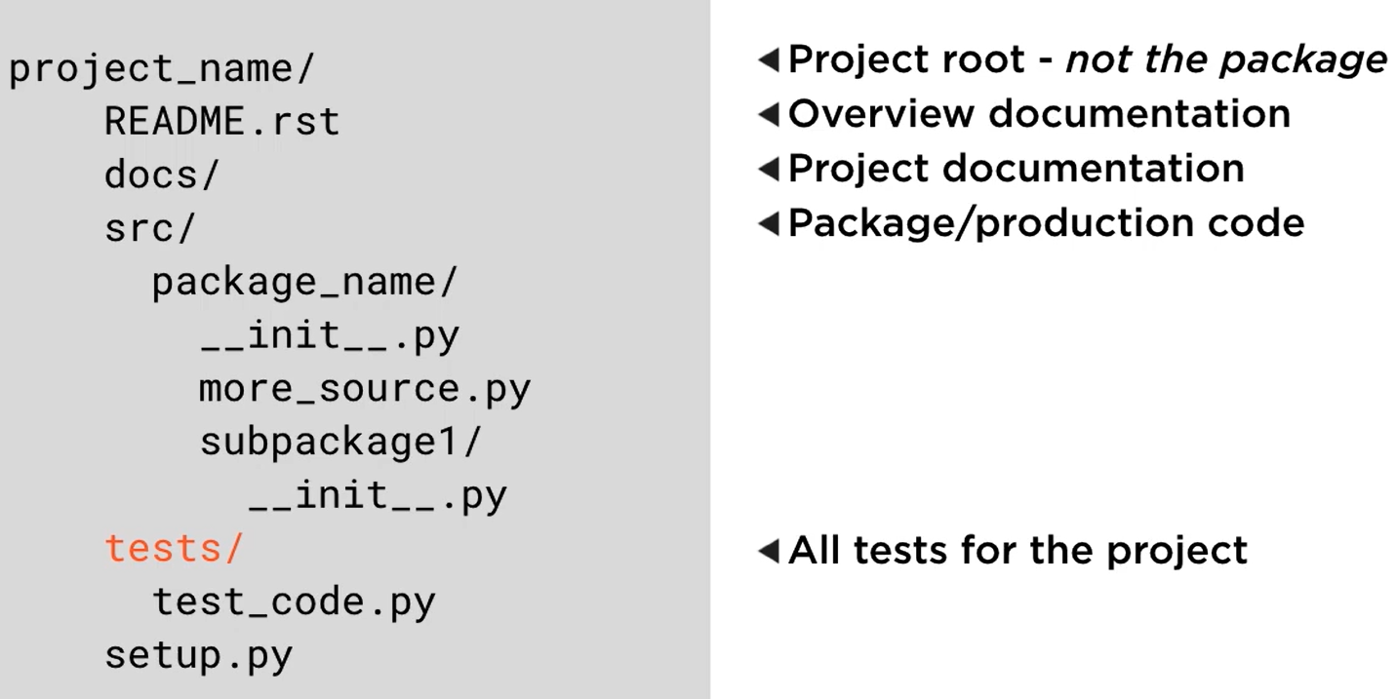

Refer demo_reader folder.

## Package Distribution

### Source Distribution

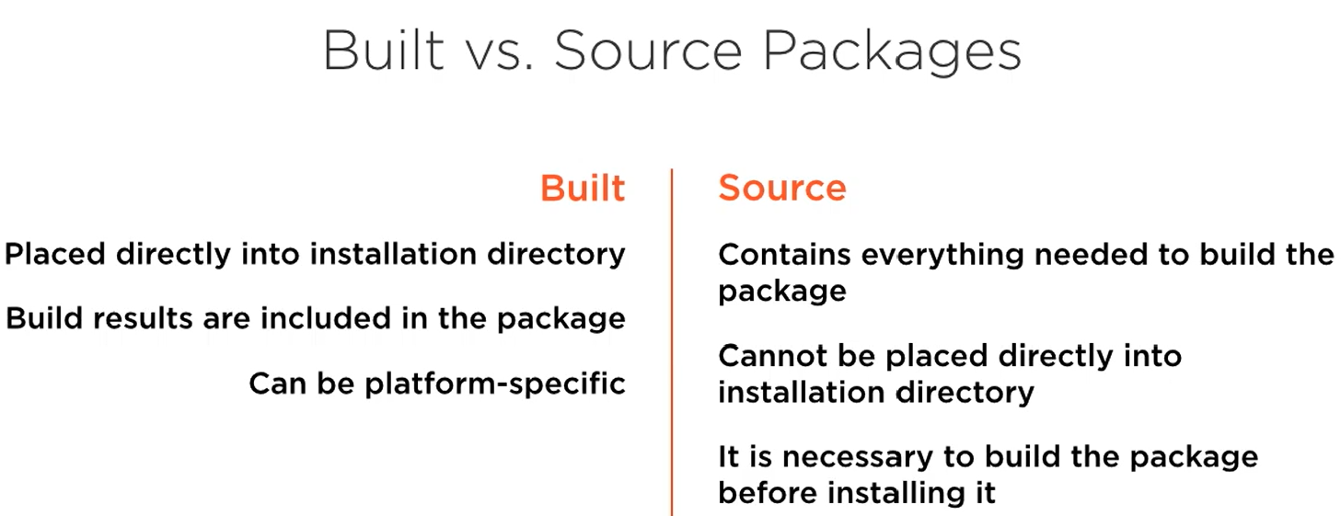

To create source distribution, we first need to change the directory to make sure we have setup.py in the pwd, then run the following command:

***python setup.py sdist***

This will generate a directory named dist and it will contain <something>.tar.gz. You can share this file and install this using pip:

***pip install <something>.tar.gz***

### Built Distribution

This requires **wheel** package, install this if not present using pip

To create built distribution, we first need to change the directory to make sure we have setup.py in the pwd, then run the following command:

***python setup.py bdist_wheel***

This will generate a directory named dist and it will contain <something>.whl. You can share this file and install this using pip:

***pip install <something>.whl***

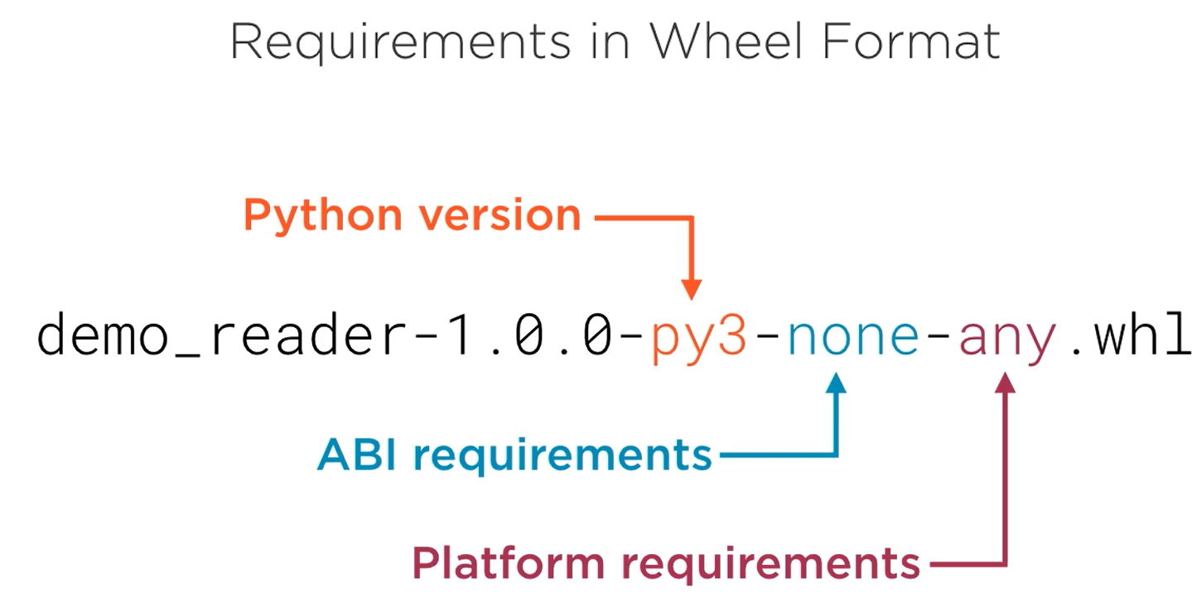

ABI: Application Binary interface (It won’t be none if the package contains any compiled elements such as C++ or Rust code)

### Uploading Packages to PYPI

For this you need **twine**, make sure to install this if not present.

Then run the command:

***twine upload <file>***

It will ask your username and password.

Enter your PYPI account’s credential. If you don’t have an account, create one and then supply the credentials. And done. You can search your package at PYPI.

# Core Python 3.6: Functions & Functional Programming

## Functions and Callables

### Callable Instances

Ho can a function maintain state, that is not possible for the global or module level functions, but is possible with methods in a class because the object maintains the state. So, we will use something like this:

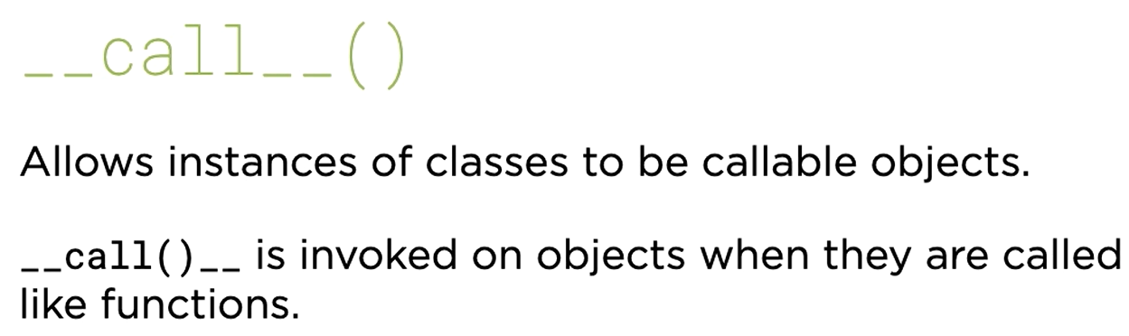

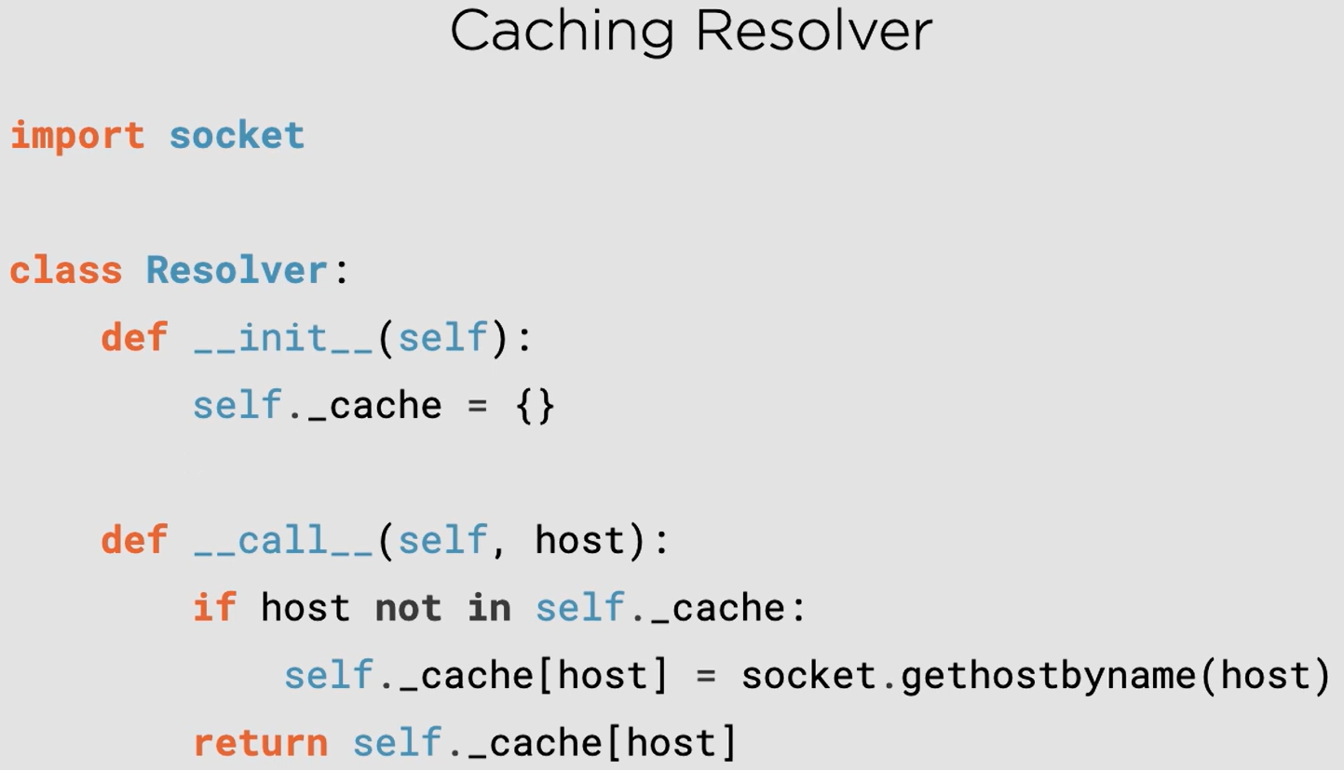

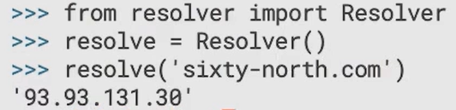

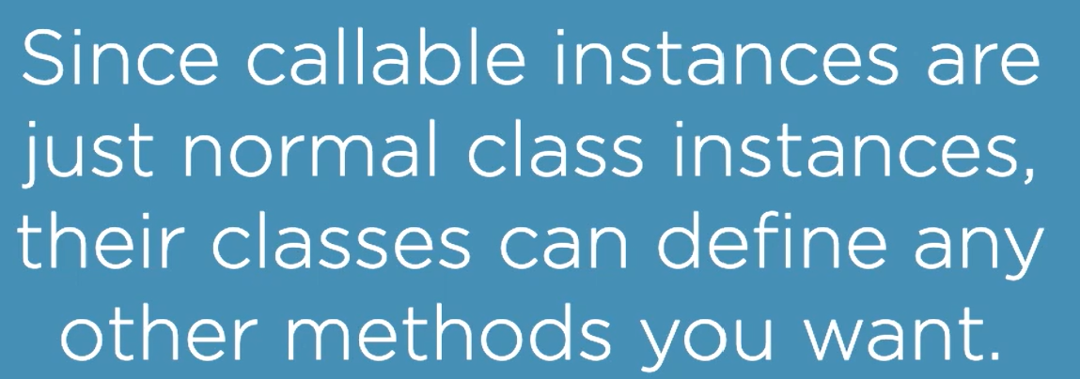

### Classes are callable

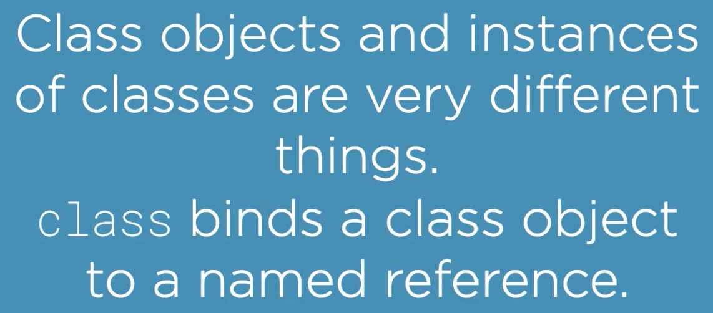

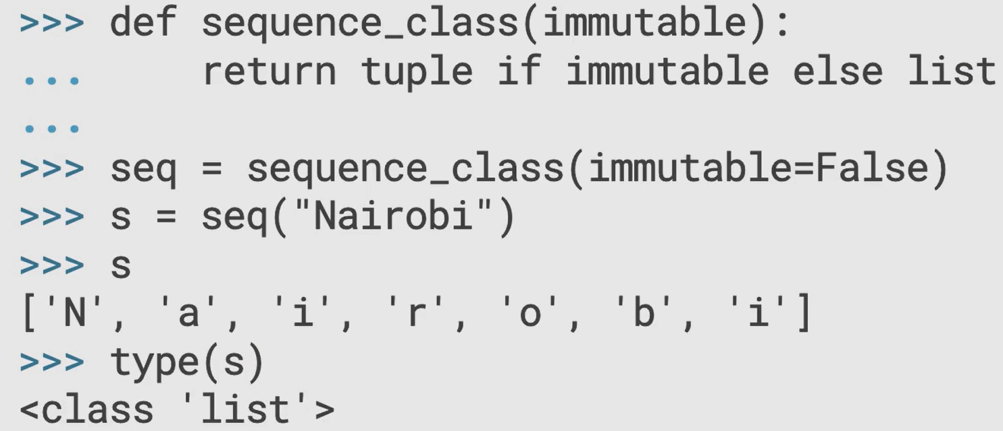

### Lambdas

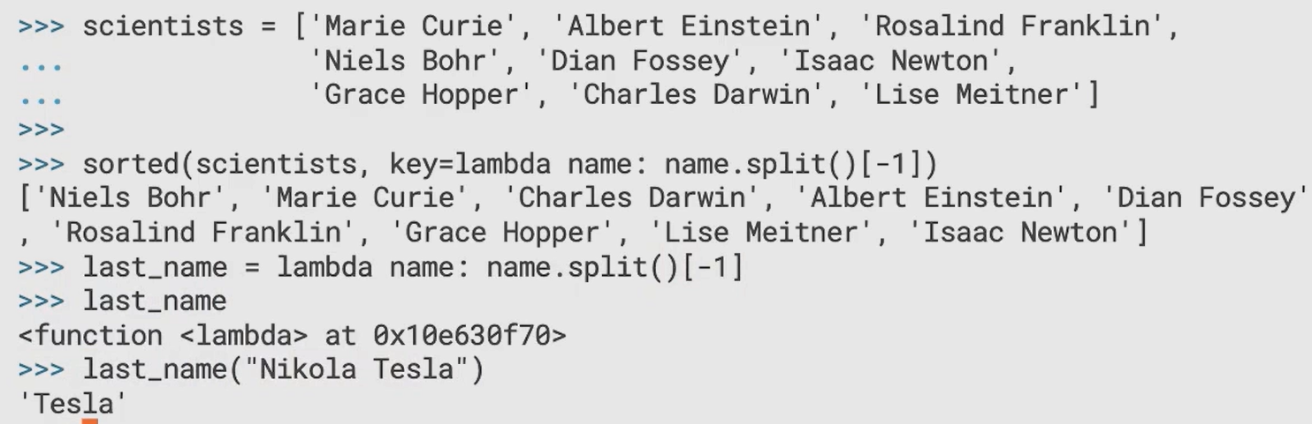

### Functions vs Lambdas

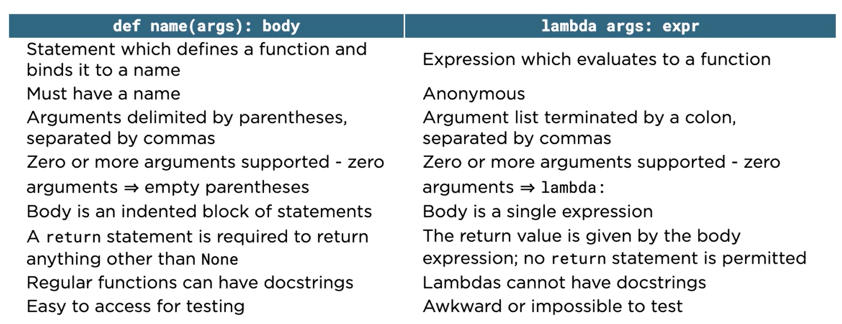

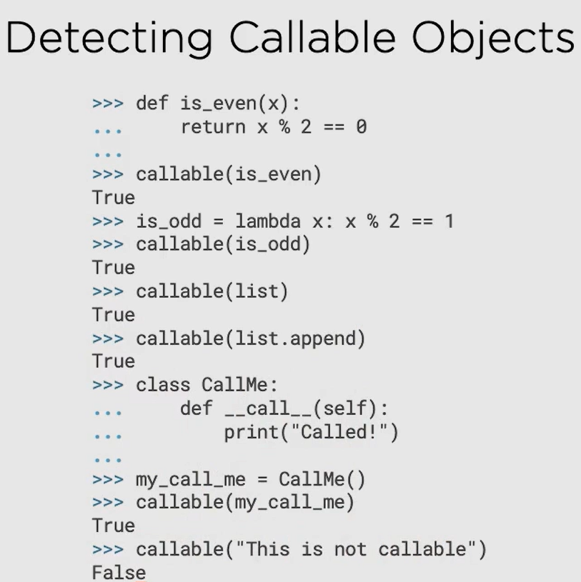

Functions are callable

Lambda expressions are callable

Class is callable

Class methods are callable

Class instances can be made callable by defining __call__ method

By default class instances are not callable

## Extended Argument and Call Syntax

### *args (Extended Formal Argument)

args is not a keyword, rather a convention (best practice). You can put *anything and it would work the same way.

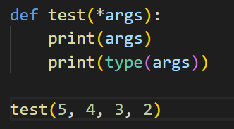

Output:

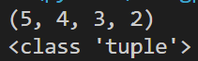

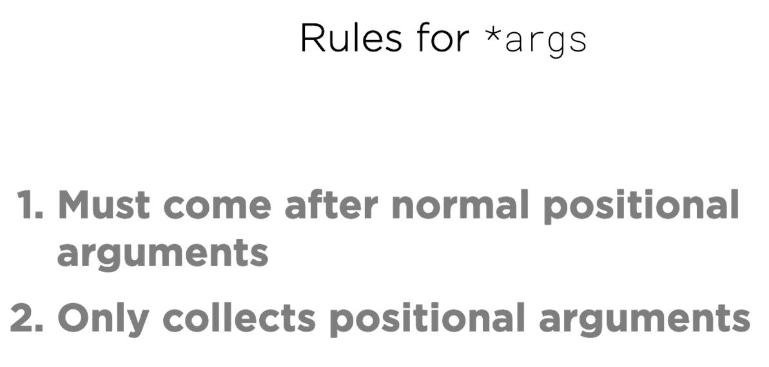

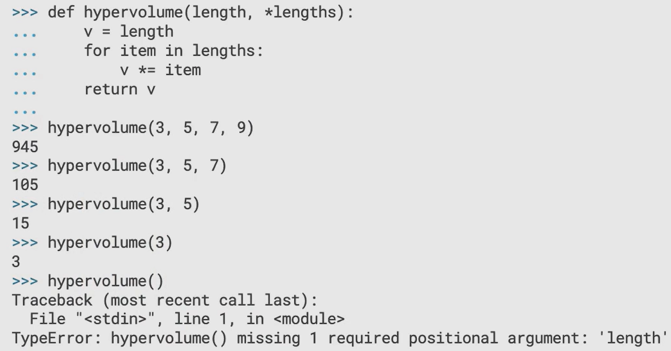

Note: When you need to make sure that your function at least requires one parameter, use the above approach where one parameter is present and then *lengths is used. We could have used *lengths only as a single parameter but then we would have to check if it is empty and then raise error, better to use two parameters and error is automatically raised.

### **kwargs (Keyword Formal Arguments)

kwargs is not a keyword, rather a convention (best practice). You can put **anything and it would work the same way.

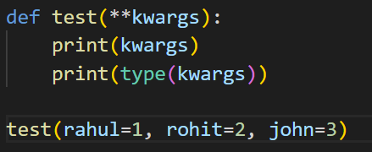

Output:

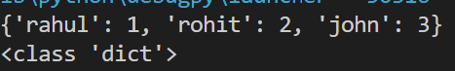

Note:

1. *args must come before **kwargs

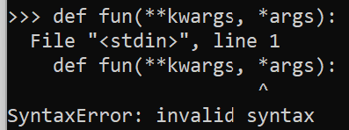

1. any arguments preceding *args are taken to be regular positional arguments

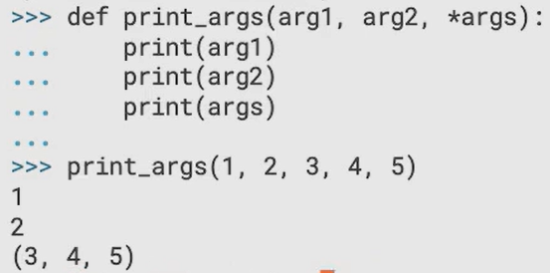

1. any regular arguments after *args must be passed as mandatory keyword arguments

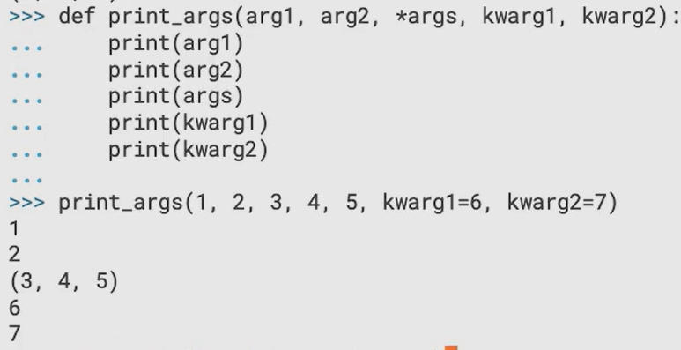

1. If you want to use mandatory keyword arguments without accepting an arbitrary number of positional arguments, omit the args from *args

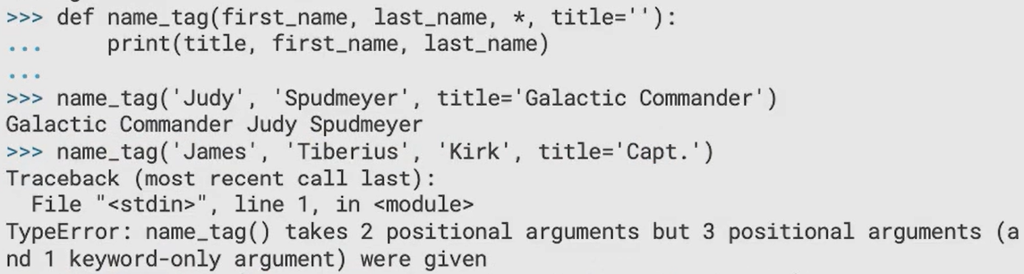

1. **kwargs, if present, must be last in the argument list

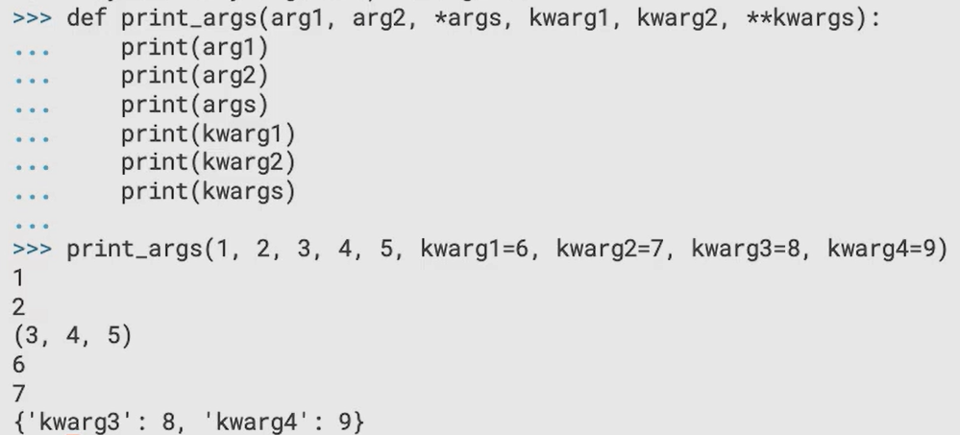

1. Please note that there are also rule that mandatory arguments must come first and then optional (default) arguments (having default value)

### Positional Only Arguments

* Available in Python 3.8 and later
* They can never be passed as keyword arguments
* Put a forward slash, any arguments before it will be treated as positional only arguments

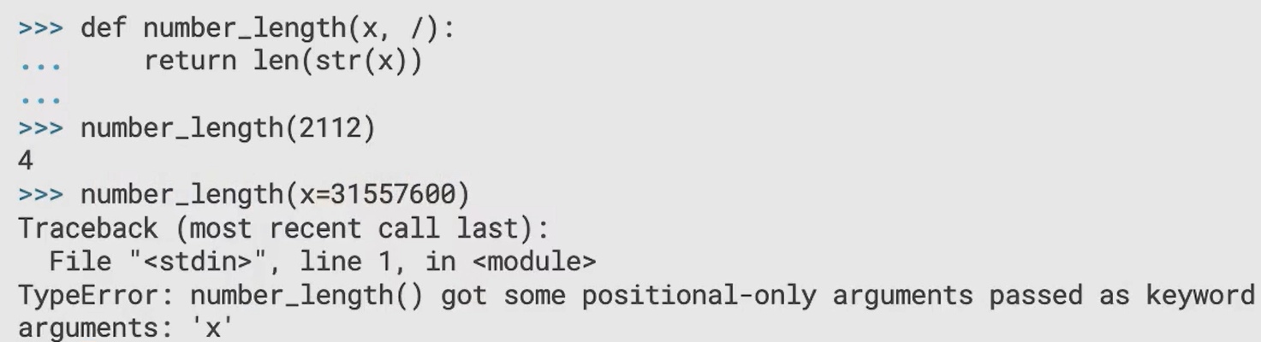

### Extended Call Syntax

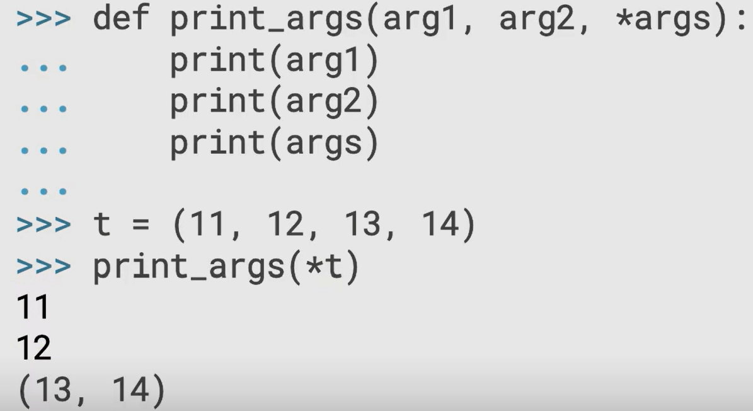

The * in the call (which unpacks) is different from the * in formal argument of function definition.

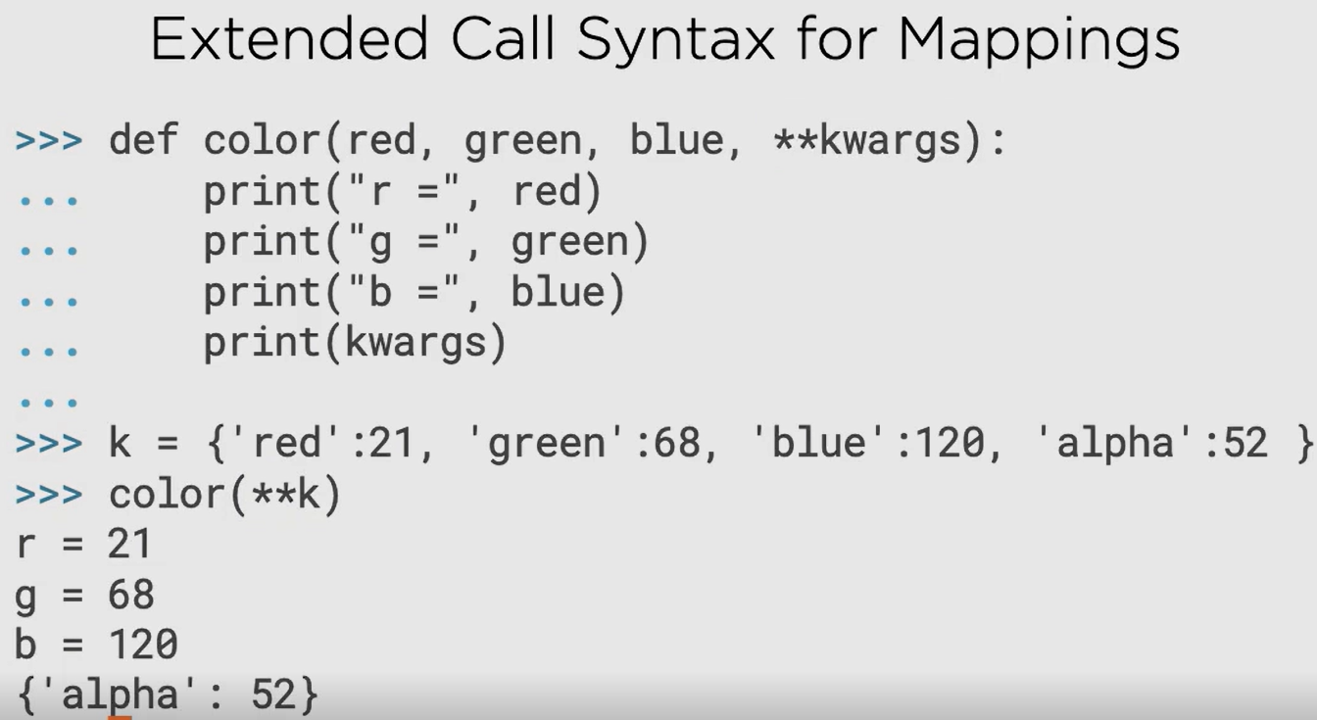

The ** in the call (which unpacks) is different from the ** in formal argument of function definition.

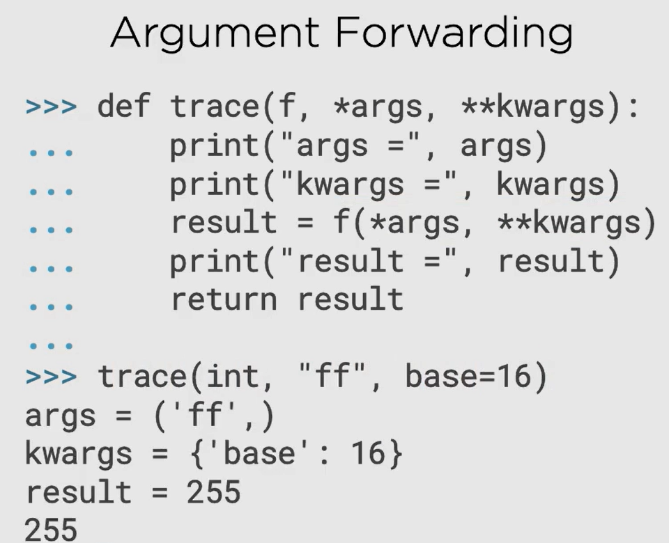

## Closures

### Local Functions

* Functions inside a function is called local function

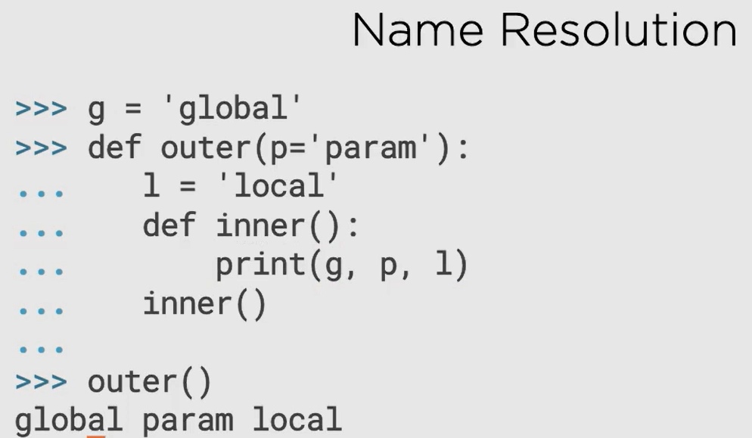

Remember the LEGB rule:



Usage of local functions:

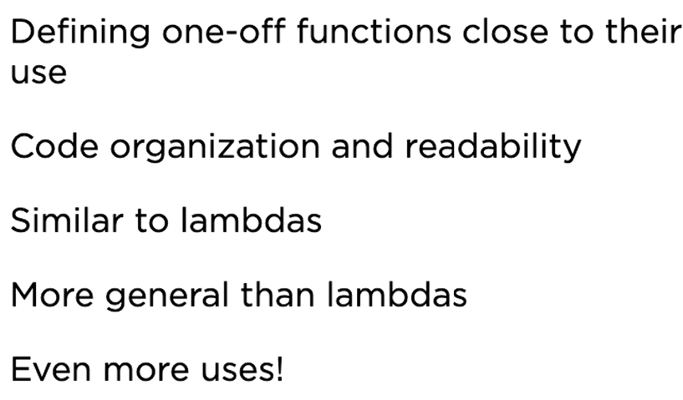

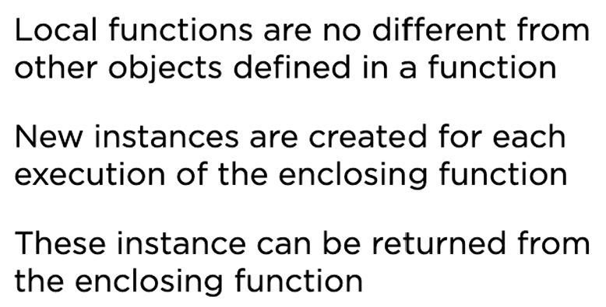

Returning local functions

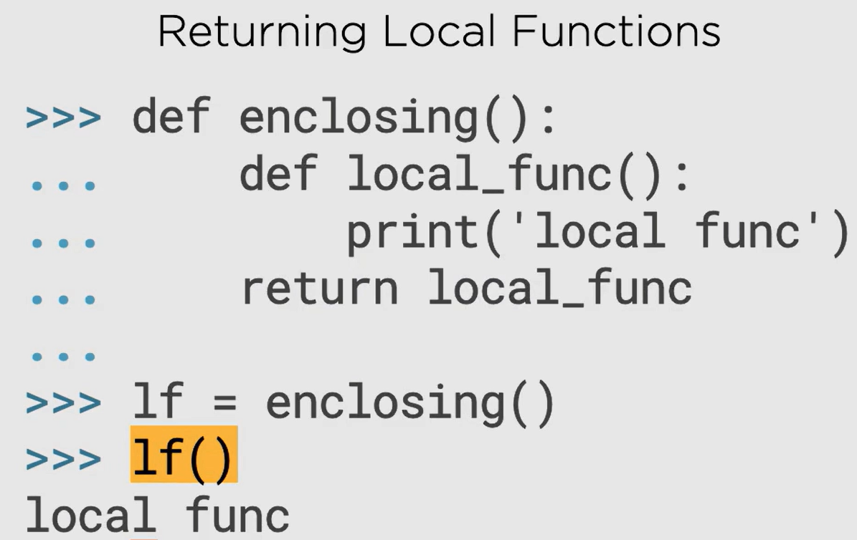

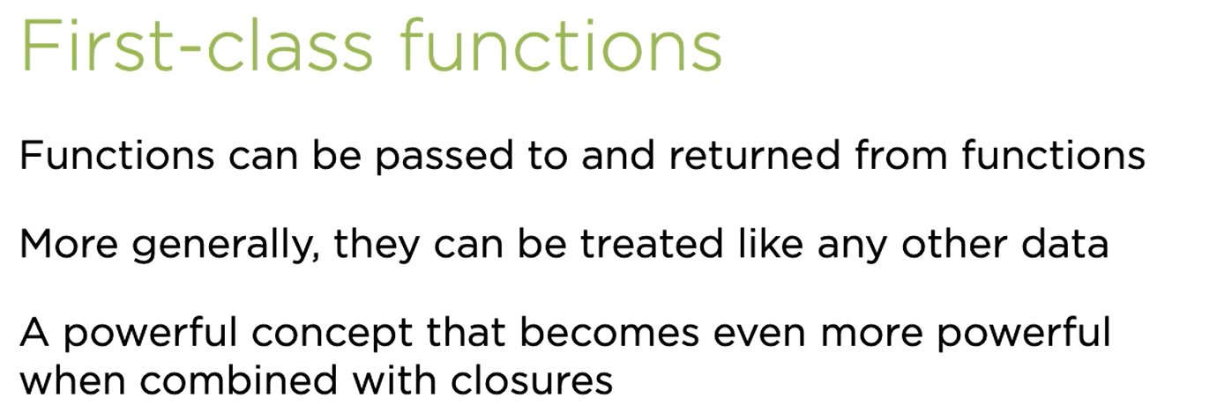

### Closure

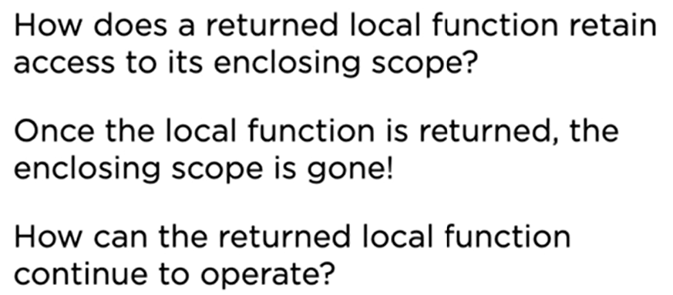

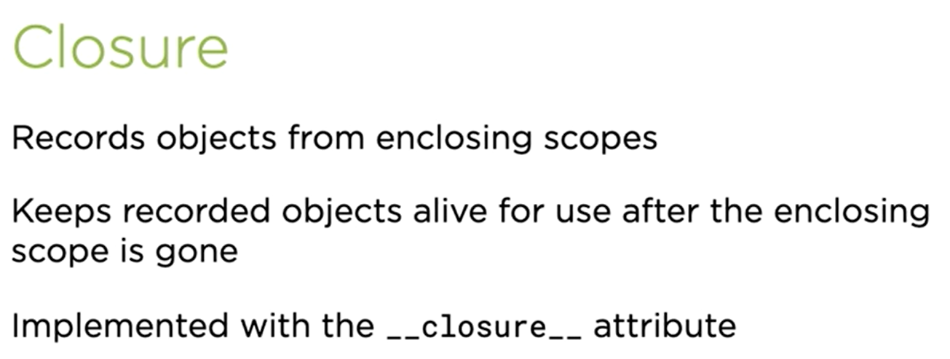

Each call to an enclosing function is independent of other call, which means the closures will not know about each other and won’t interfere with the values of one set of object and other.

Preventing from garbage collection

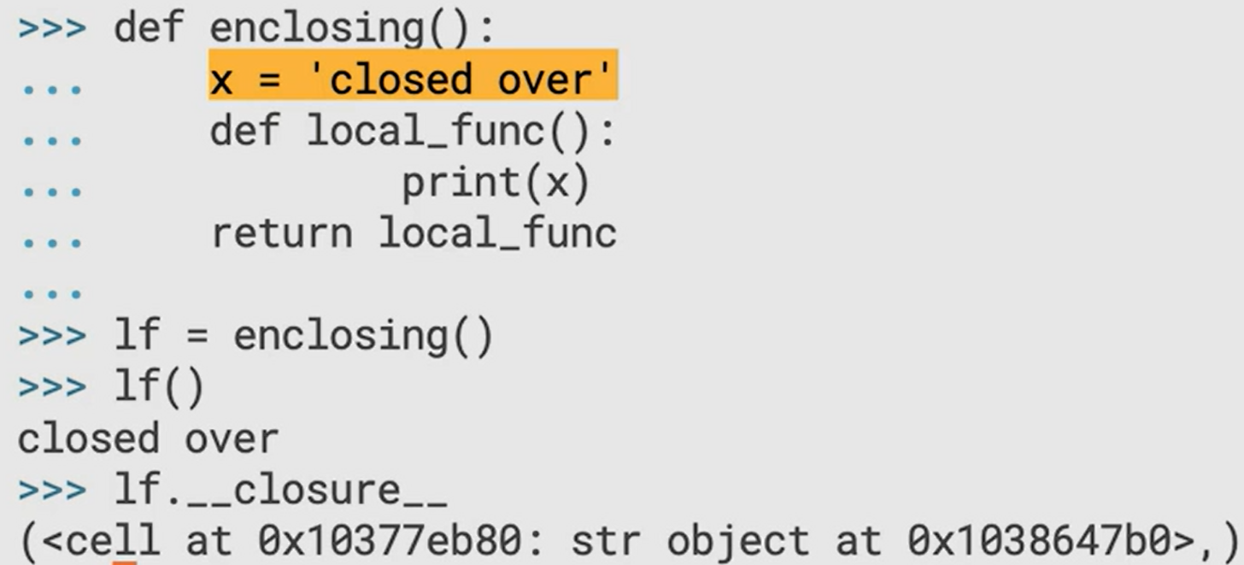

Use case for closures:

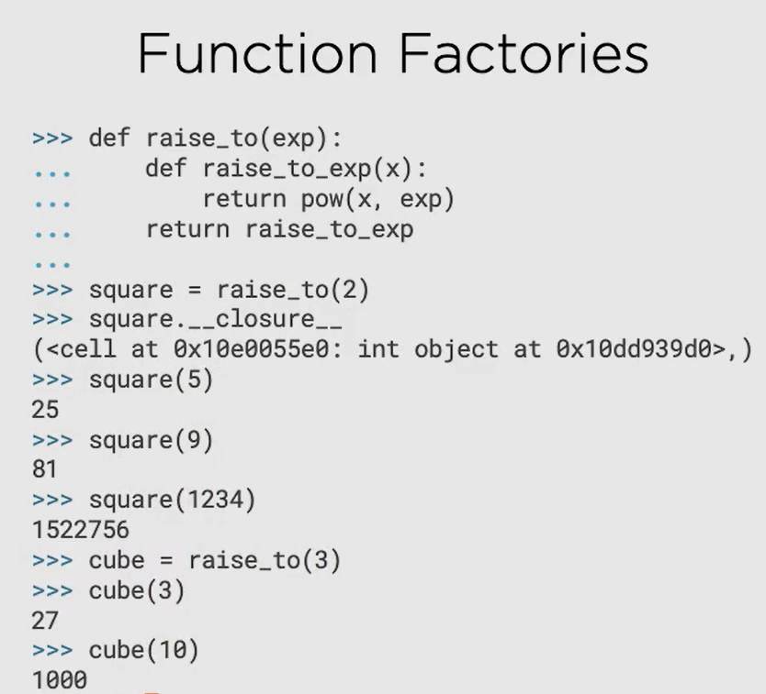

### nonlocal keyword

Let’s first see what actually happens to variables with the same name in different scopes: they are created again. In the example below there are different variables with the same name in three different scopes.

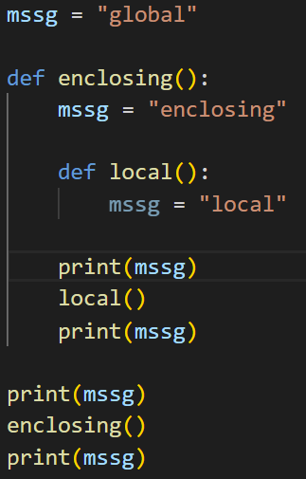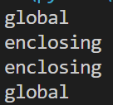



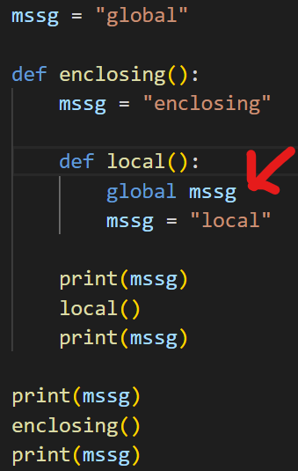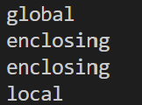

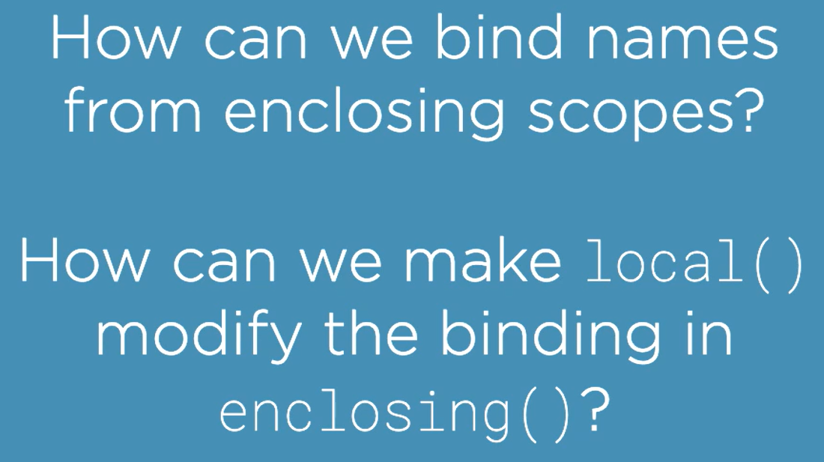

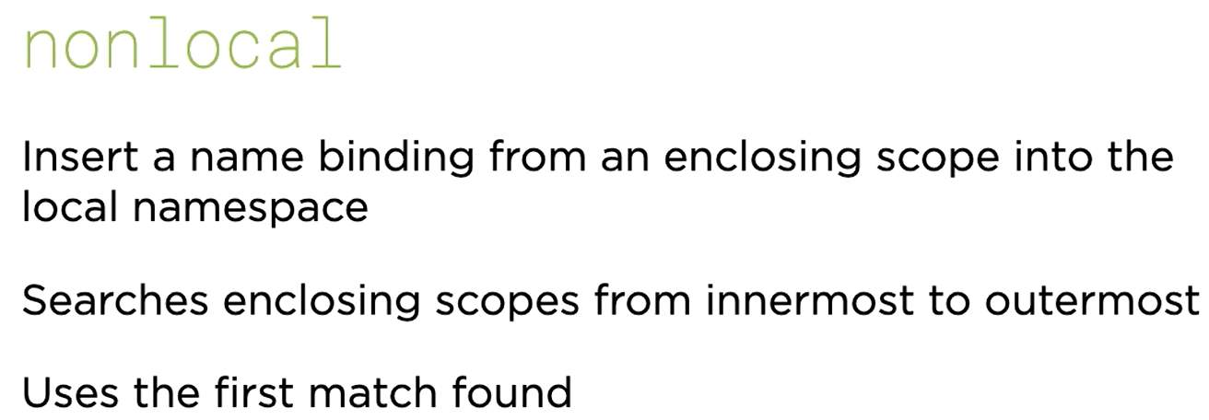

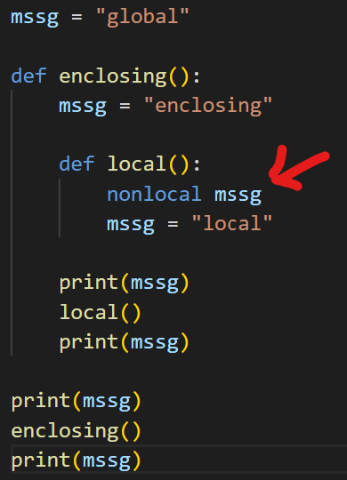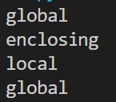

## Decorators

### Function Decorators

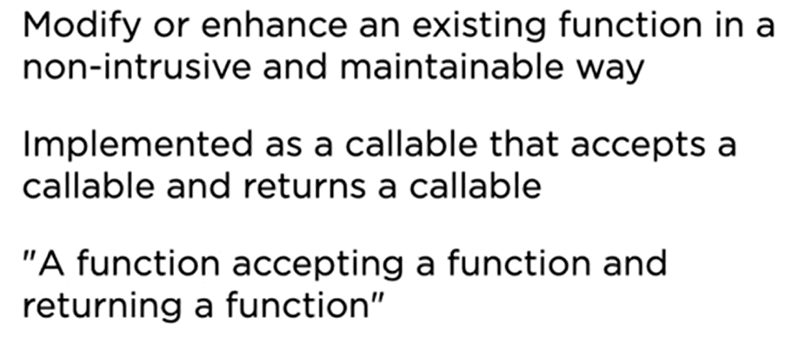

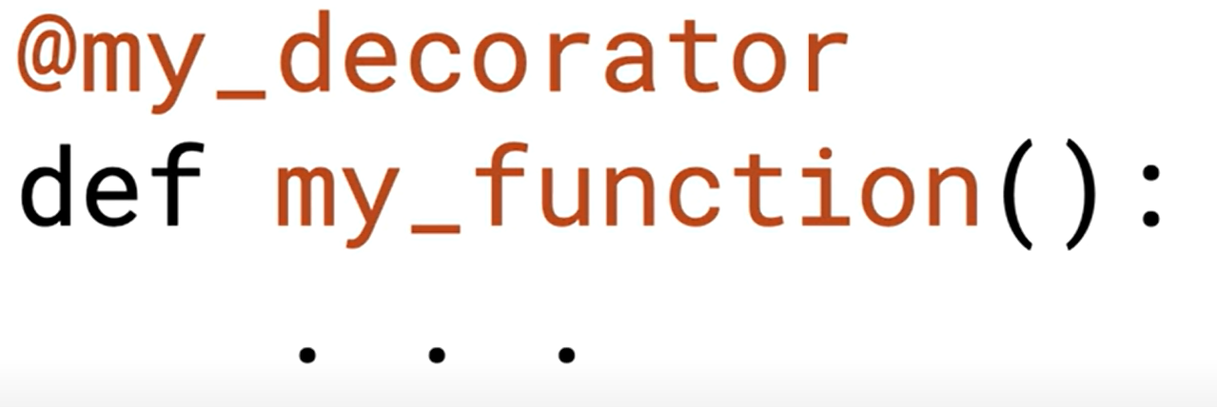

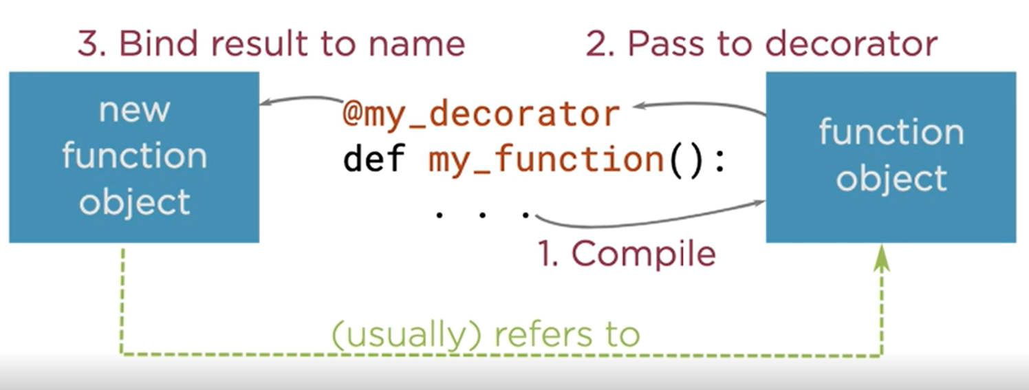



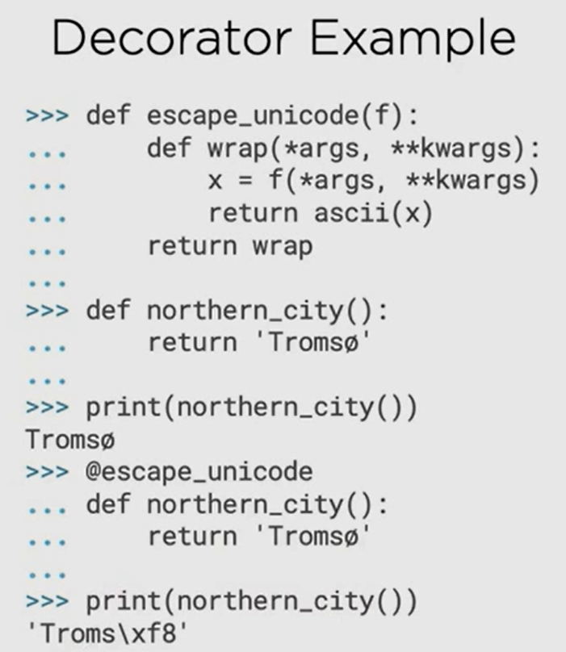

### Class Decorators

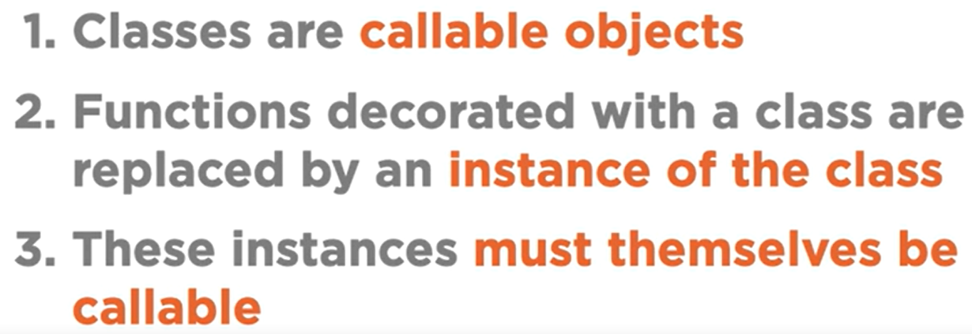

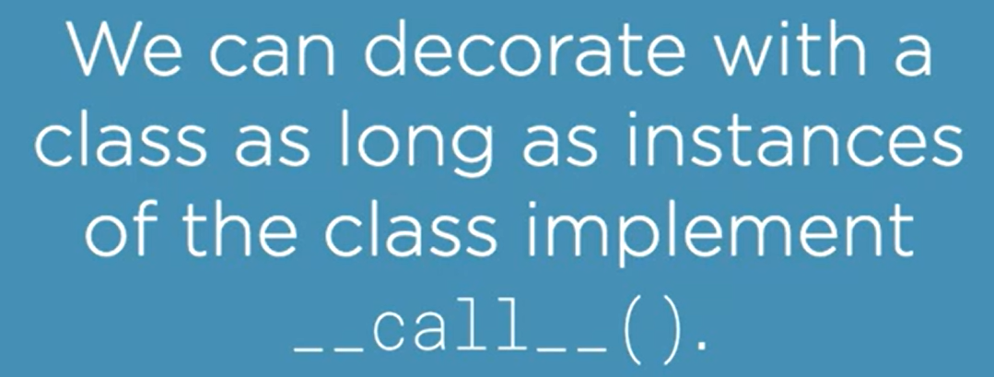

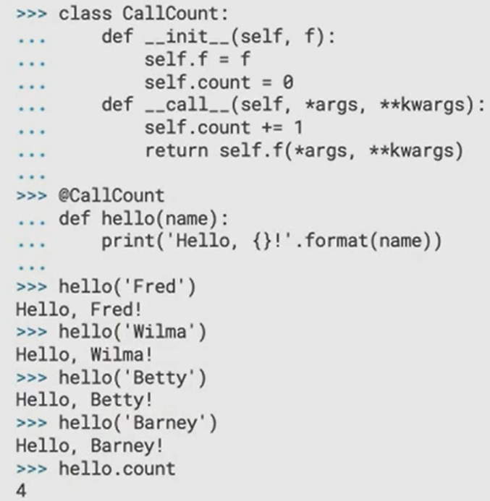

### Instance Decorators

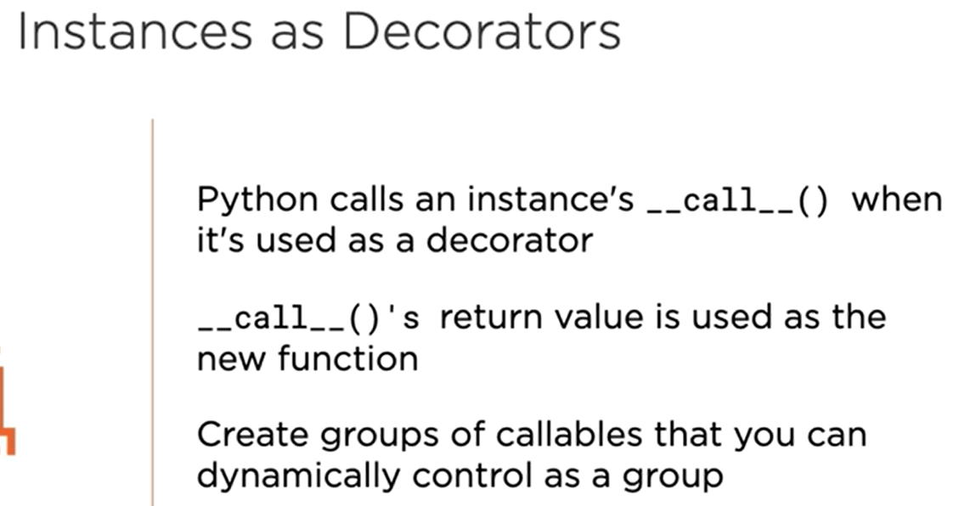

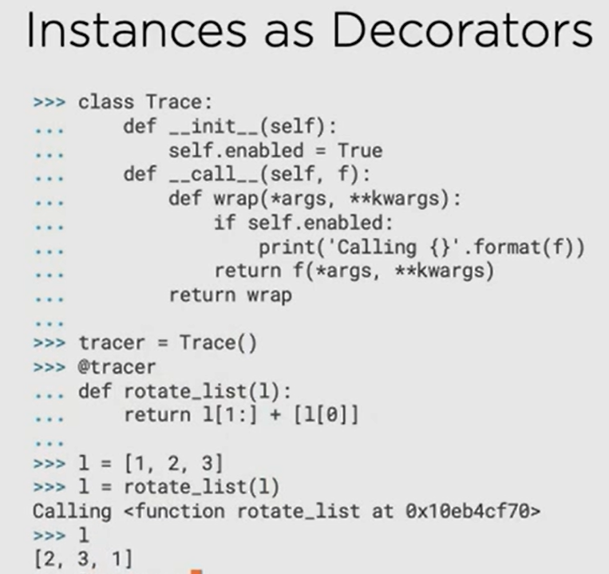

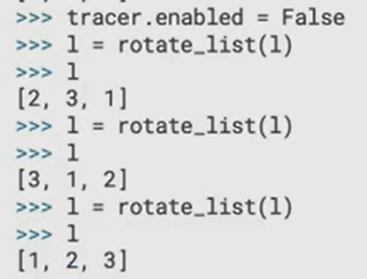

### Multiple Decorators

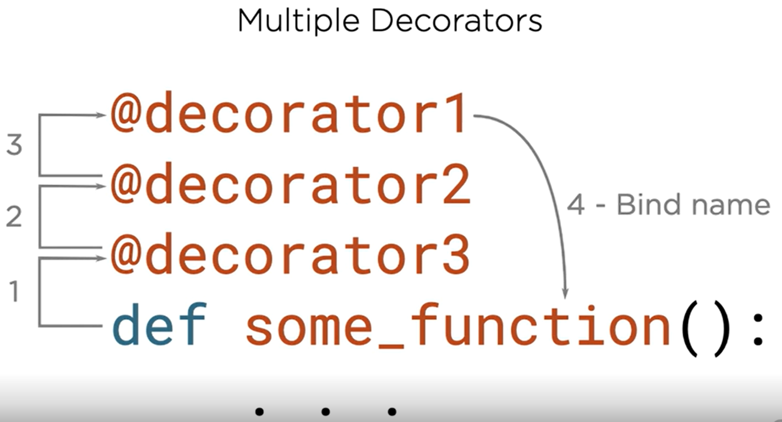

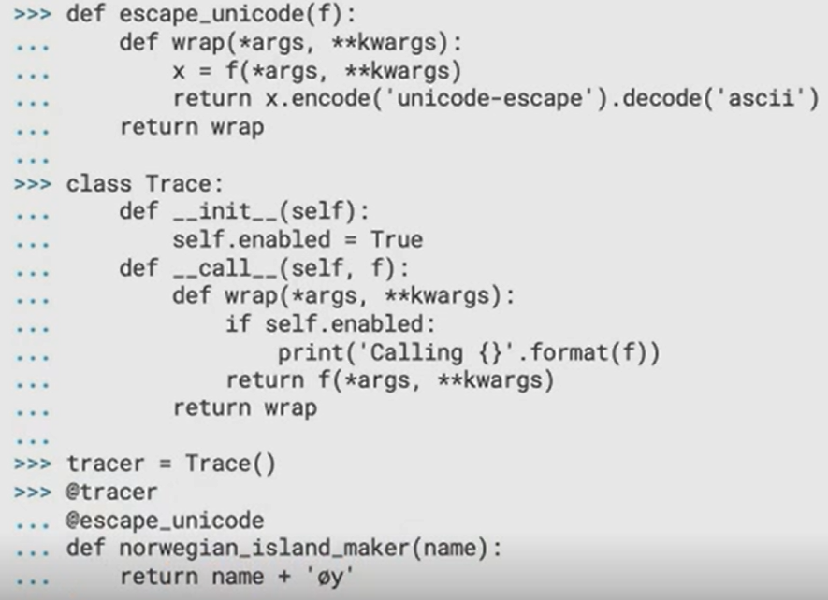

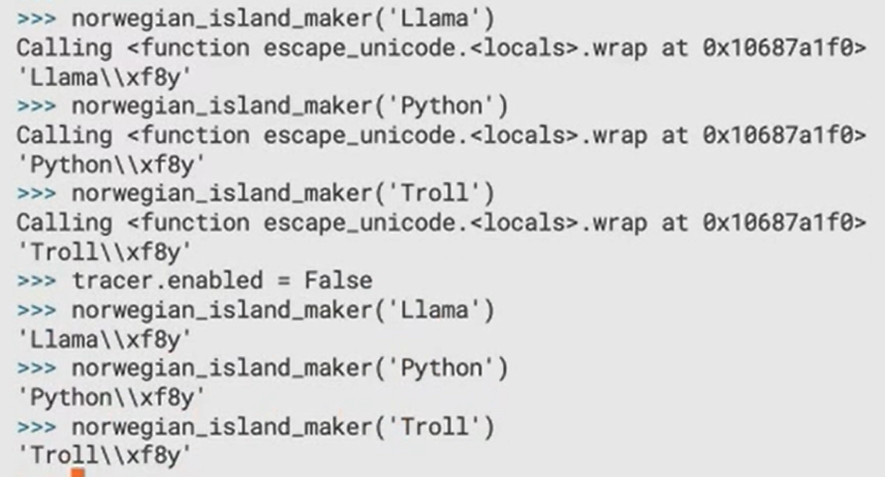

### Preserving Function Metadata

Function without decorator

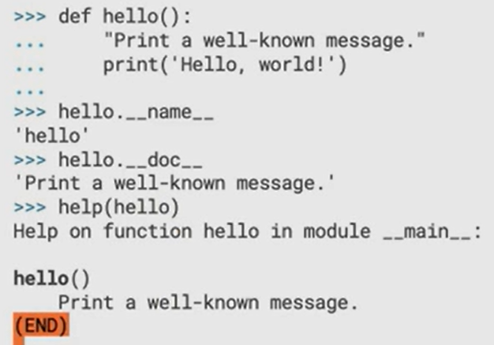

Function with decorator:

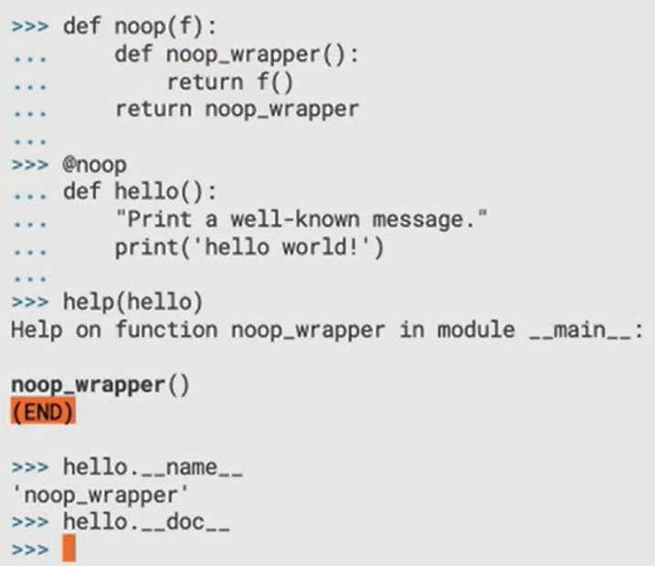

Solution to preserve metadata of original function:

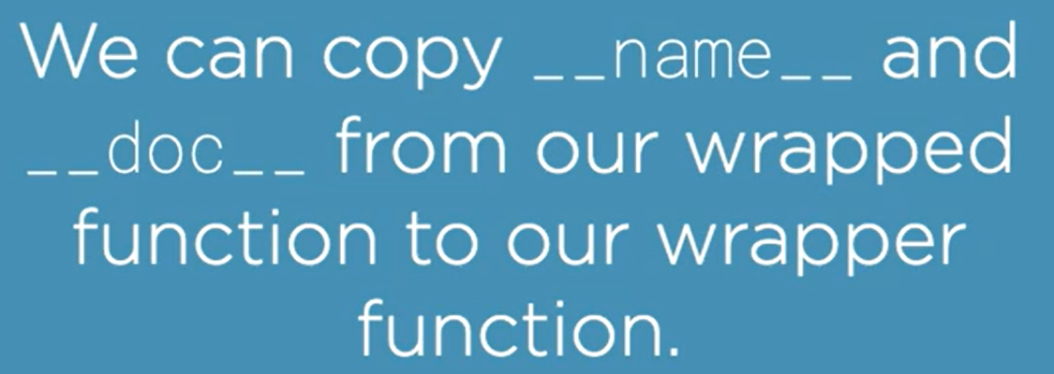

To automatically do this copying, use:

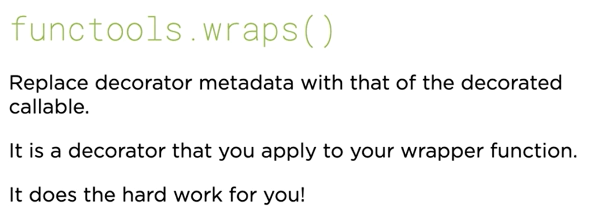

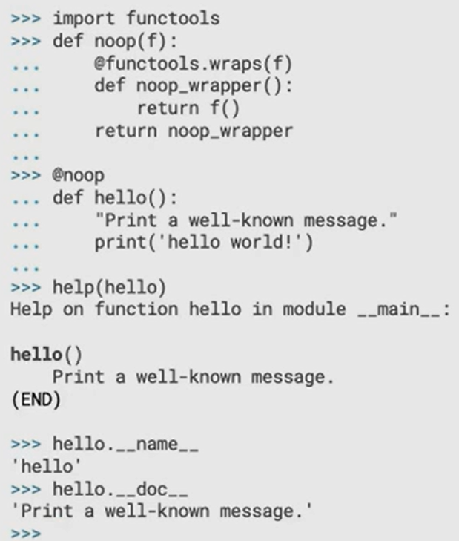

### Parameterized Decorators

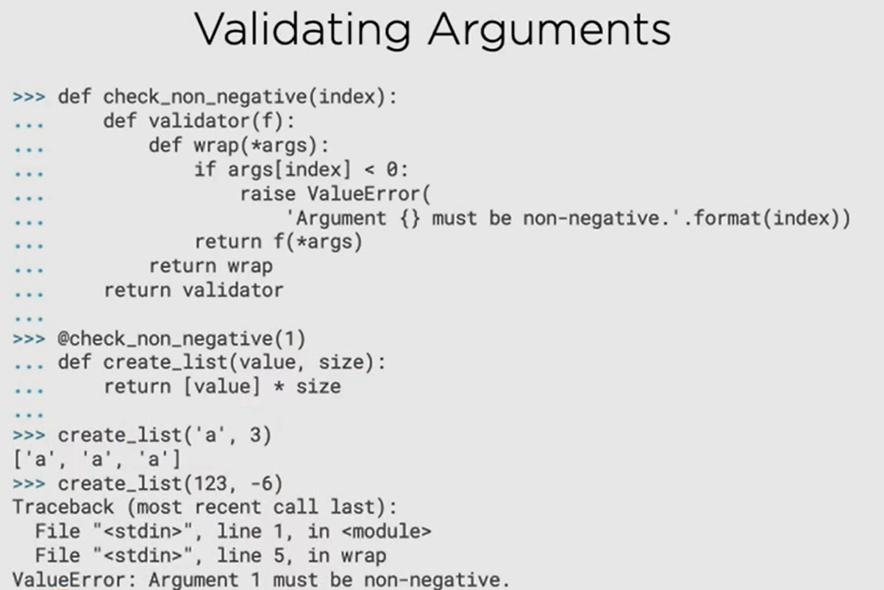

## Functional-style Tools

### map

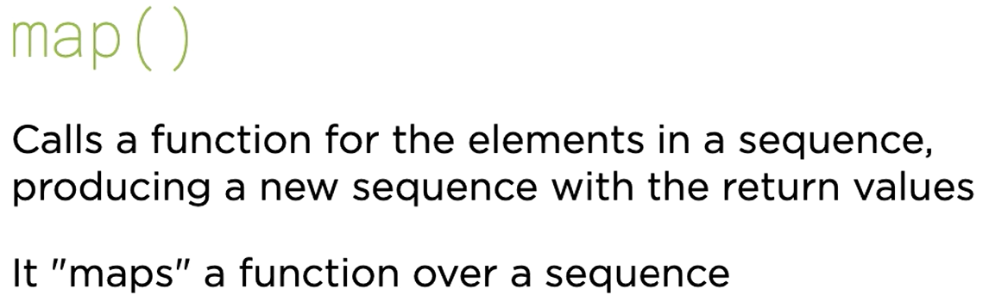

It performs lazy evaluation

Returns an iterator object

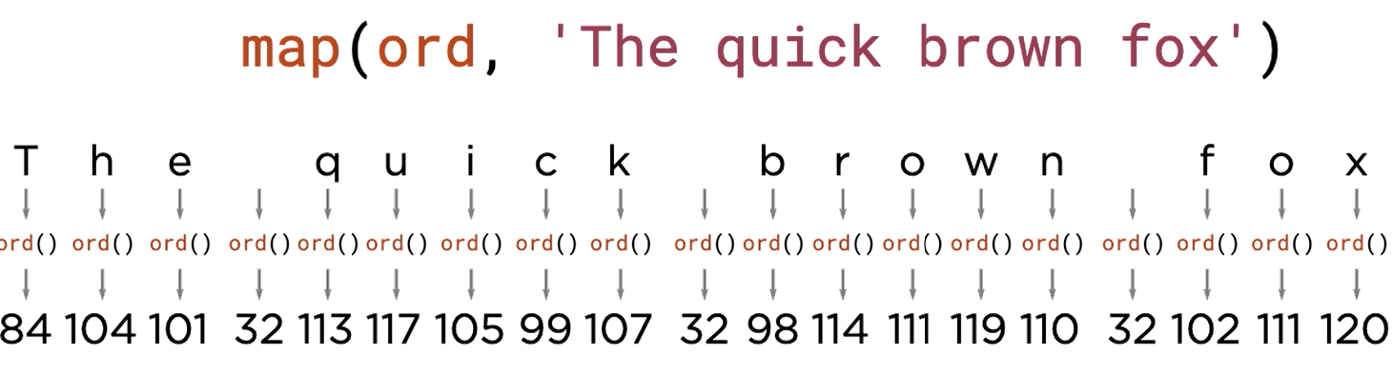

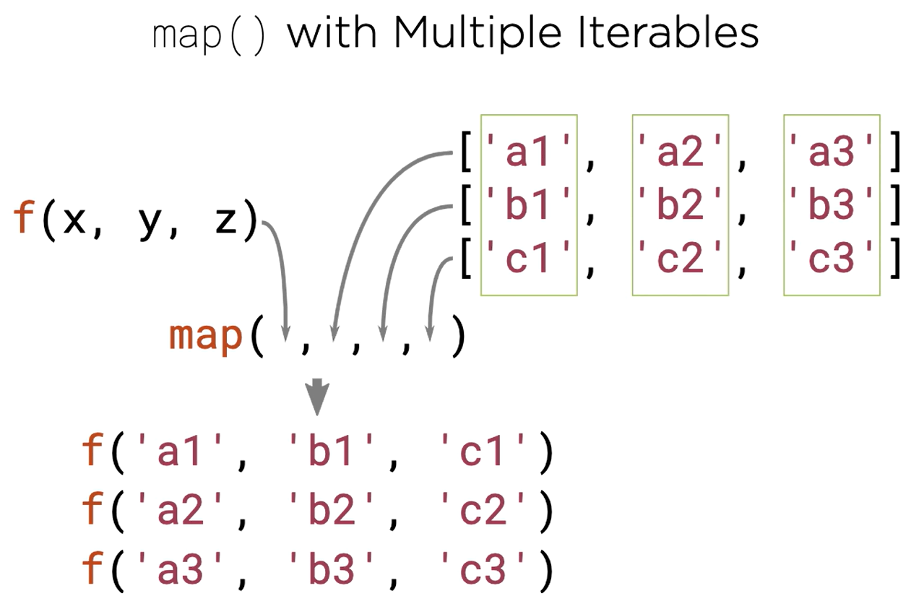

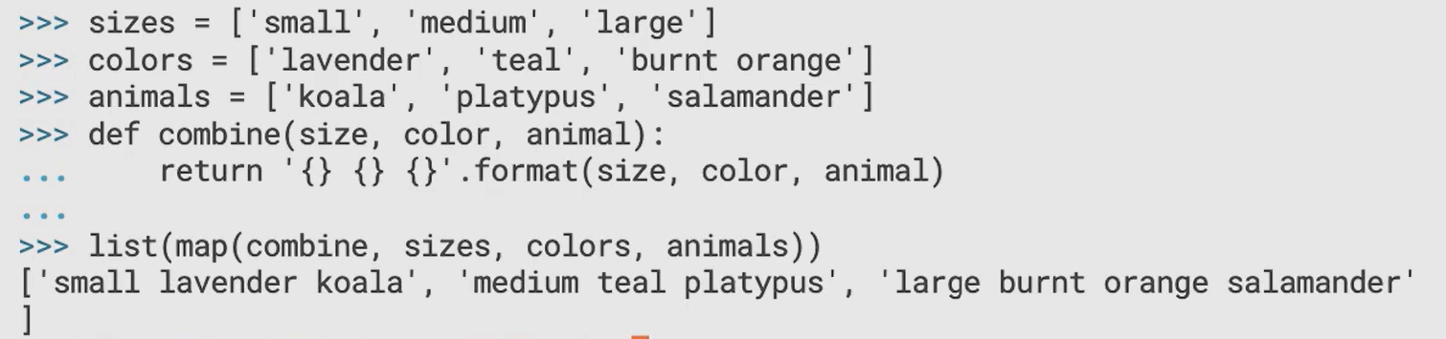

map will stop the iteration as soon as any of the iterables reaches ends.

### filter

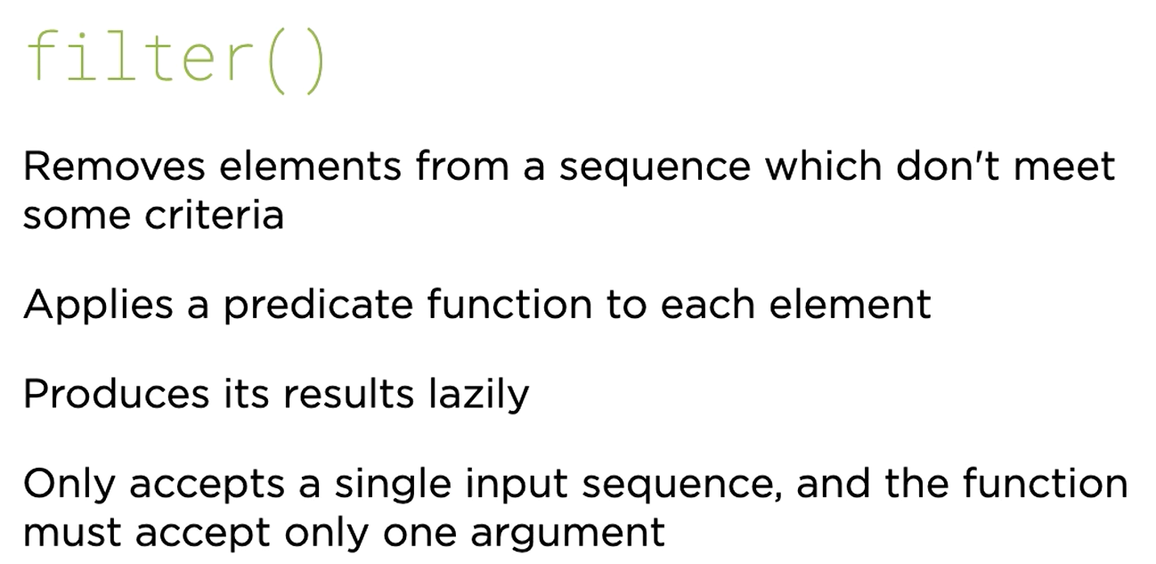

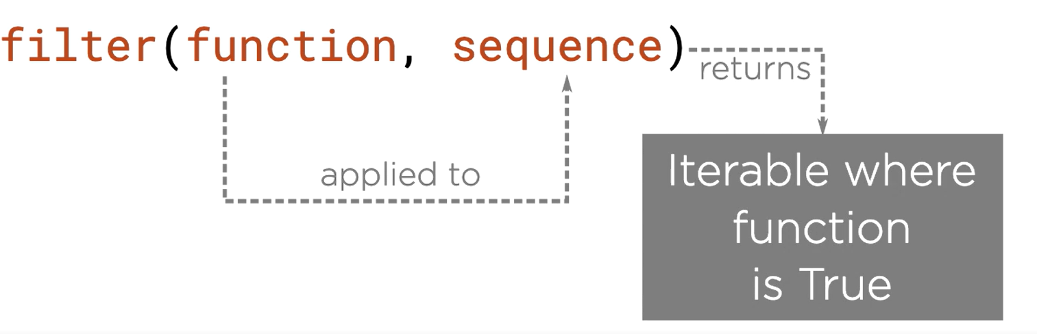

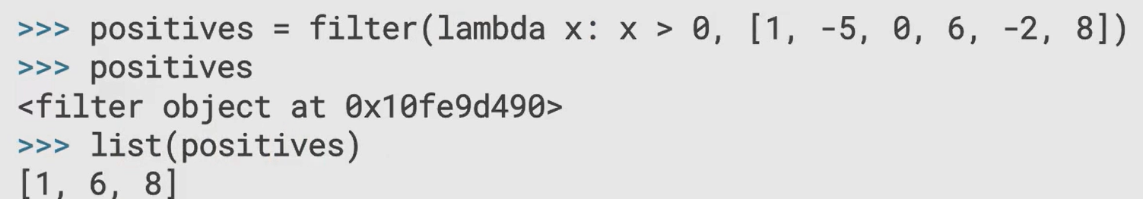

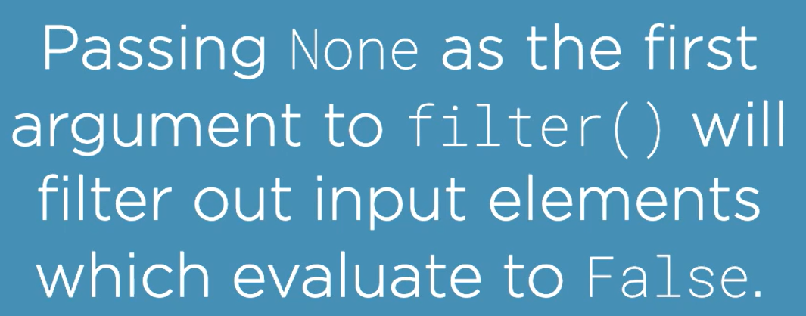



### reduce

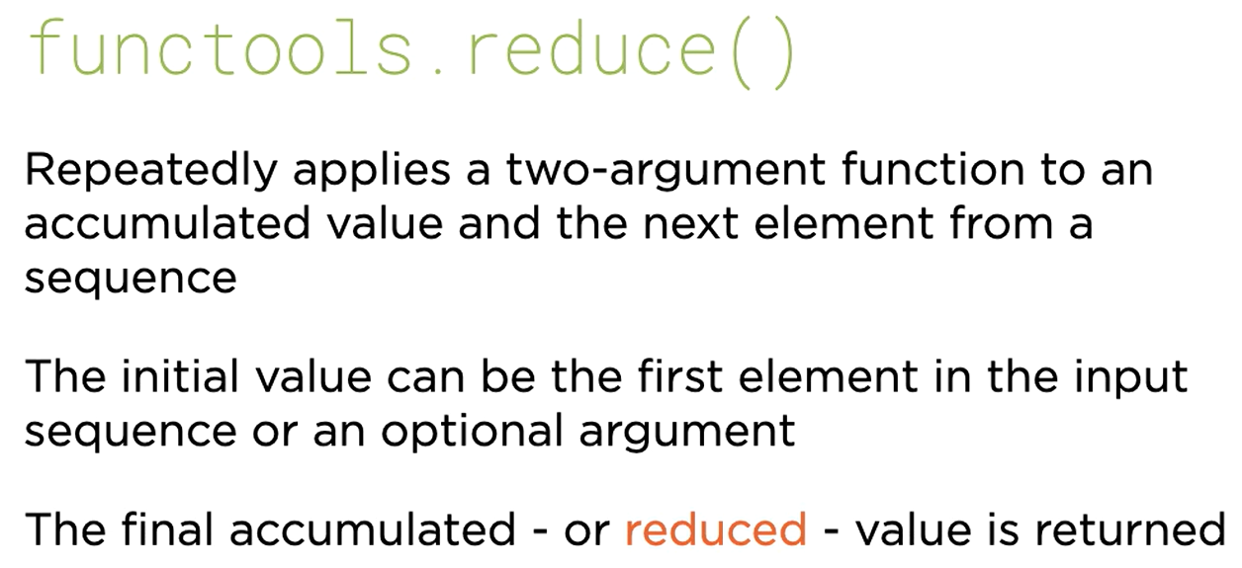

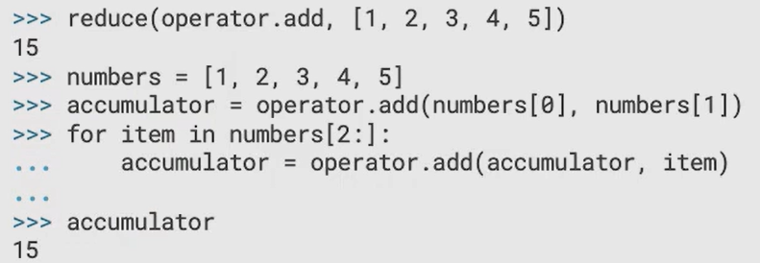

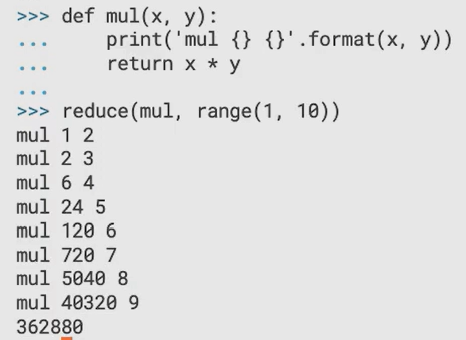

Note:

* Empty sequence can’t be supplied to reduce()
* If you supply a single element in the sequence to reduce() then the function within reduce is not even called, and the single element in the sequence that was passed is returned

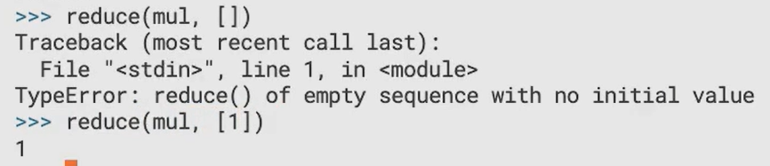

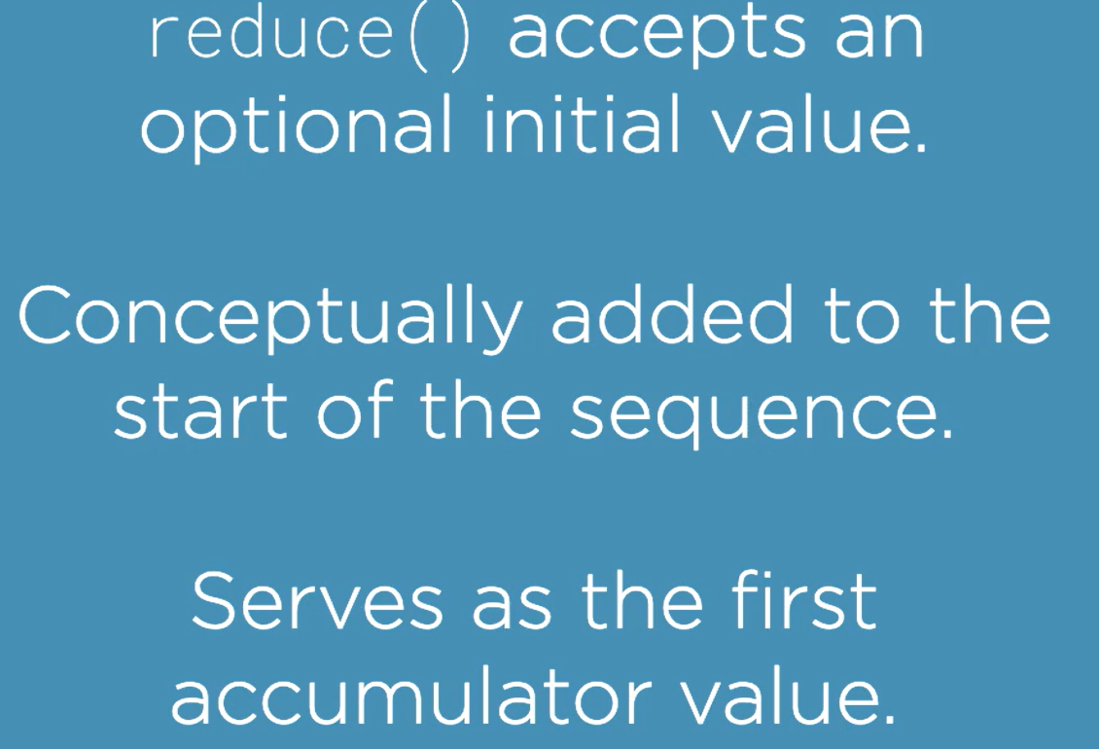

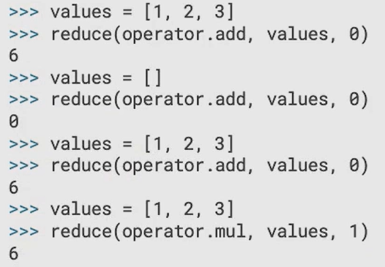

### map-reduce

Refer program map-reduce.py

## Multi-input & Nested Comprehension

### Multi-input Comprehension

Let’s recall simple comprehensions:

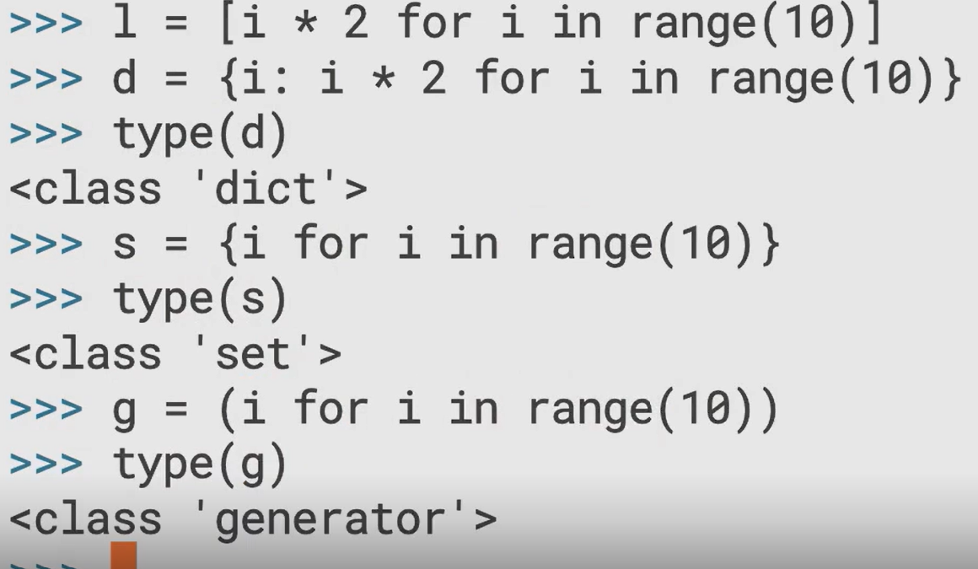

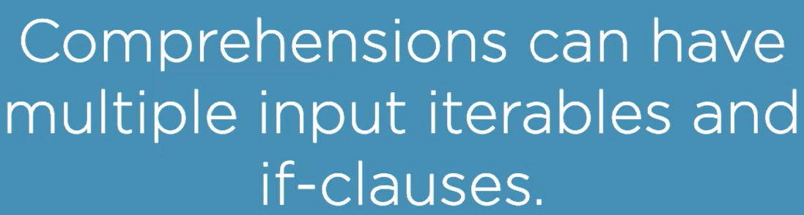

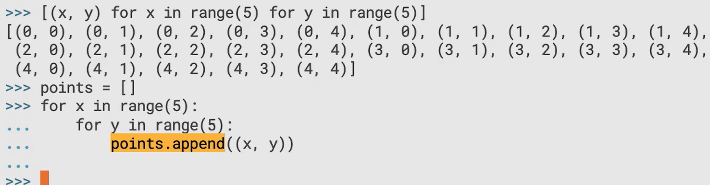

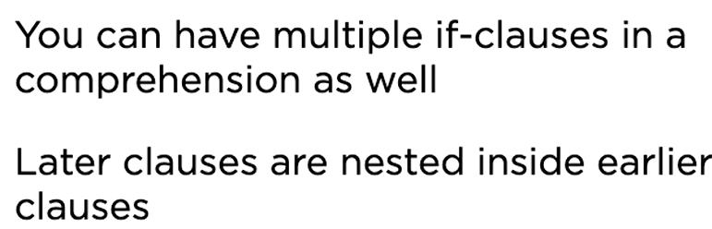

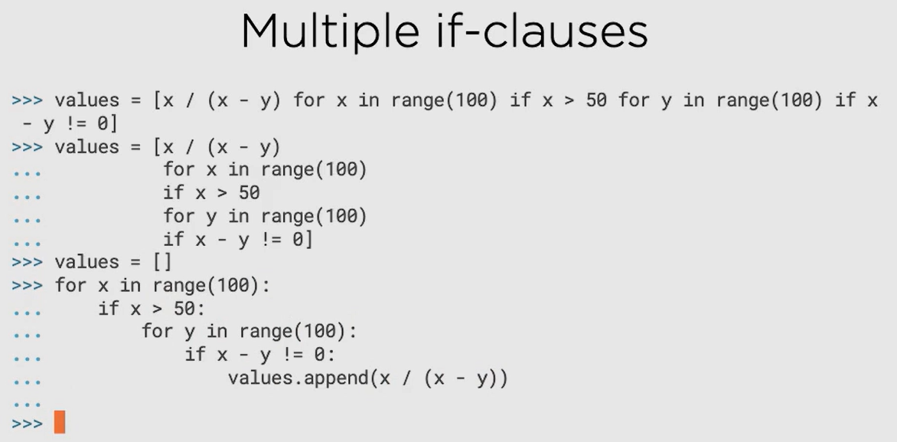

### Nested Comprehensions

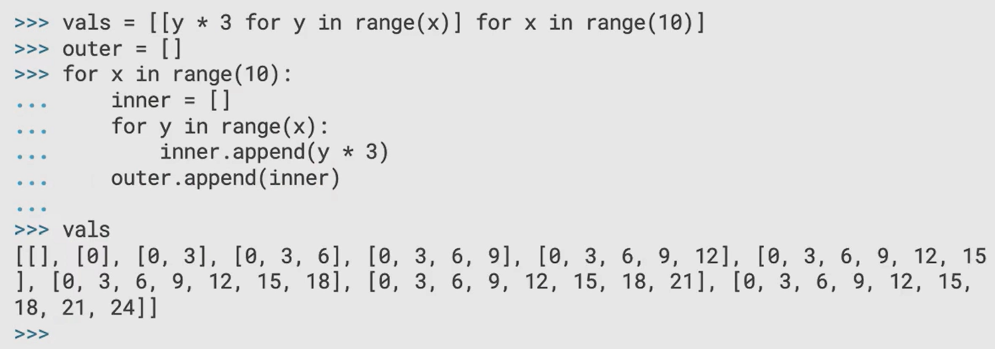

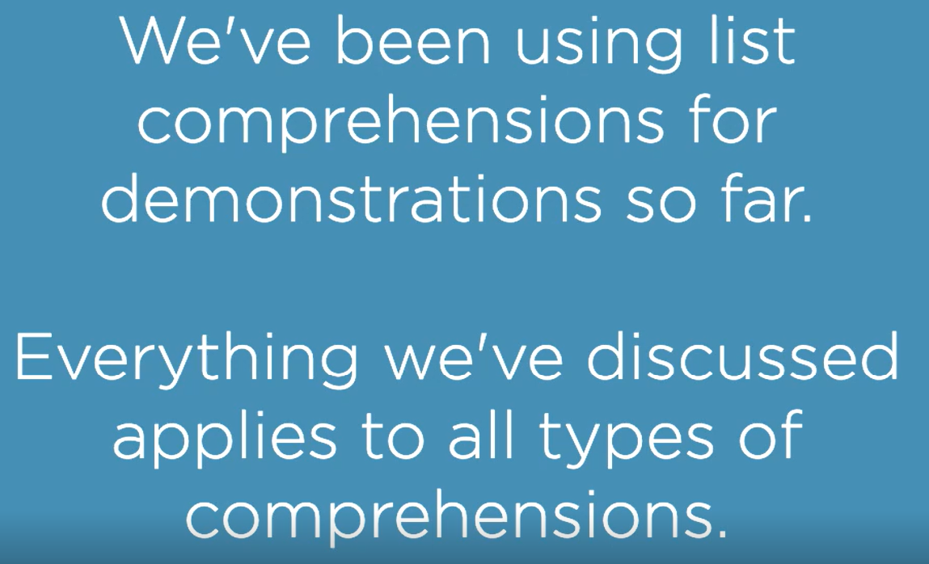

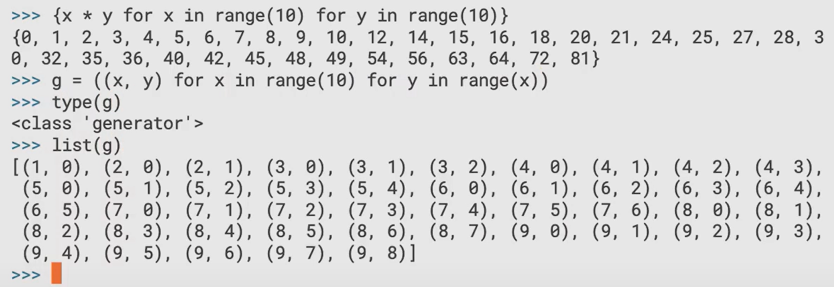

# Core Python 3.8: Classes and Object-orientation

## Classes Attributes, Methods, and Properties

Refer program shipping-container.py

### Class Attributes

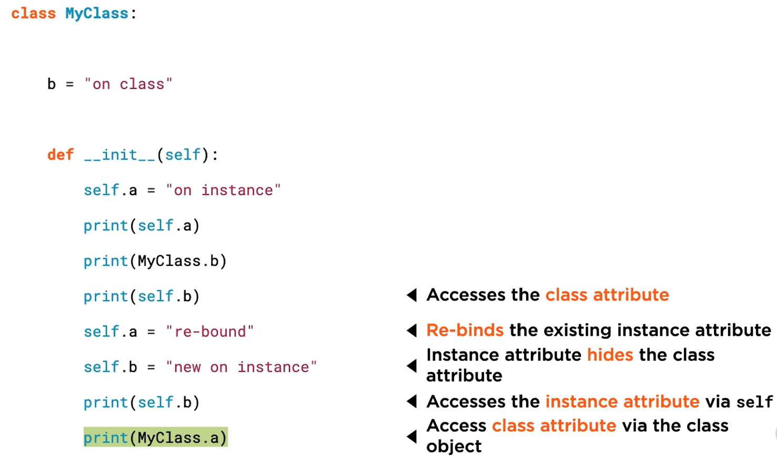

Last statement is wrong as there is no class attribute a

### Static Methods

Use @staticmethod annotation

These methods have no knowledge about the state of the class, they are simply present in a class because they are related to the class. They expect neither self nor cls as parameter. They can be called from outside the class without creating an object, but is rarely used like this. They are mostly used as a helper function withing the class.

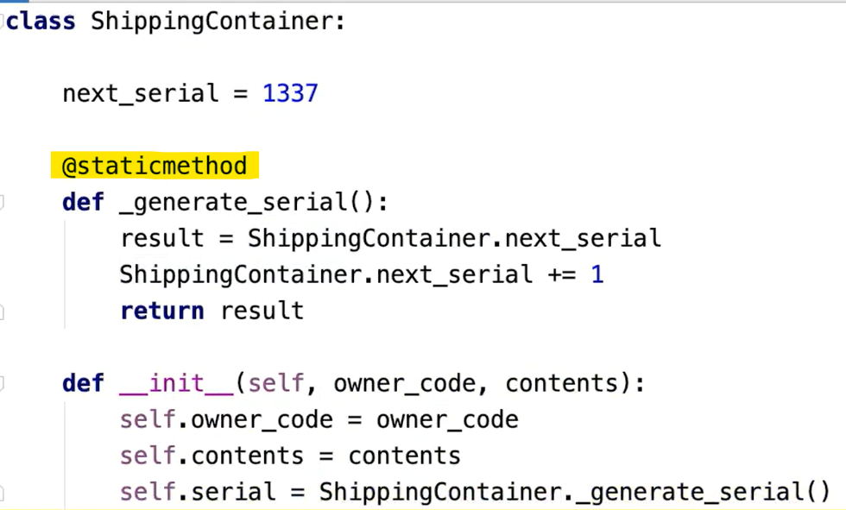

### Class Methods

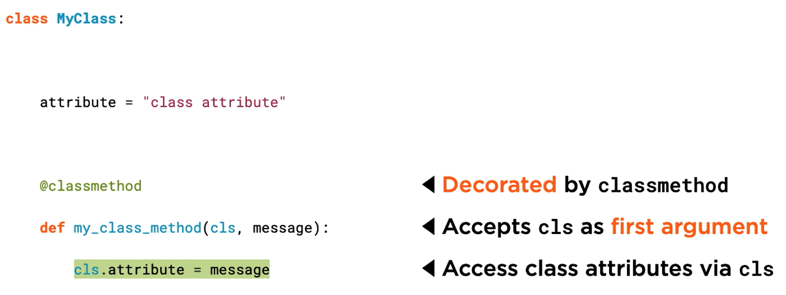

These methods expect cls as parameter. They can be called from outside the class without creating an object, but is rarely used like this. They are mostly used as a helper function withing the class.

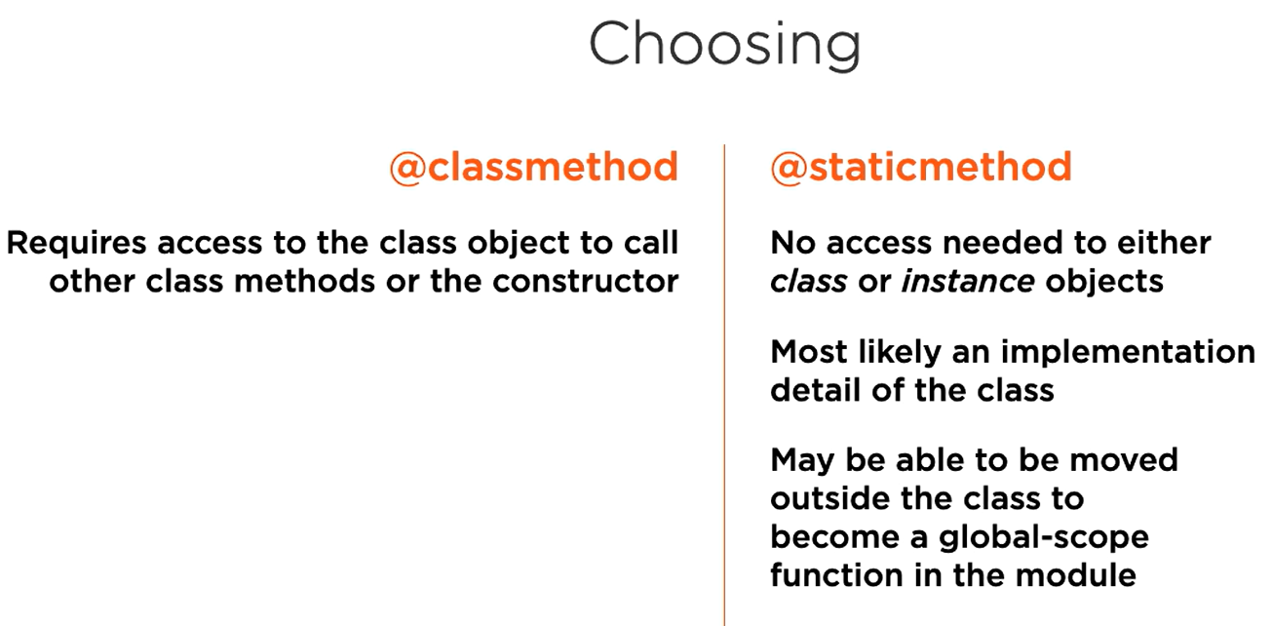

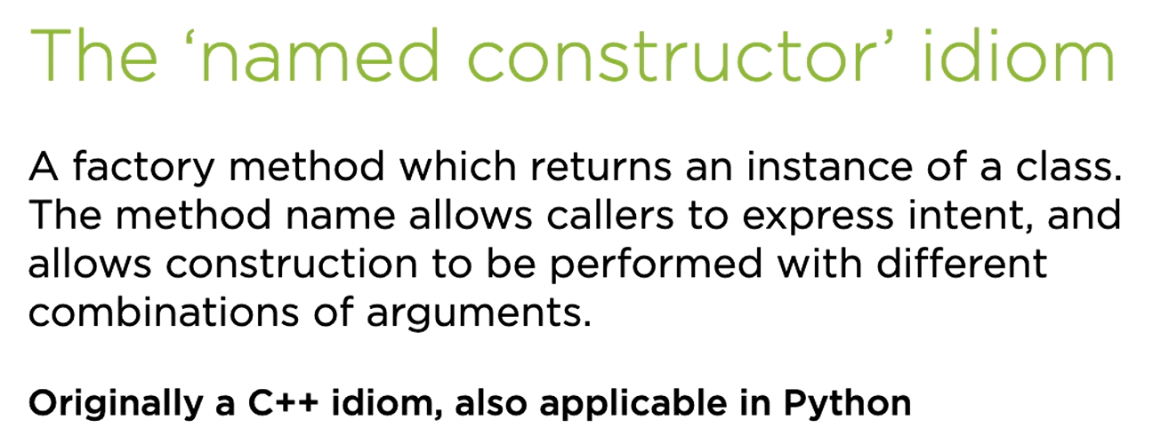

Class methods can be used as named constructors.

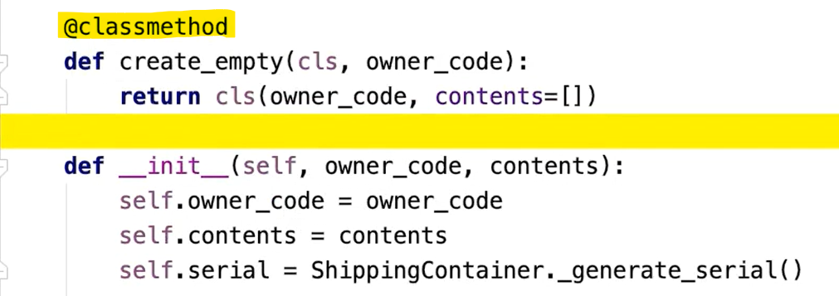

### Static Methods with Inheritance

Refer static-method-inheritance.py

### Class Methods with Inheritance

Refer class-method-inheritance.py

### Properties

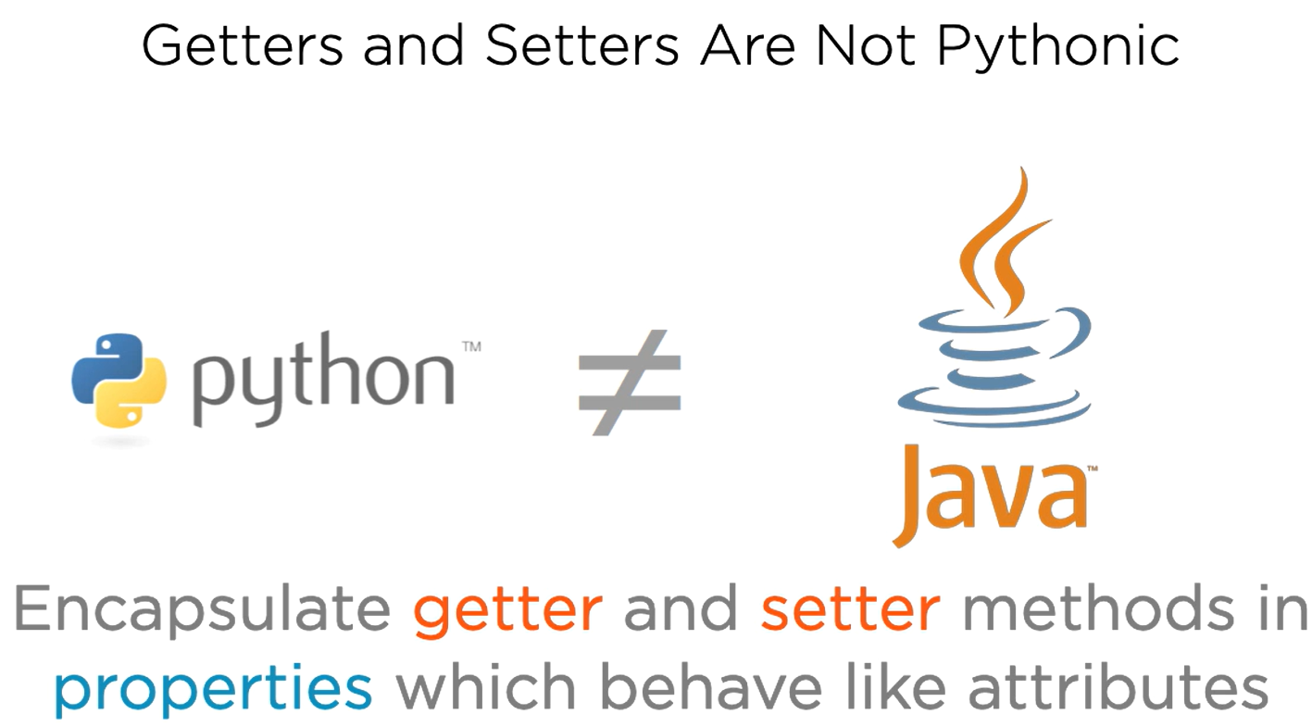

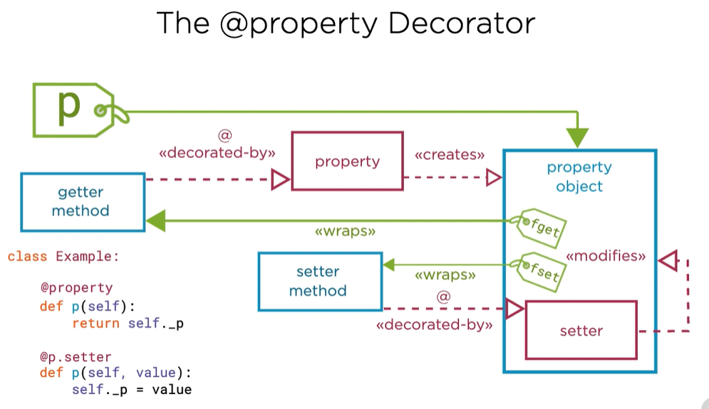

Refer property-encapsulation.py

Note that it is important to define property first (which is getter), then only we can define setter because their name has to be same.

Also, refer shipping-container.py

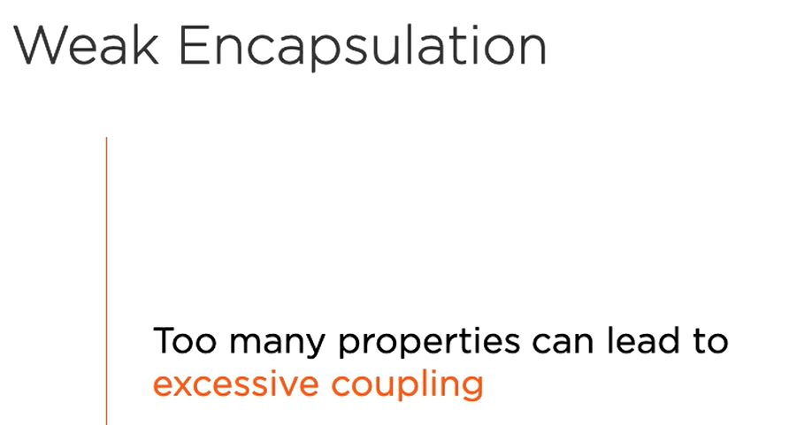

Solution:

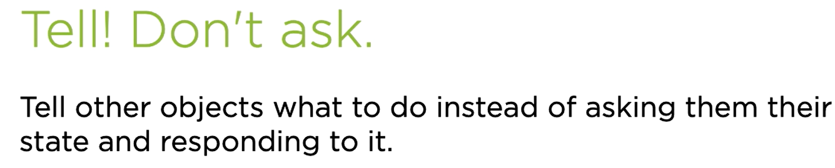

### Properties Inheritance



Example for setter which is property in Python:

Property in parent class



Property in child class

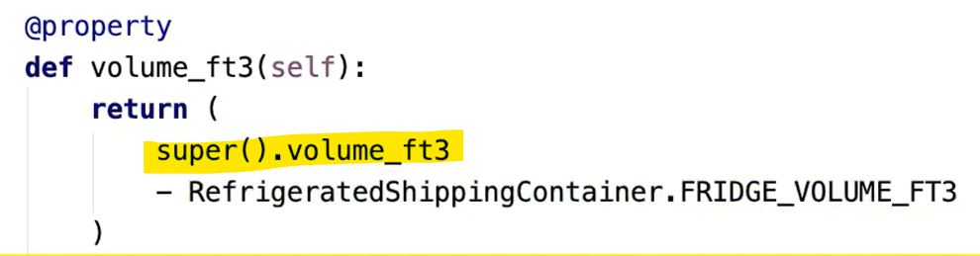

However, for setter, it is a bit difficult

Setter in parent class

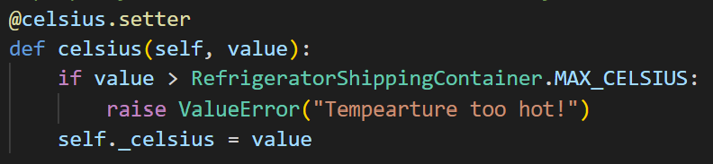

Setter in child class

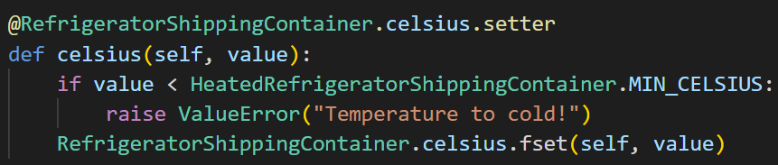

Although the above example works, it is not best practice, let’s simplify this using **TEMPLATE METHOD** design pattern.

### Overriding Properties with Template Method

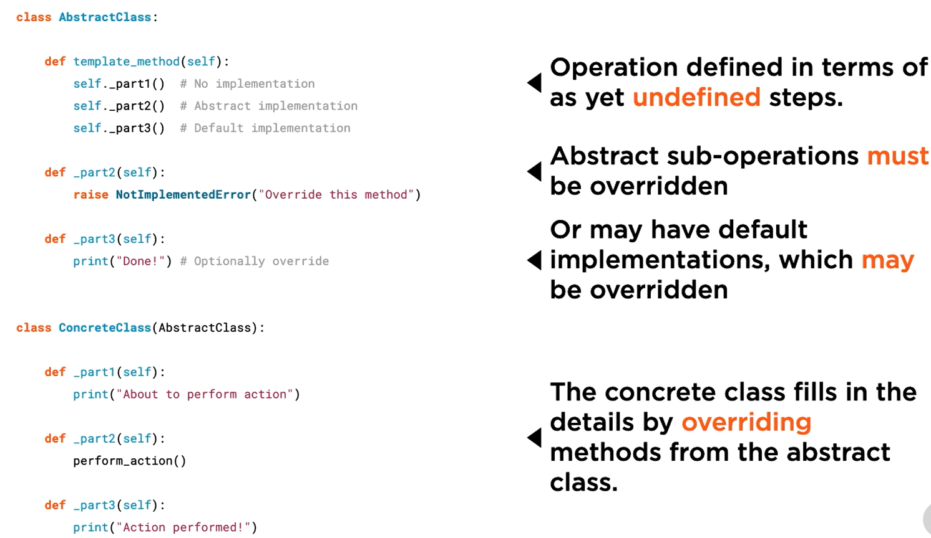

Let’s try to first simplify the property overriding:

In parent class:

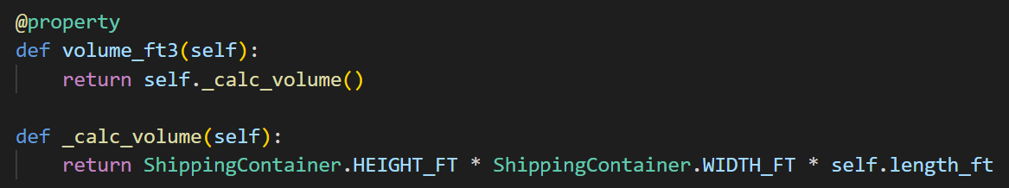

In child class:



We delegated the work of volume calculation to another function which is being overridden. Property remains in the parent class, which calls the appropriate _calc_volume() method.

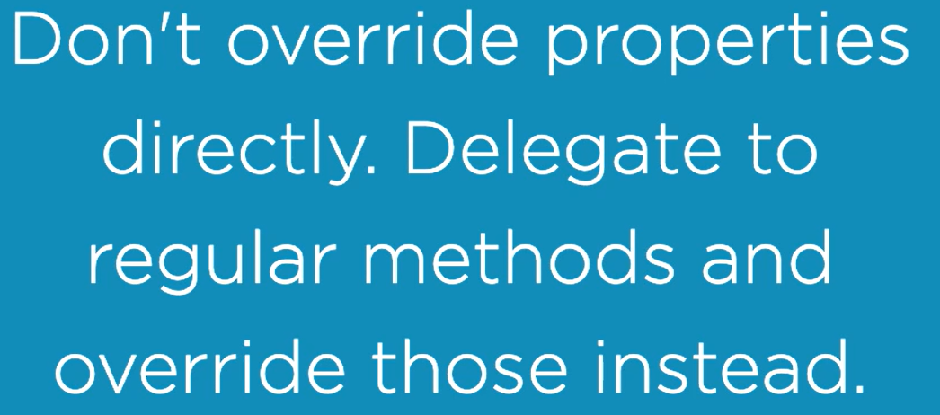

## String representation of Objects

Refer program position.py

Let’s see what repr(), str() and format() prints by default

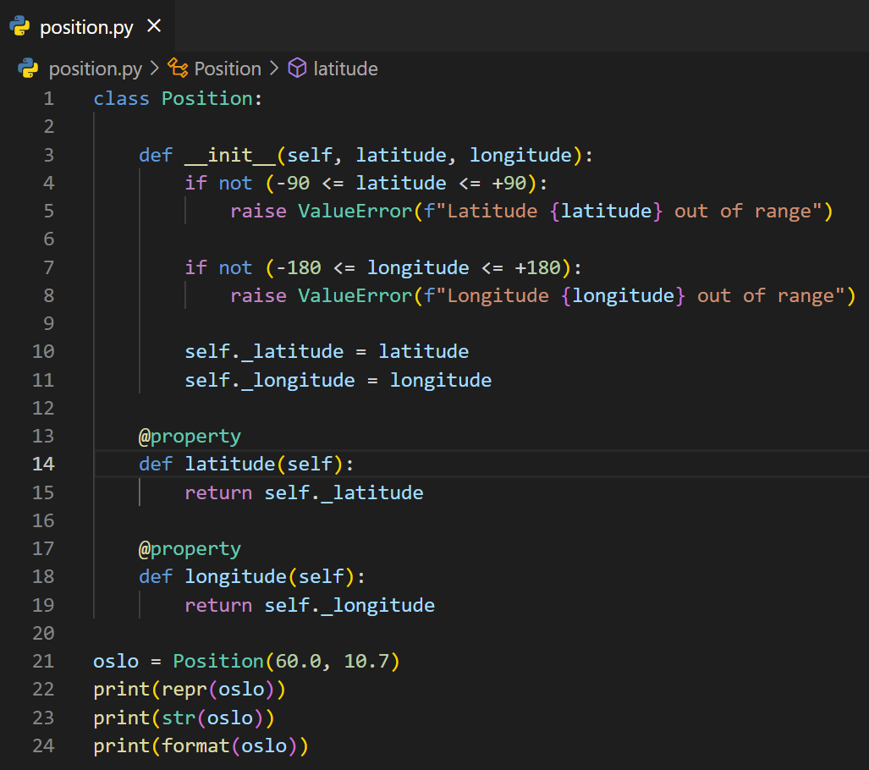

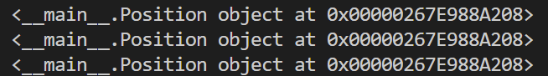

Prints the same thing

Note: By default, all the classes inherit from class “**object**”



### Customizing repr()

* **This is very important and helps developers in debugging.**
* **Intended for developers.**

In the same program, let’s add a method

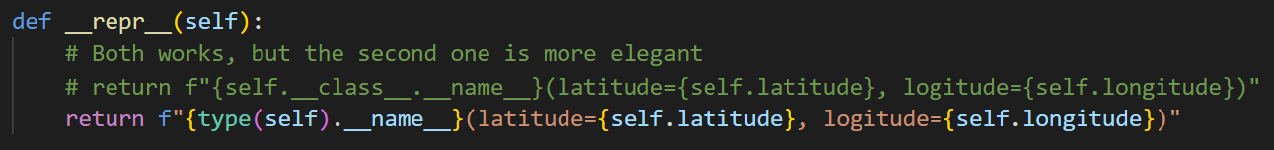

Now, the output is

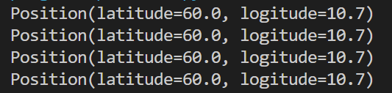

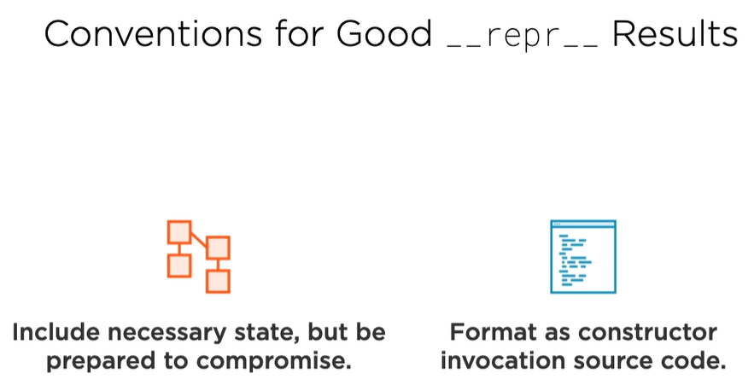

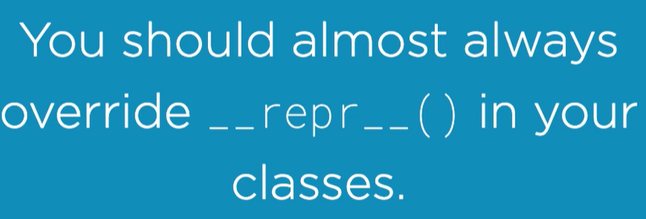

### Customizing str()

* **Intended for users, people in user interfaces.**

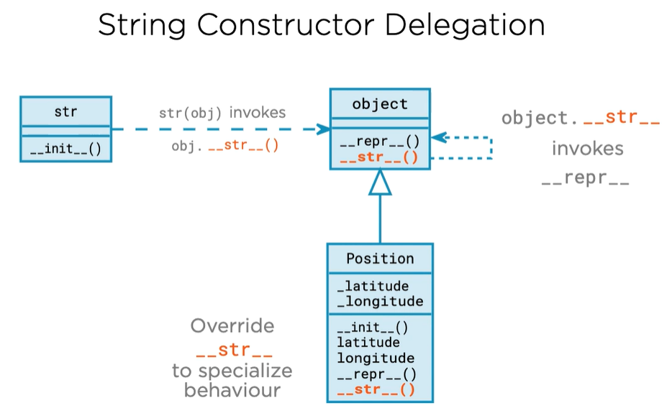

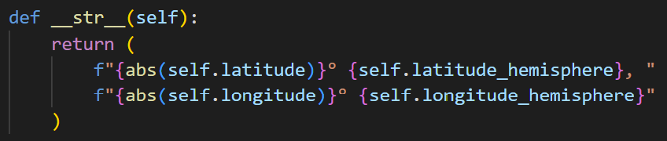

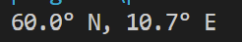

### Customizing format()

* **Used by f-strings**
* **Used by format() method**

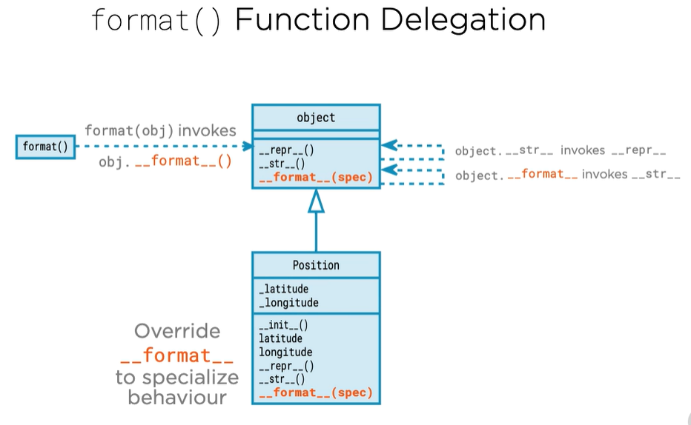

Example:

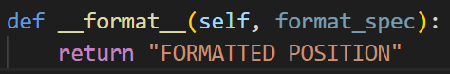

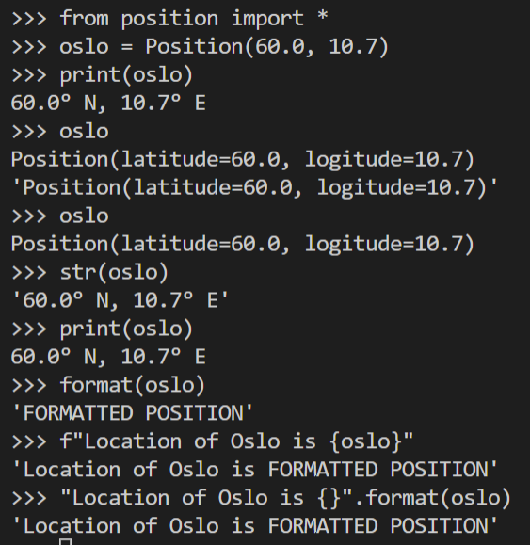

**Understanding the built-in format() method**

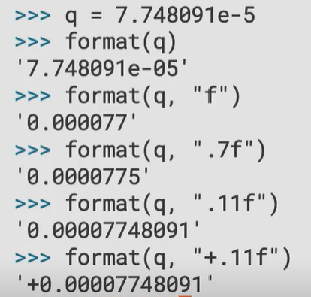

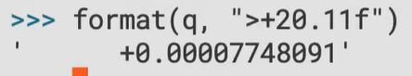

Note: The interpretation of the format strings is not done by built-in format method itself. The task is delegated by format to the __format__ method of the object being formatted, in the above case float __format__.

**Understanding the f-string**

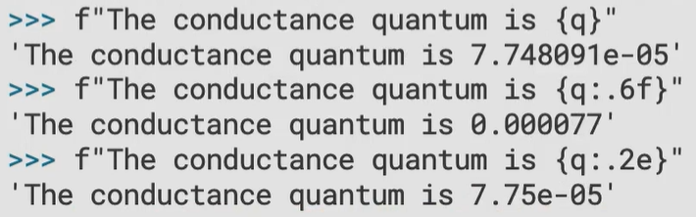

These examples here are equivalent to calling the former format() method.

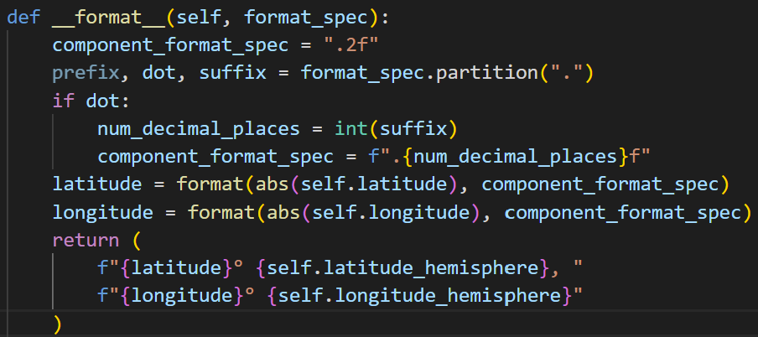

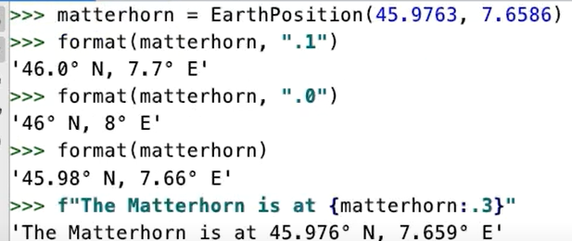

When we do not supply format_spec, the format() method passes blank string as format_spec to the __format__ method.

Now, we can simplify our __str__

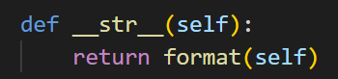

Force use of __repr__ from f-strings

* using !r





* using =



Force use of __str__ from f-strings using !s





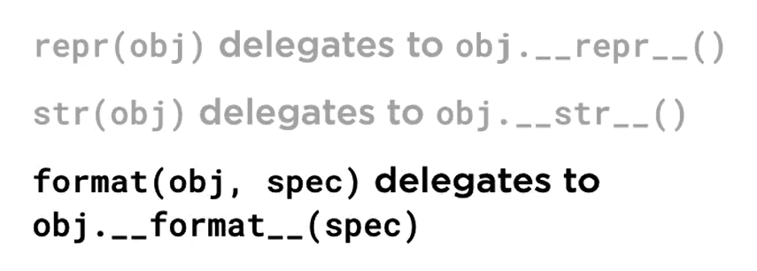

## Multiple Inheritance

### Type Inspection

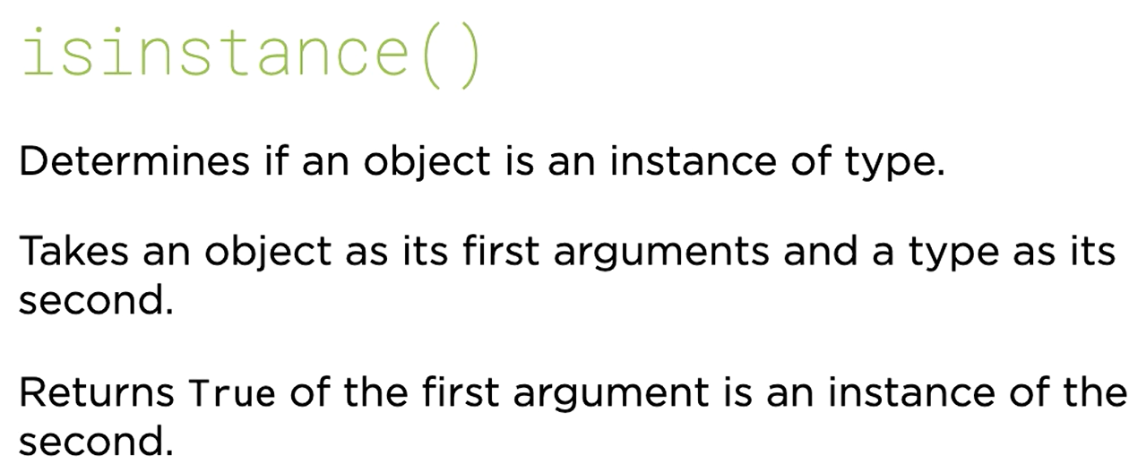

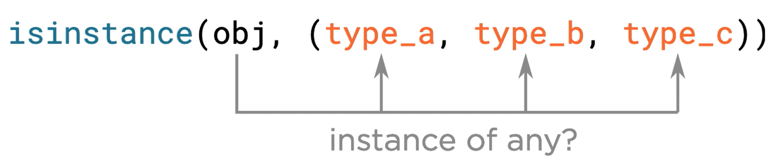

1st parameter is object, 2nd one is class.

isinstance() will return True on parent classes as well.

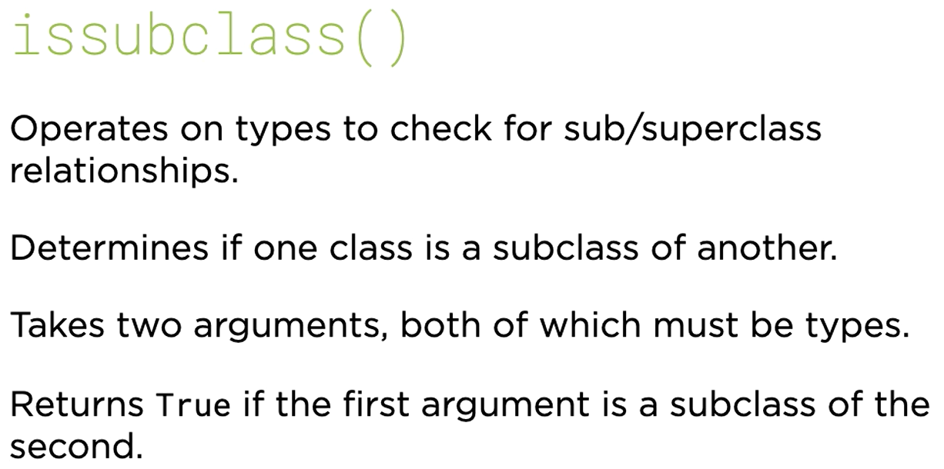

Both arguments must be classes.

Refer is-sub-class.py

### Multiple Inheritance

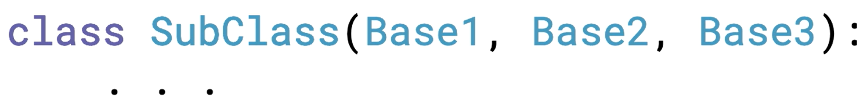

Refer multiple-inheritance.py

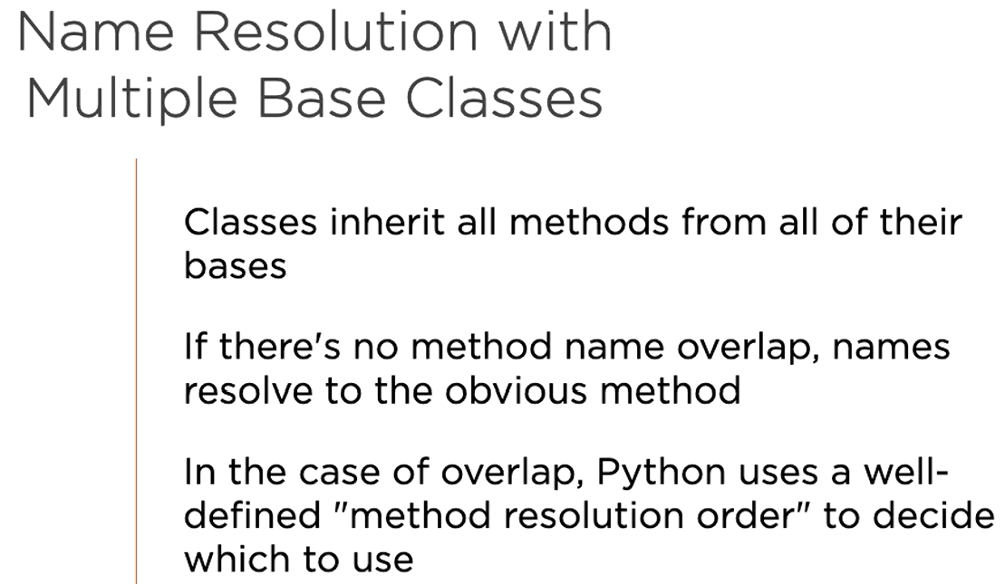

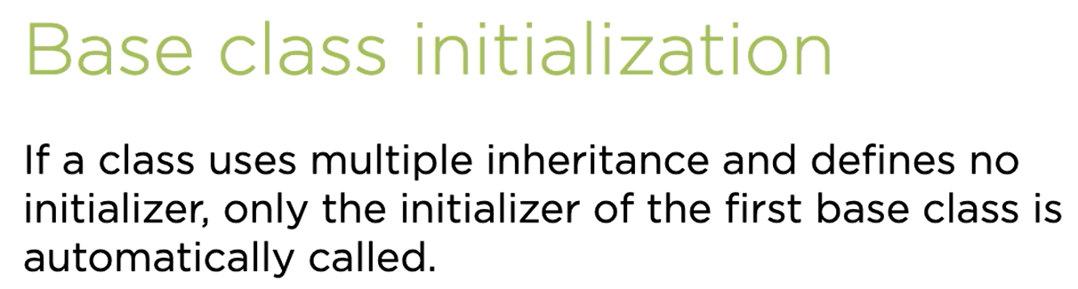

Refer multiple-inheritance2.py

__bases__

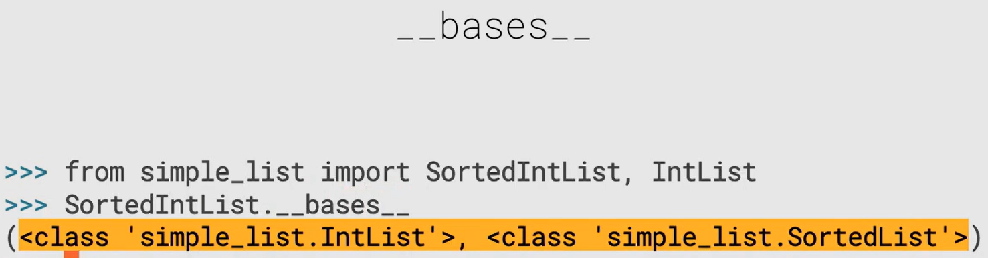

### Method Resolution Order

__mro__

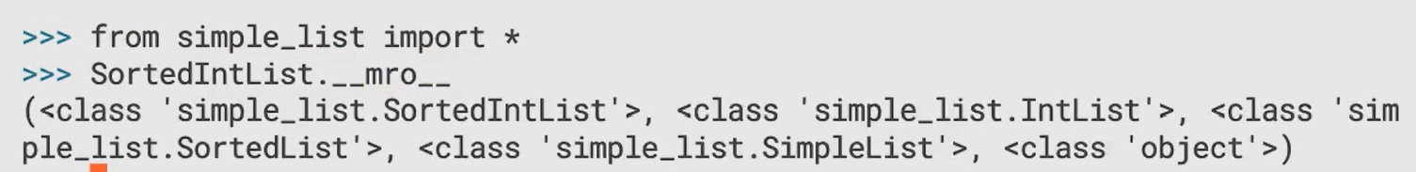

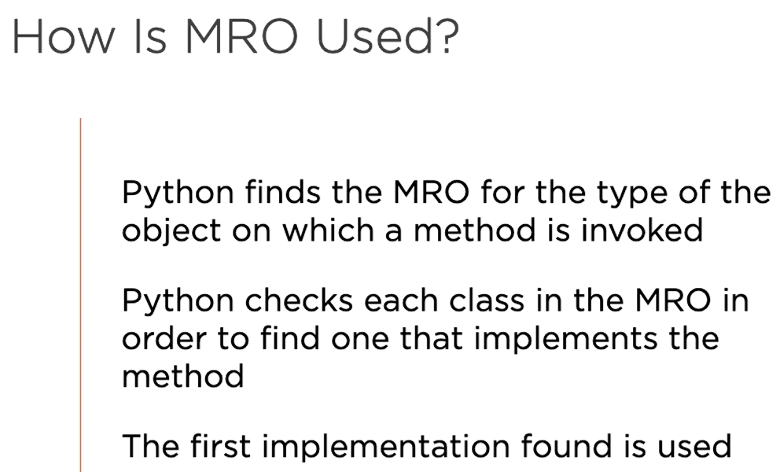

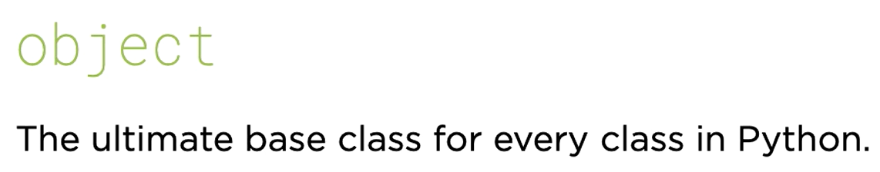

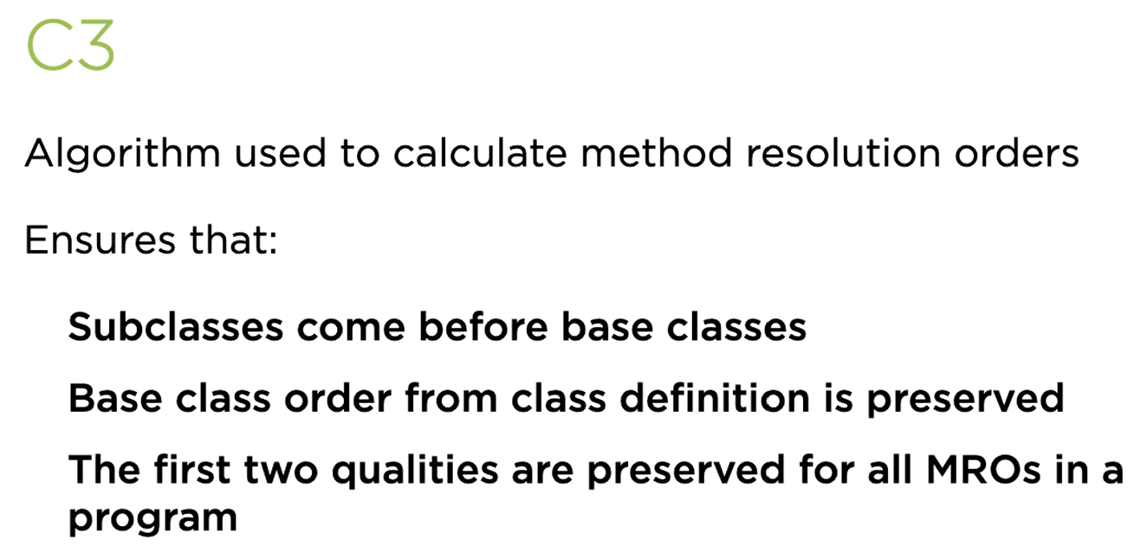



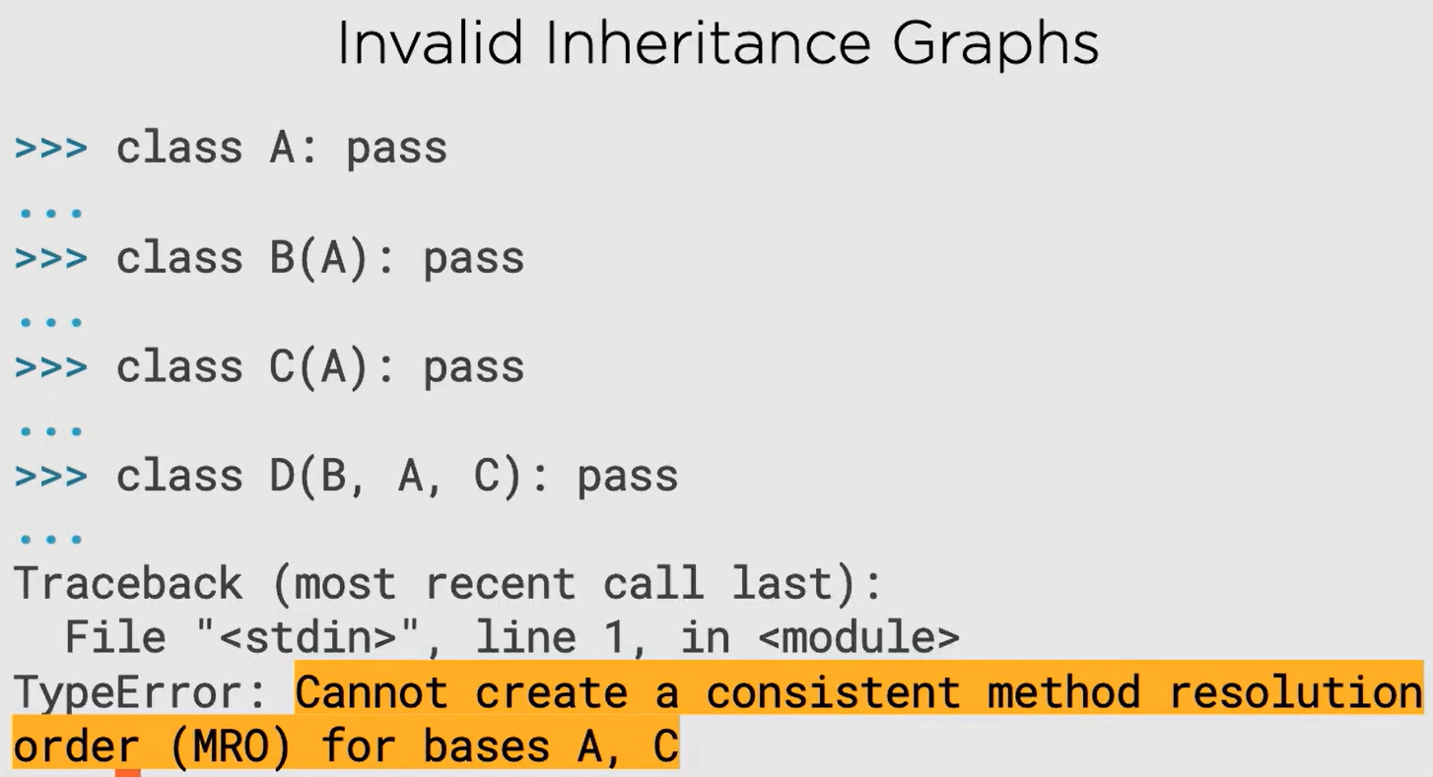

### super()

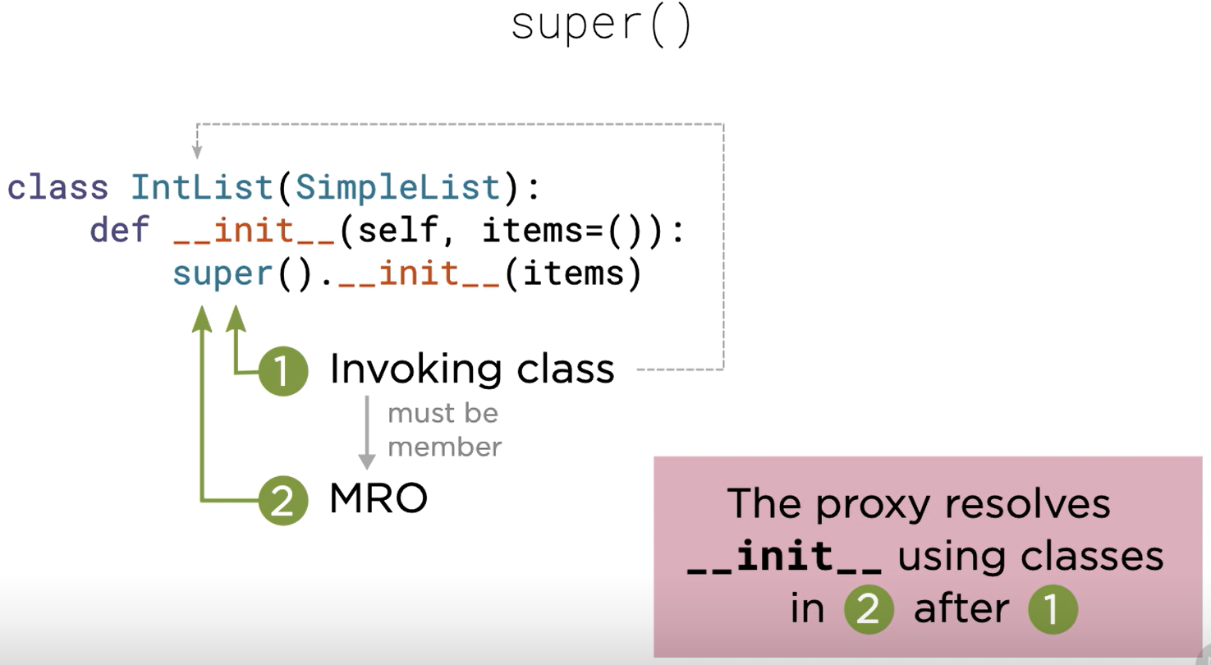

#### Instance Bound Super Proxies

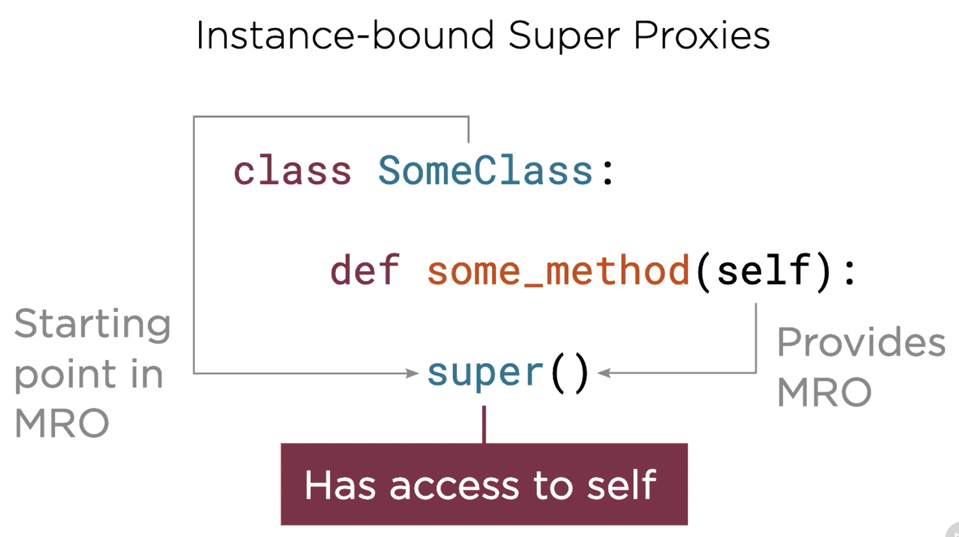

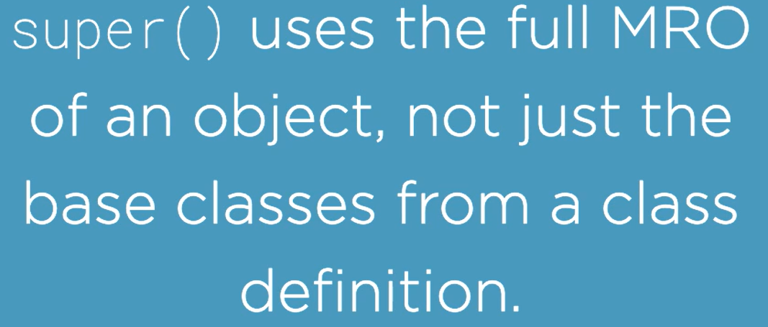

Refer multiple-inheritance.py

#### Class Bound Super Proxies

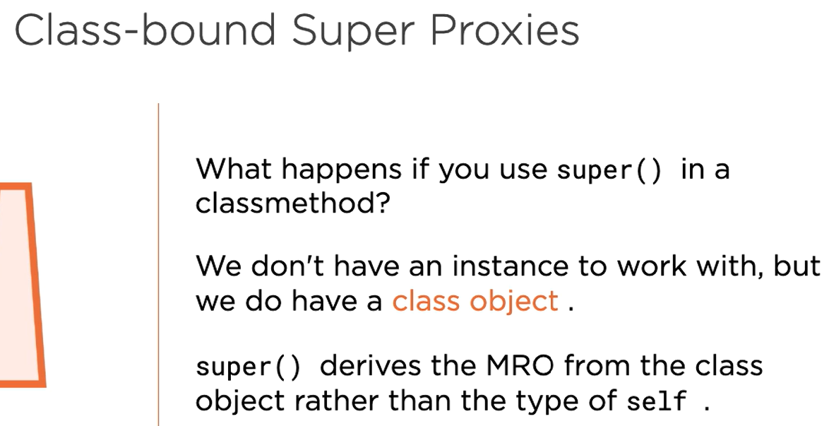

Refer class-bound-super-proxy.py

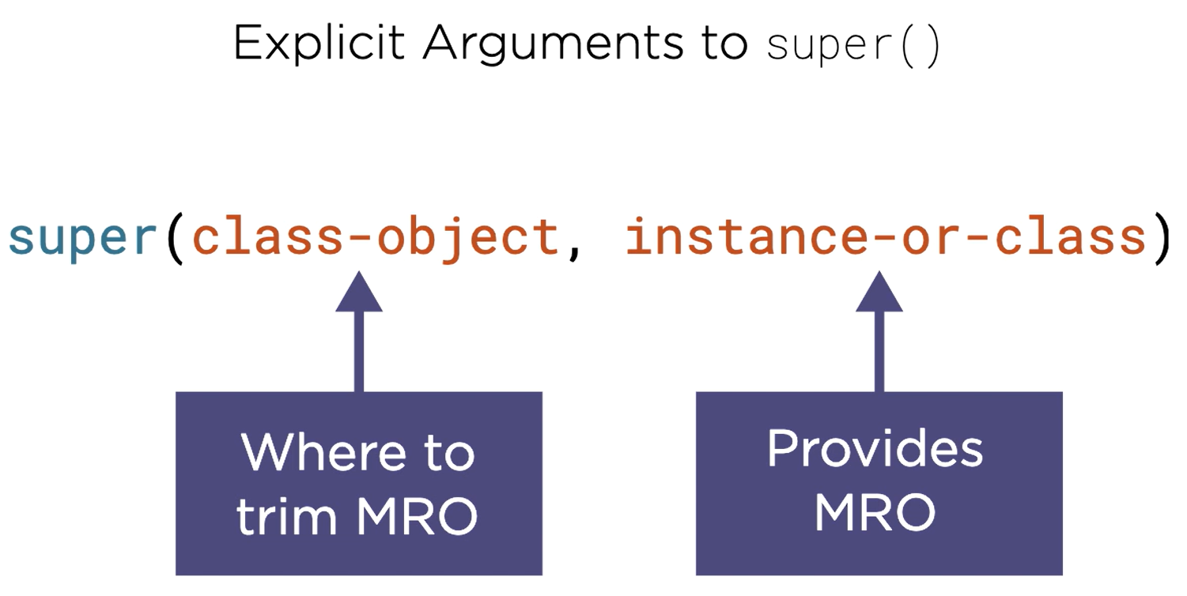

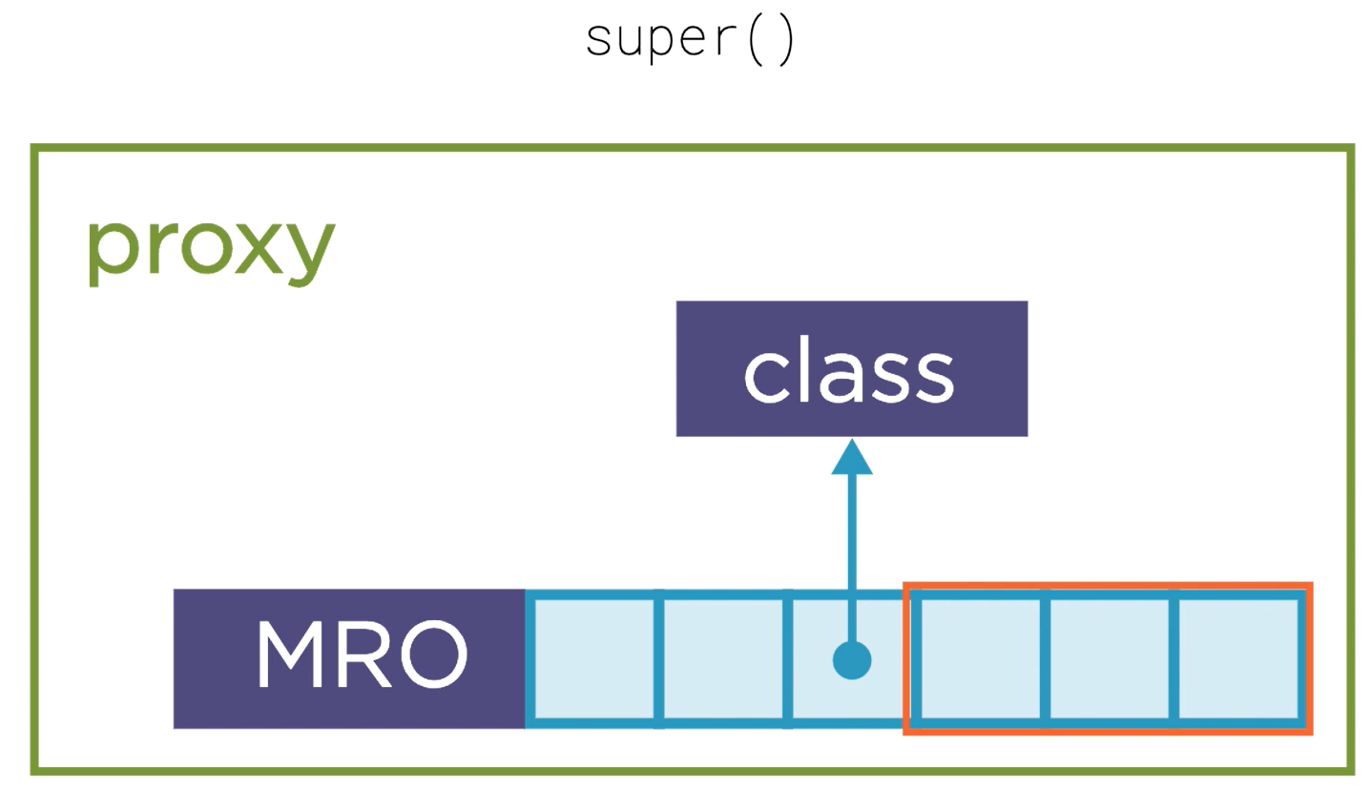

## Class Decorators

Refer class_decorator.py

Here we tried decorating a class and put the __repr__ method using decorator.

### Class Decorator Factories

Beyond the scope of my understanding.

[Core Python 3.8: Classes and Object-orientation | Pluralsight](https://app.pluralsight.com/course-player?clipId=3a6f1ca5-3da9-4a76-a76d-d0129ec6d221)

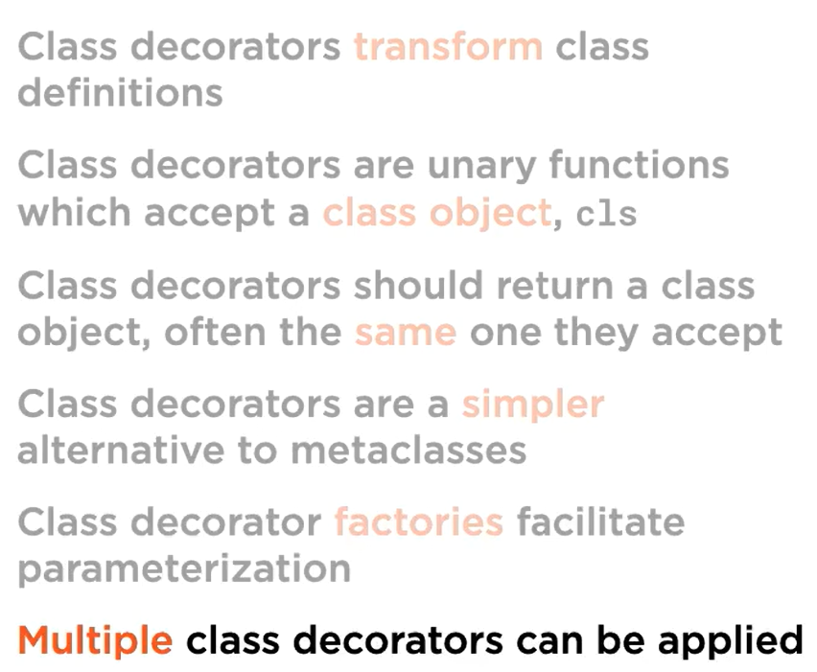

## Data Classes

* It is a simple class with data attributes and little or no behaviour of its own
* We use data class in the above case because it simplifies our work, we don’t have to write lots of code to overwrite lots of dunder methods

### Data Classes

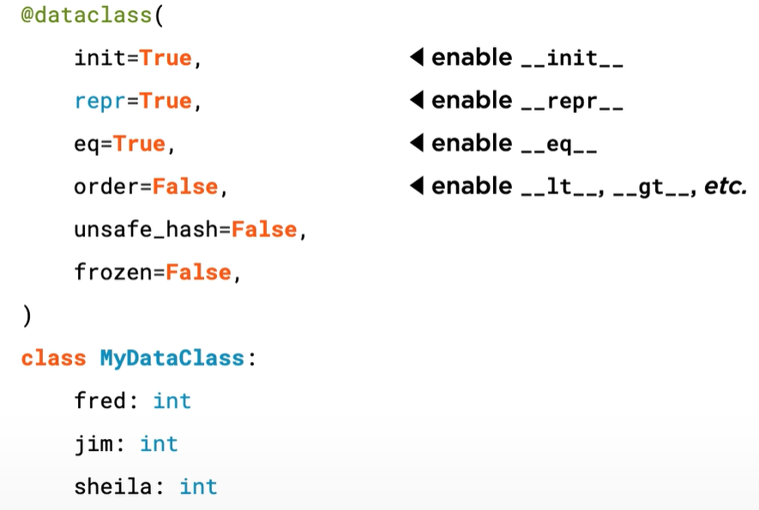

Refer data_class.py

### Hash and Hashability

If they have the same hash code, they might be equal, but if they are equal , they must have the same hash code.

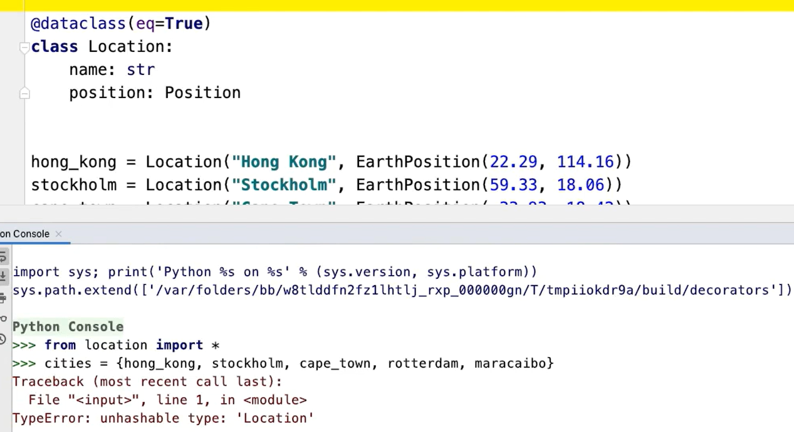

To make a class hashable:

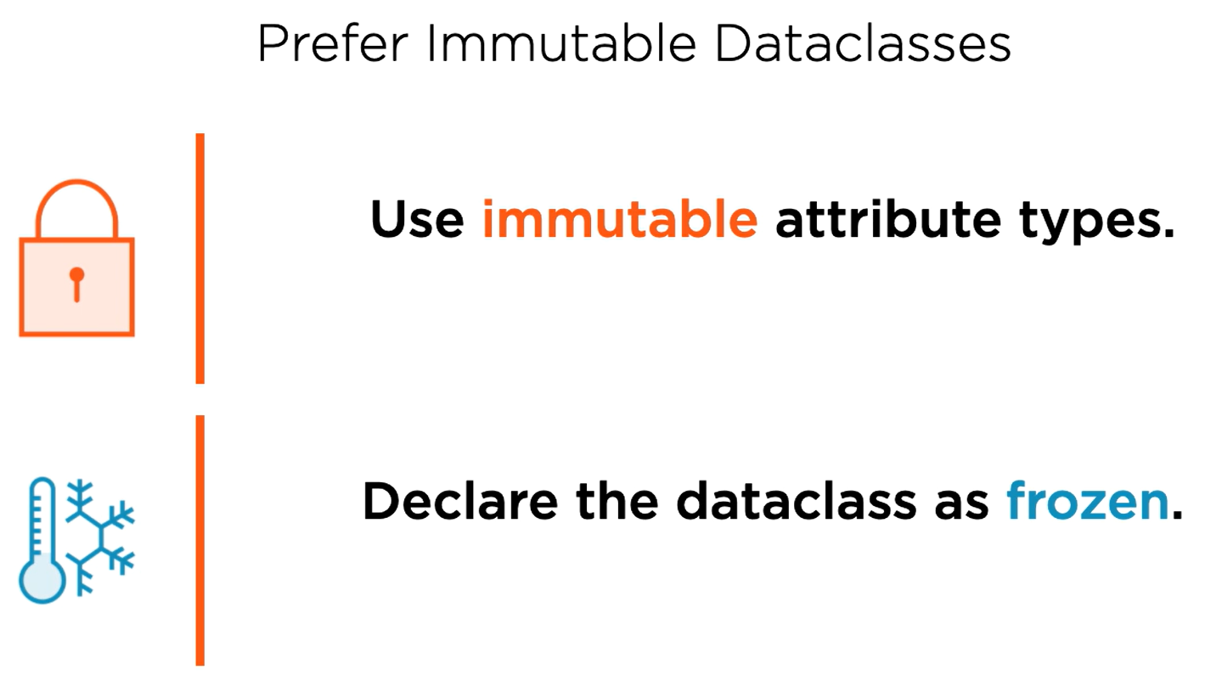

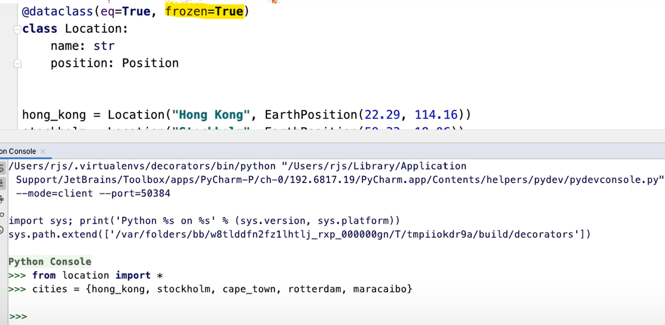

We also need to make sure the Position class is hashable, then only the above example will return True.

### Dataclass Invariants

With data class in picture, how do we impose rules/validations which we were able to do in __init__ earlier, like preventing empty names form being entered, etc.

Of course we can write __init__ to implement this, but remember there was a reason that we skipped it and started using data classes (to make sure we don’t have to keep on reimplementing lots of dunder methods when our classes have little or no behaviour of its own and merely just stores data). So, we have another way:

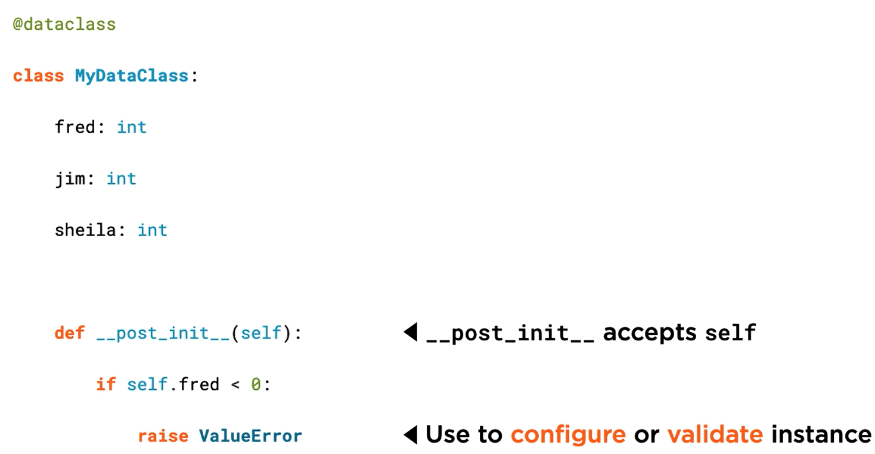

__post__init__ is executed after __init__, so when we work with post__init__ all the arguments have already been initialized and we can directly use them through self:

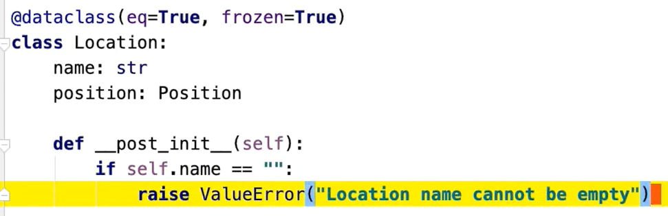

# Core Python 3.8: Implementing Iterators, Iterables, Collections

In this chapter, we will be working to create our own data structure called SortedFrozenSet using TDD. Refer SortedFrozenSet folder.

## Iterators and Iterables

### Iterators and Iterables

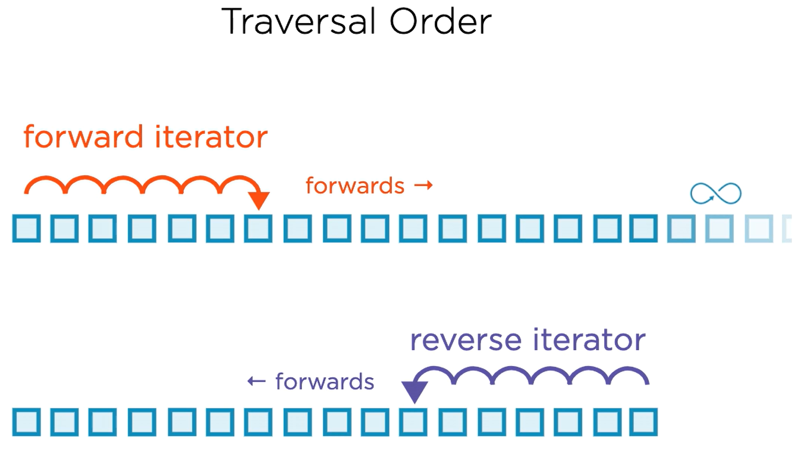

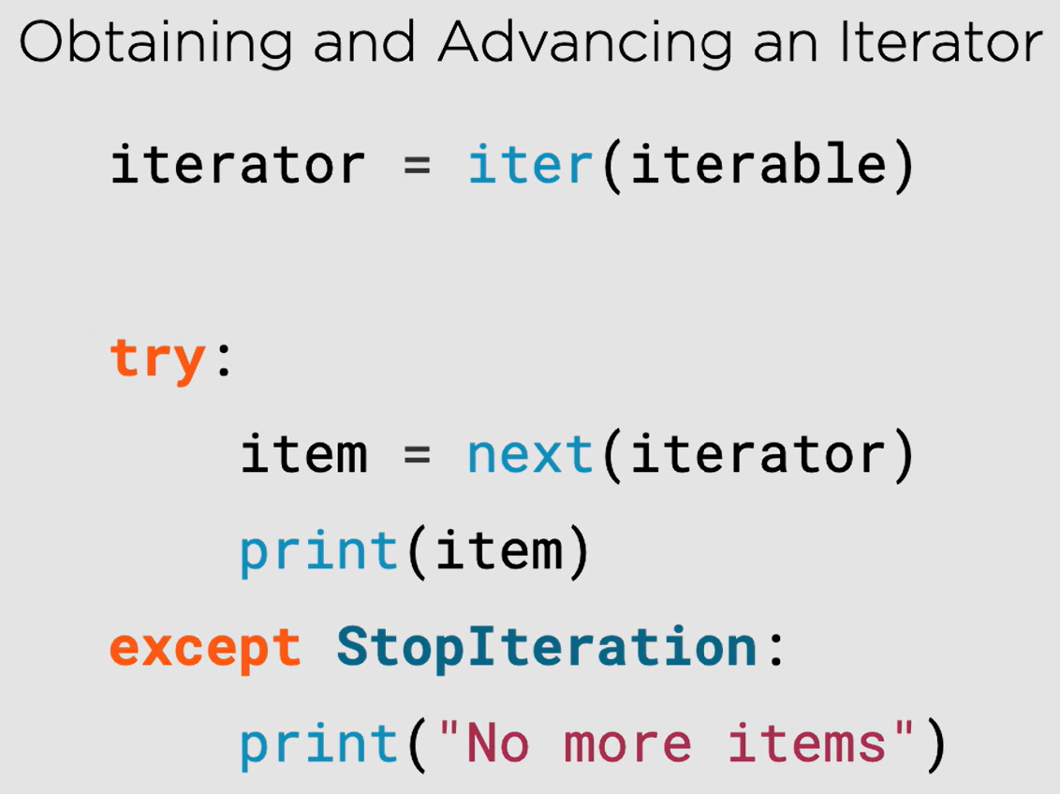

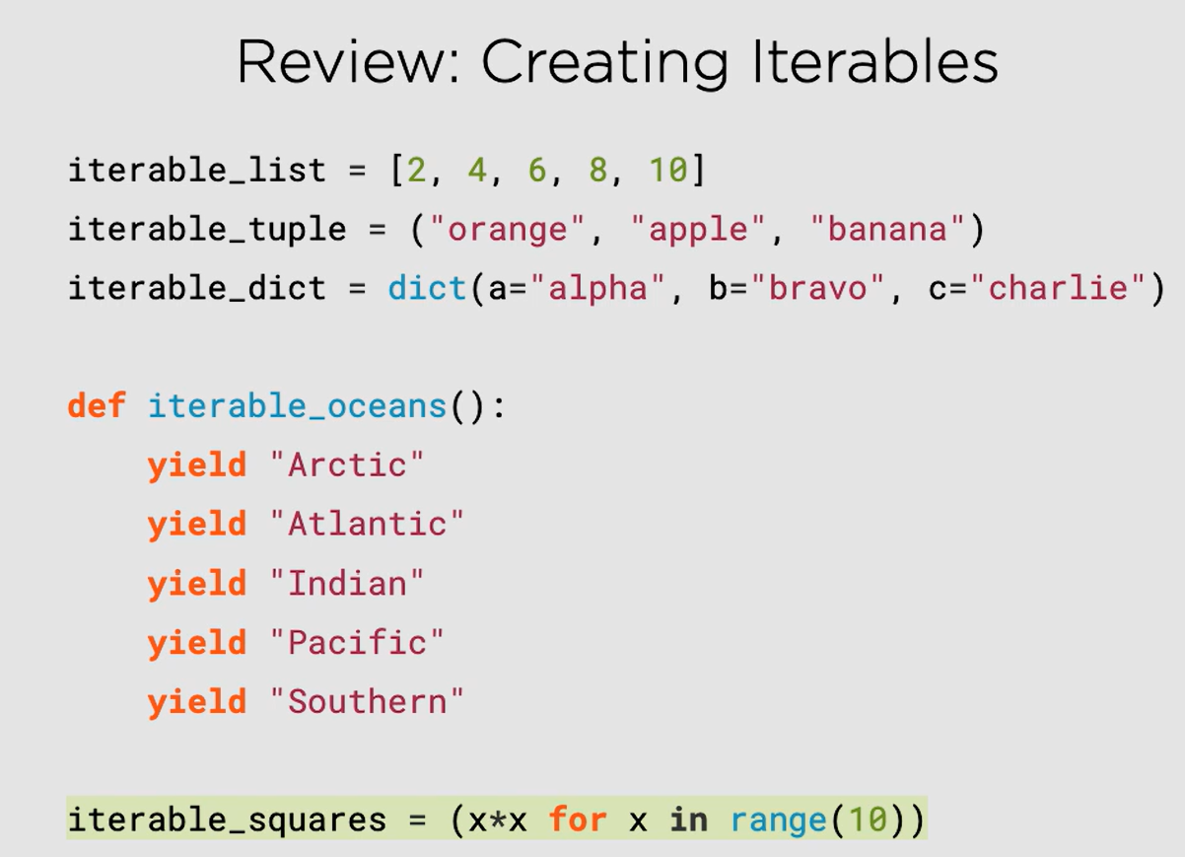

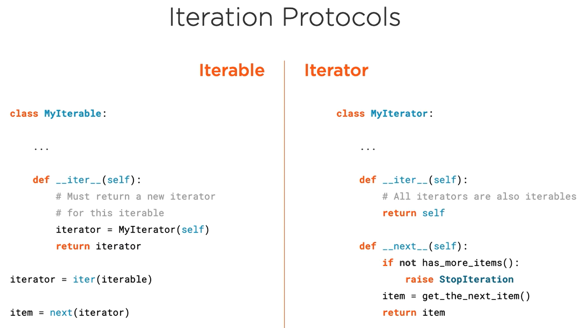

Iterators can do a lot of things such as:

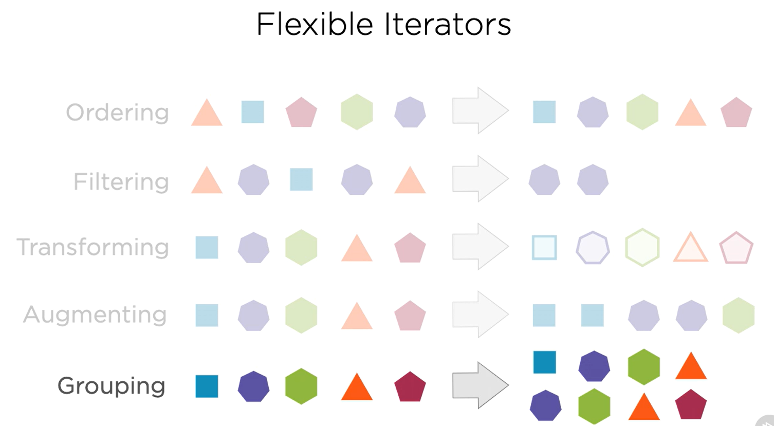

### Breadth-first, Level-order Iterator

Refer Iterator/LevelOrderIterator.py

### Depth-first, Pre-order Iterator

Refer Iterator/PreOrderIterator.py

### Depth-first, In-order Iterator

Refer Iterator/InOrderIterator.py

### Filtering Iterators

Refer Iterator/SkipMissingIterator.py

### Iterables

Refer Iterator/PerfectBinaryTree.py

### Alternative Iterable Protocol

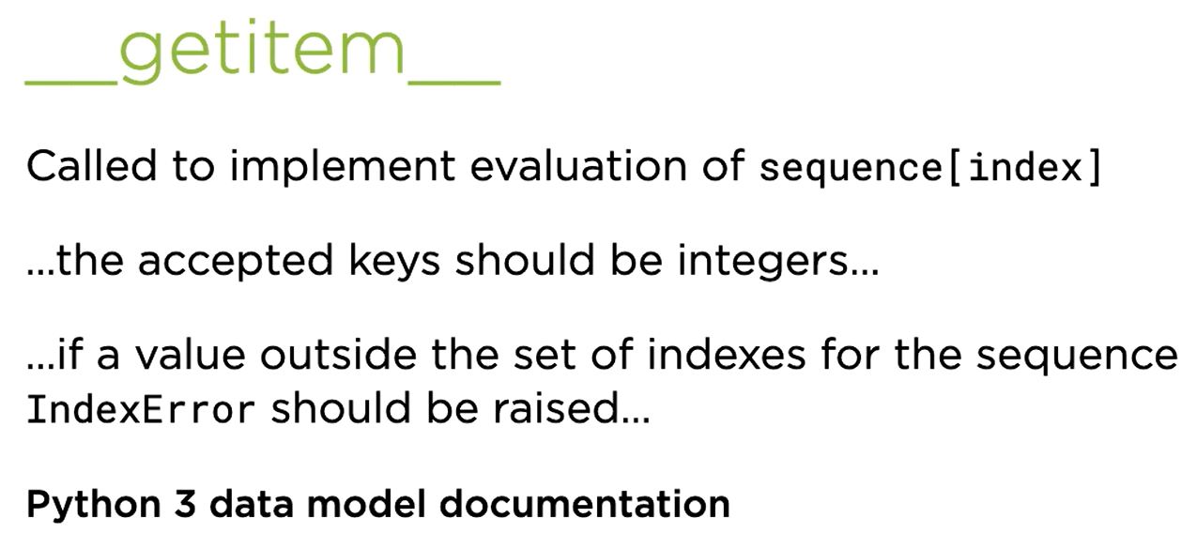

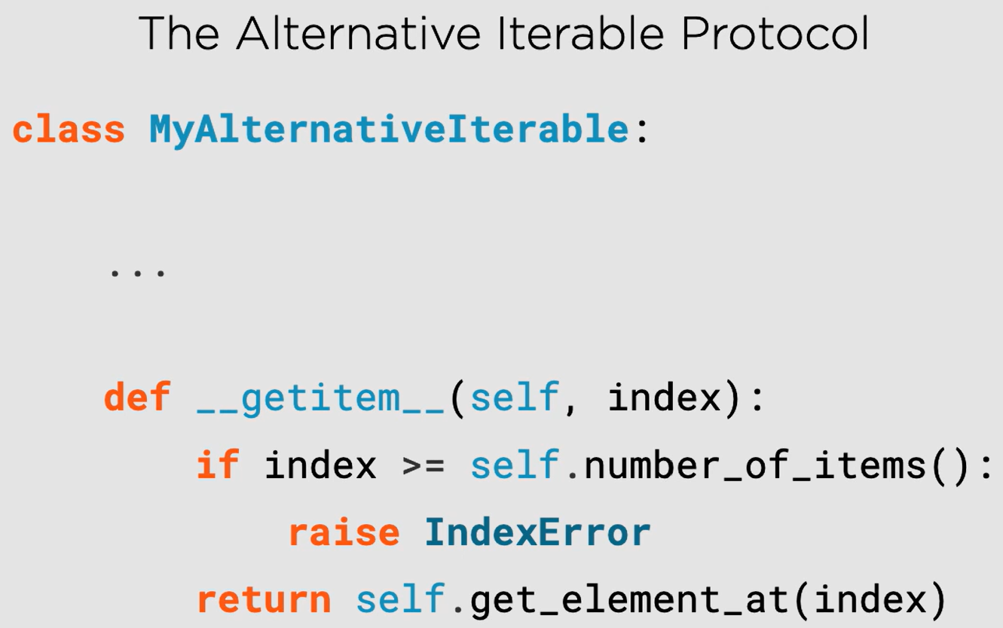

Refer Iterator/RationalRange.py

### Extended iter() form

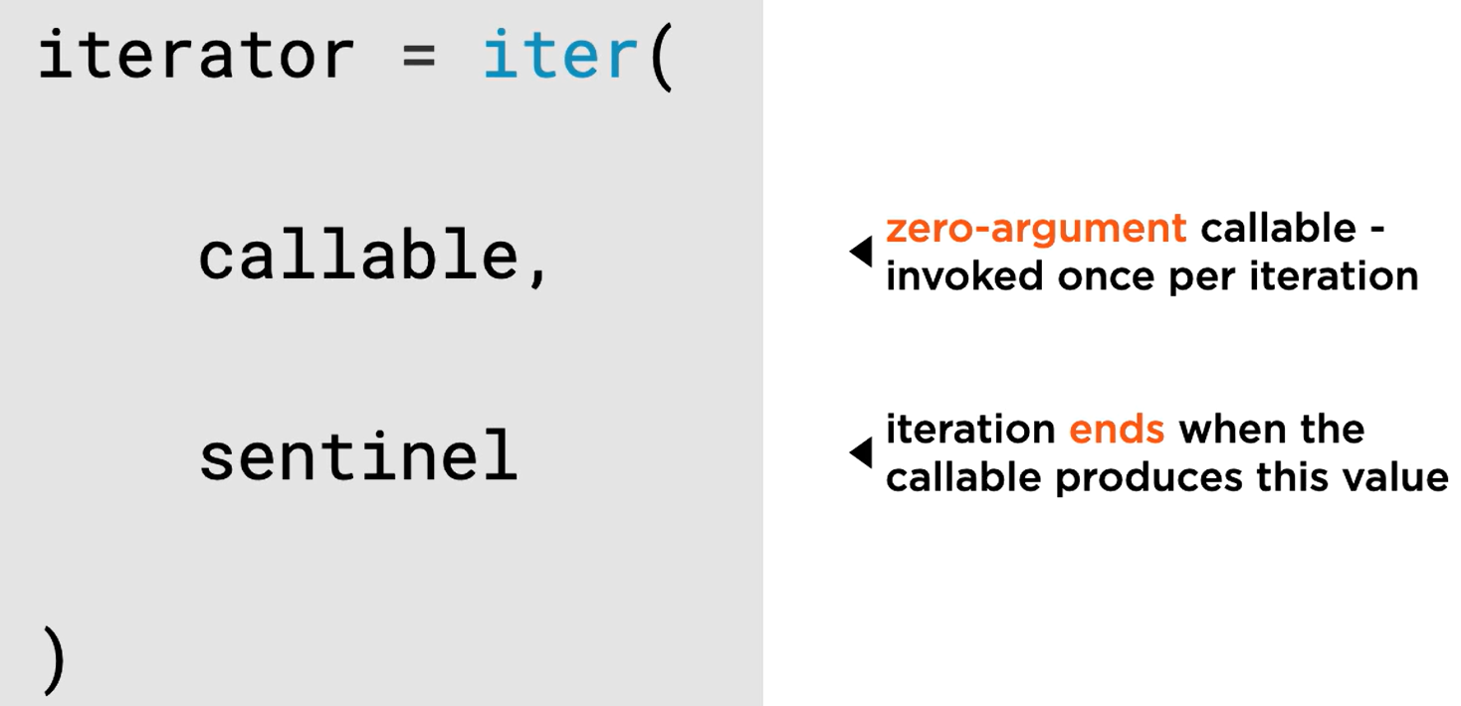

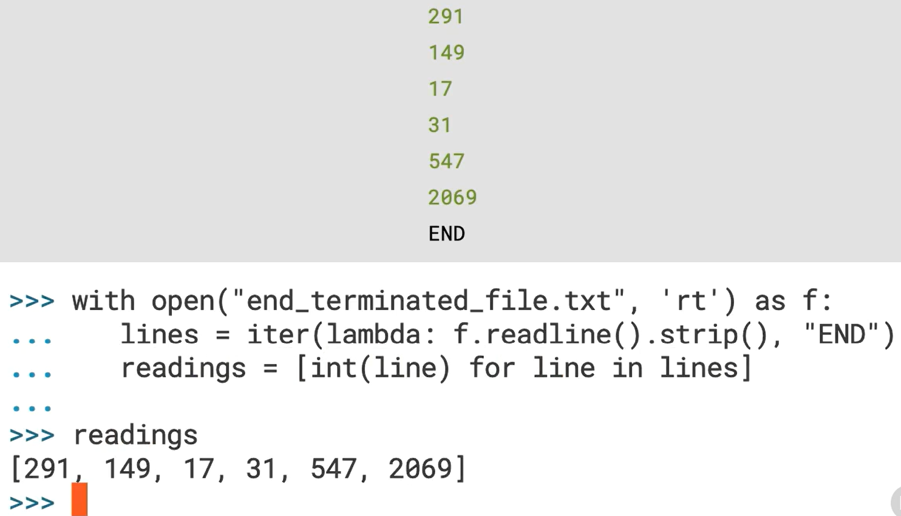

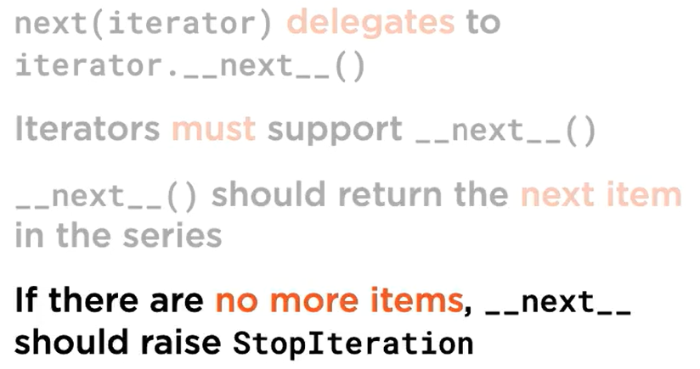

## Collection Protocol

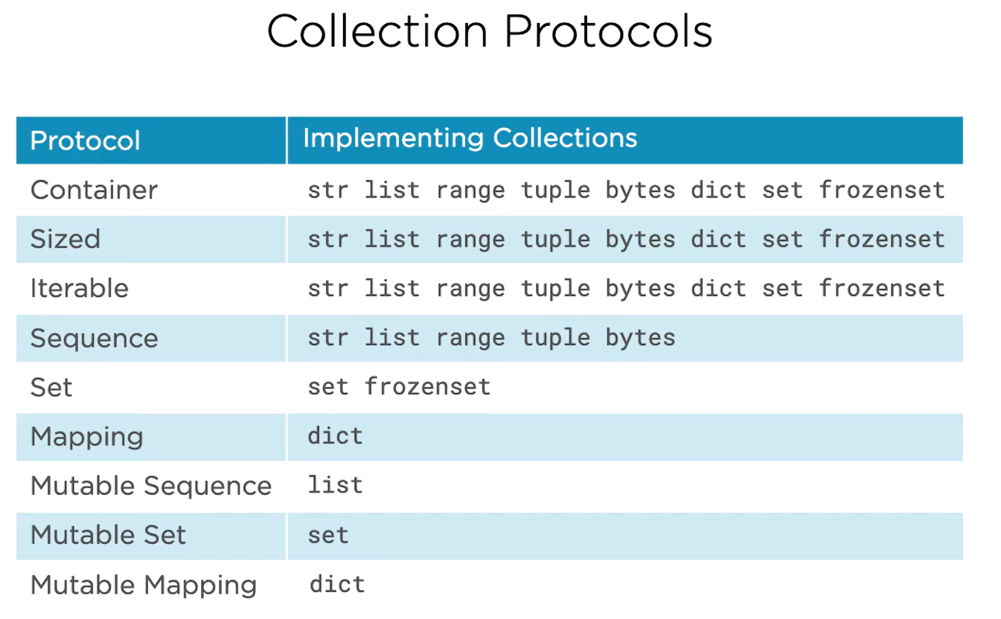

* Container requires the support of **in** and **not in** operator
* Sized requires the support of **len()** function
* Iterable requires producing items one by one as they are requested which means they support **iter()** function to produce an iterator
* Sequence requires that **item can be retrieved using squared brackets with an integer index**
* Set supports **set algebra operations**
* Mapping associates hashable keys with values



## Container Protocol

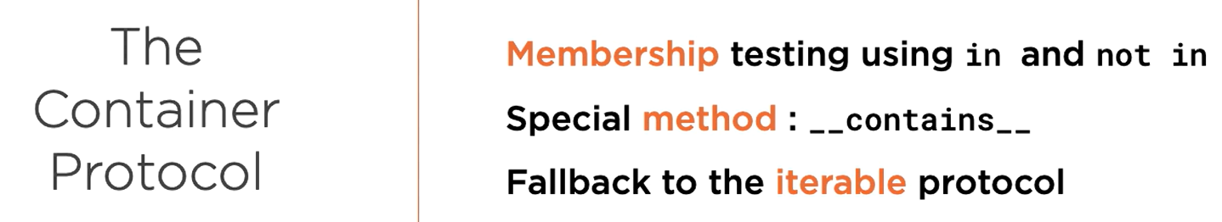

## Sized Protocol

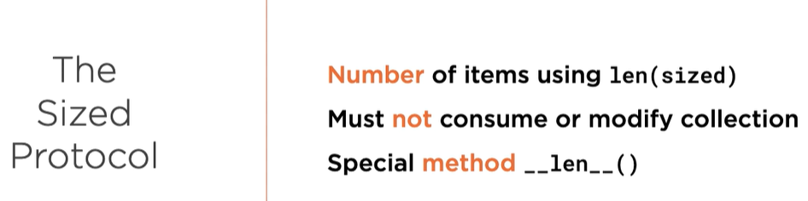

## Iterable Protocol

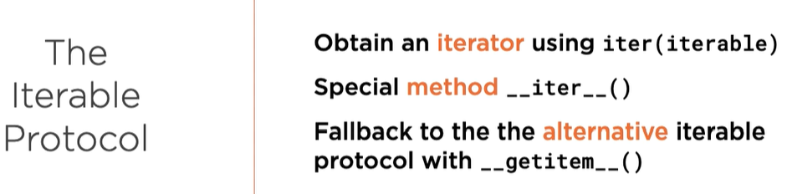

## Sequence Protocol

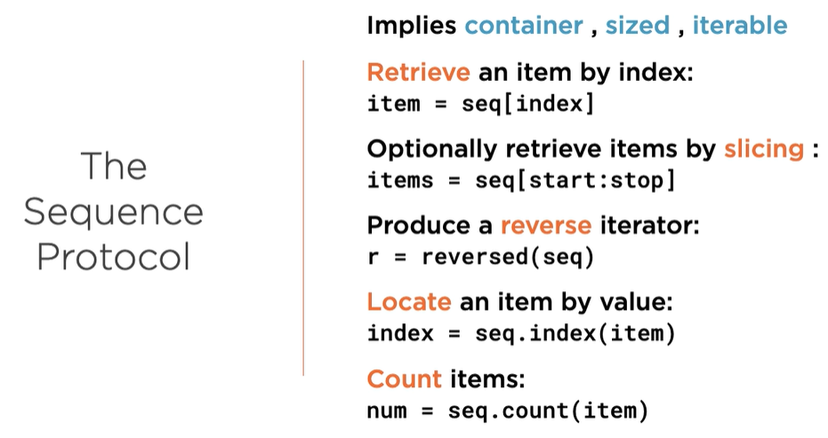

### Indexing

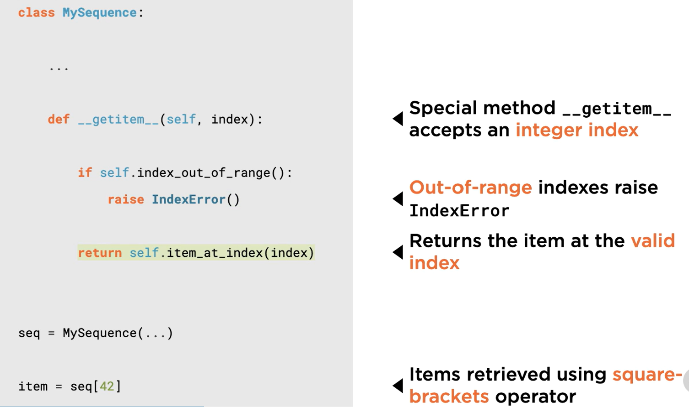

### Slicing

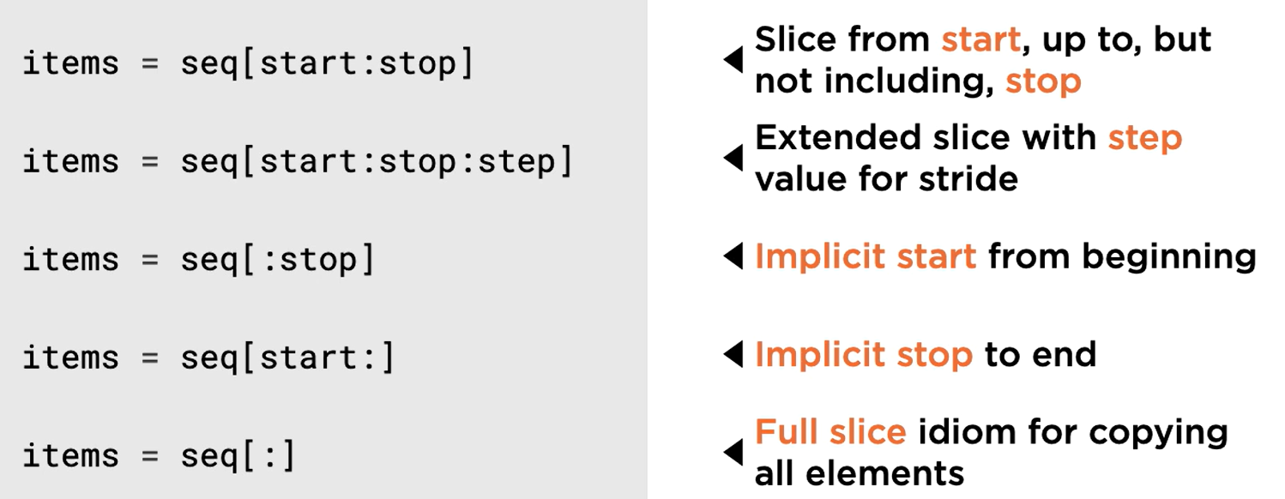

### String Representation

Dealt with __repr__

### Value Equality

Dealt with __eq__

This must also implement hashable protocol

### Hashable Protocol

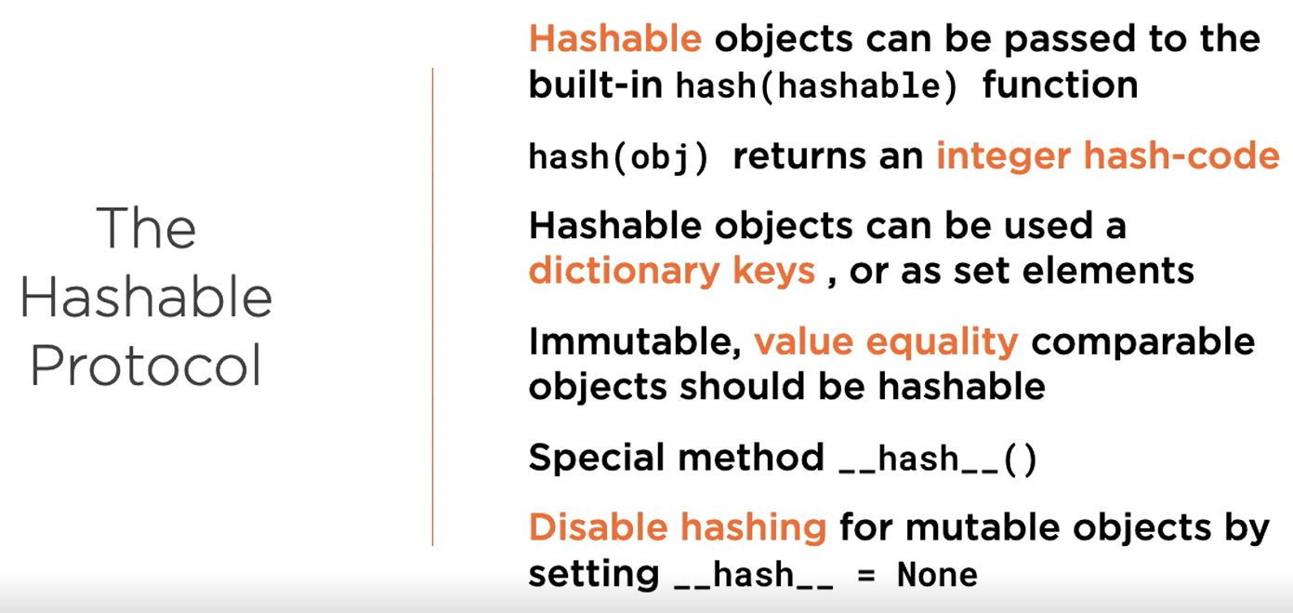

### Reversing a sequence

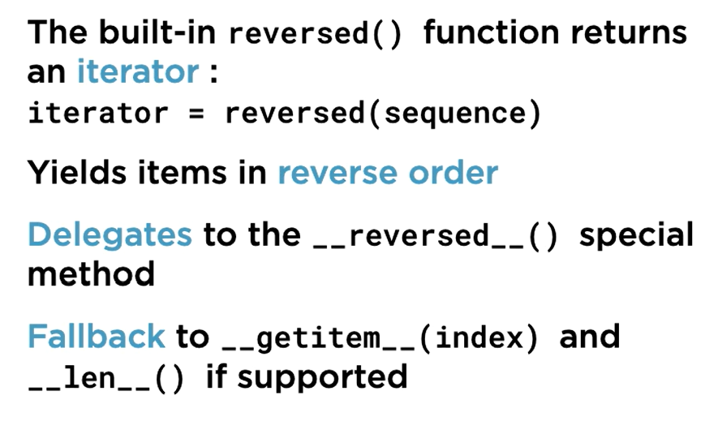

### The index() method

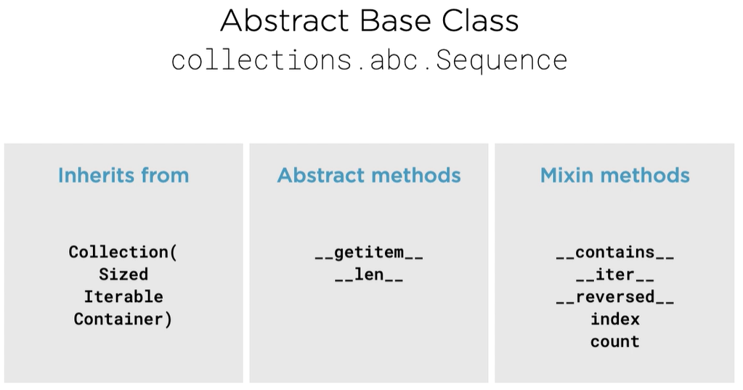  
Just inherit from Sequence class and make sure you have implemented __getitem__ and __len__.

### The count() method

Just inherit from Sequence class and make sure you have implemented __getitem__ and __len__.

### Extended Sequence Protocol

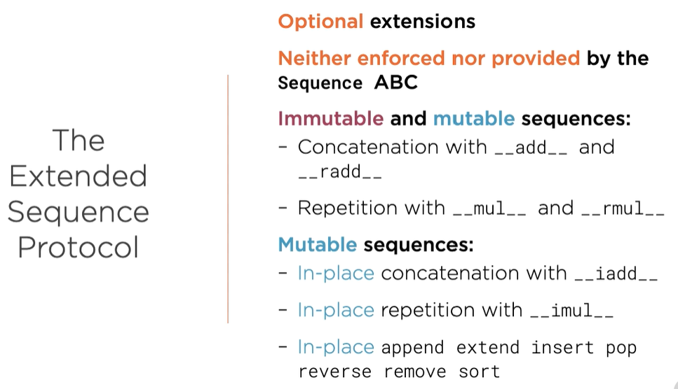

## Refactoring to improve performance

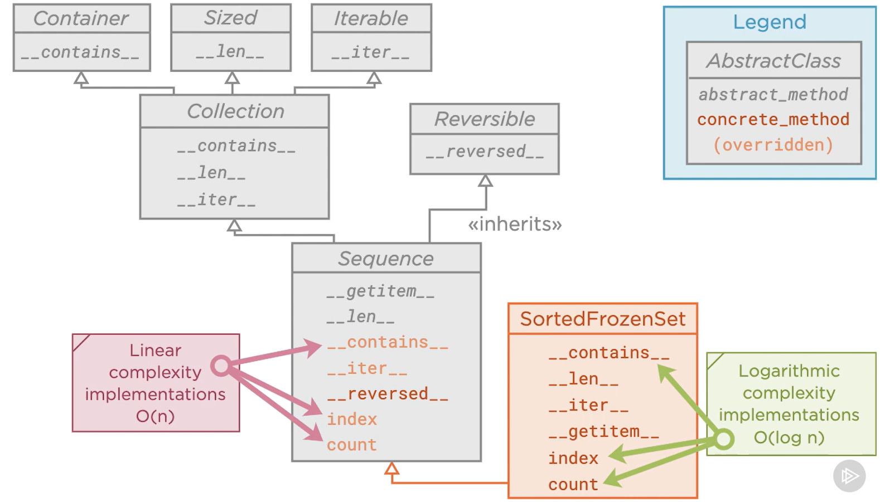

Even though our data structure is sorted, the methods __contains__, index and count are not using the sorted property to their advantages. They work in O(n) but we can improve them to work in O(Log n).

## The Set Protocol

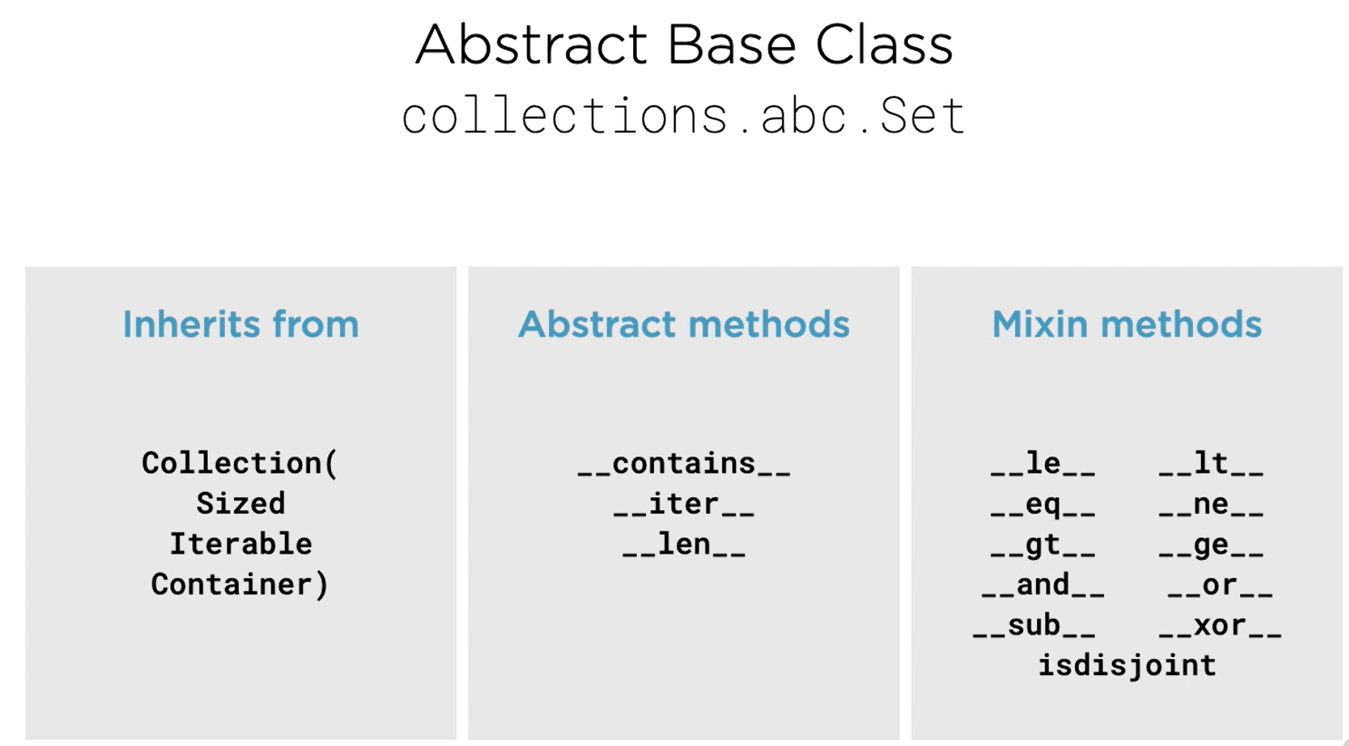

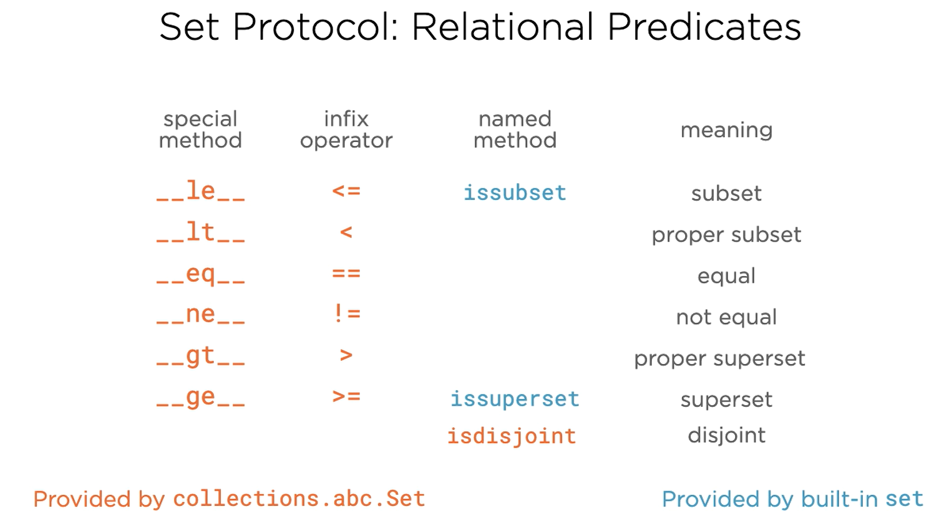

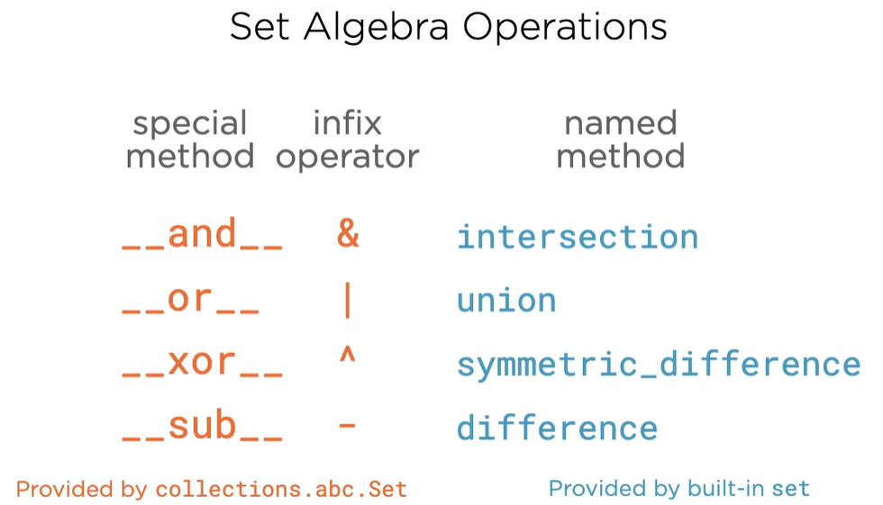

### Going further Mutability

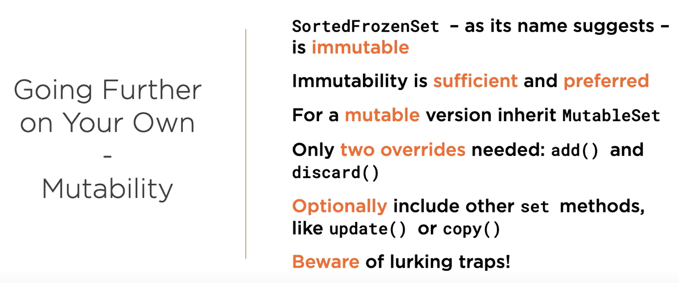

# Core Python 3.8: Robust Resource & Error Handling

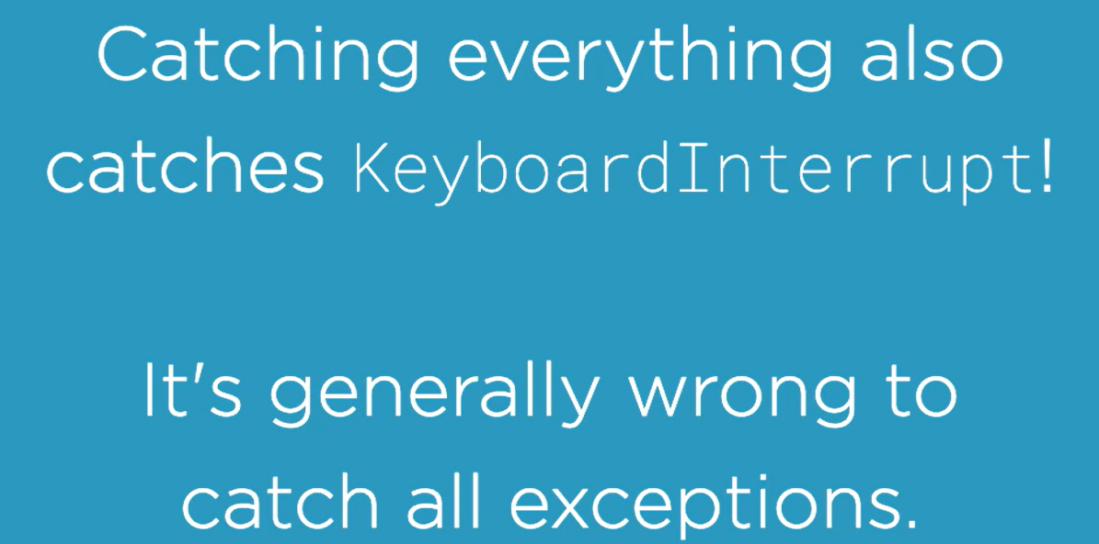

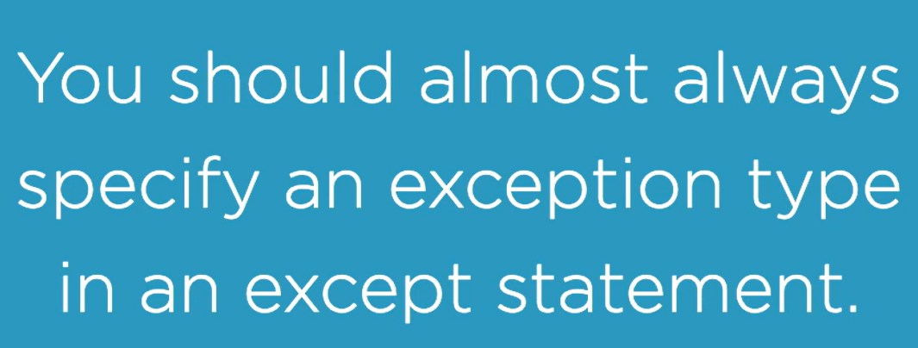

## Exception Hierarchy

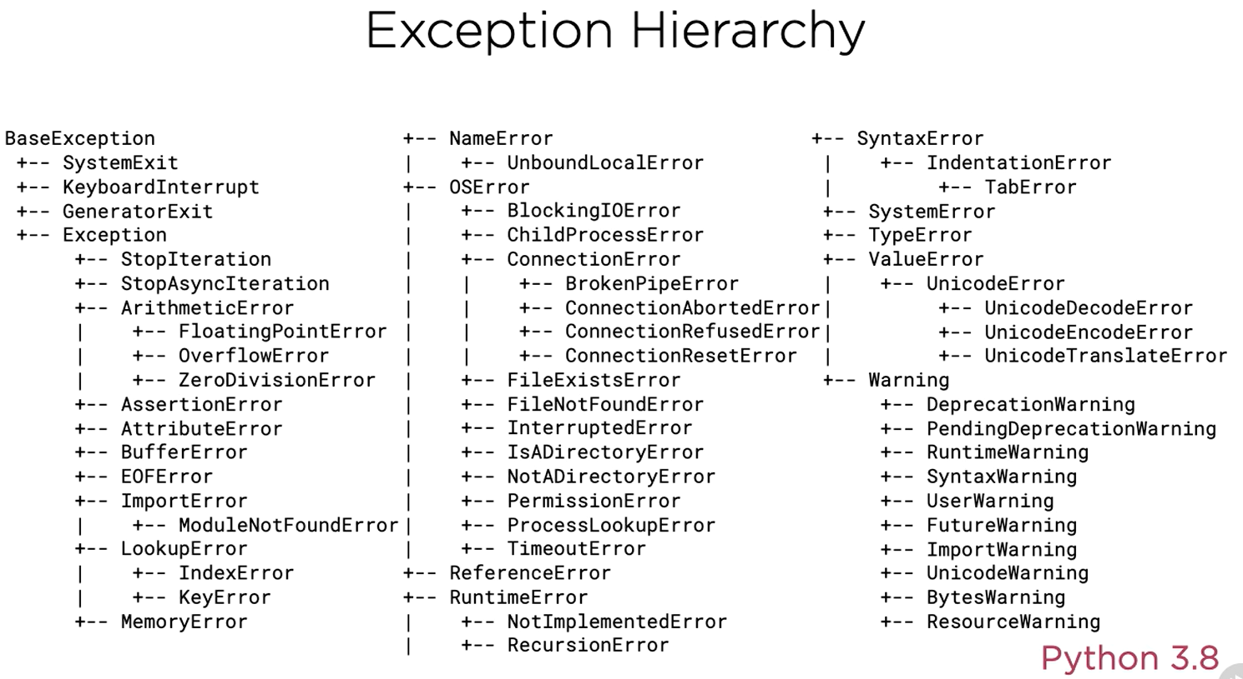



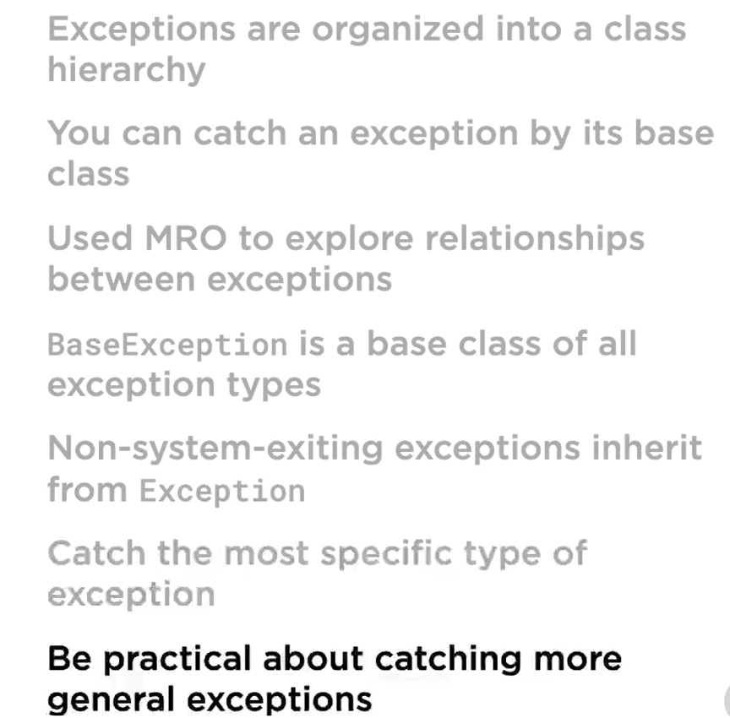

## Exception Payloads

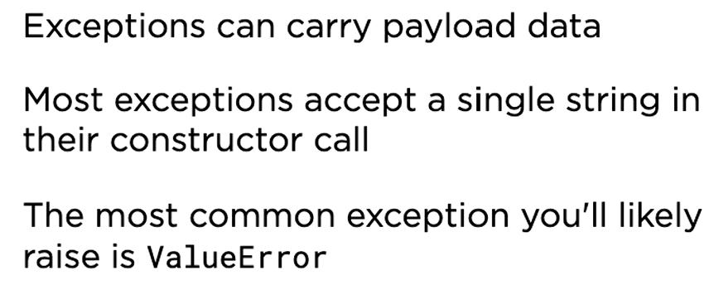

Raise exception:

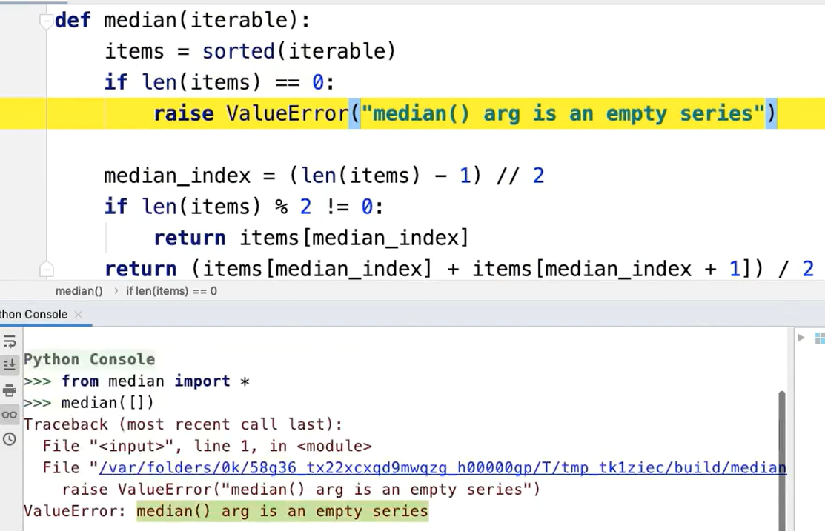

Get details from exception:

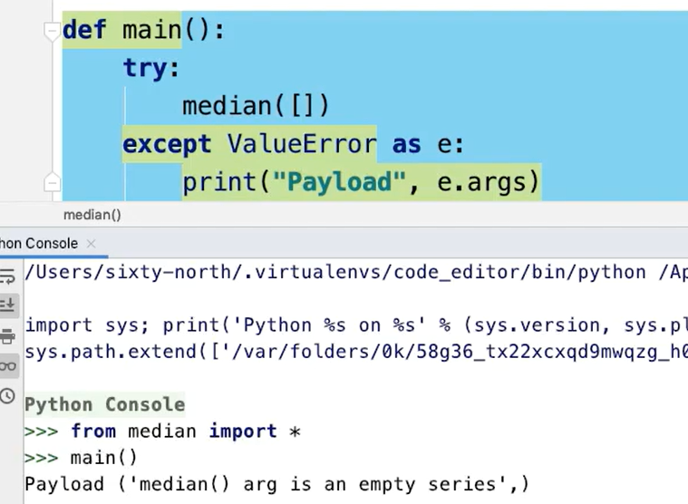

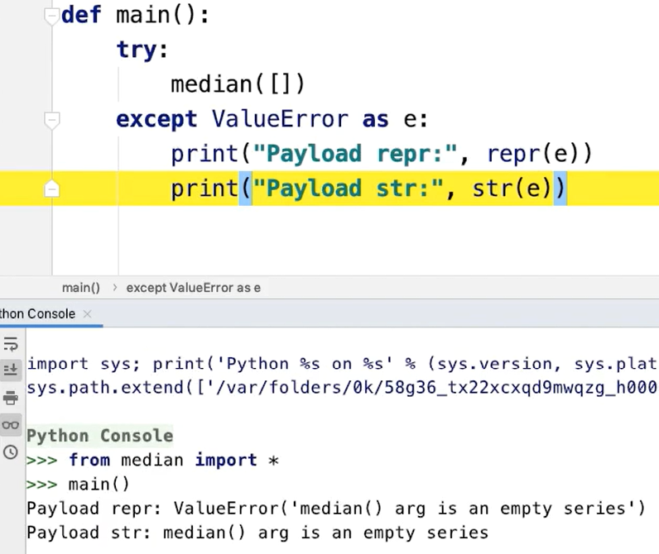

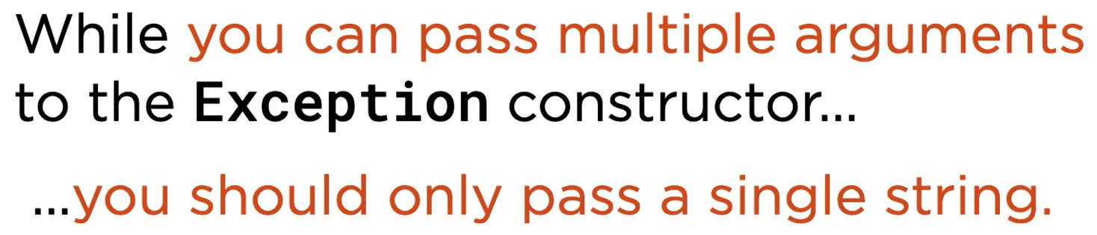

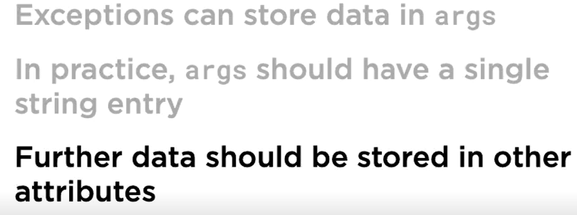

## User-defined Exceptions

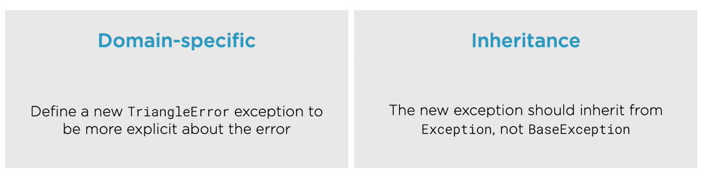

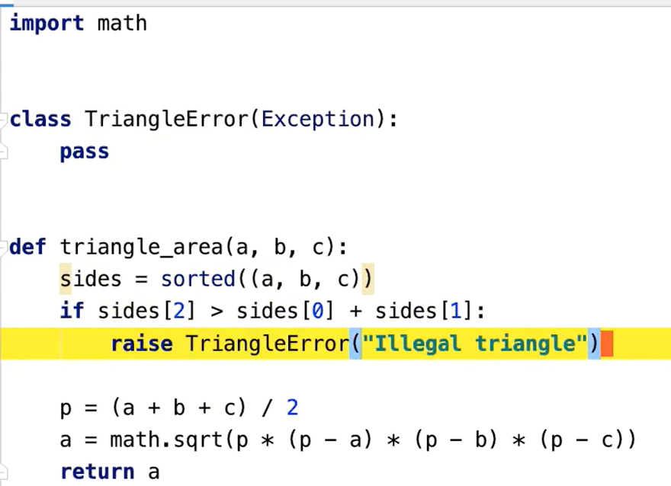

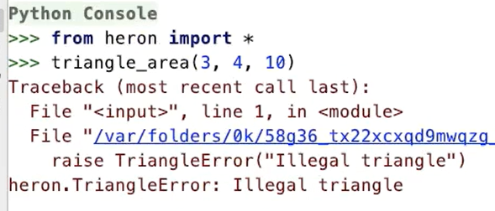

Refer exception/exception_handling.py

## Exception Chaining

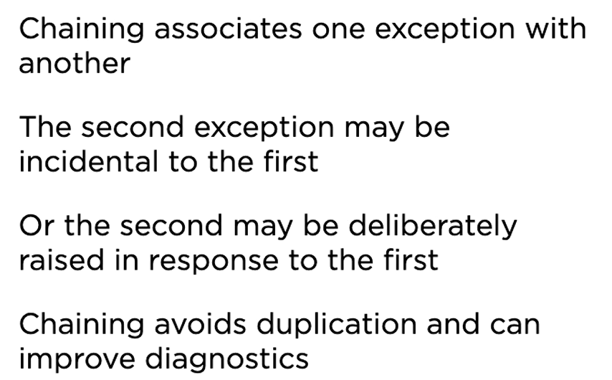

### Implicit Chaining

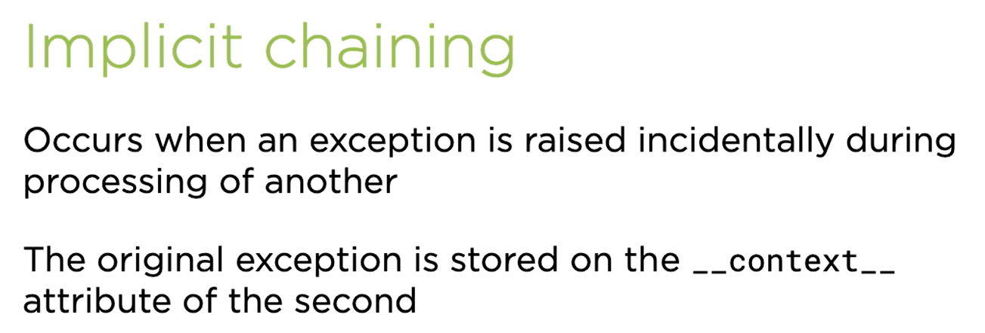

Refer exception/exception_chaining_implicit.py

### Explicit Chaining

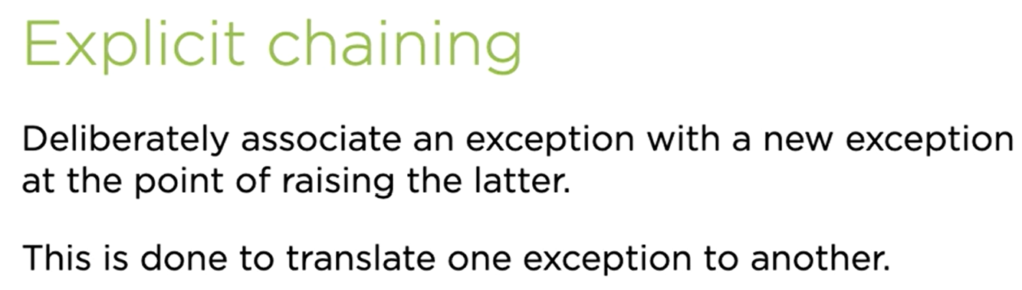

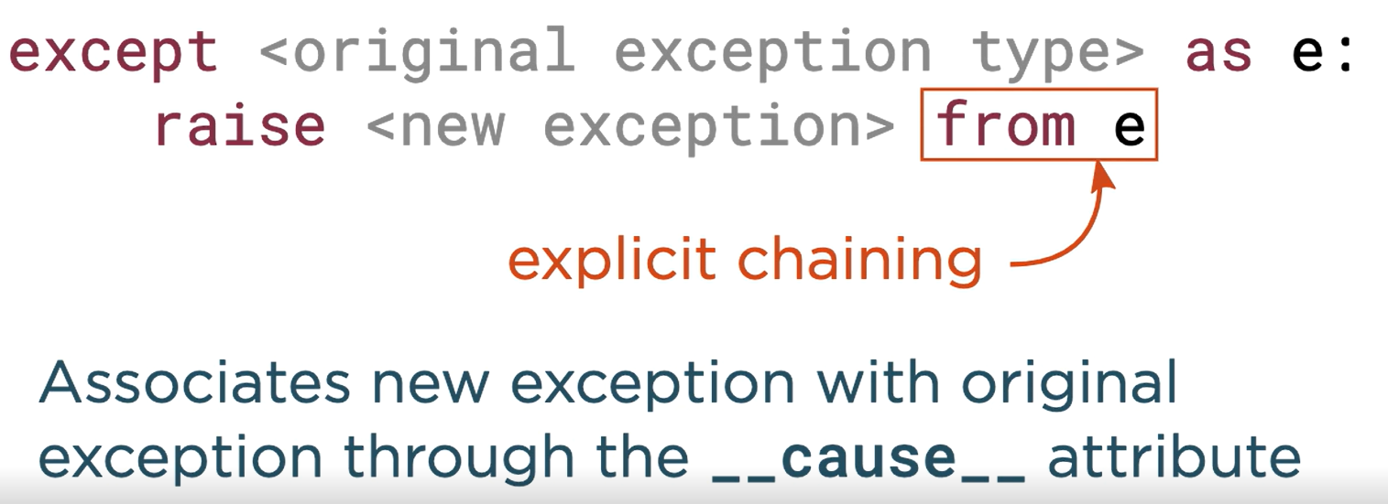

Refer exception/exception_chaining_explicit.py

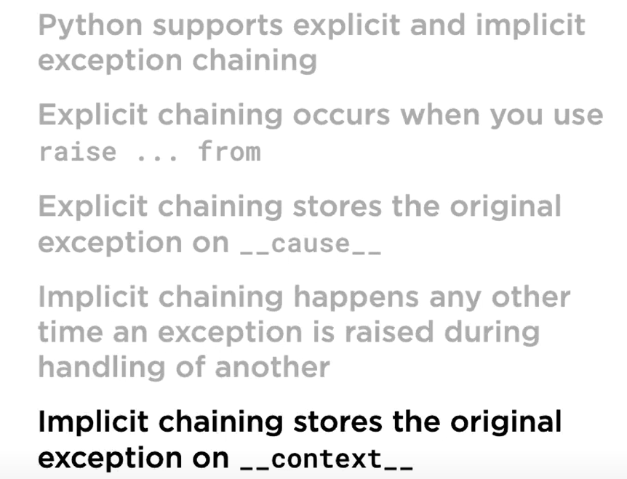

## Tracebacks

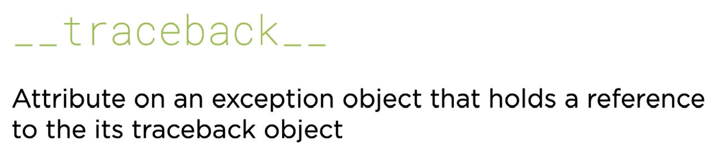

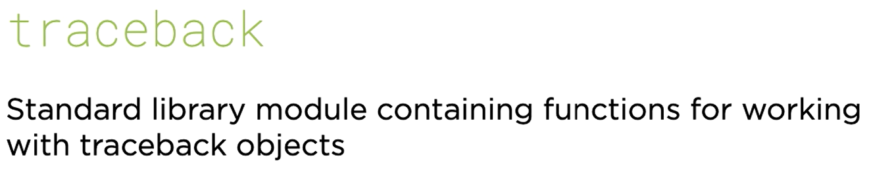

Refer exception/exception_traceback.py

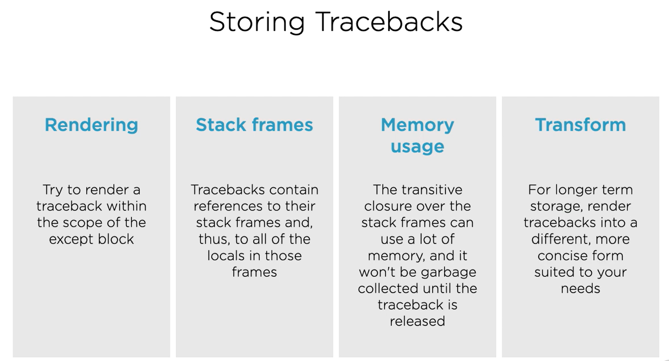

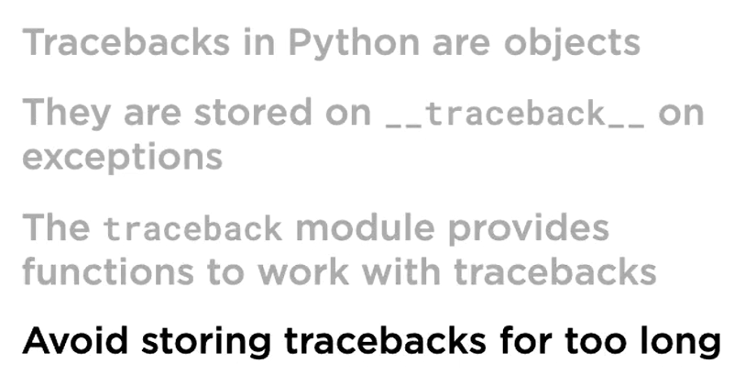

## Assertions

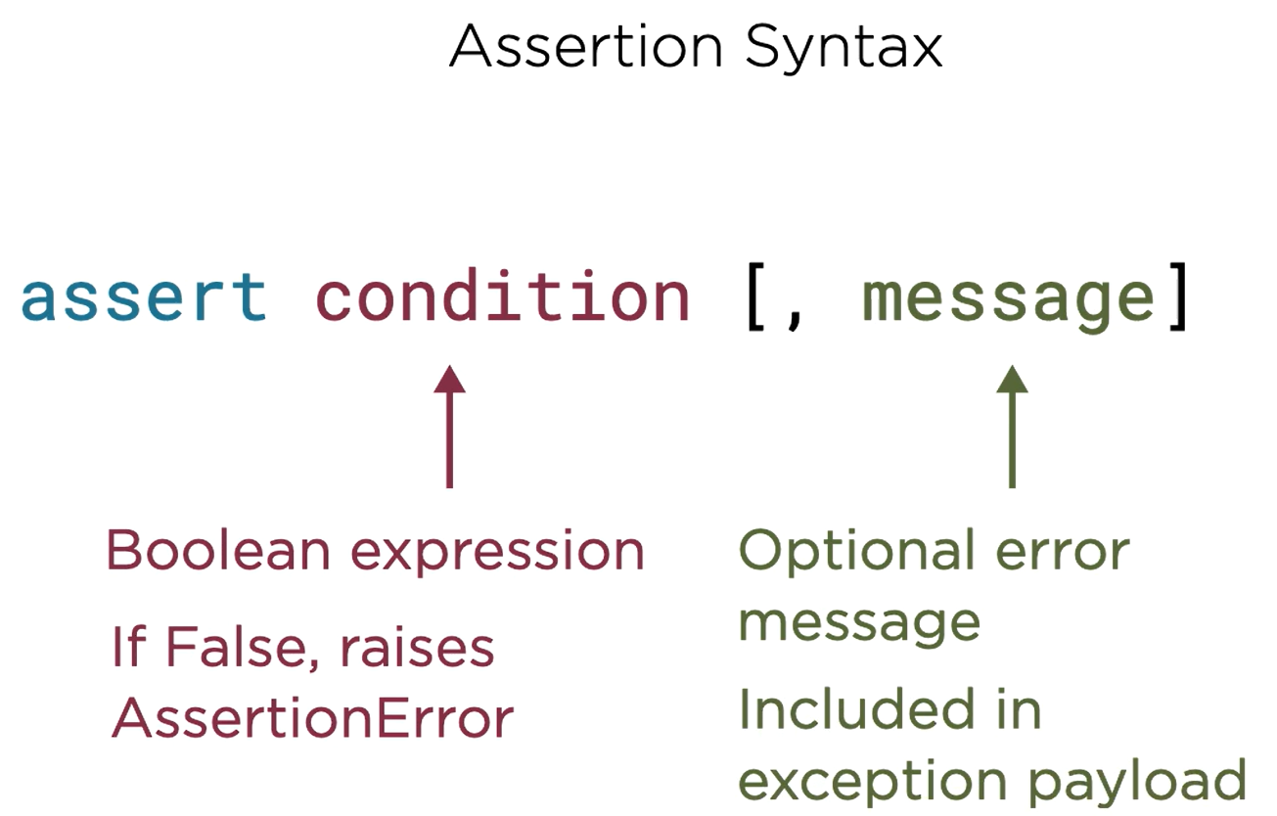

### Assertion and Invariants

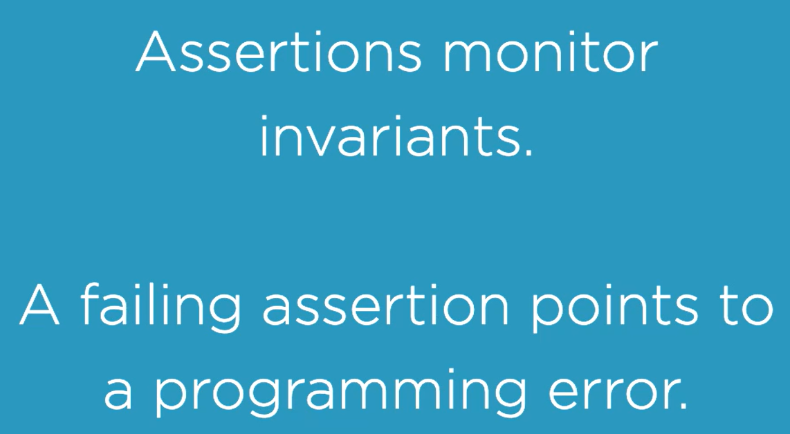

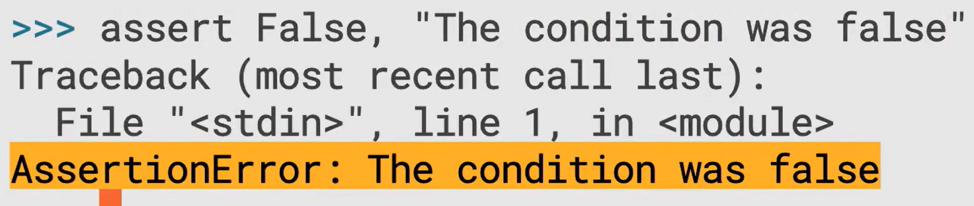

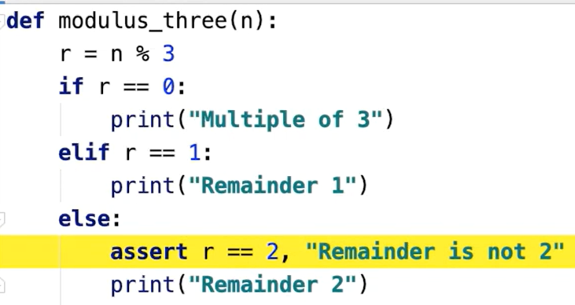

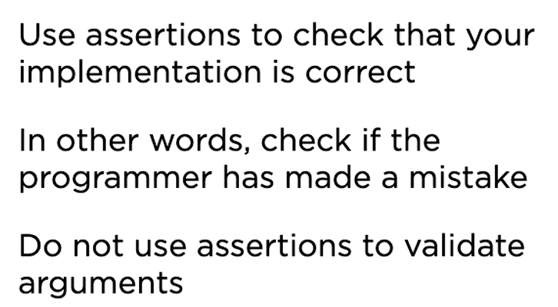

### Class Invariants

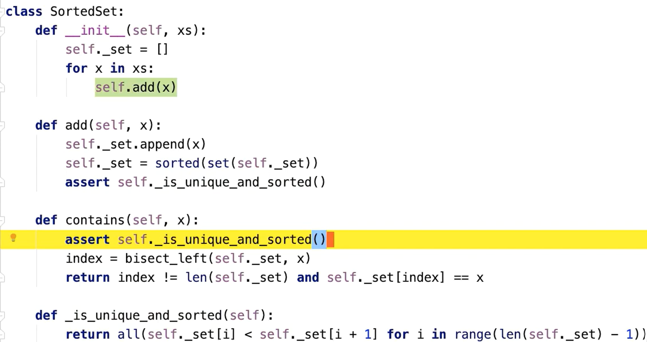

### Assertion and Performance

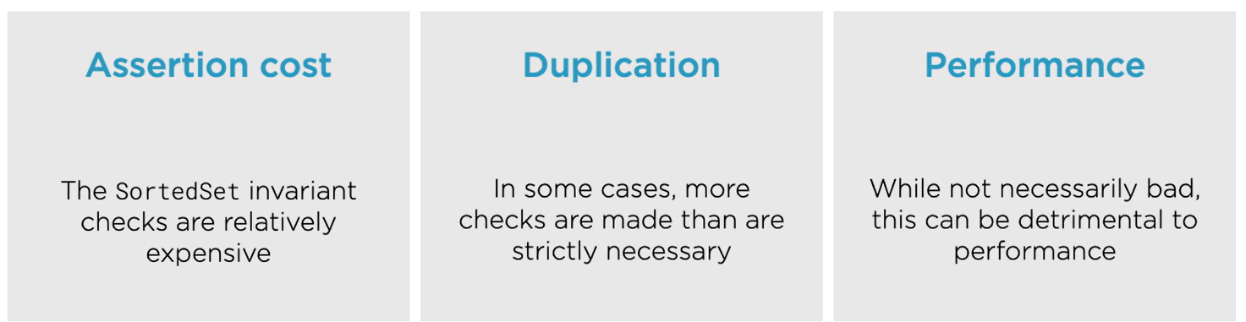

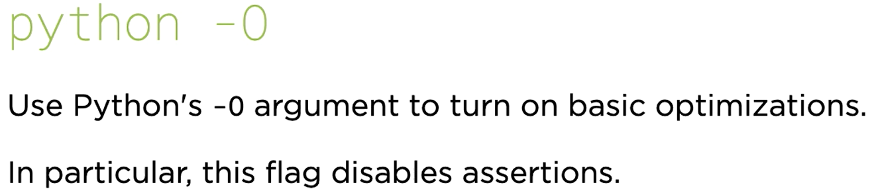

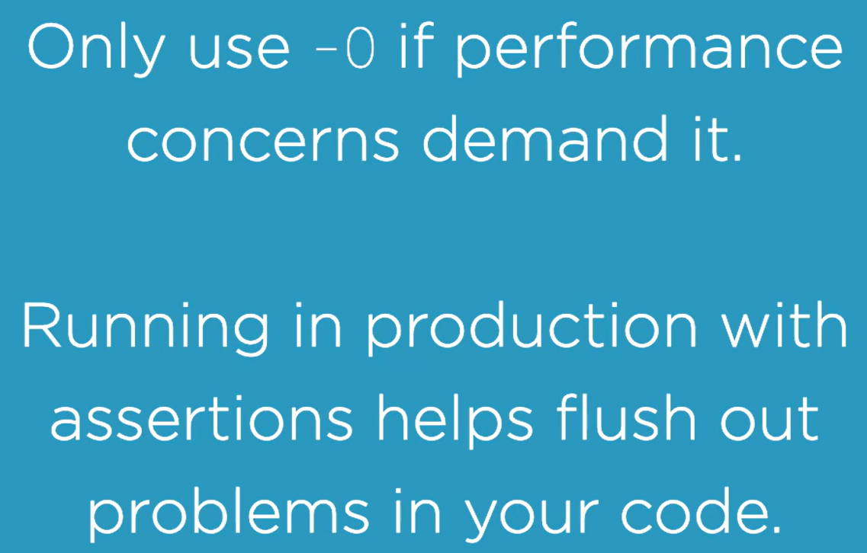

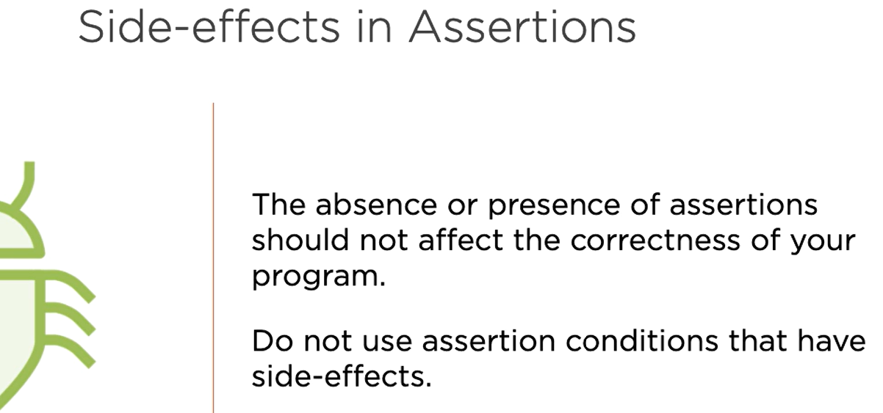

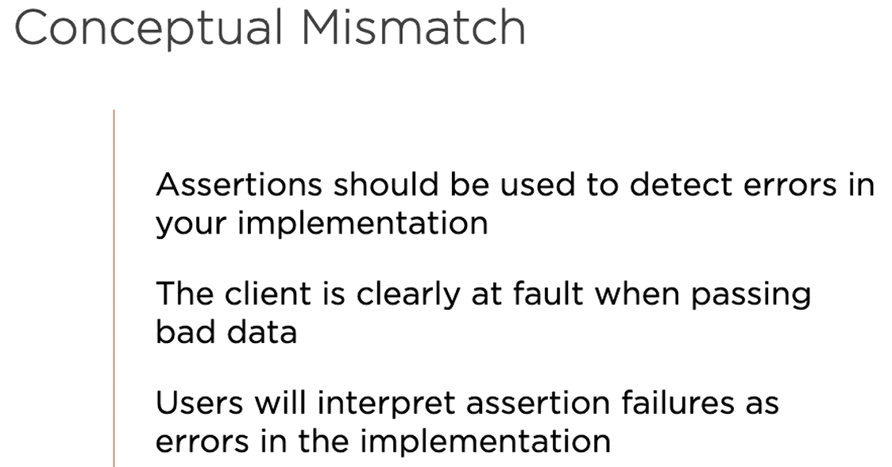

Do not use assertions to check/validate arguments of a function.

## Context Managers

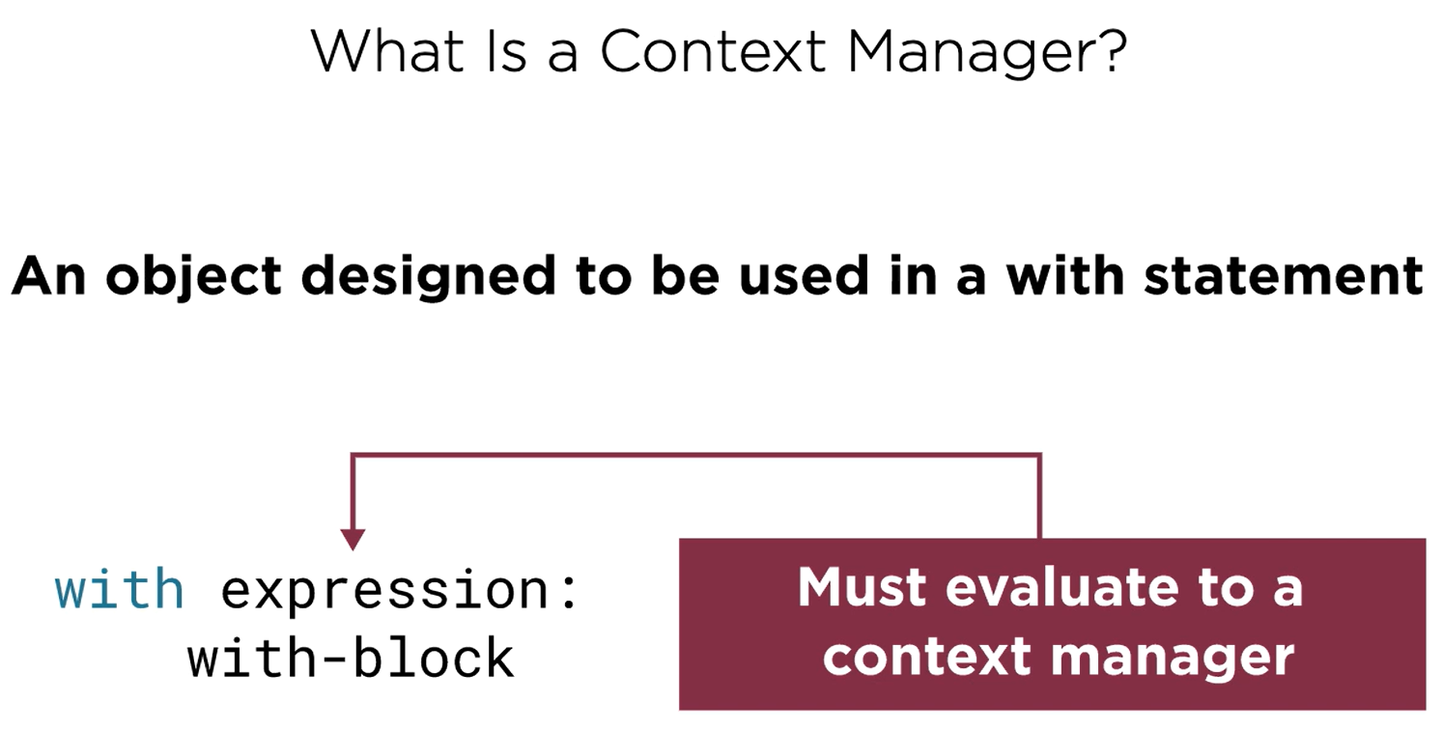

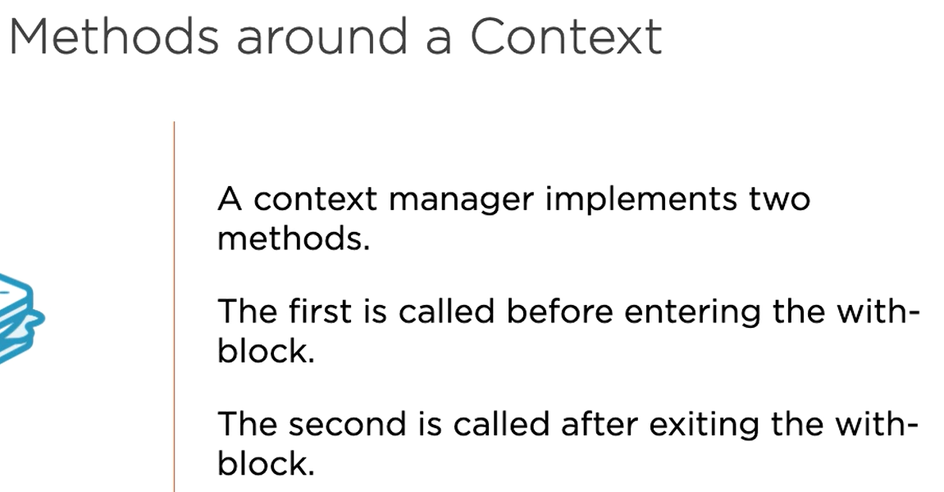

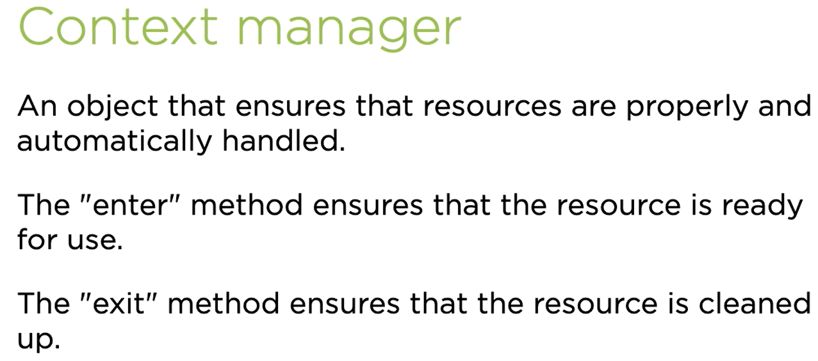

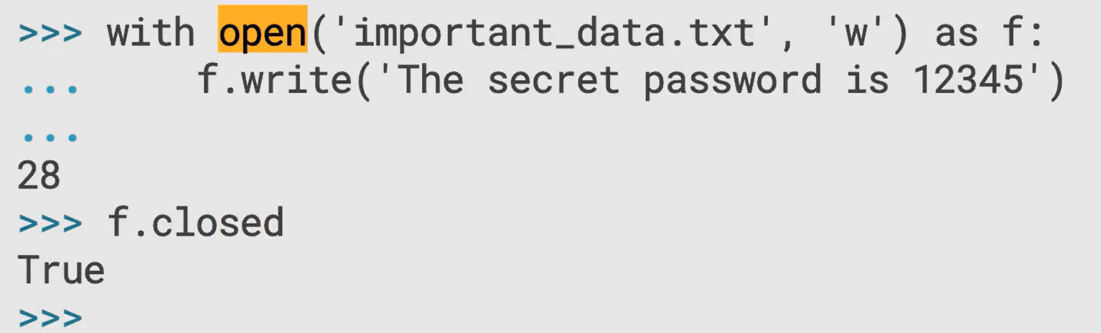

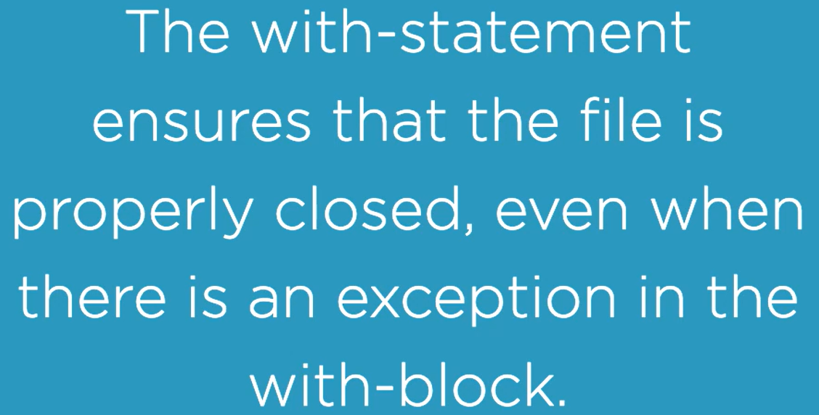

### Context Manager Protocol

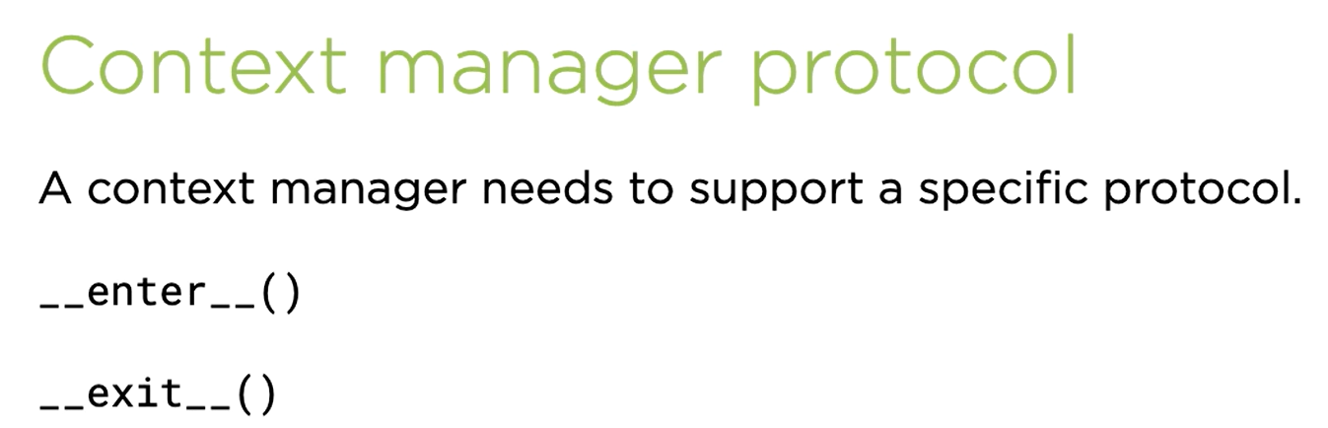

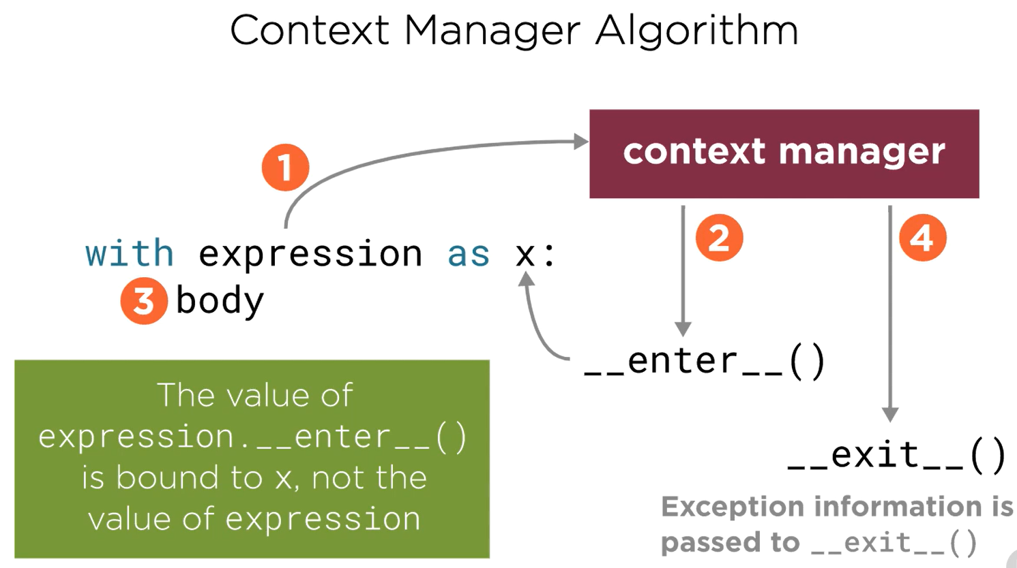

Refer context_manager/context_manager.py

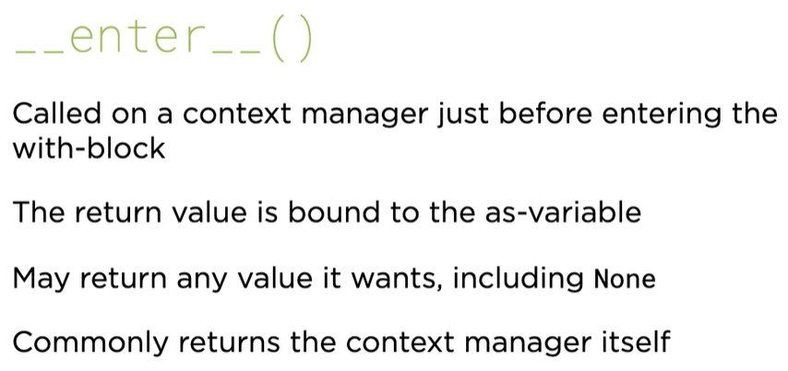

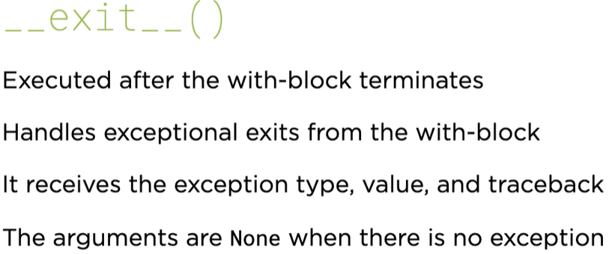

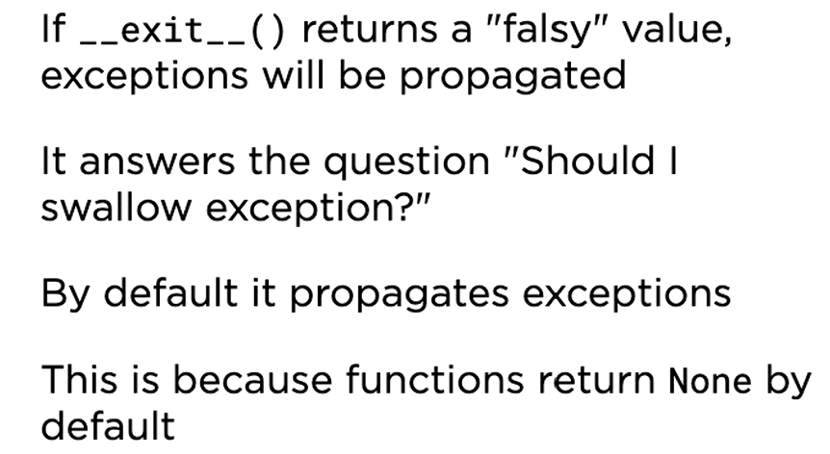

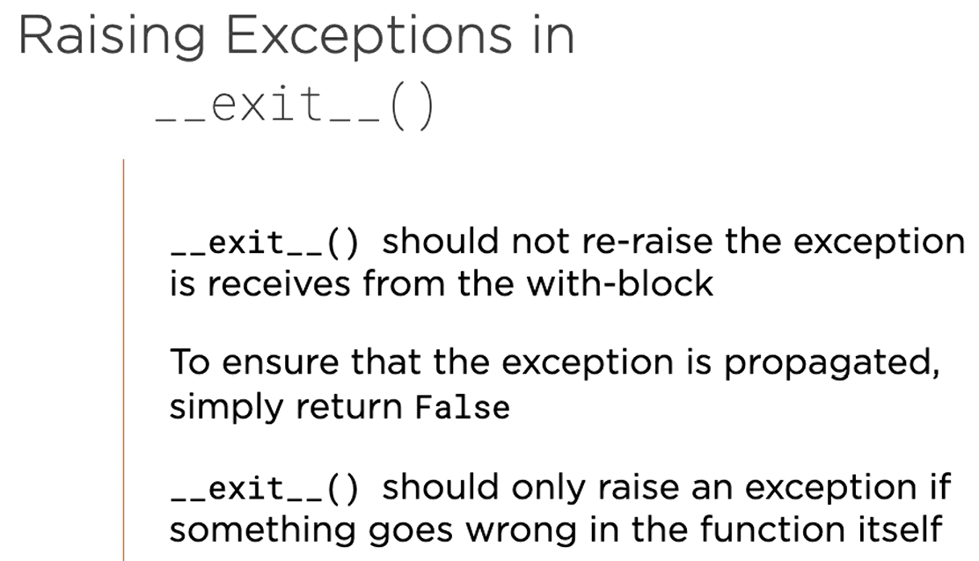

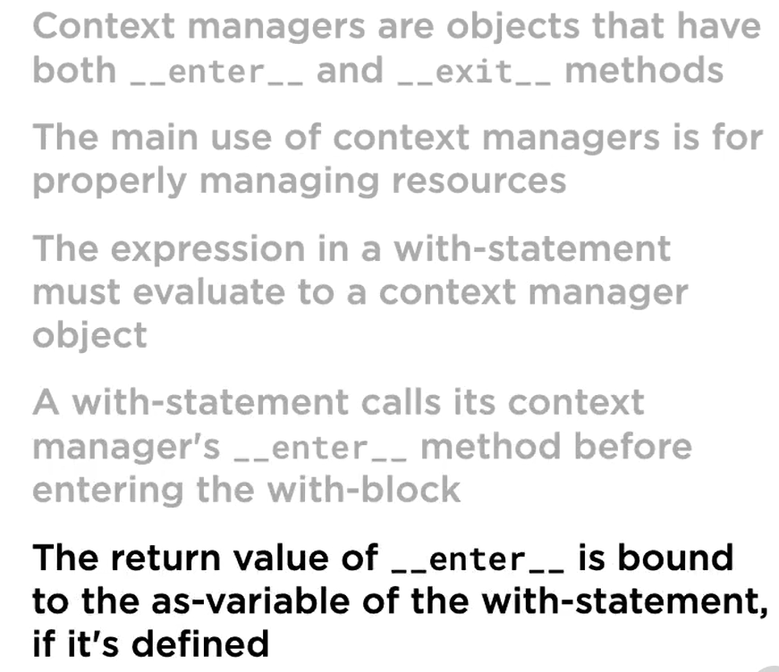

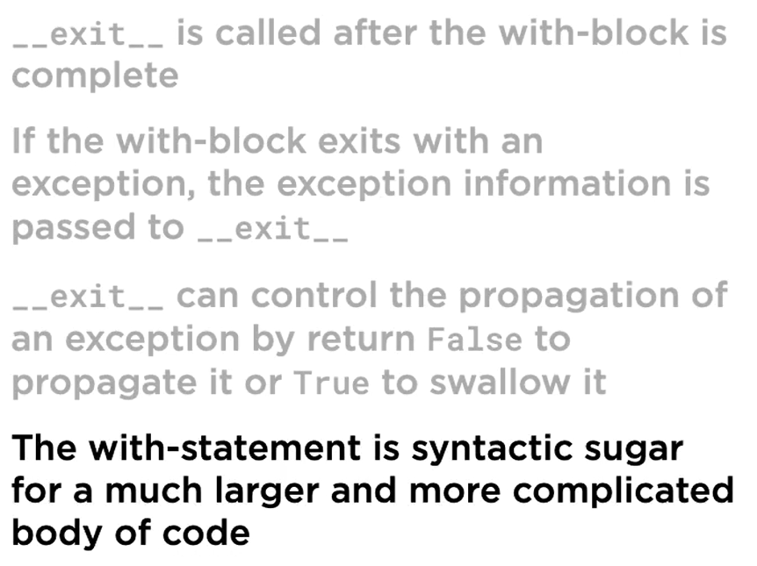

## Context Manger Decorator

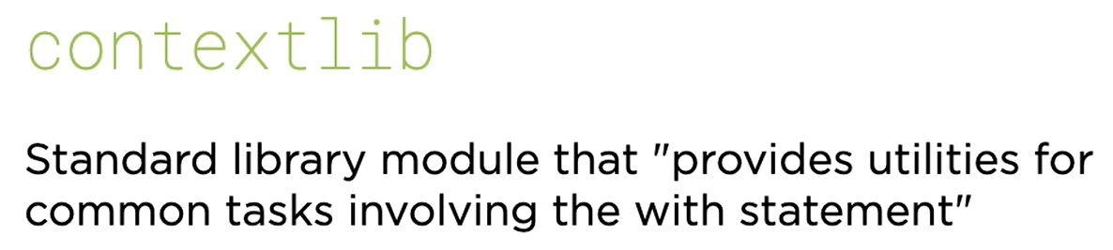

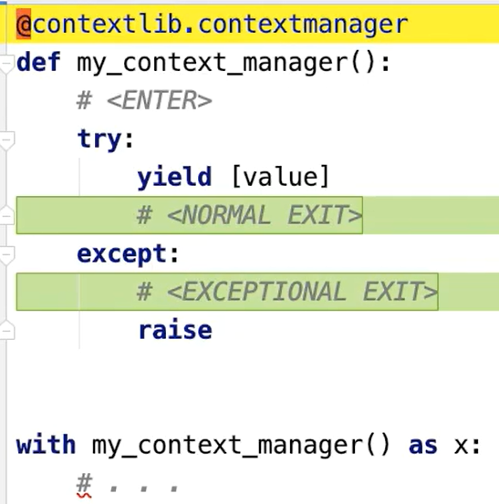

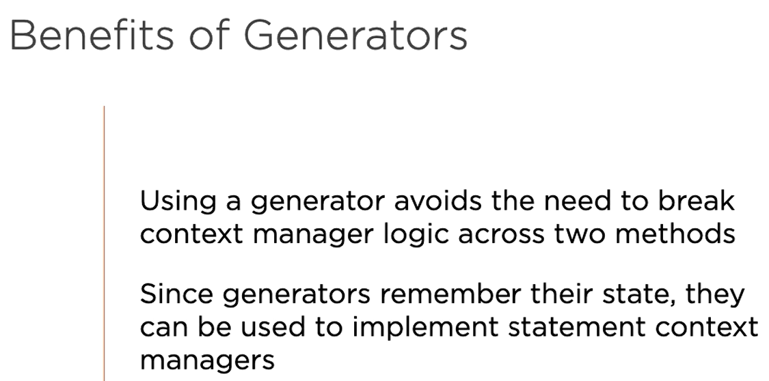

Refer context_manager/context_manager_decorator.py

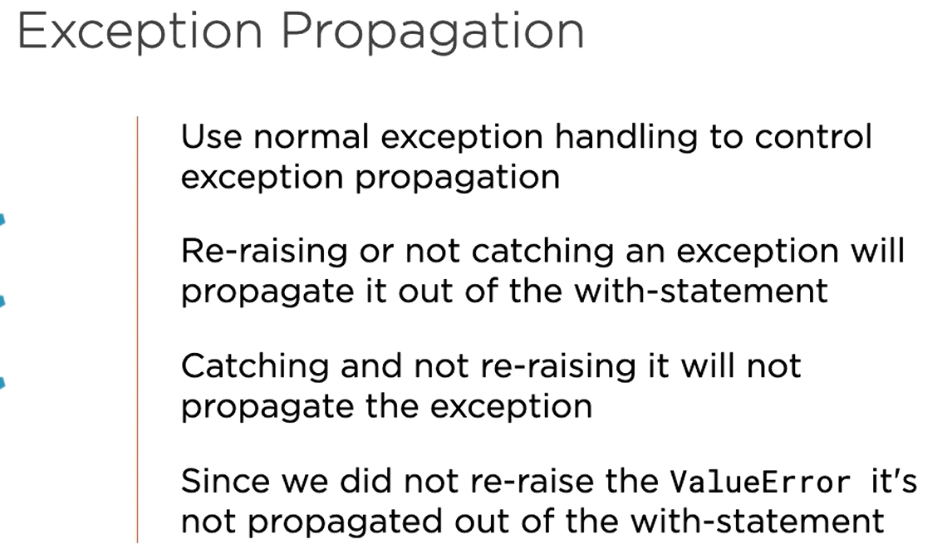

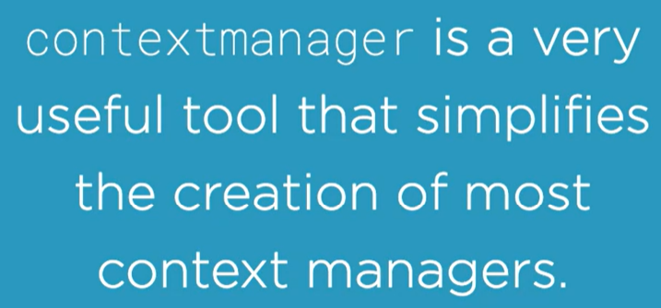

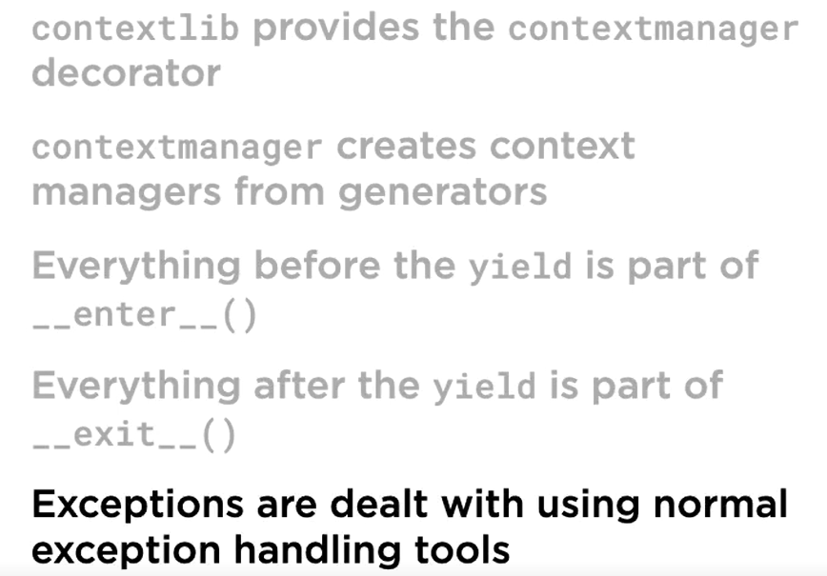

## Multiple Context Managers in a With-Statement

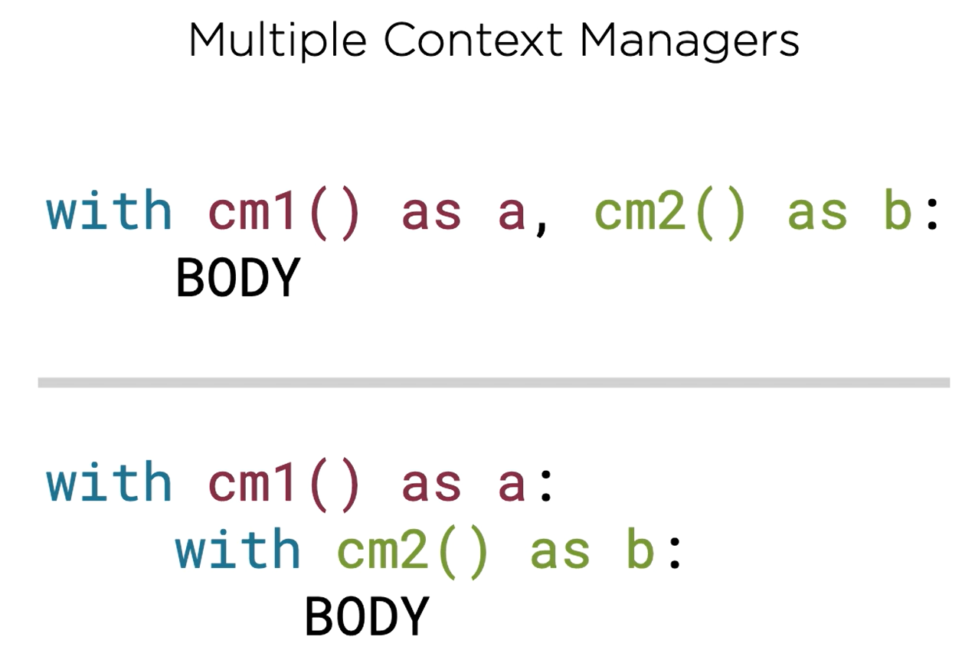

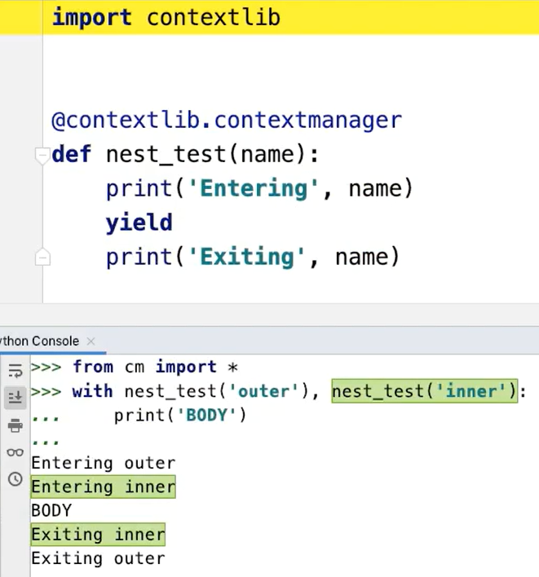

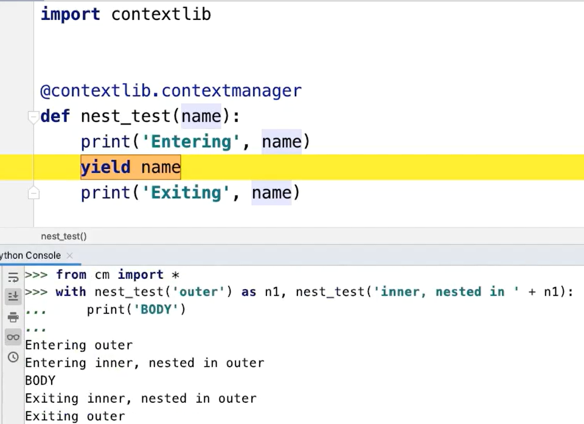

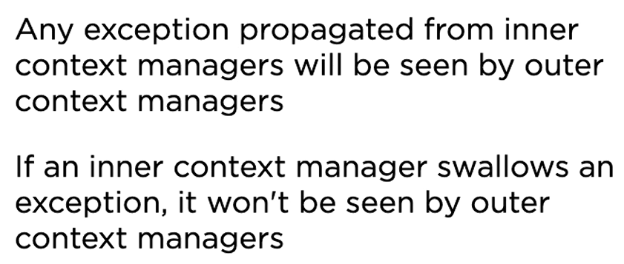

Refer context_manager/context_manager_multiple.py

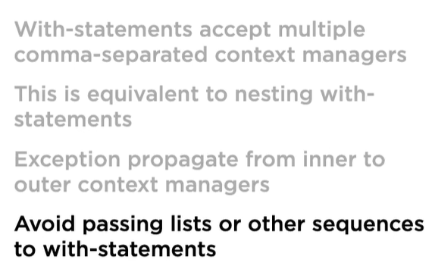

Refer context_manager/db_transaction_modeling.py

# Core Python 3.6: Introspection

## Introspecting Types

* type()
* issubclass()

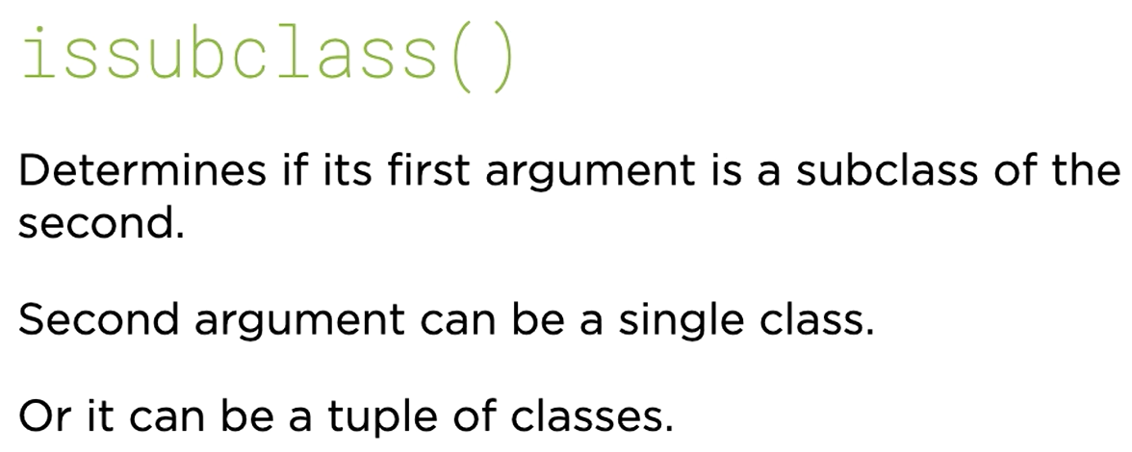

* isinstance()

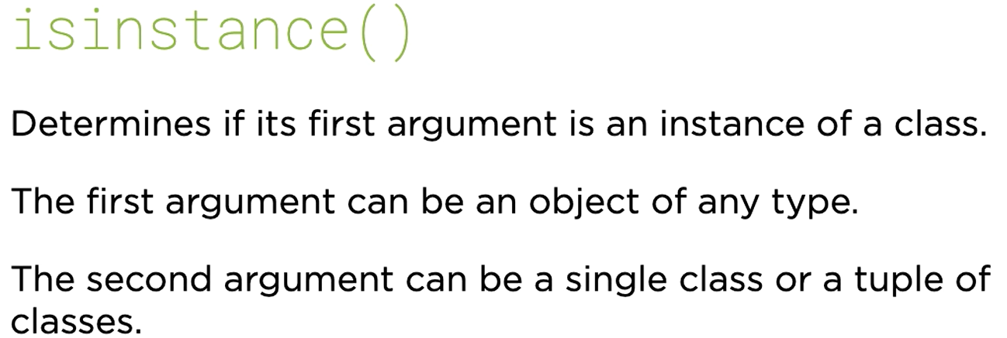

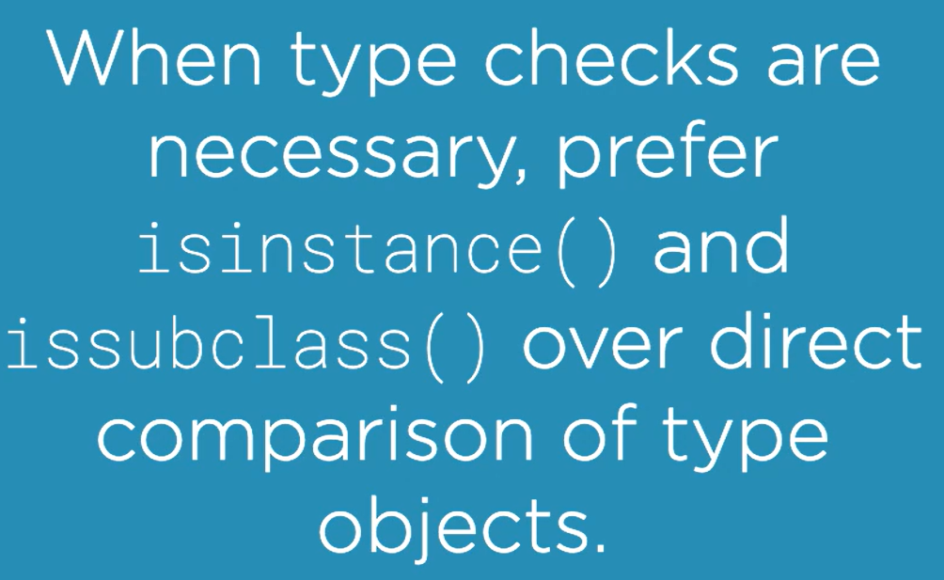

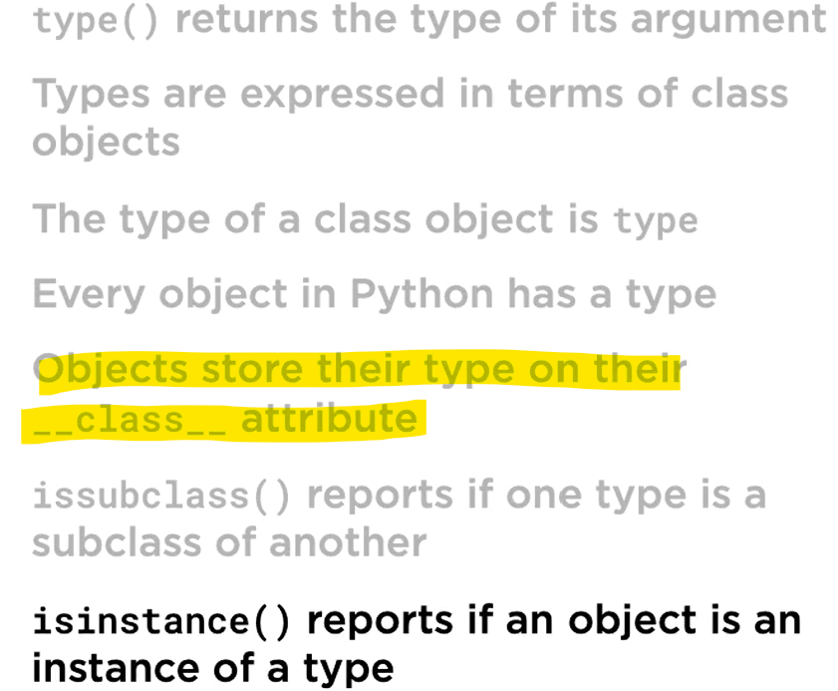

## Introspecting Objects

* dir()

returns a list of attributes names for an instance (including methods)

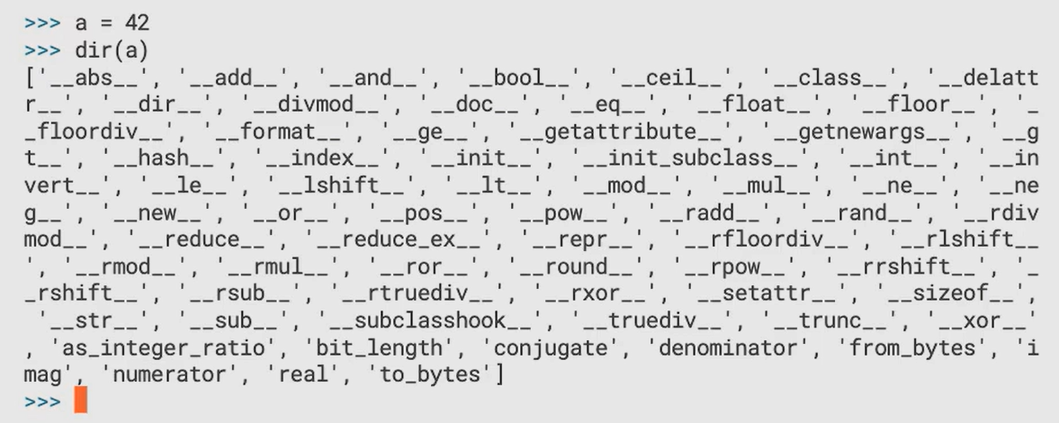

* getattr()
* hasattr()
* callable()

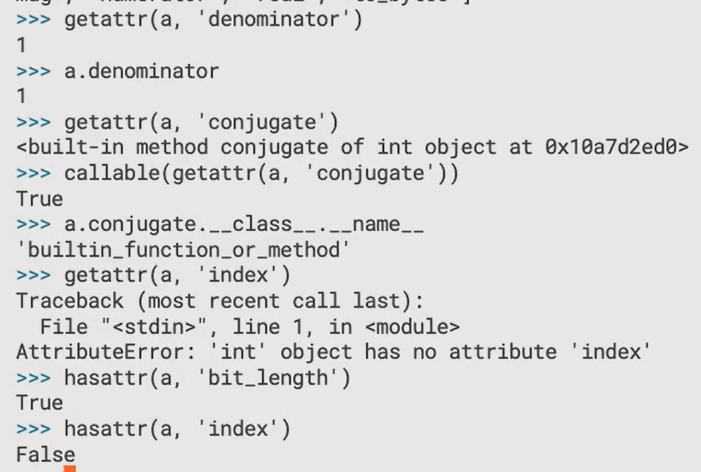

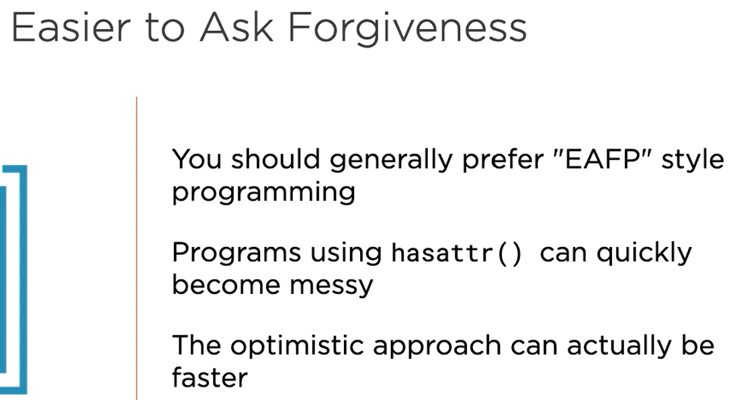

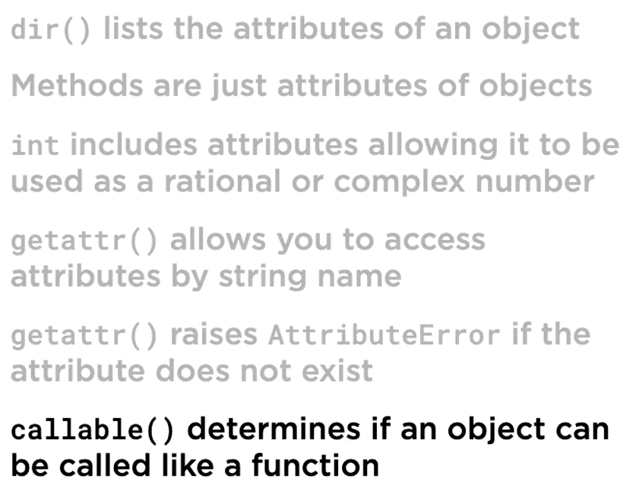

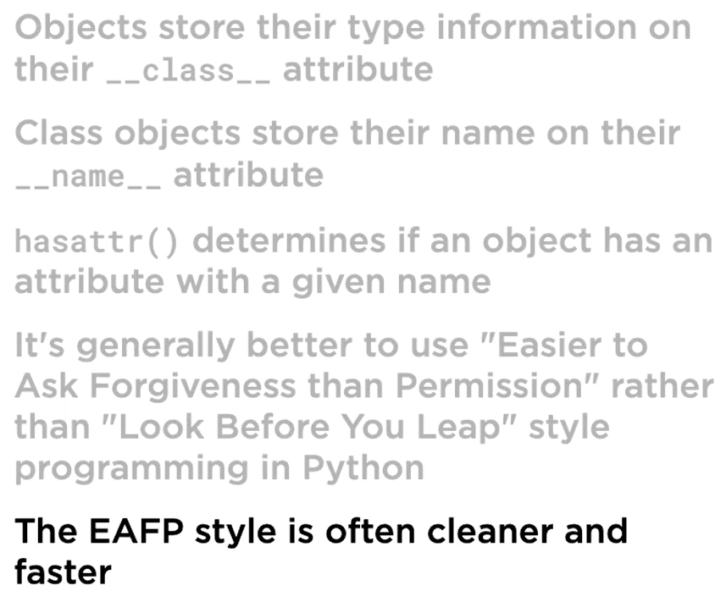

## Introspecting Scopes

* globals()

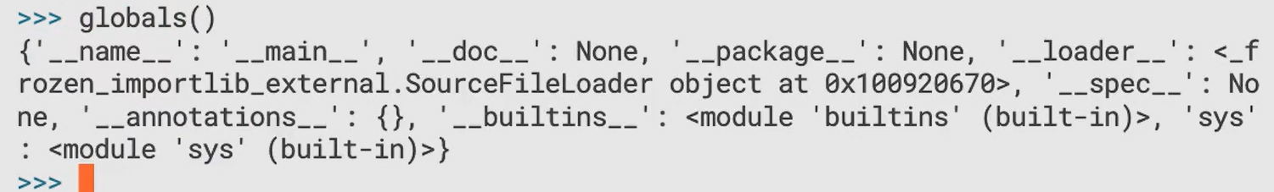

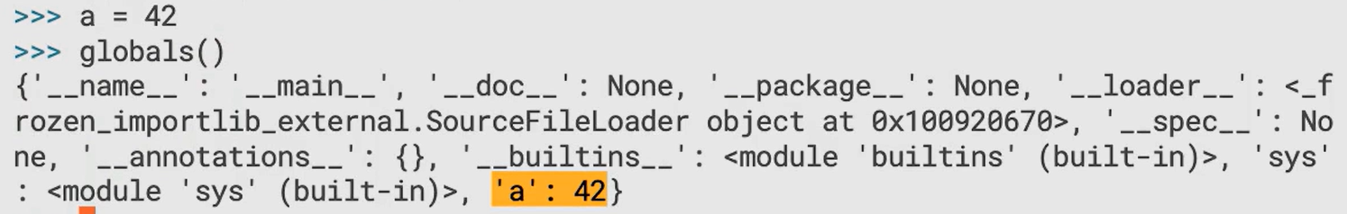

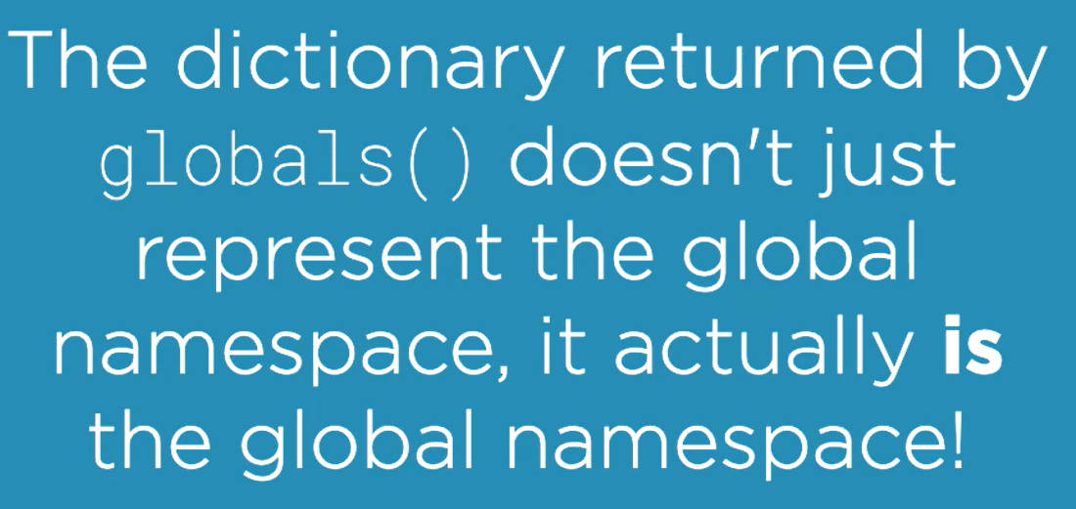

* locals()

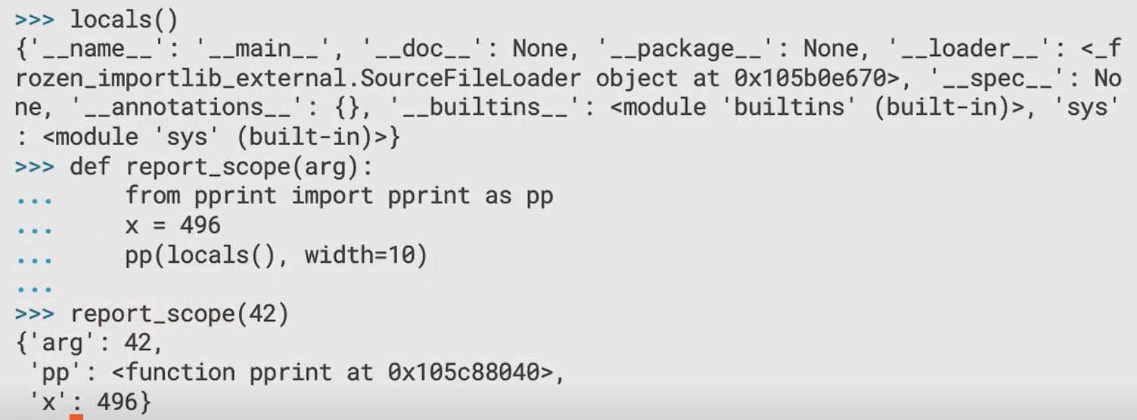

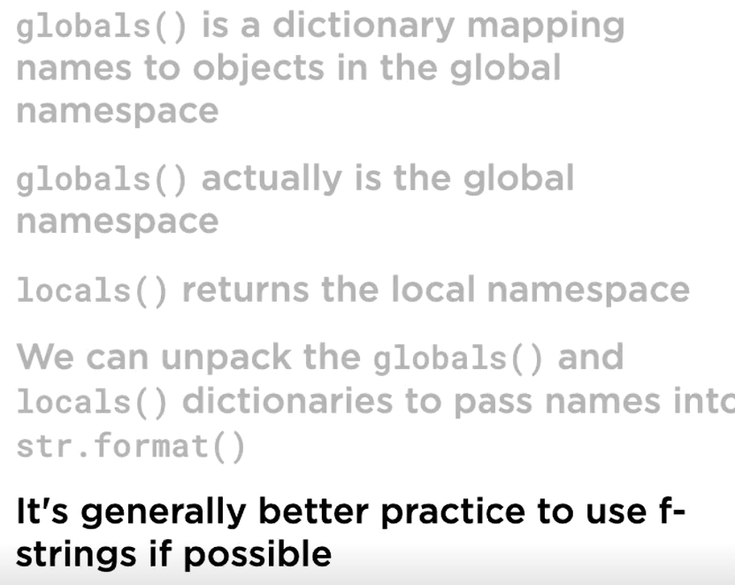

## Inspect Module

* inspect.ismodule()

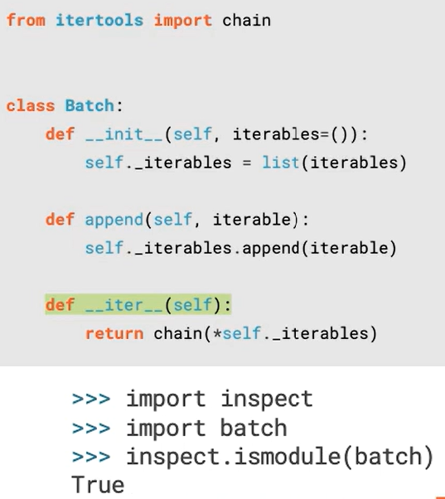

* inspect.getmembers()



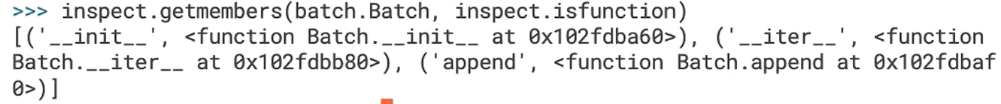

* inspect.signature()

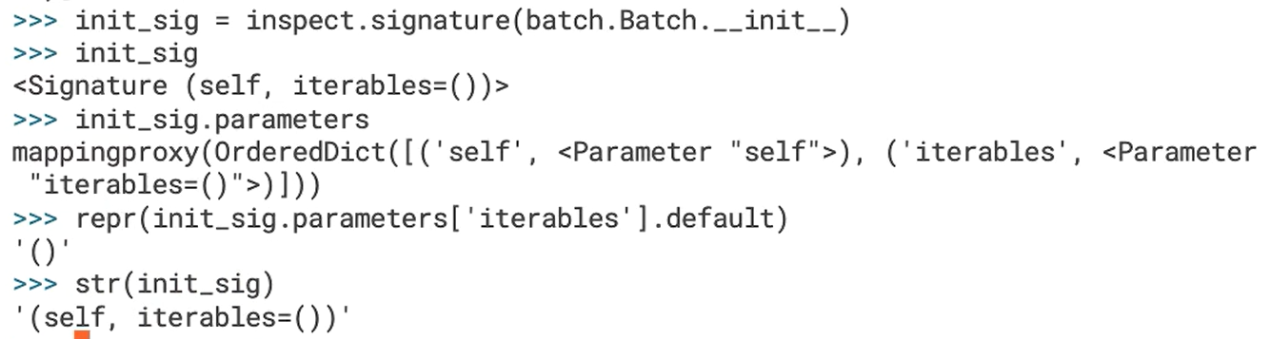

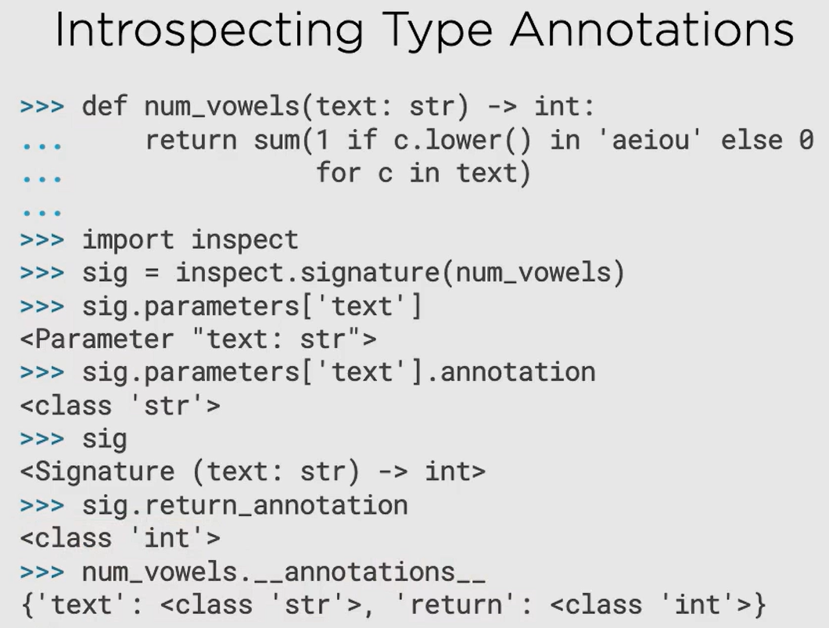

Refer program object_inspection_tool.py

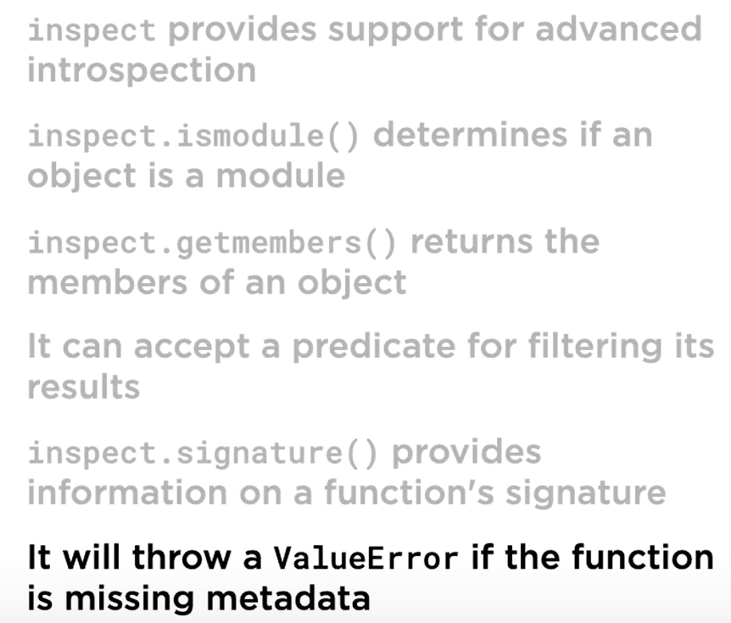

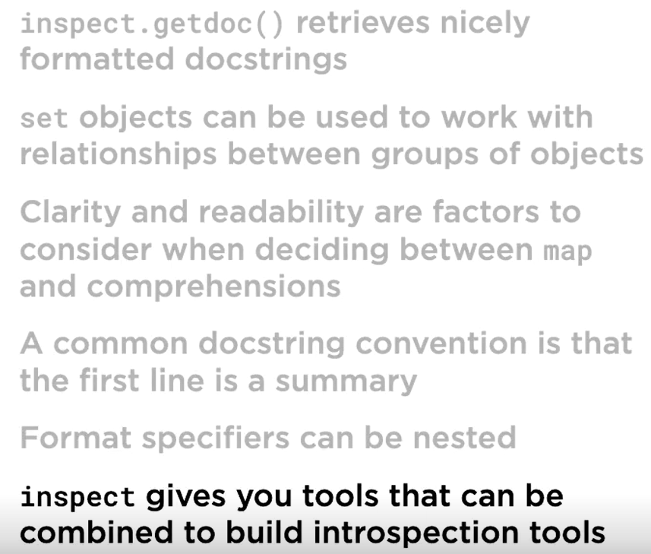

# Core Python 3.6: Numeric Types, Dates, and Times

## Review of int and float

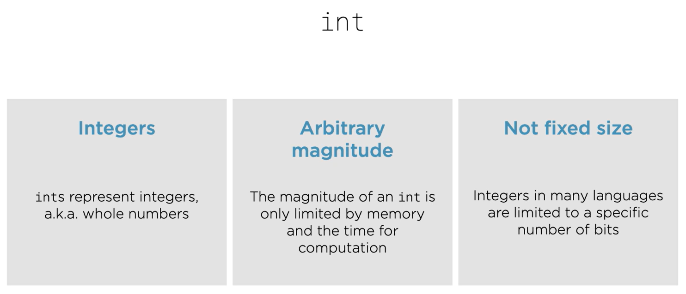

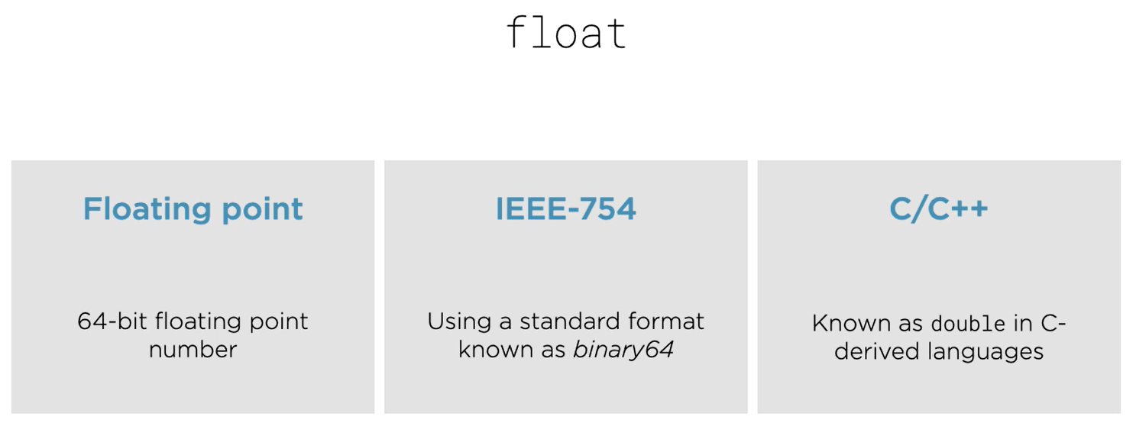

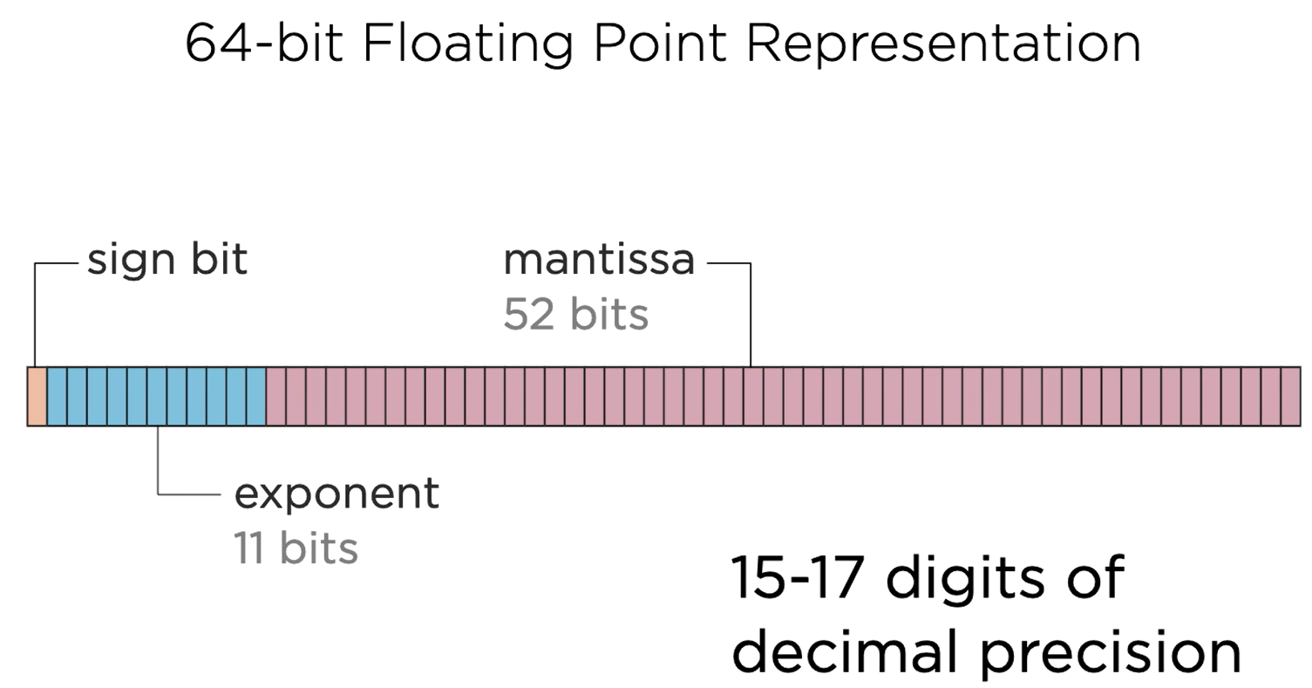

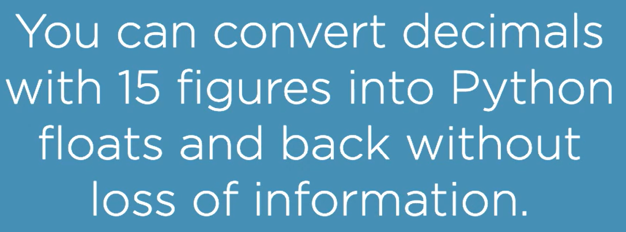

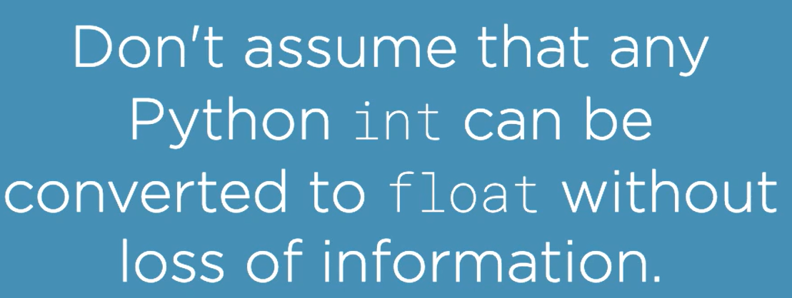

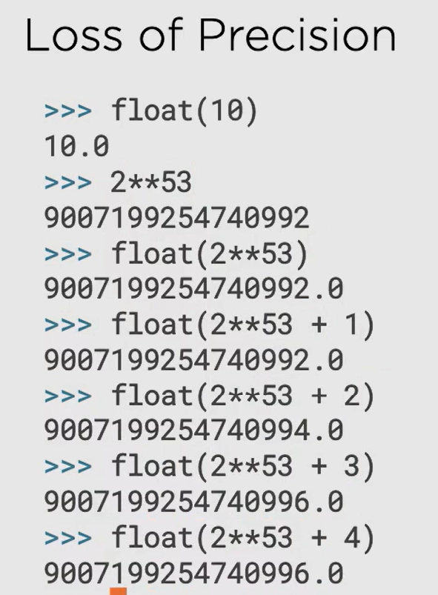



Problem with float, the precision:

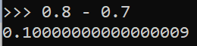

**Avoid using float as much as possible, use decimal.Decimal() instead.**

## Decimal Module

When float is not sufficient, use decimal module. In fact use decimal whenever you have to deal with decimal values. For example 0.8 and 0.7 can’t be represented properly using float:



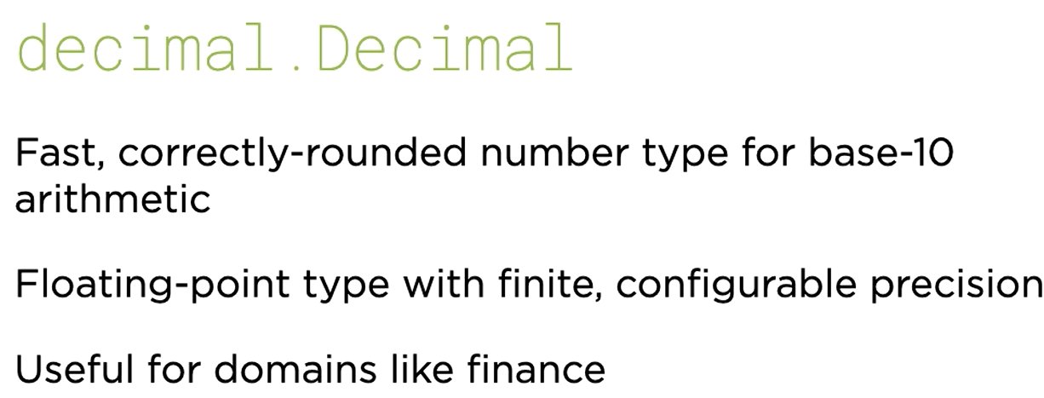

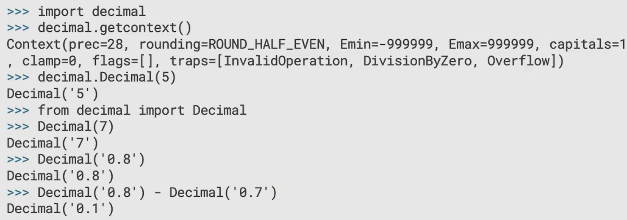

### Fractional Values

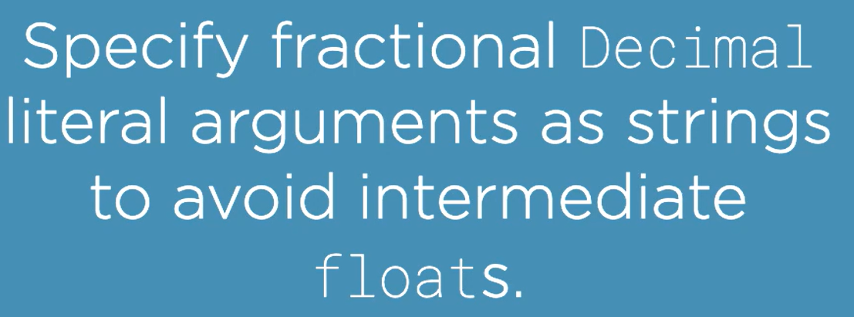

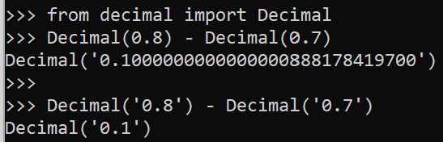

To prevent accidentally using float values in Decimal(), use:

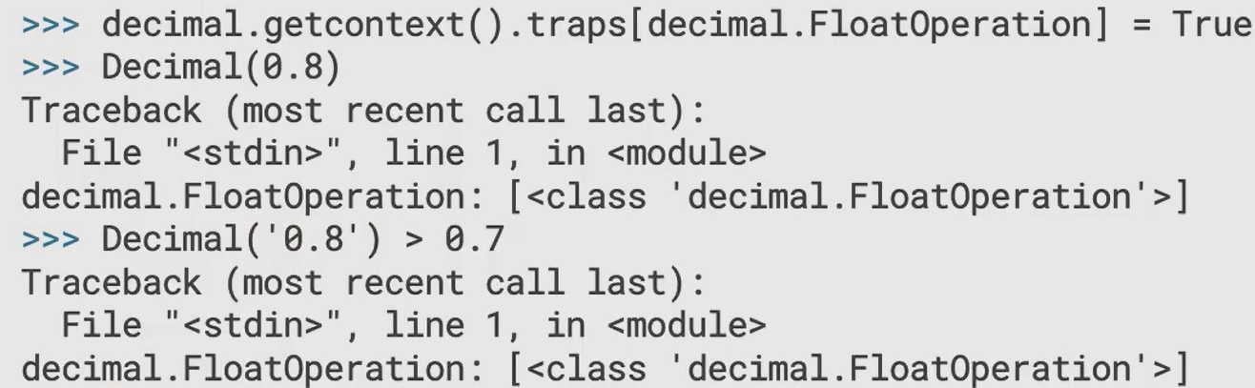

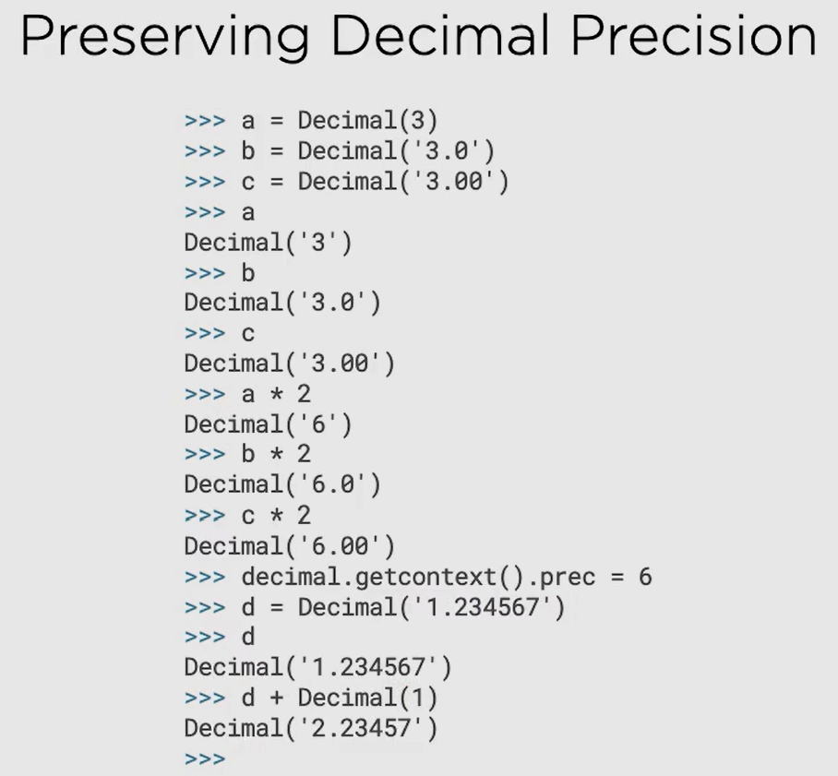

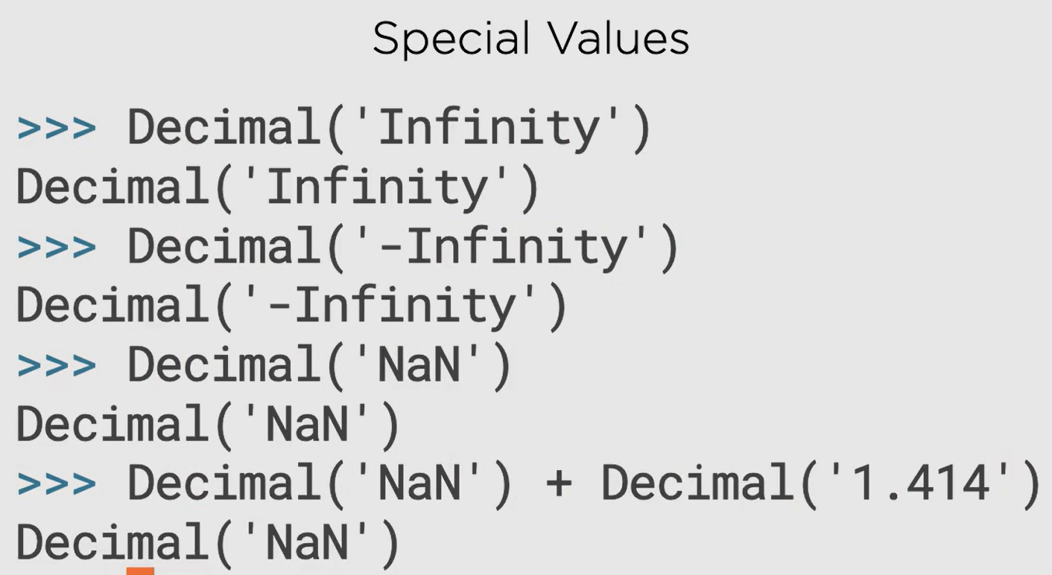

### Combining with Other Types

Decimal with float:

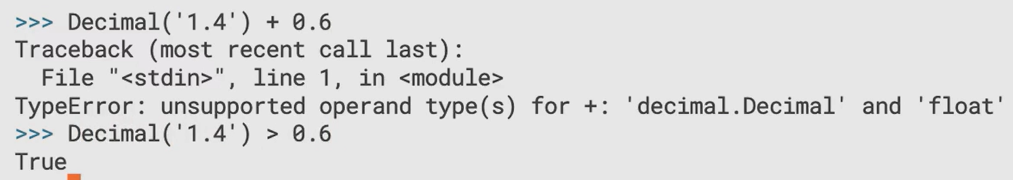

Beware of Decimal in the following situations:

1. Modulus

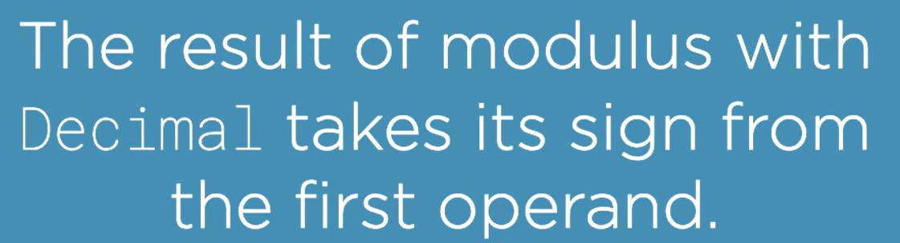

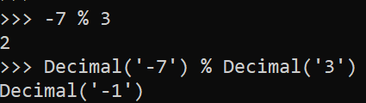

1. Floor Division

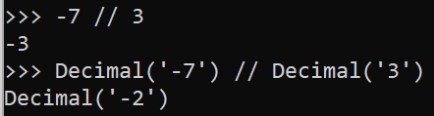

1. Math functions can’t directly be used with Decimal()

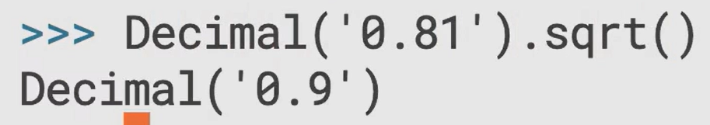

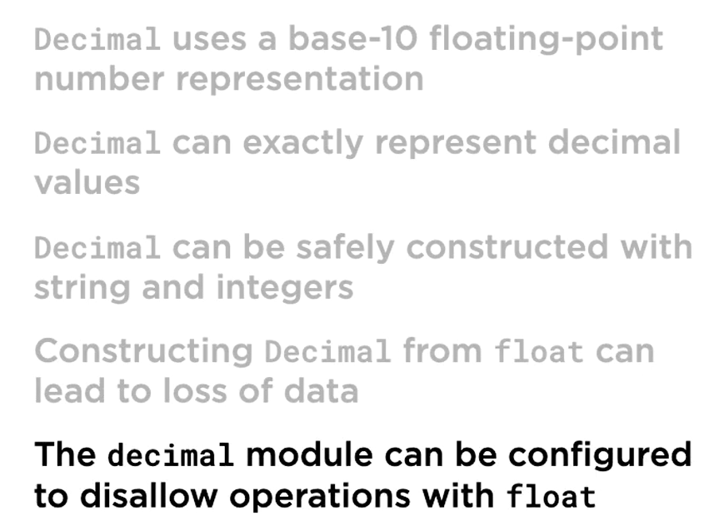

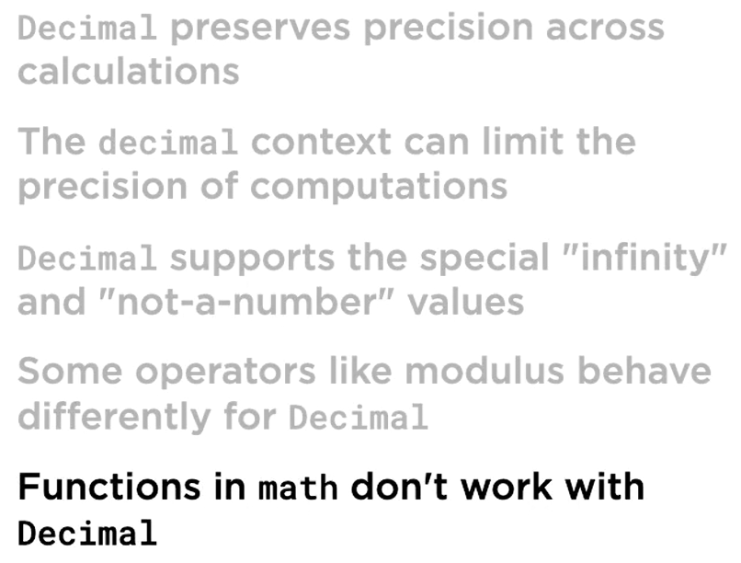

## Fraction Module

float and decimal.Decimal are not sufficient to deal with numbers like 2/3

Hence, Fraction Module

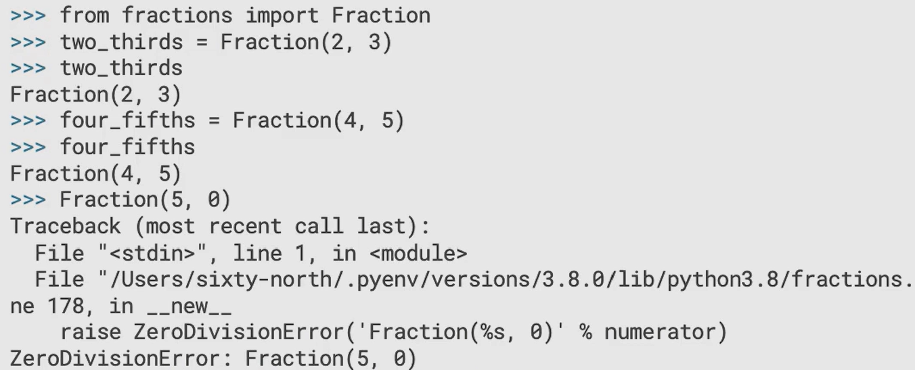

### Arithmetic and operations

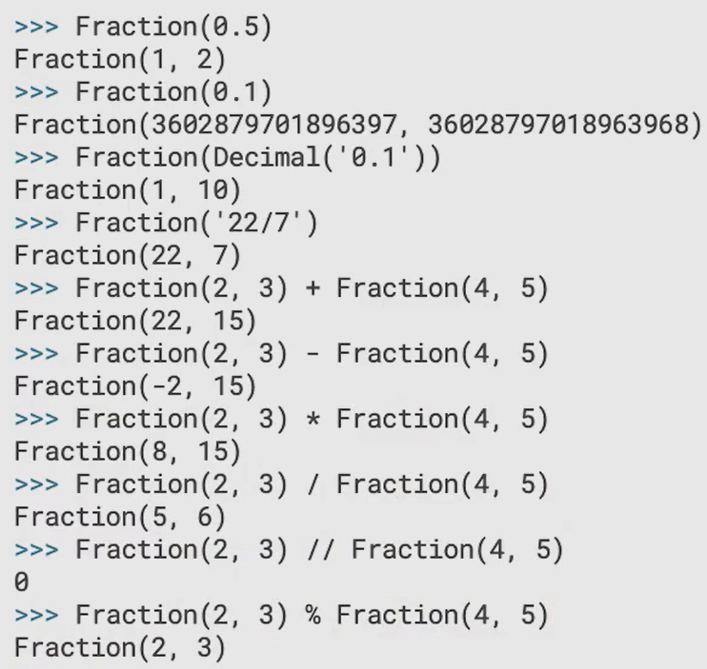

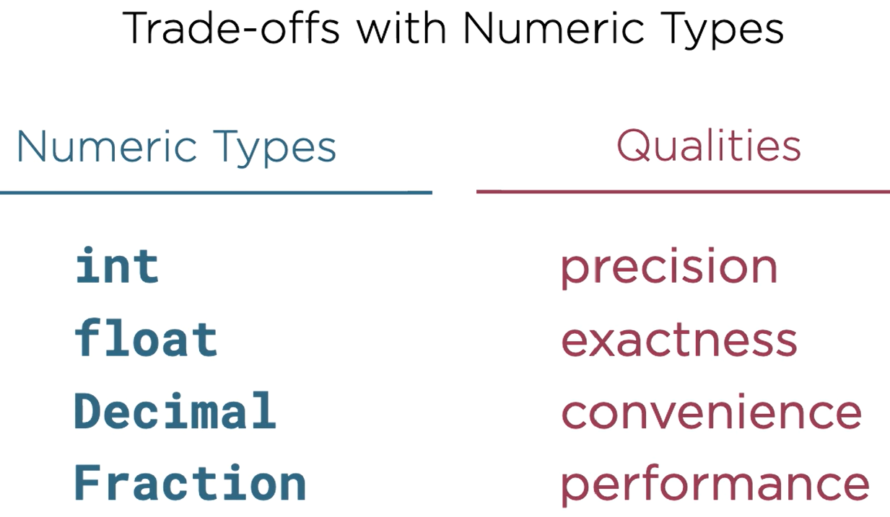

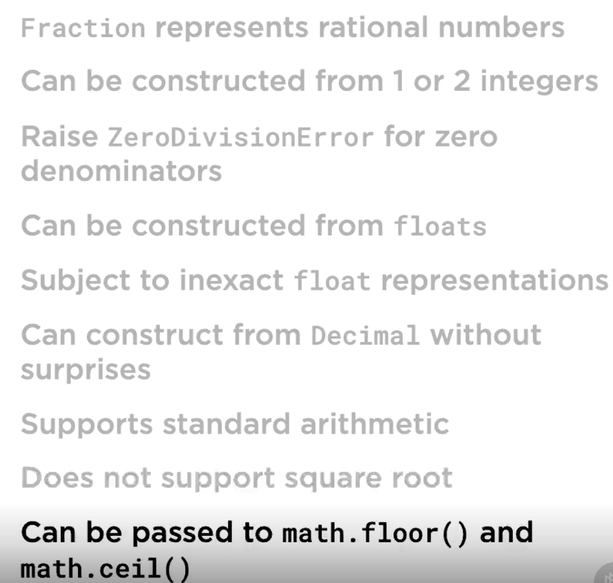

## Complex Numbers

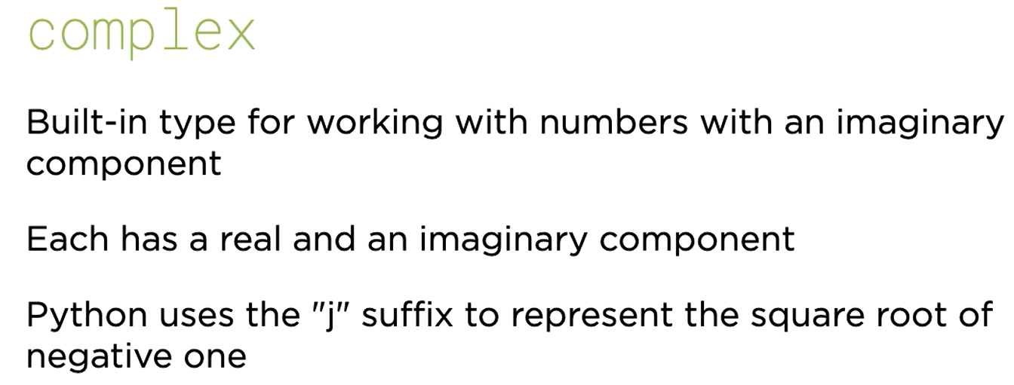

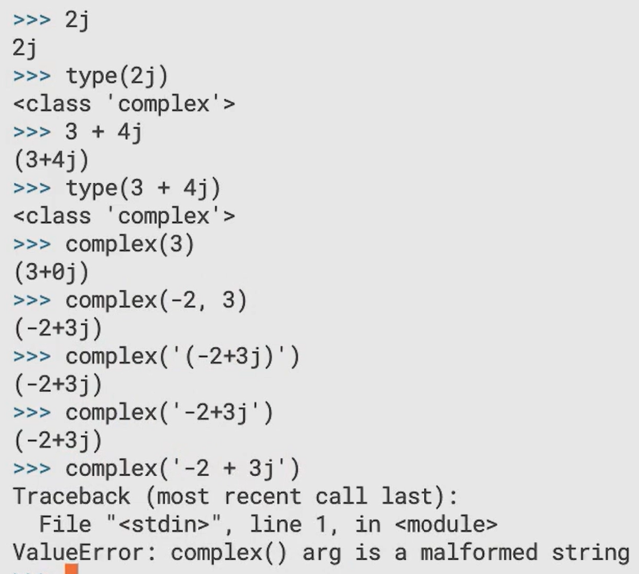

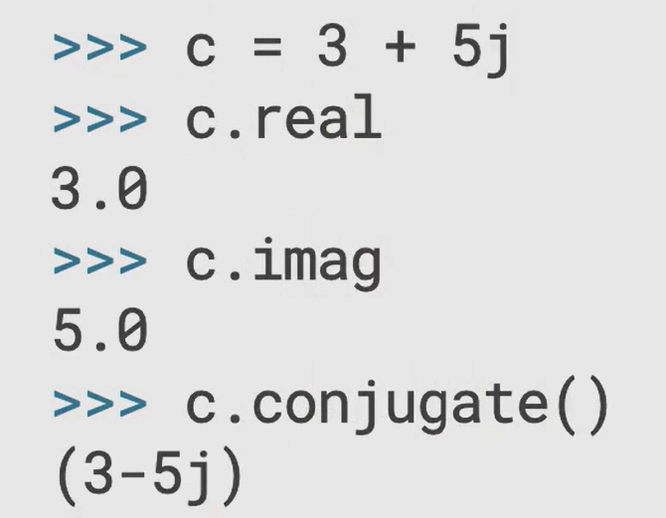

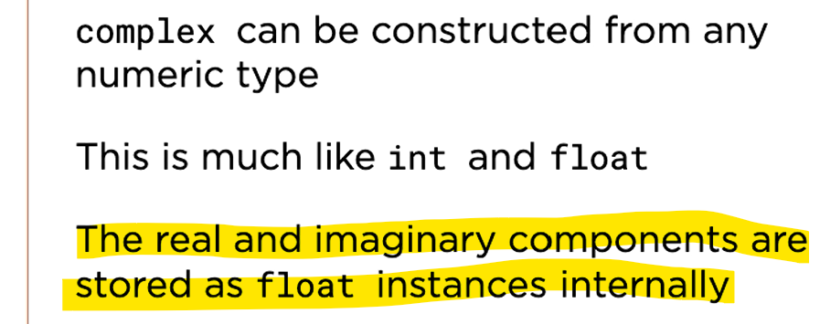

### Operations

Use cmath module for mathematical operations

## Built-in Functions relating to Numbers

1. abs()

returns the magnitude of a number

1. round()

useful for rounding, rounds to even number when 5 is in question after decimal:

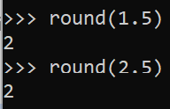

Beware of using round with floating point values, it can give weird result:

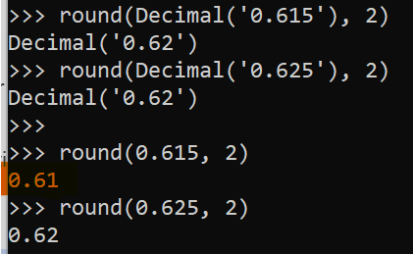

Third result was not expected but this is because of issues with precision of floating point numbers, use decimal.Decimal() to get out of this

Search Keyword: round issue round, rounding issue, rounding problem, round problem round

### Base Conversion

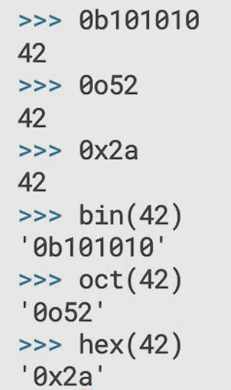

0b stands for binary

0o stands for octal

0x stands for hexadecimal

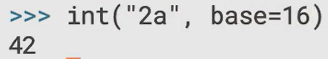

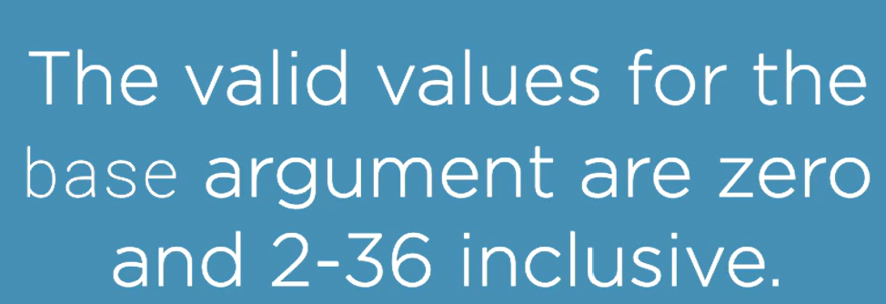

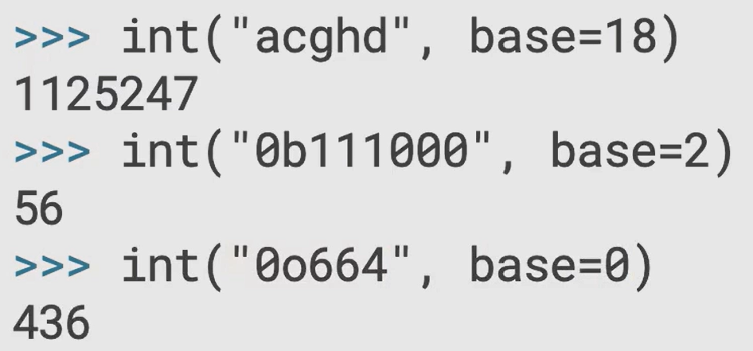

Base 0 means auto detect the prefix to figure out the base, if no prefix -> treat as base 10

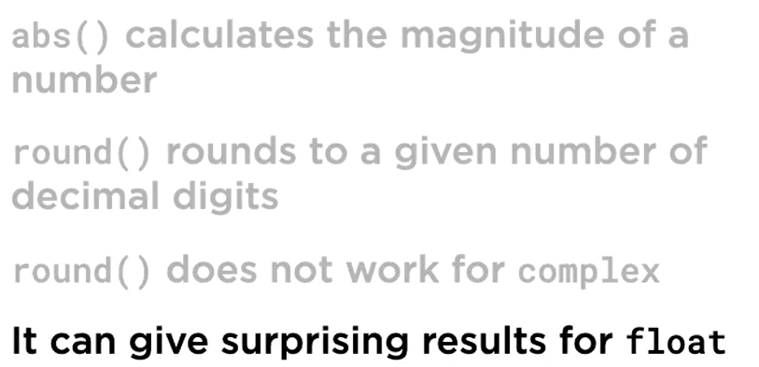

## Dates and Times with Datetime module

### The Datetime Module

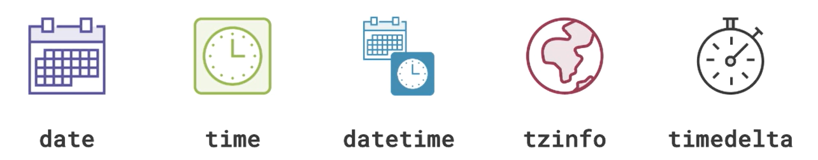

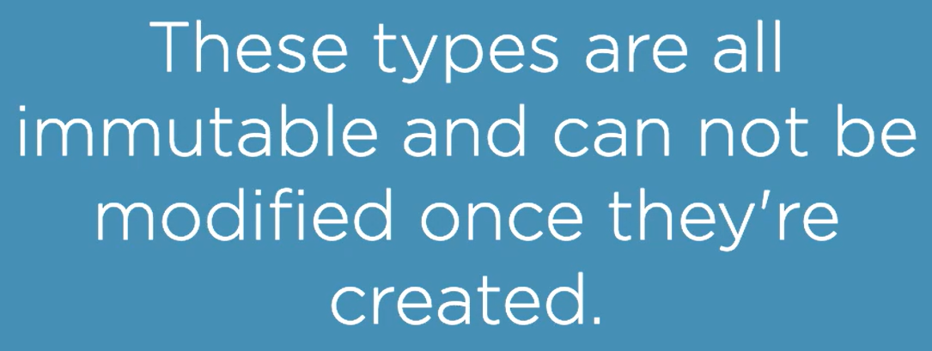

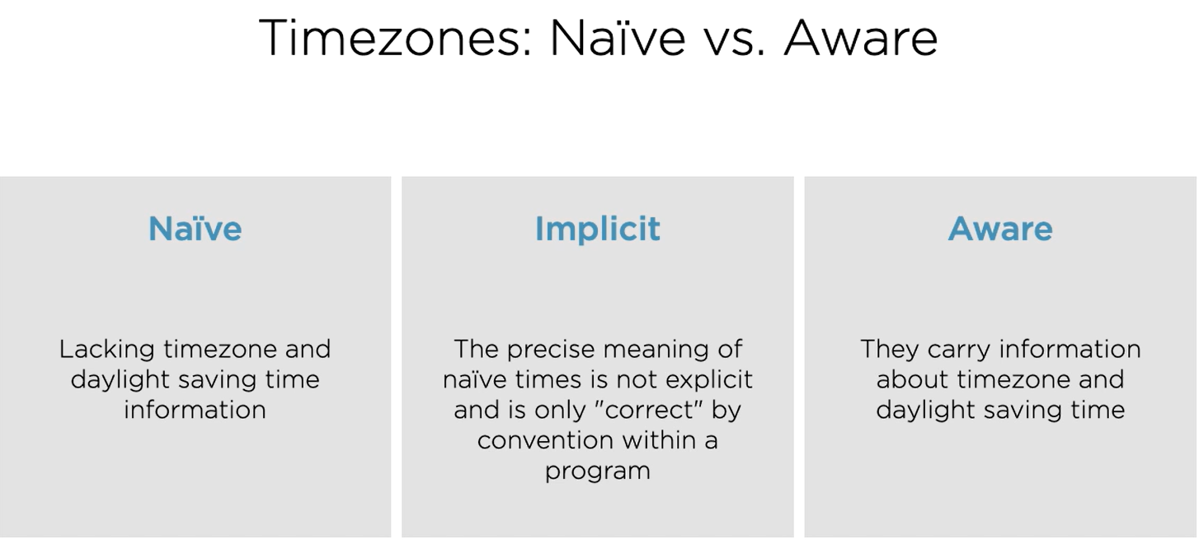

### Dates

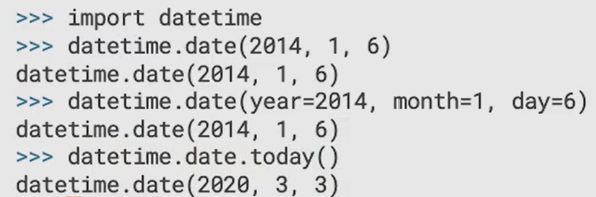

Create a date from a POSIX timestamp (which is the number of seconds since 1st Jan 1970)

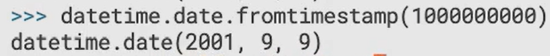

Create a date from an integer number of days which starts on 1st Jan 1 considered as day 1.

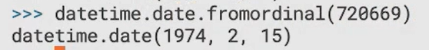

Get day, month and year from a date

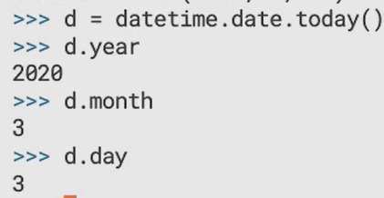

weekday(): Monday is 0 and Sunday is 6

isoweekday(): Monday is 1 and Sunday is 7

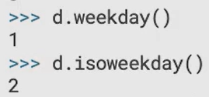

To represent dates as text:

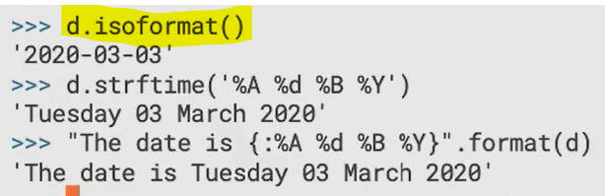

The last two in the above statement is not portable to other systems and might give different result, instead use:



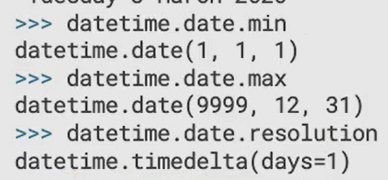

### Times

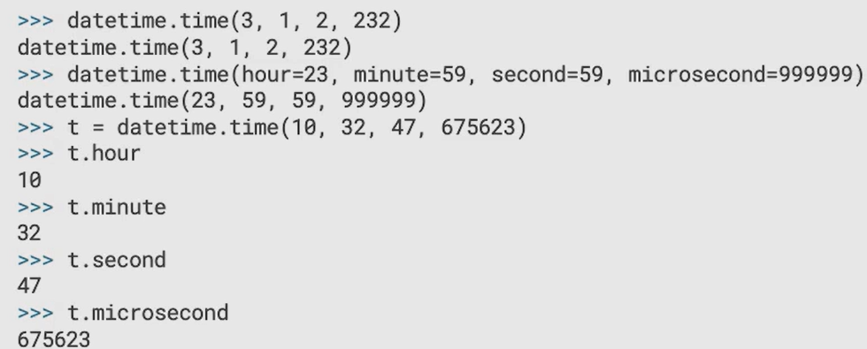

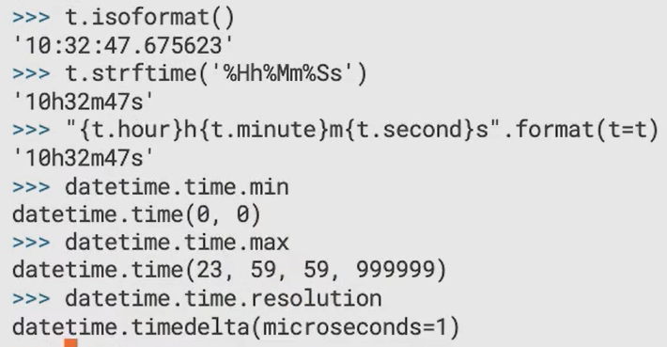

### Combined Dates and Times

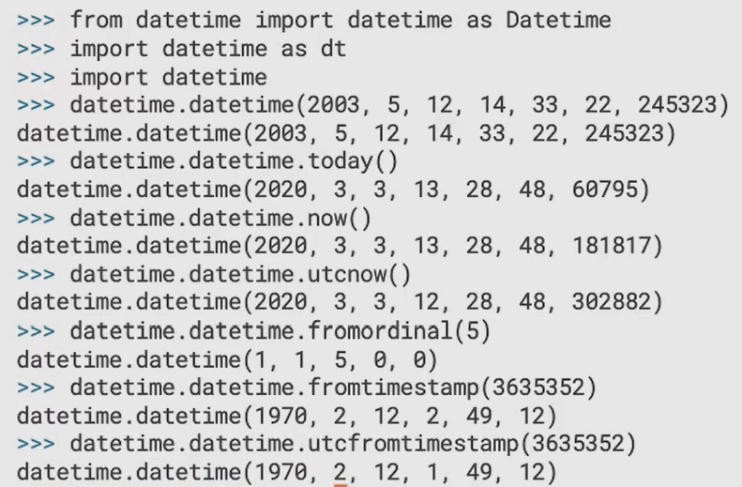

Combine date and time:

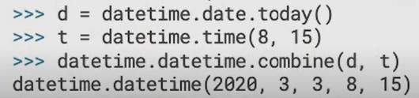

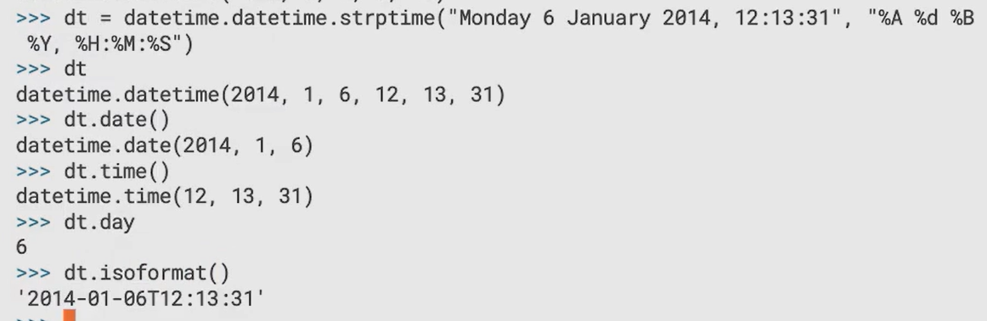

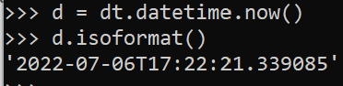

### Durations

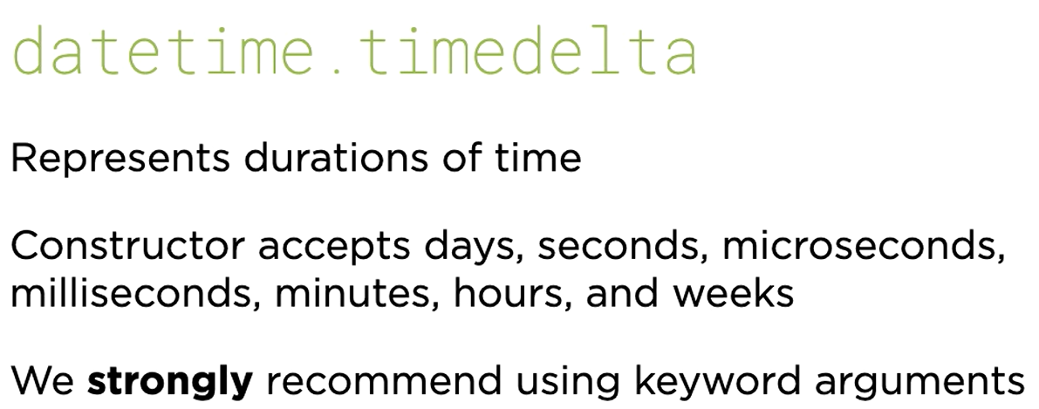

Stores only days, seconds and microseconds

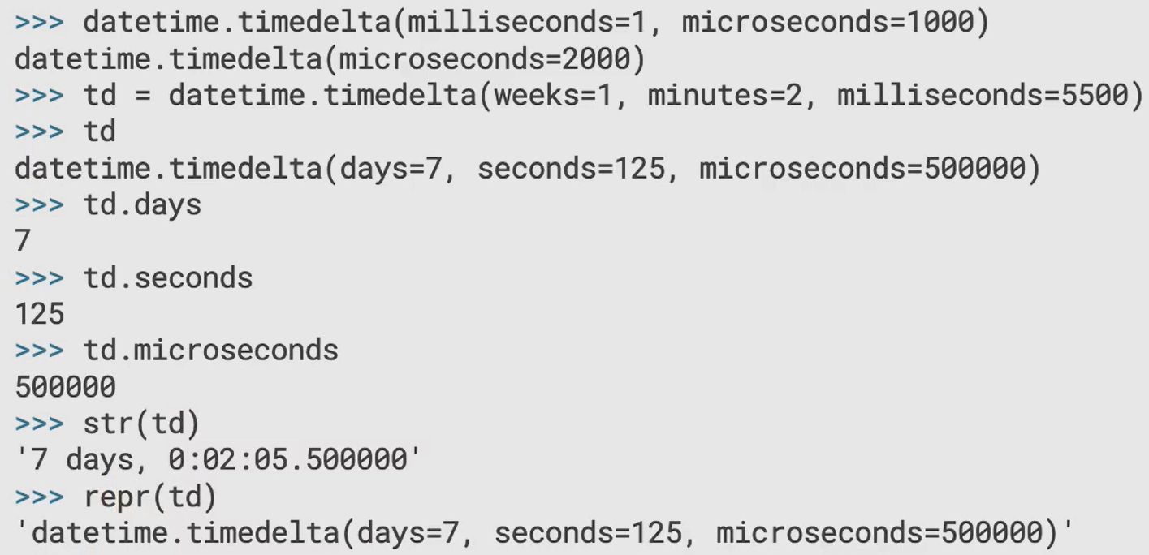

Arithmetic operations are supported for datetime.datetime but not for datetime.time:

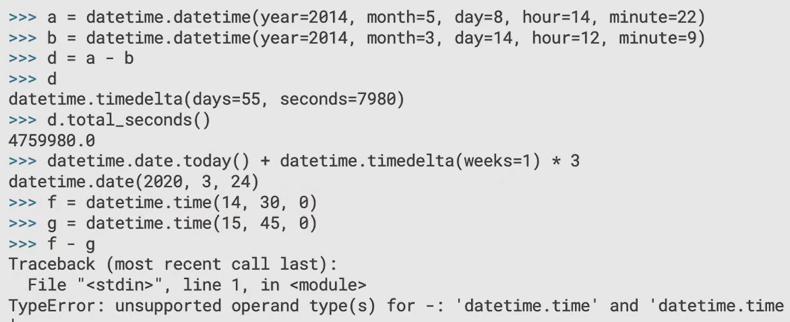

### Timezones

All of the time related objects created so far are naïve times, which represent times in local time.

To create timezone aware objects, we must attach instances of a tzinfo object to our time values.

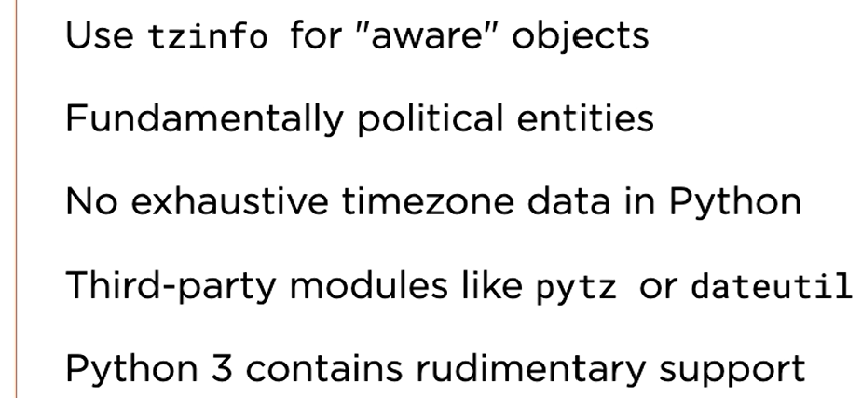

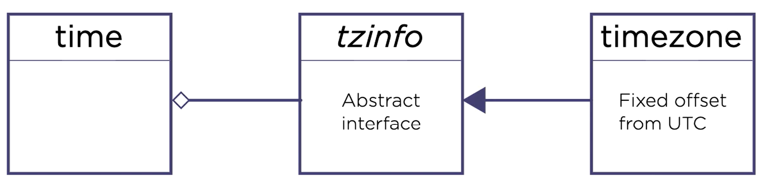

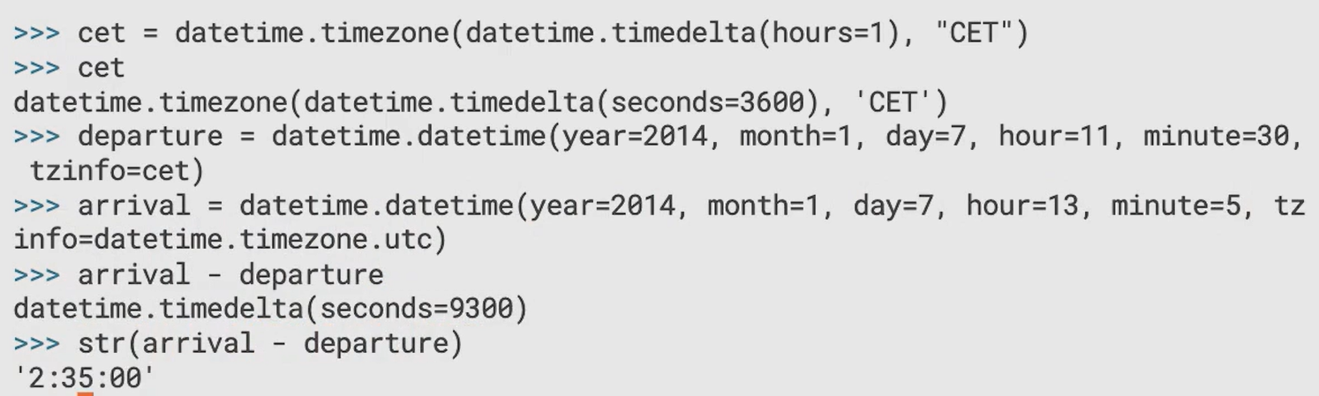

## Computational Geometry

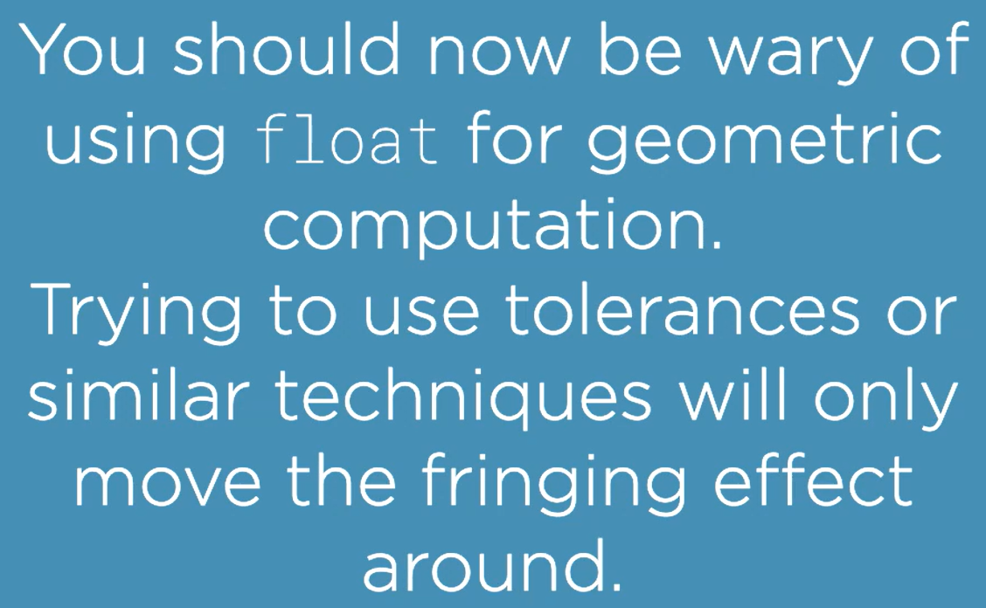

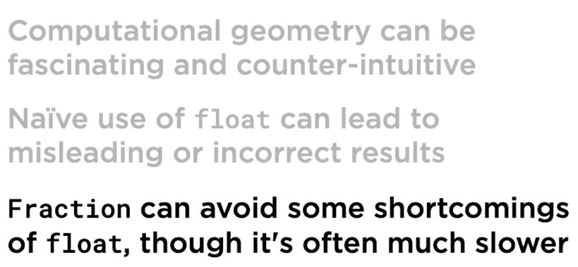

# Core Python 3.8: Advanced Flow Control

## Loop-else Clauses

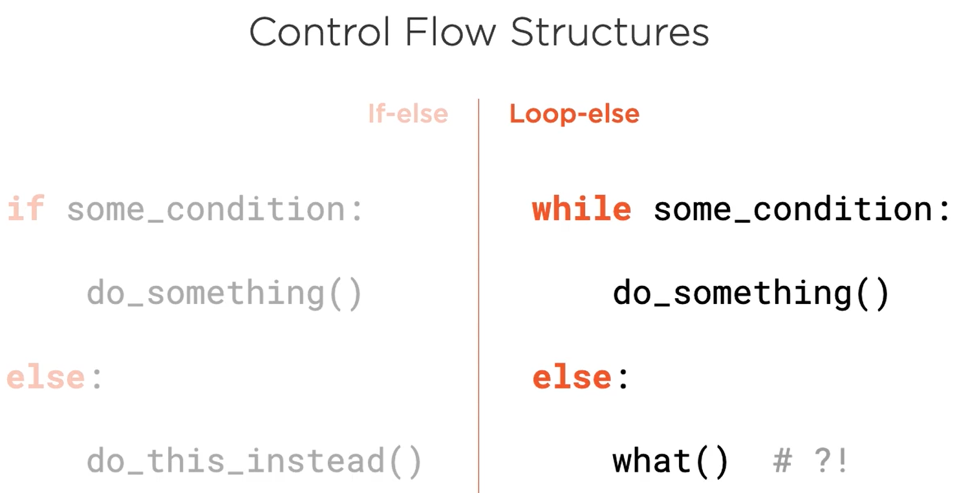

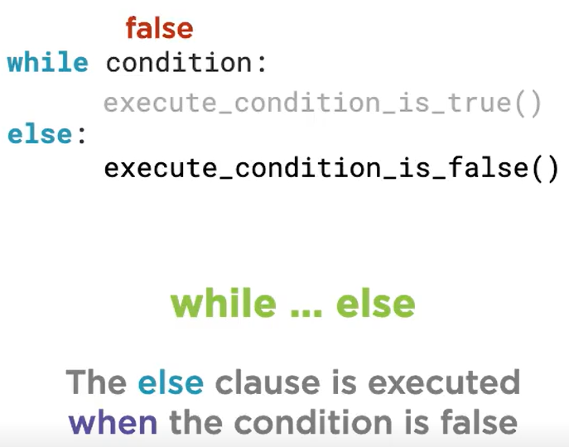

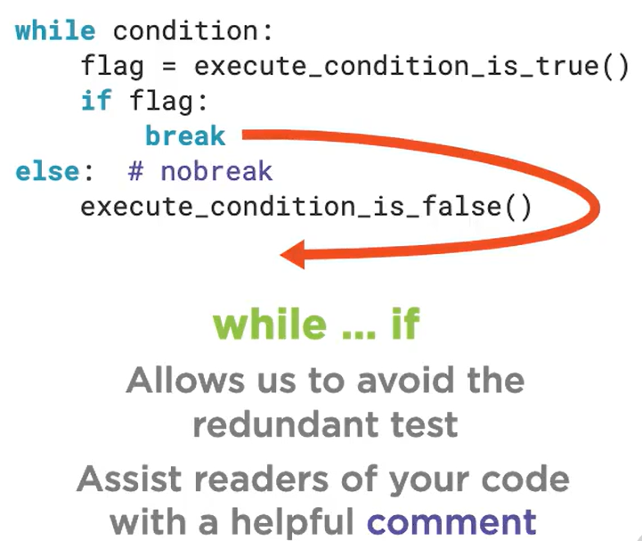

## For-else clause

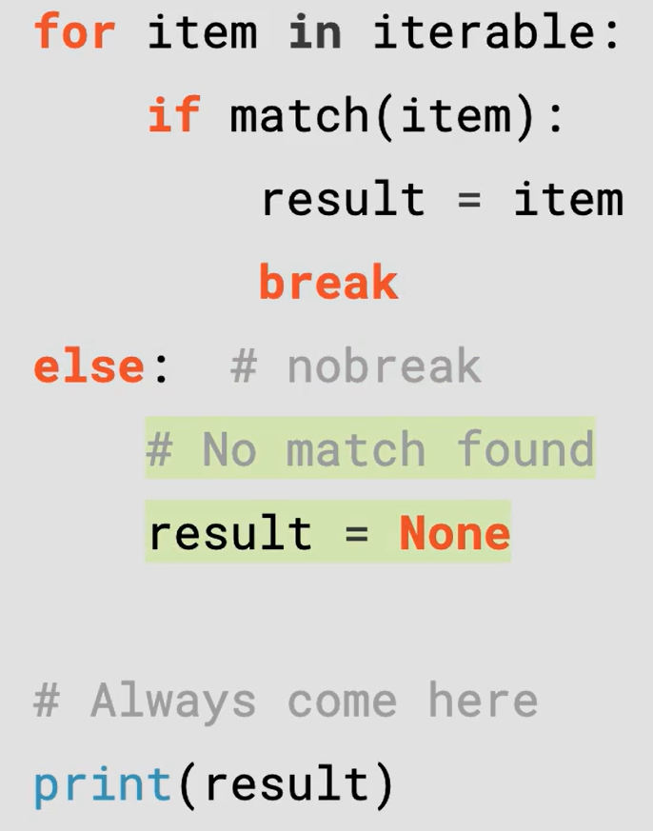

Loop-else and for-else clauses are not recommended to be used at these are neither widely used nor wisely understood.

## Try-else clause

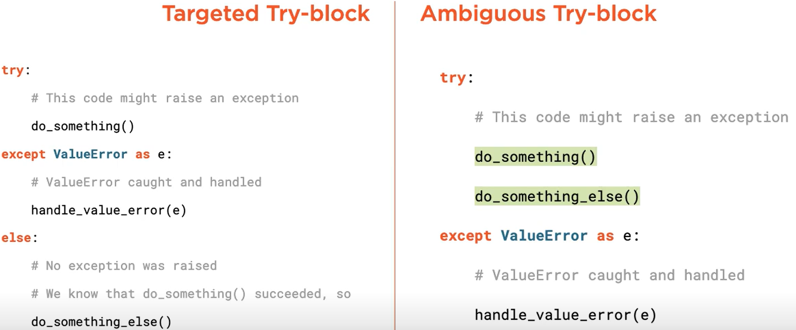

Left one is what should be used

## Emulating Switch

Instead of using if-elif statement, use dictionary of callables (can be functions or lambdas)

Refer program emulate_switch.py

## Dispatching on Types

### singledispatch decorator



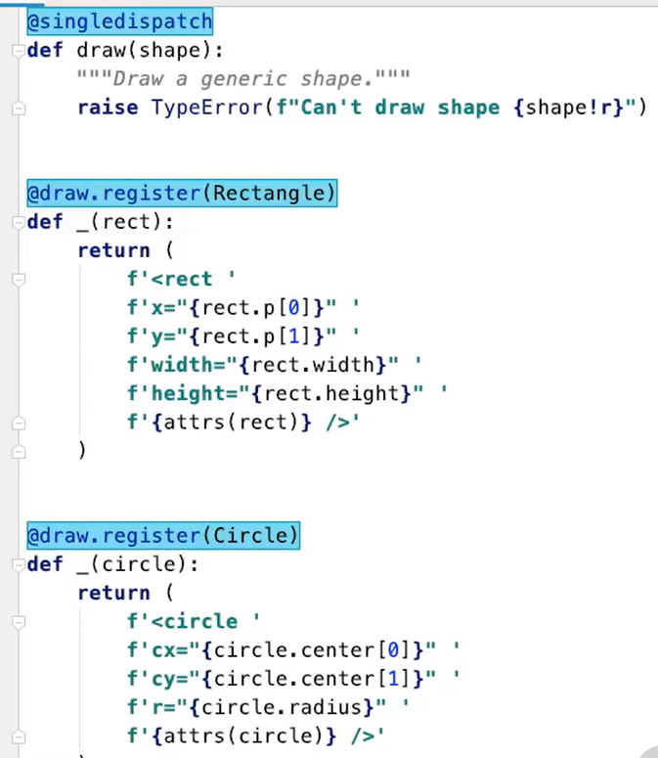

In the above example we can see singledispatch in action. Apply the singledispatch decorator on the base generic function, which defines the name of the function and which deals with TypeErrors, together with an arbitrary number of type-specific overloads attached with the register decorator factory.

singledispatch works fine with functions but not with methods.

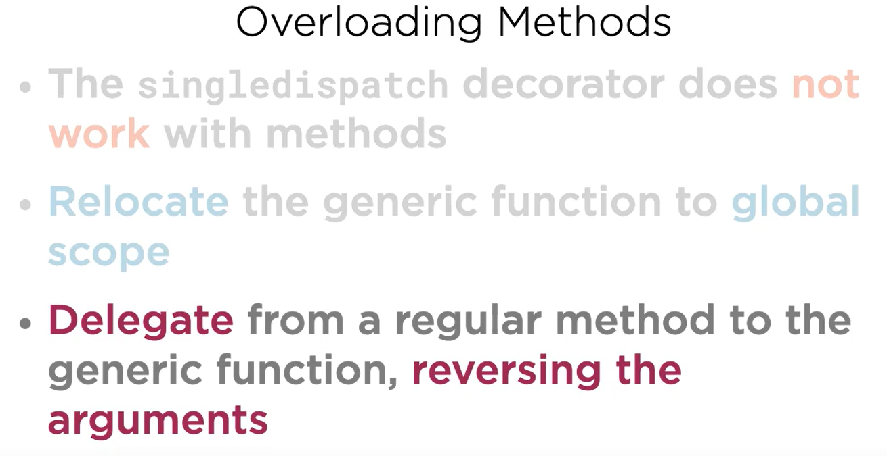

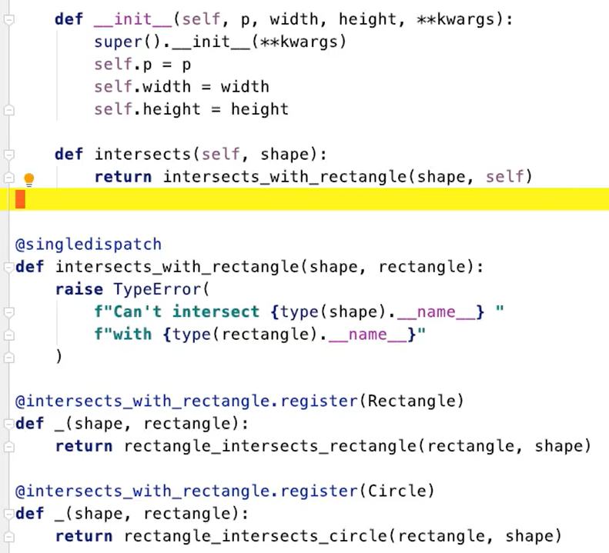

## Short-circuit Evaluation

### Short-circuit evaluation

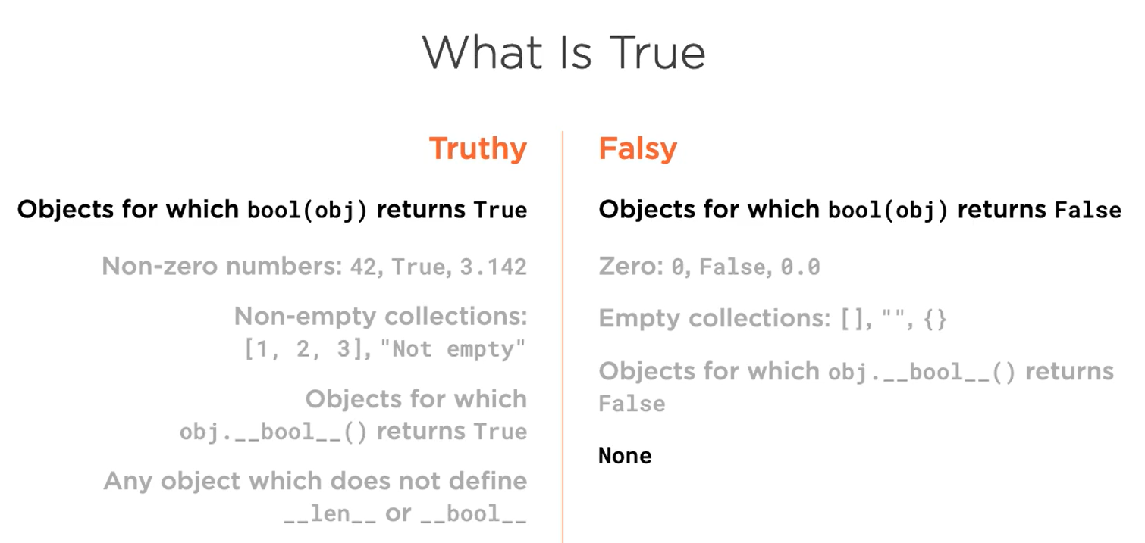

### Logical-and Operator

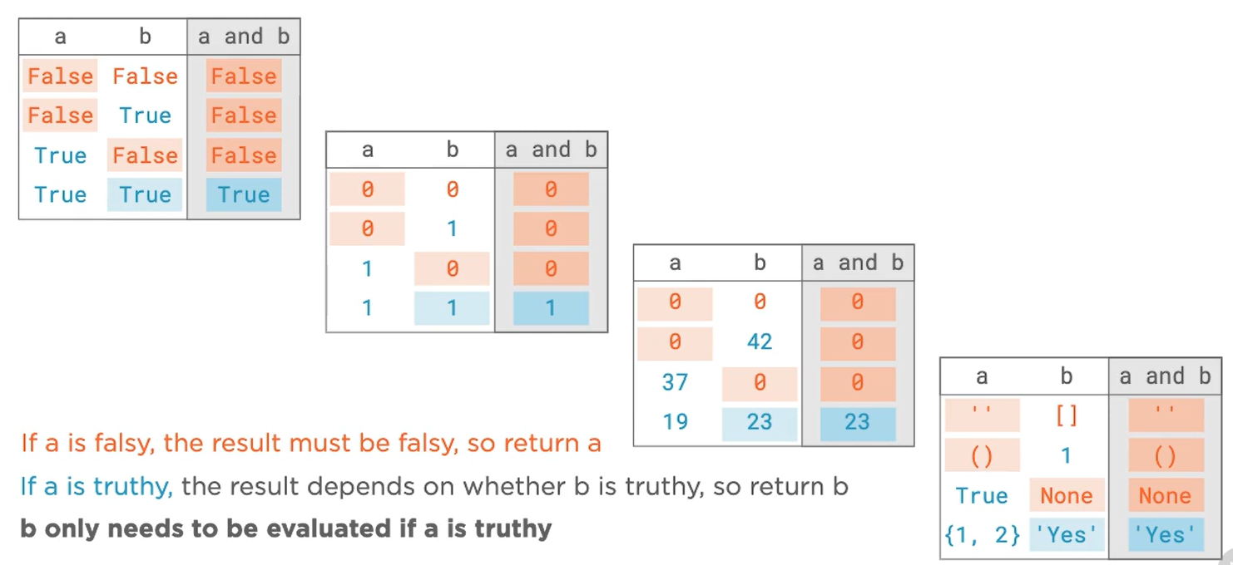

### Logical-or Operator

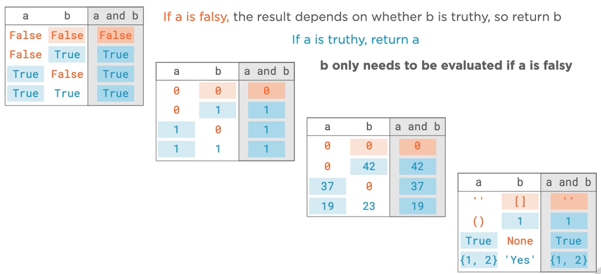

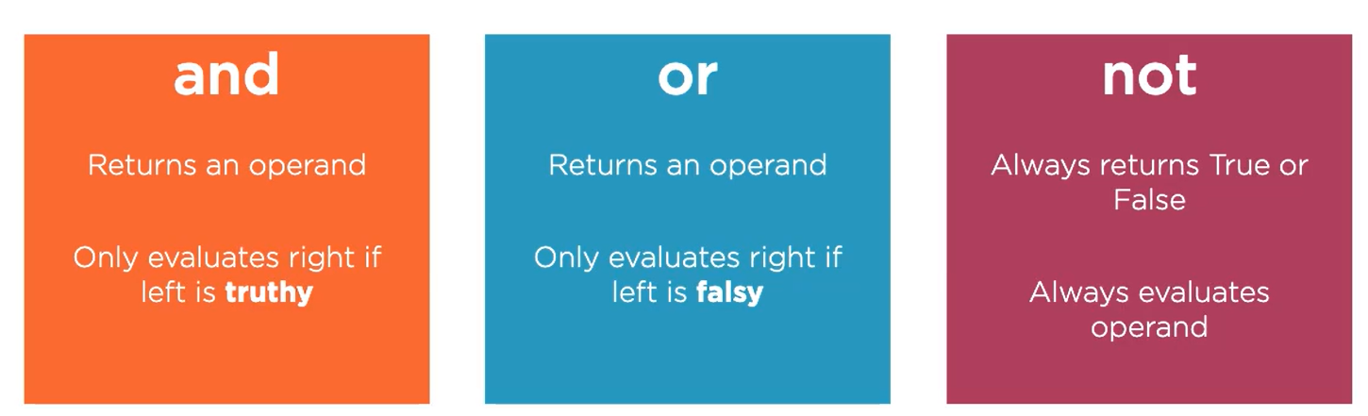

### Coalescing Nulls

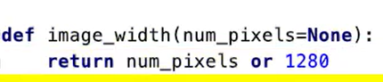

When no argument is supplied, the 1st operand evaluates to Falsy, so return the second operand.

When arg is having any Truthy value, return the 1st operand directly.

So, in this example, 1280 works like a default argument value, if you do not supply a value to num_pixels then 1280 is returned.

### Guarding Expressions with Logical-and

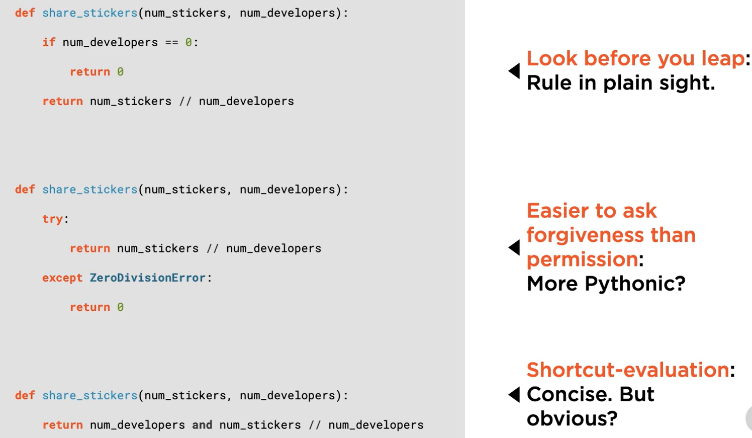

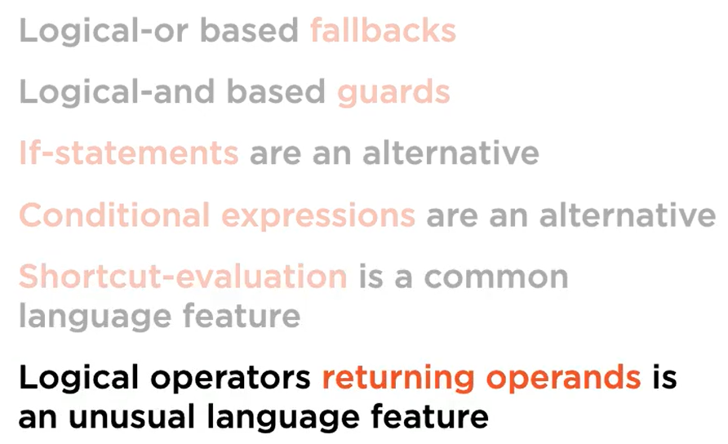

# Core Python 3.9: Byte Oriented Programming

## Bit- and Byte-wise Operations

### Bits and Bytes

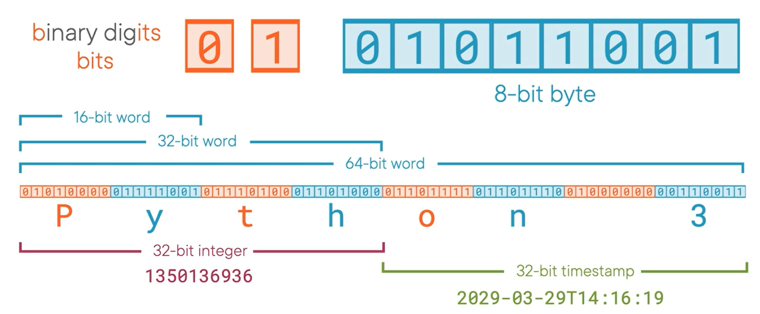

Although the smallest unit of information is the bit, the smallest addressable unit of information is byte. This means that programming languages and micro-processors can’t manipulate individual bits in isolation. In order to manipulate a bit, we must obtain the byte of which it forms the part, modify the byte, and store the modified byte back in memory.

Hence, bit manipulation operators are actually byte manipulation operators.

### Bitwise operators

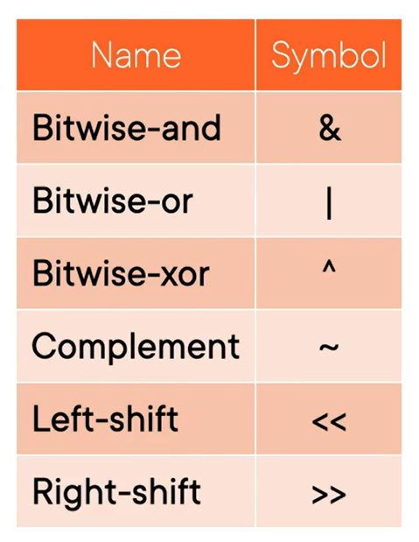

#### Bitwise-and

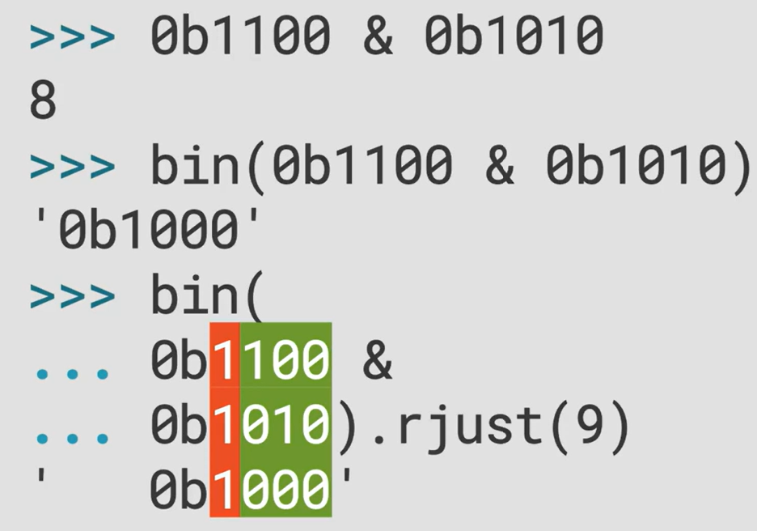

Masking with Bitwise-and

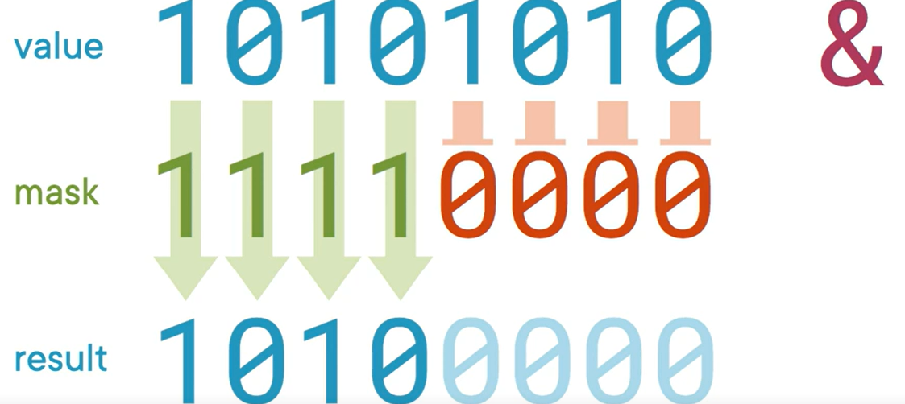

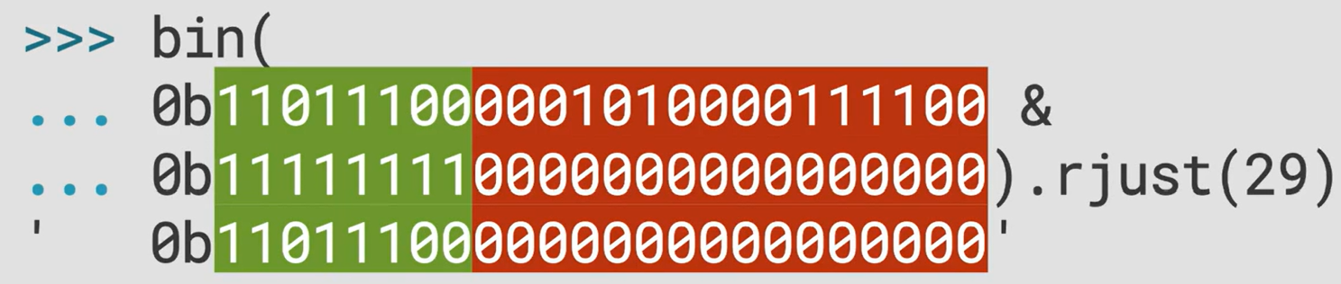

#### Right Shift

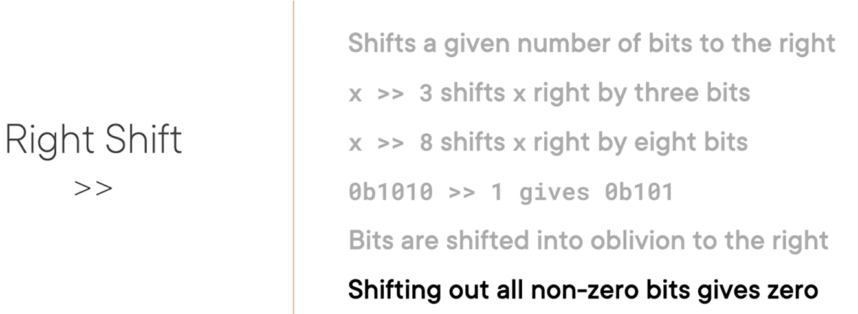

#### Left Shift

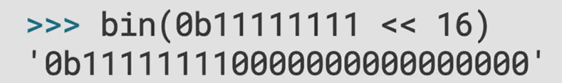

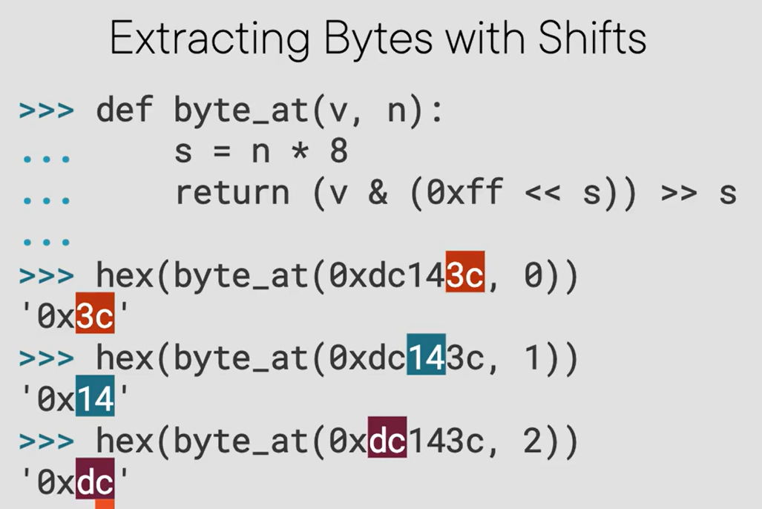

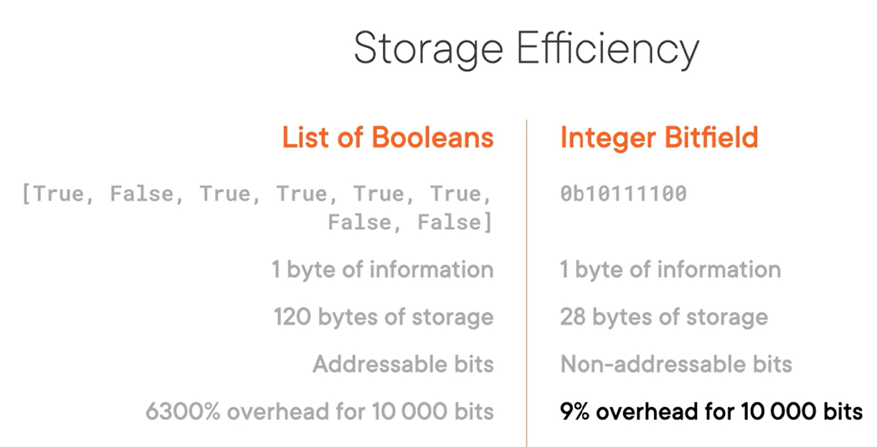

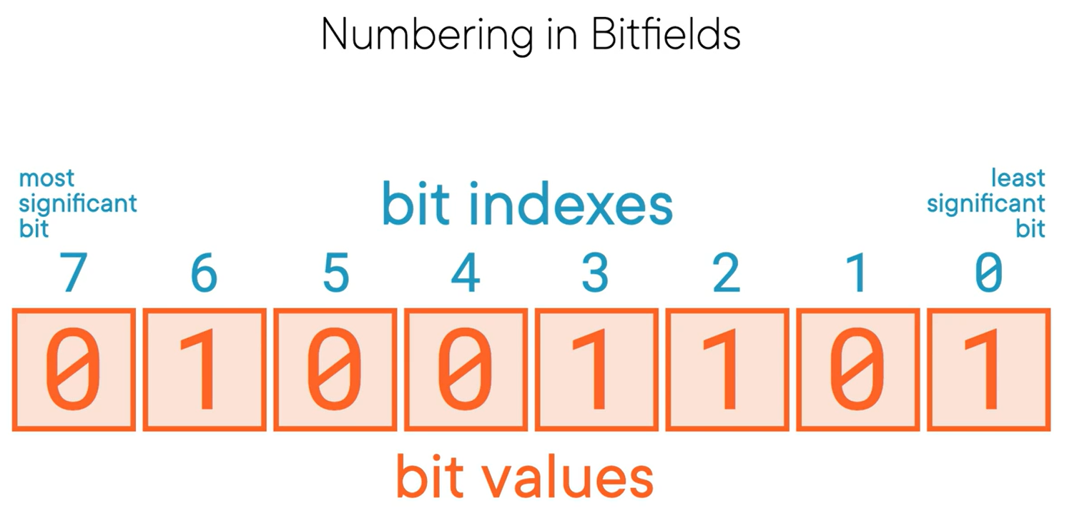

Check if a bit is set -> use bitwise-and operator:

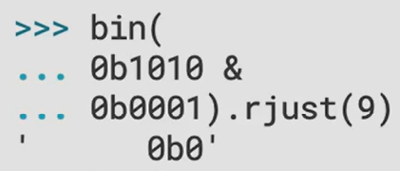

Clear a set bit -> use bitwise-and operator:

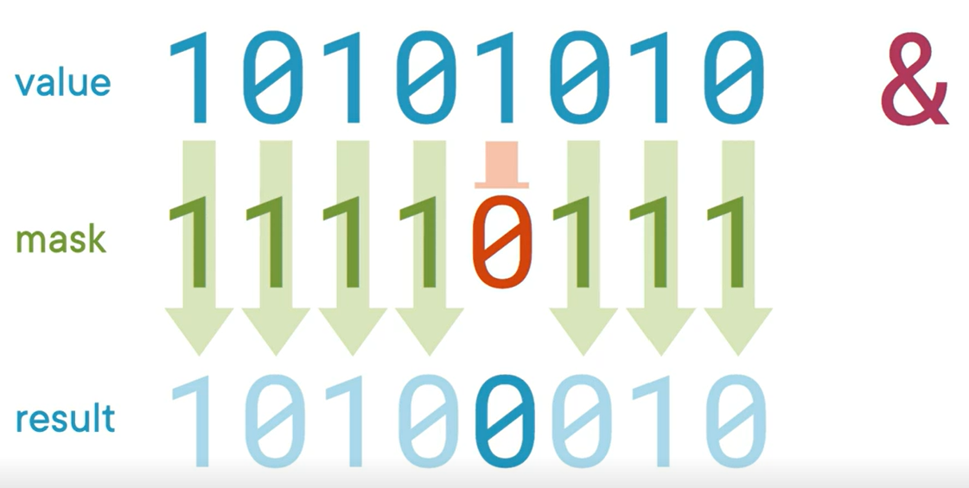

#### Bitwise-or

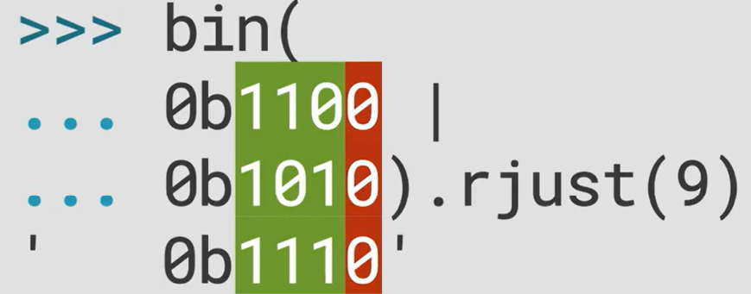

Setting a bit -> use bitwise-or operator

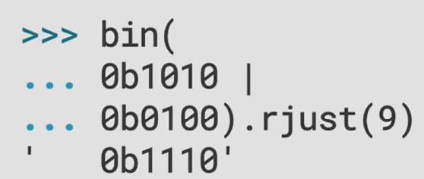

#### Bitwise Exclusive-or

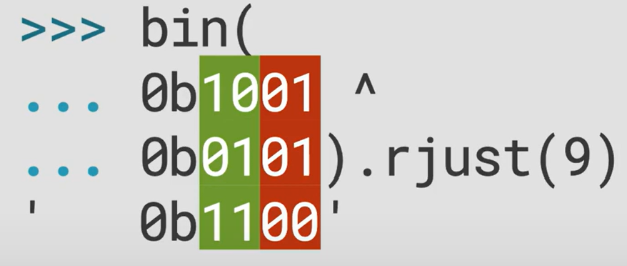

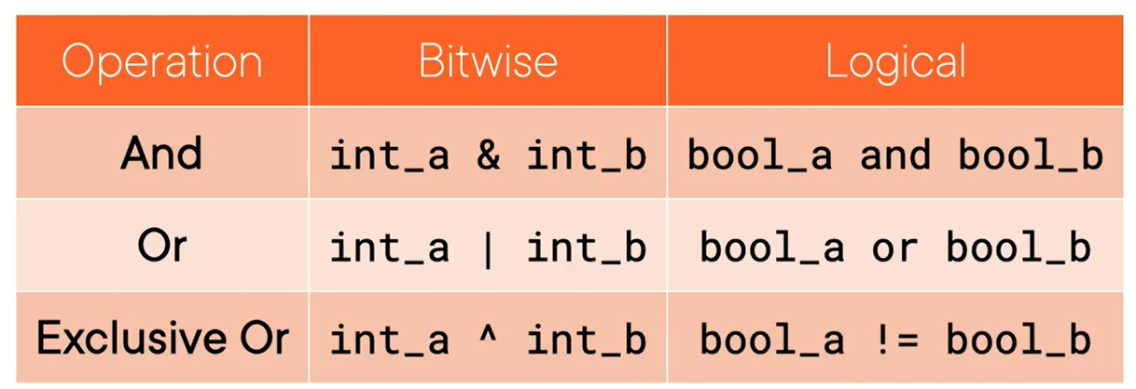

#### Bitwise Complement

Also known as bitwise not

Flips each bit

So, **~ 1 1 0 1** will give **0 0 1 0**

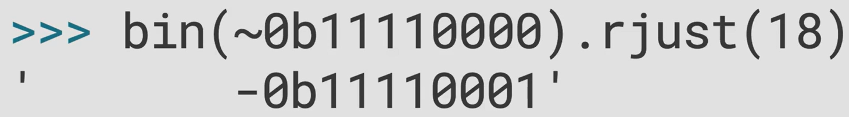

Whoa what just happened. How negative numbers work is important to understand.

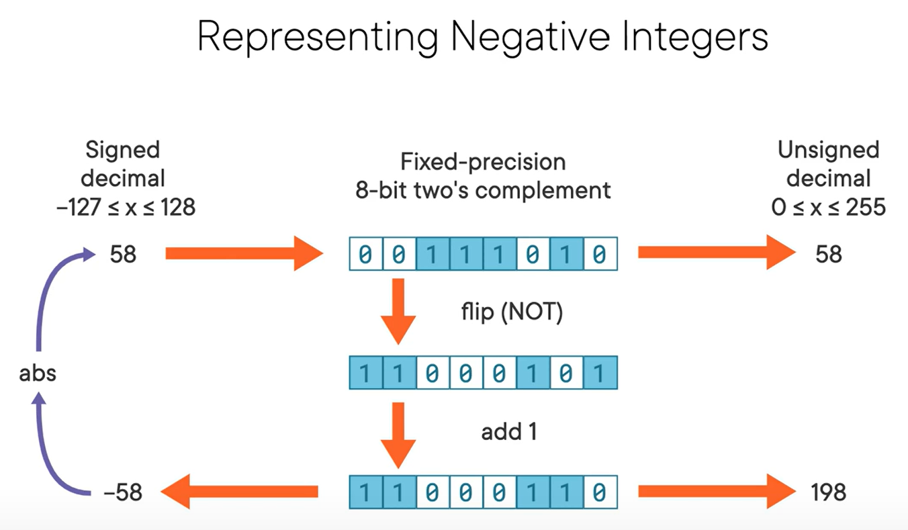

The problem is we cannot get the exact binary representation of negative numbers in Python. Hence, see the example below:

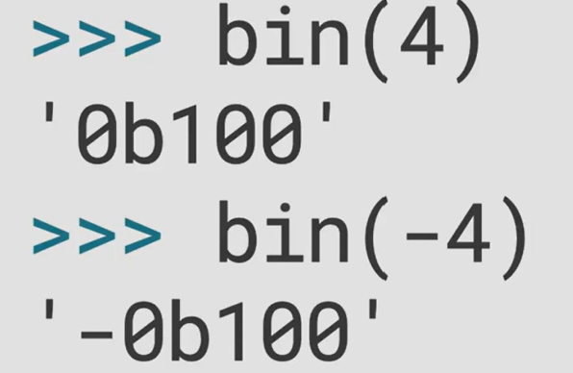

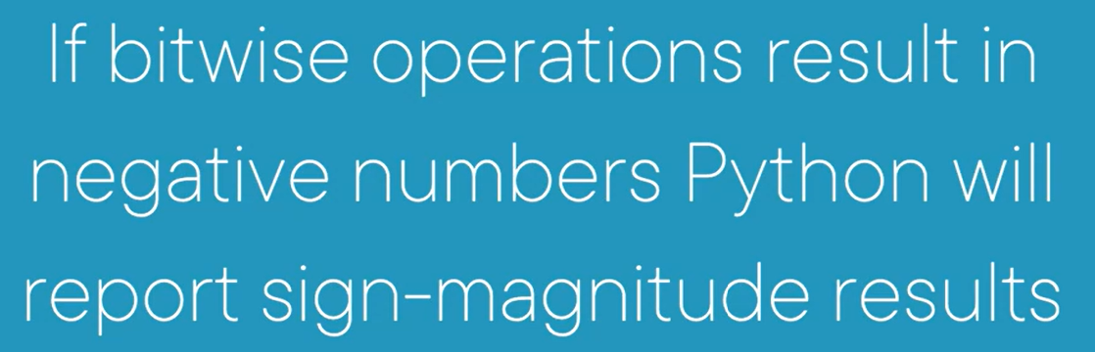

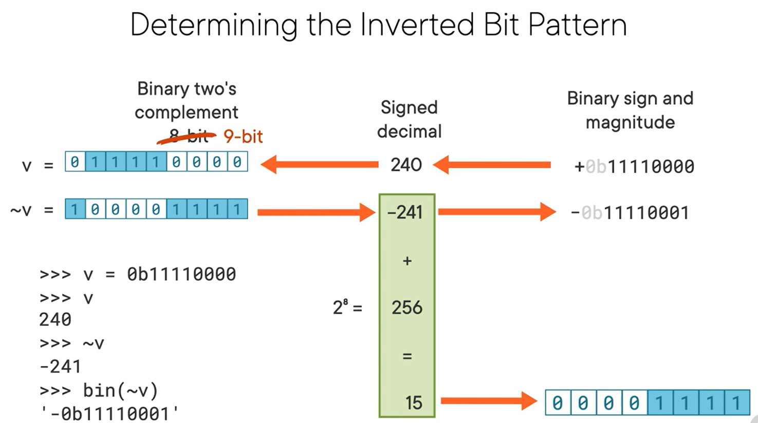

### Byte-wise Operations with Integers

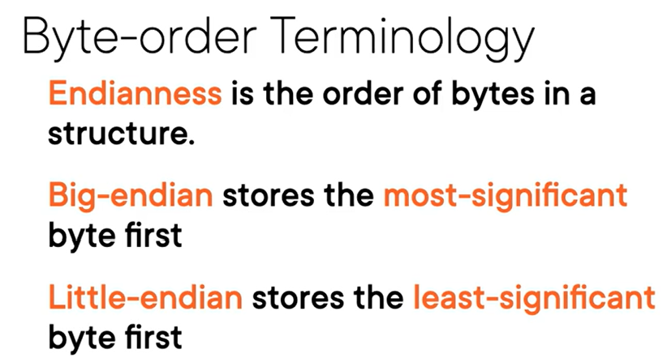

### Bit Sets

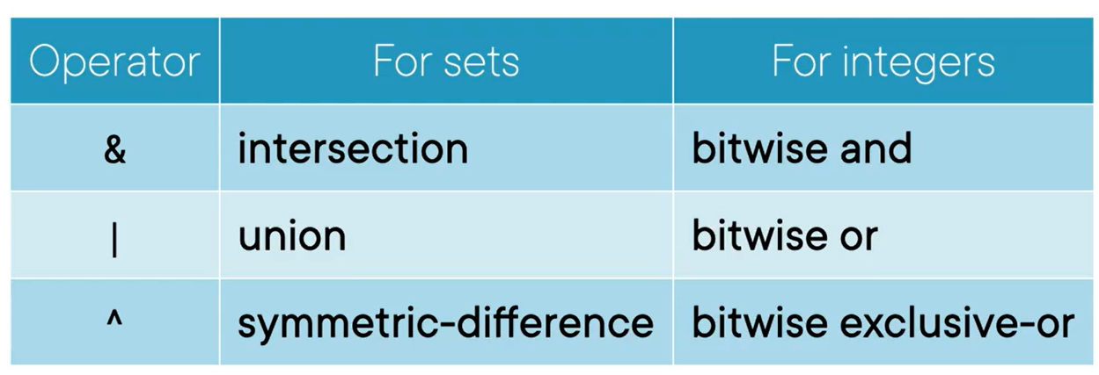

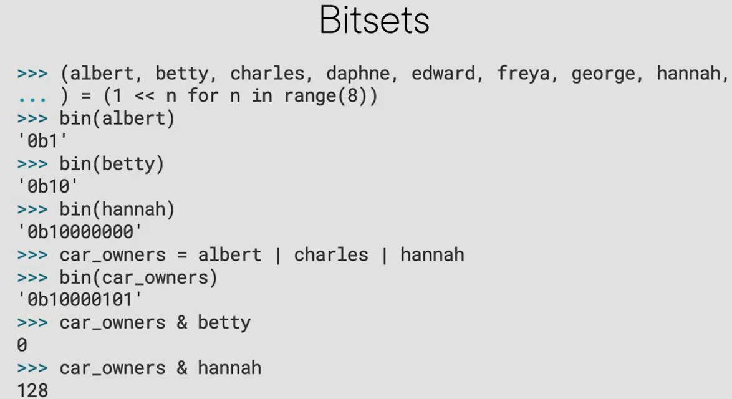

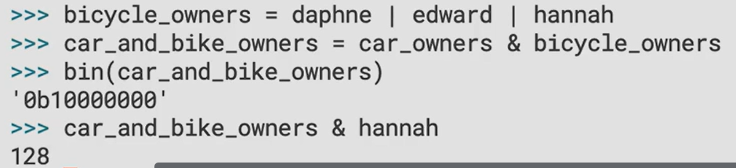

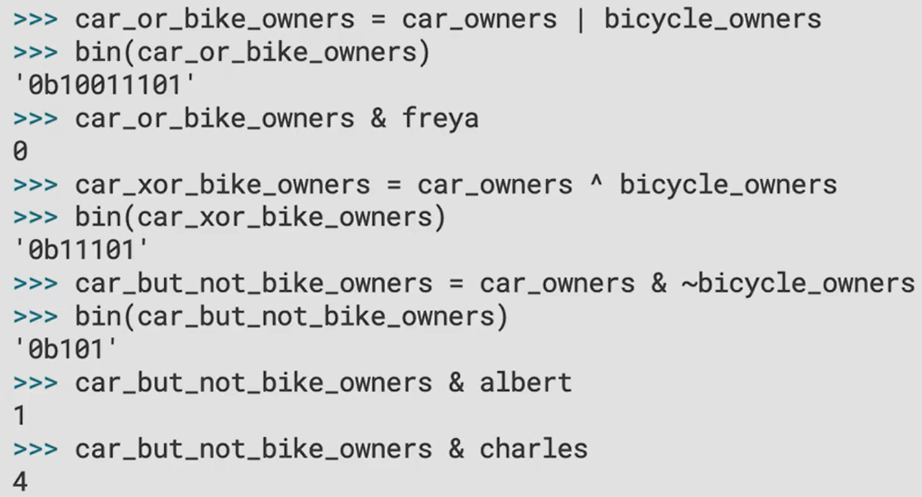

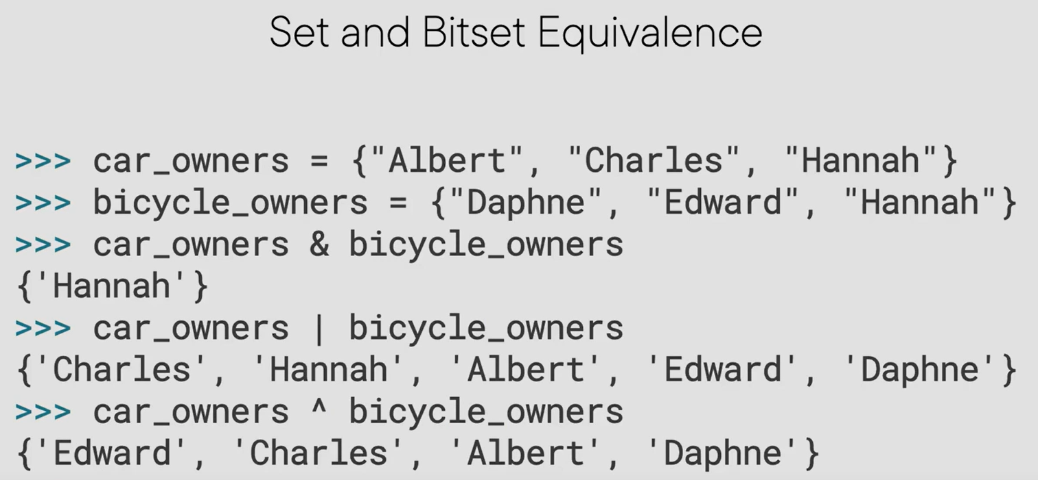

## Byte-oriented Types

### The bytes Type

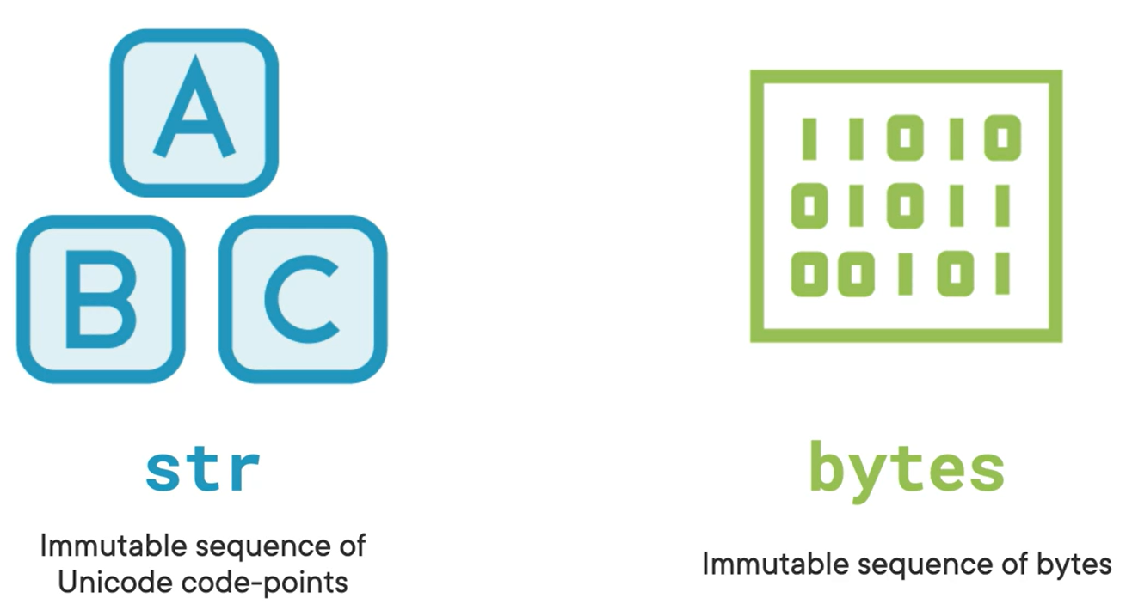

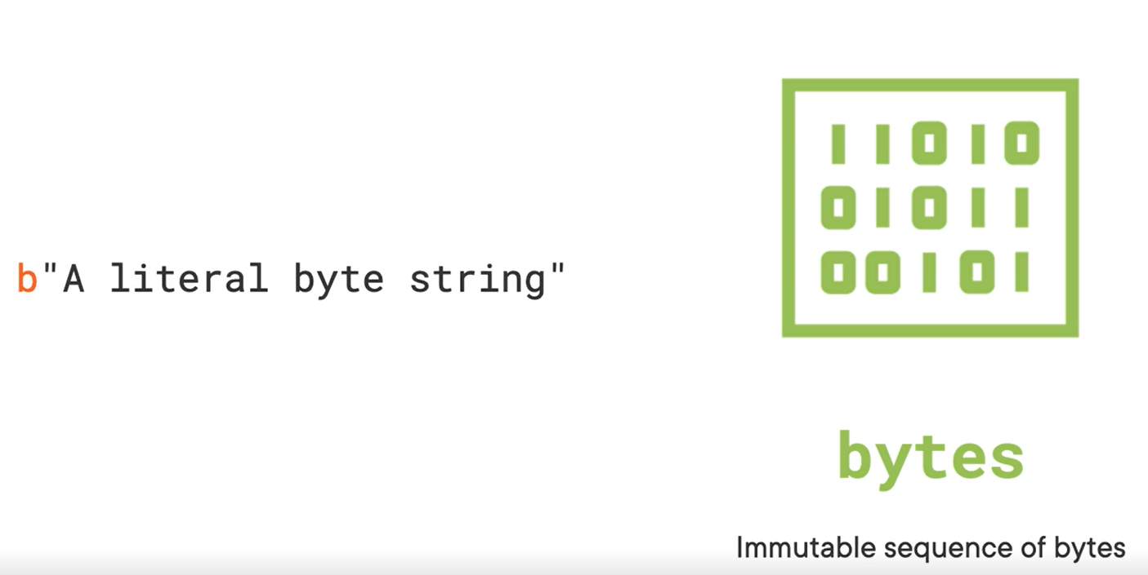

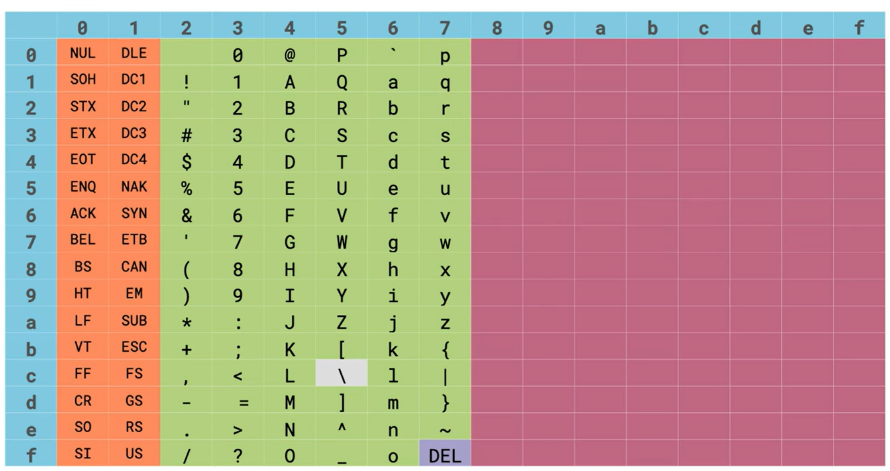

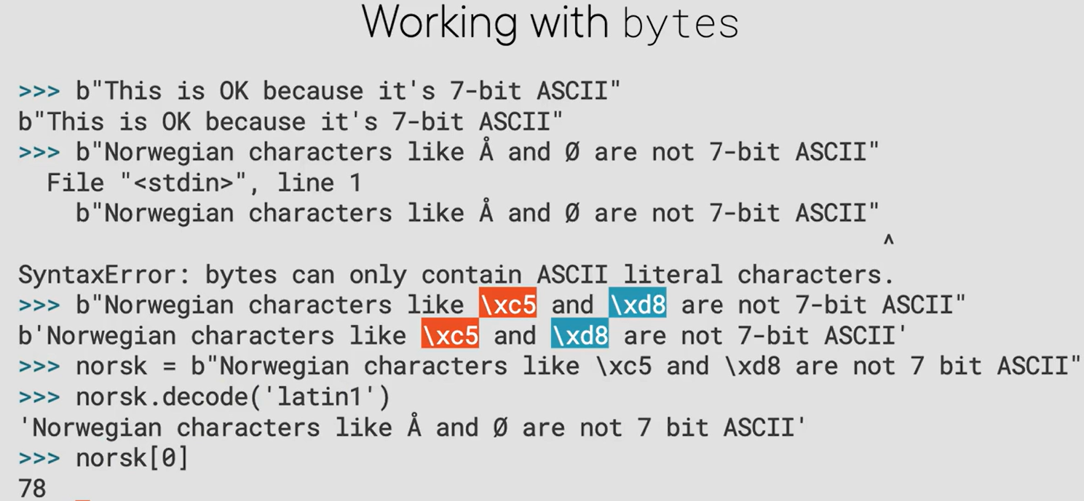

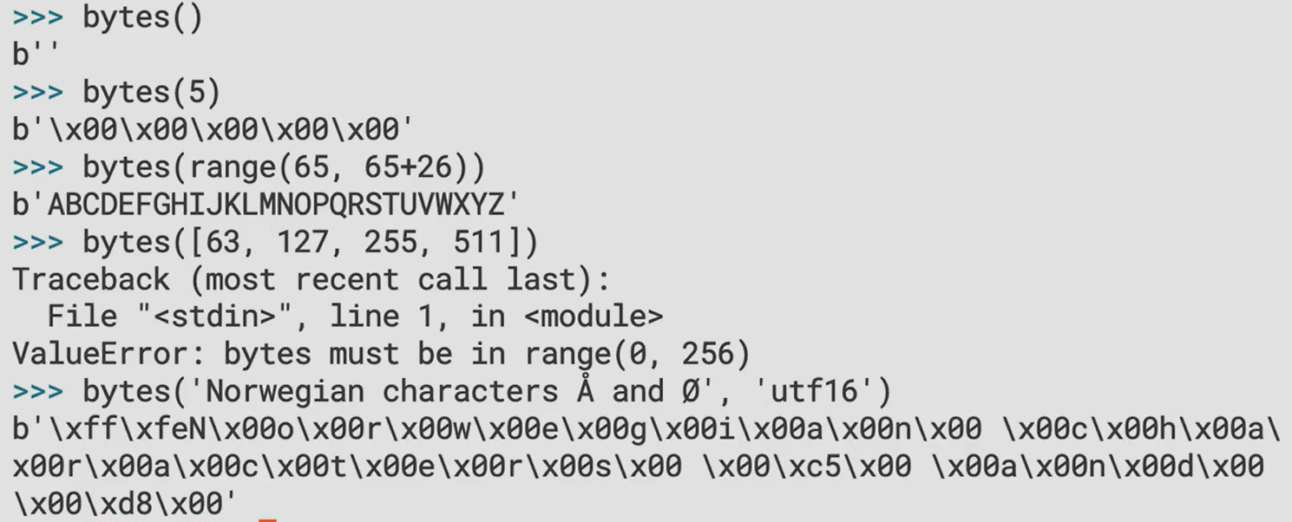

### The bytearray Type

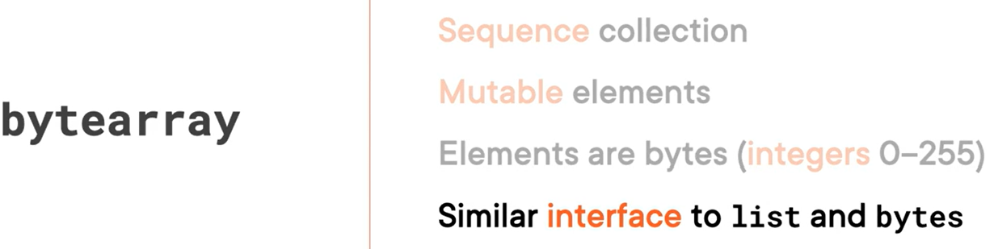

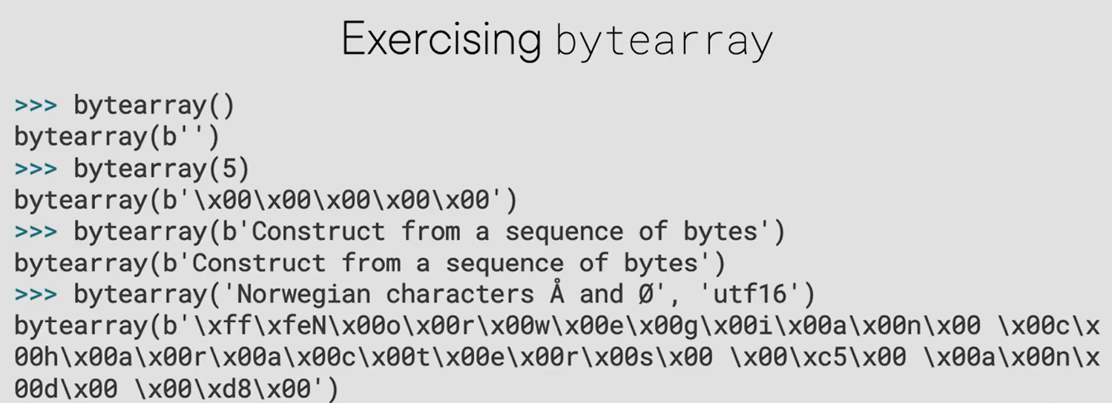

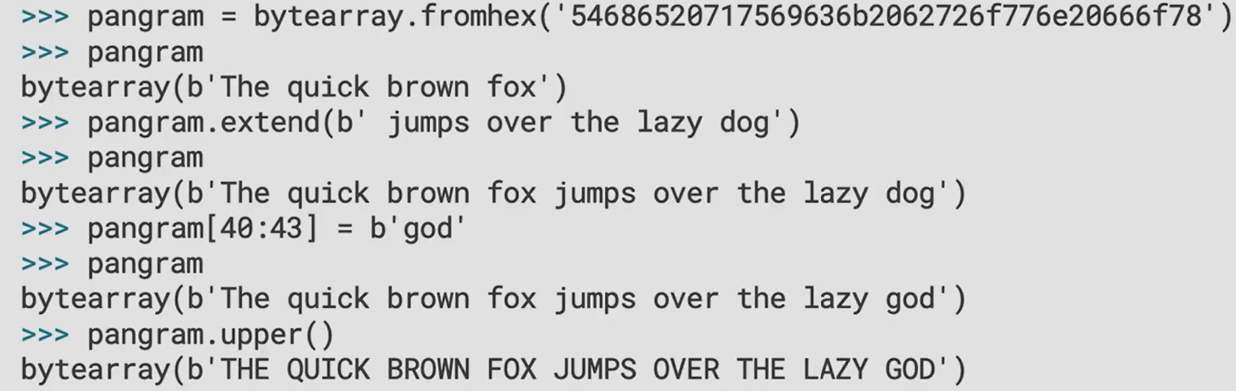

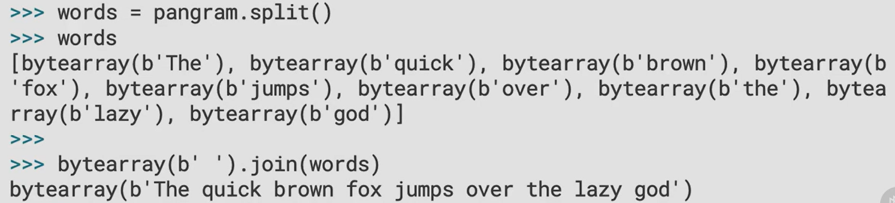

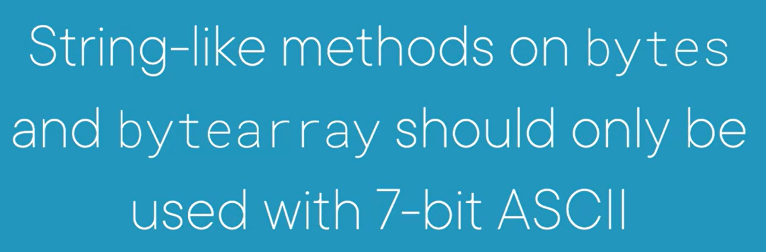

## Interpreting Binary Structures

### The struct Module

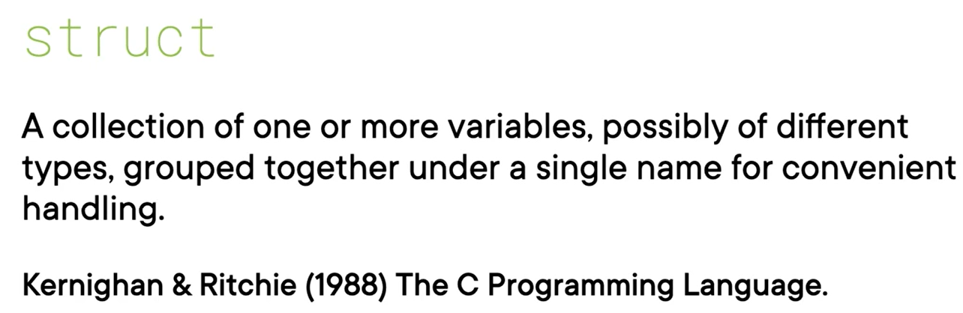

Beyond the scope of this doc.

## The memoryview Type

Beyond the scope of this doc.

## Memory-mapped Files

Beyond the scope of this doc.

# Core Python 3.9: Custom Attributes and Descriptors

## Object Internals

Refer object_internals/object_internals.py

### Dynamic Attribute Initialization

Refer object_internals/dynamic_attribute_init.py

### Custom Attribute Read Access

Intercepting attributes

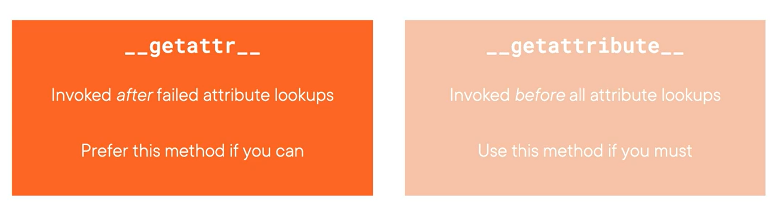

### Preventing Attribute Write Access

__setattr__

### Preventing Attribute Deletion

__delattr__

### Using vars() to access __dict__

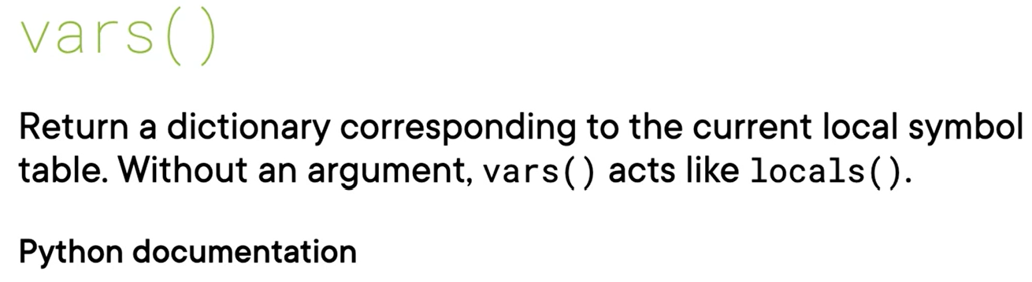

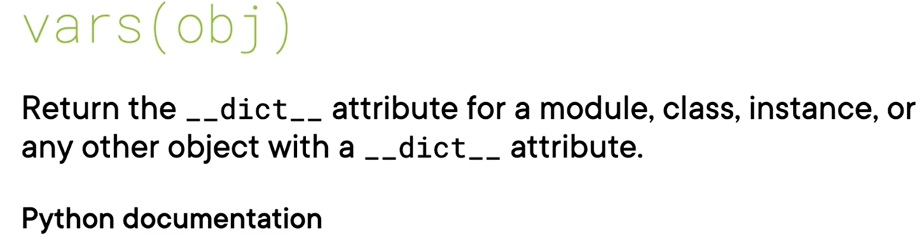

### Intercepting All Attribute Access

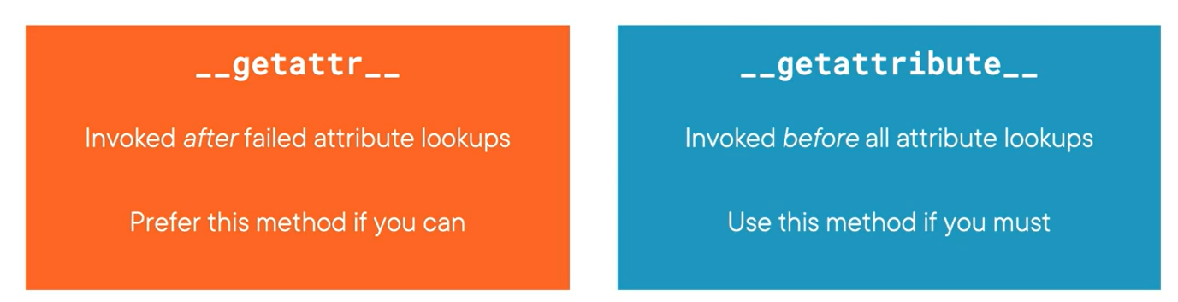

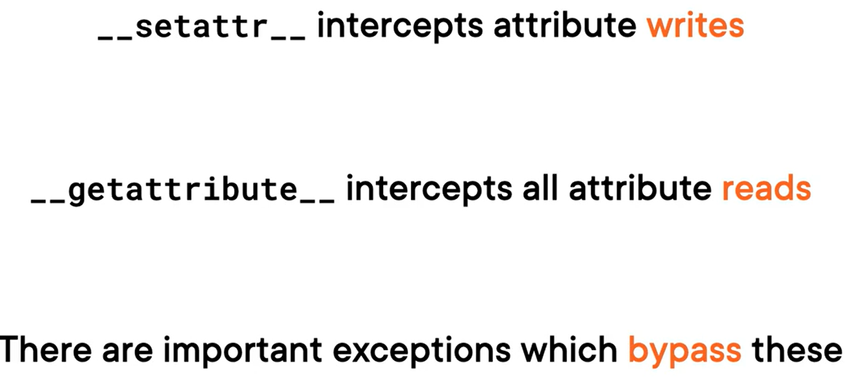

### Built-in Protocols Bypass Attribute Lookup

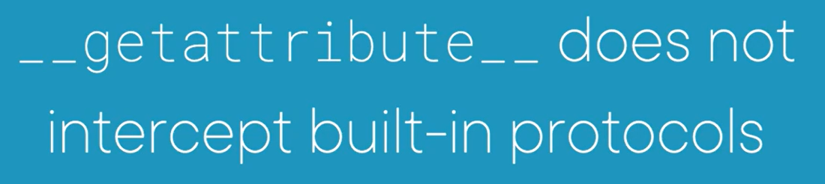

It only intercepts attribute lookup through the dot operator

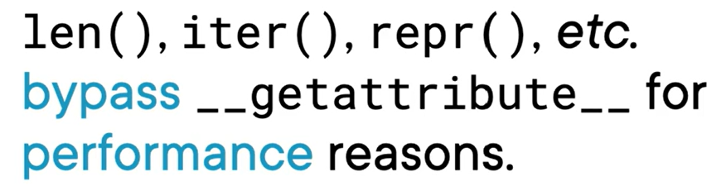

## Class Internals

Refer program object_internals/class_internals.py

## Optimizing Memory Usage with slots

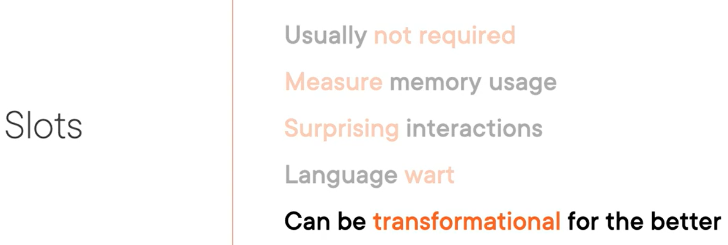

## Descriptors

Beyond the scope of this doc.

# Core Python: Metaclasses and Allocation

## Instance Creation

__init__ is responsible for initializing the object which means object is already created by then. __new__ is responsible for creating object.

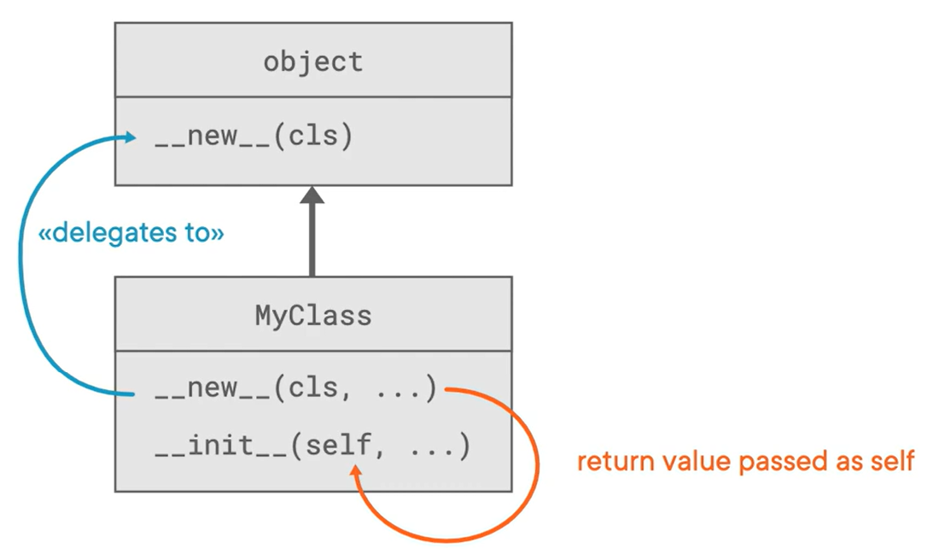

Refer program object_creation.py

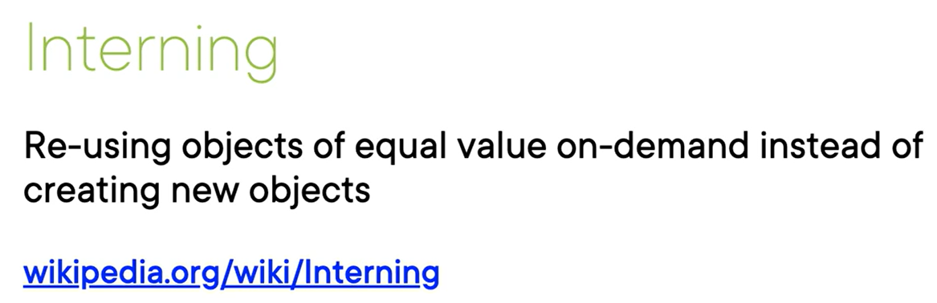

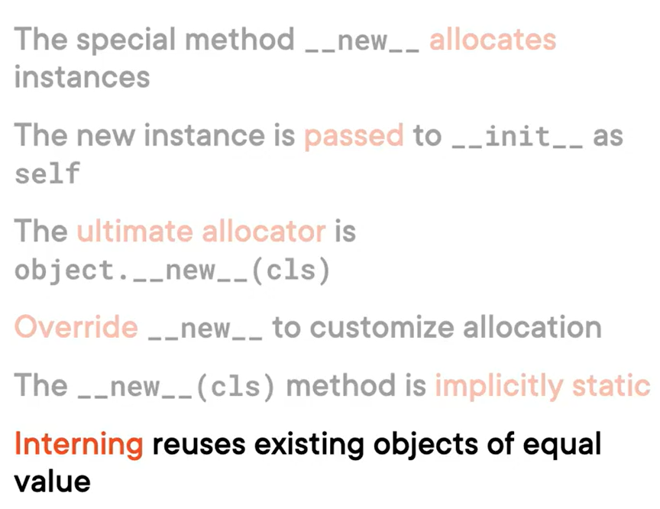

## Metaclasses and Class Creation

The type of any class in Python is its metaclass.

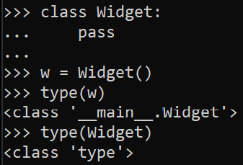

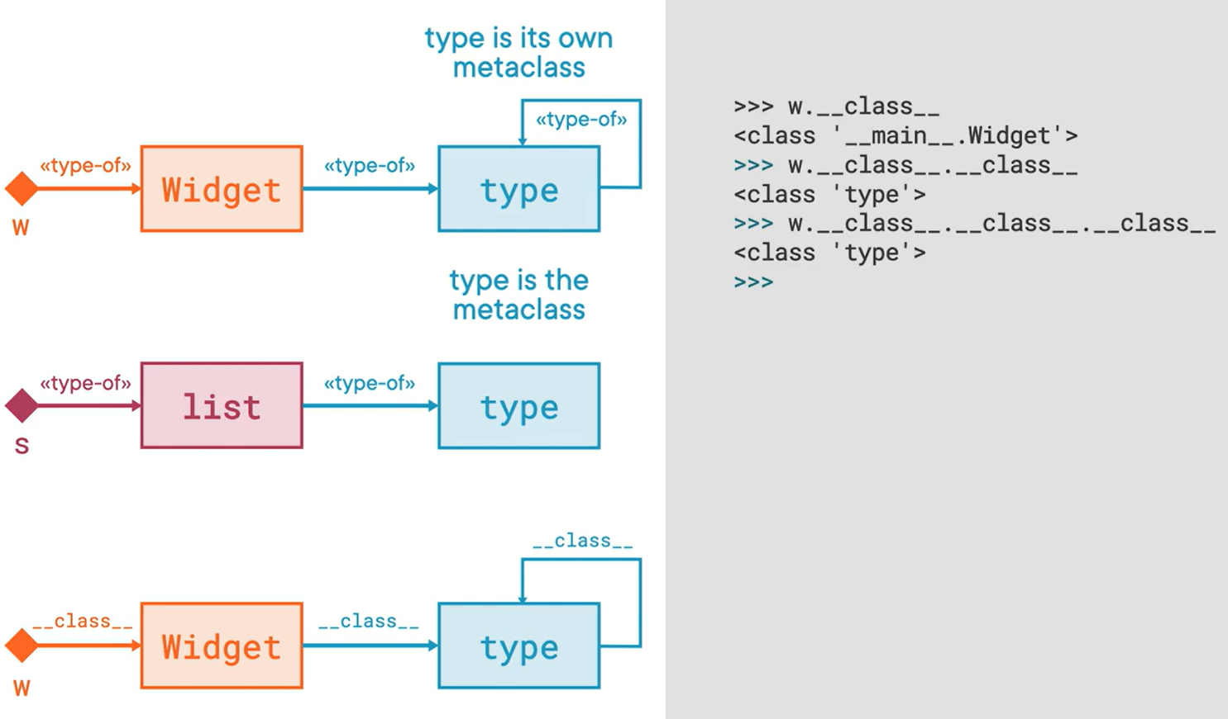

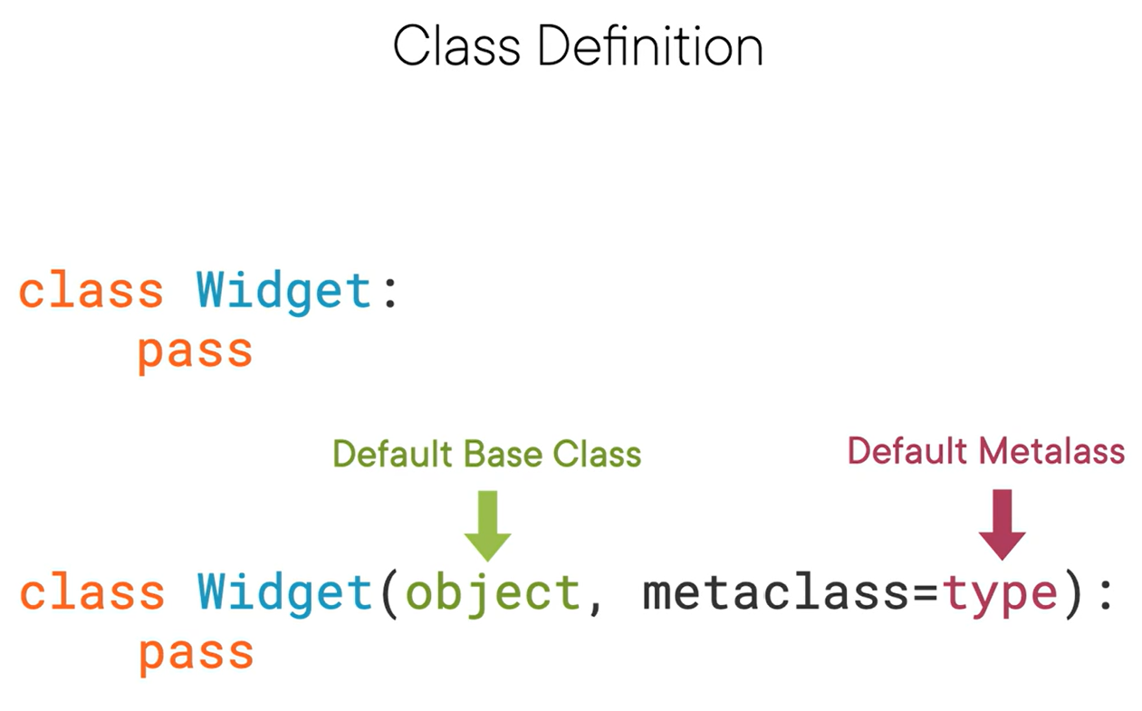

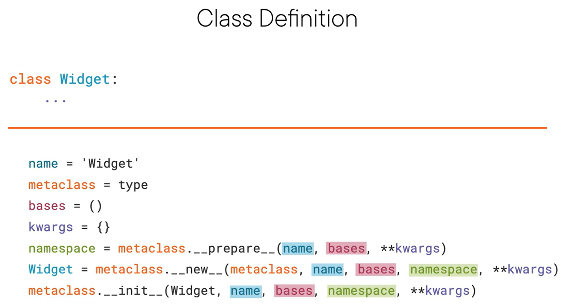

Skipping content as this is beyond the scope of this doc.

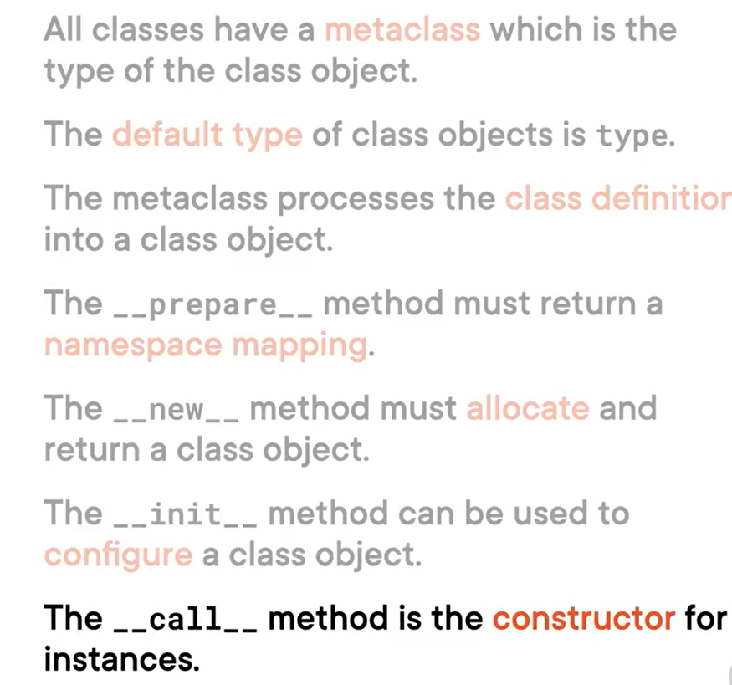

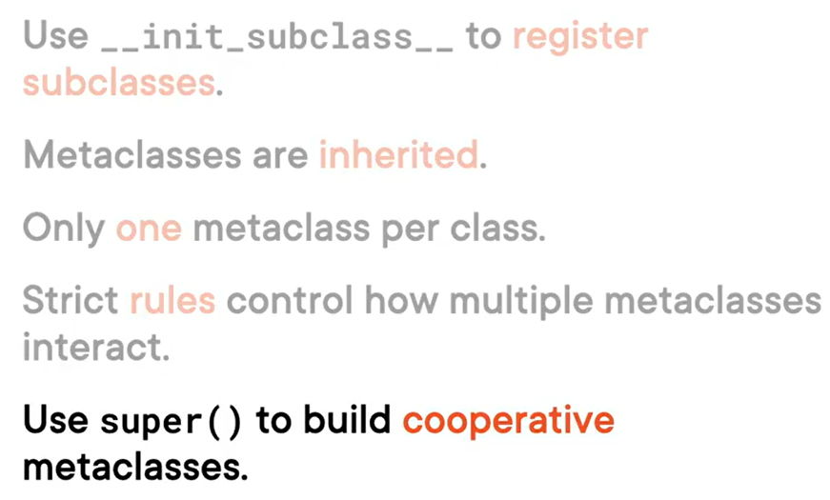

# Core Python 3: Numeric Tower, Conversion & Operators

## Numeric Types

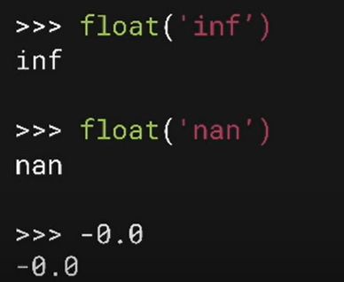

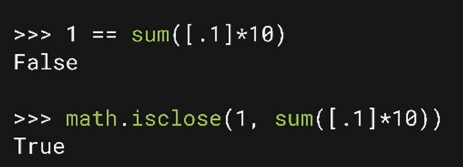

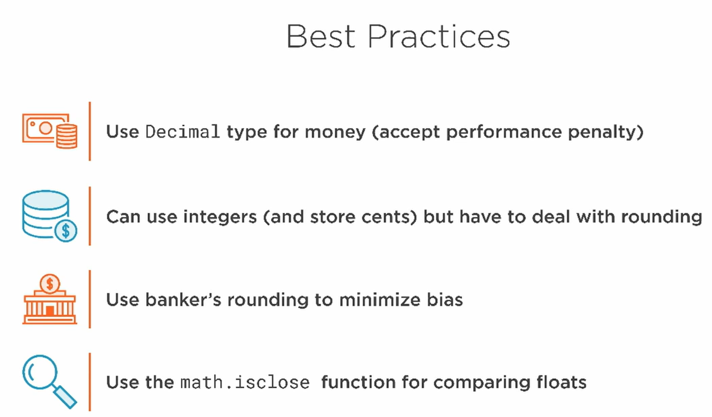

### Decimal

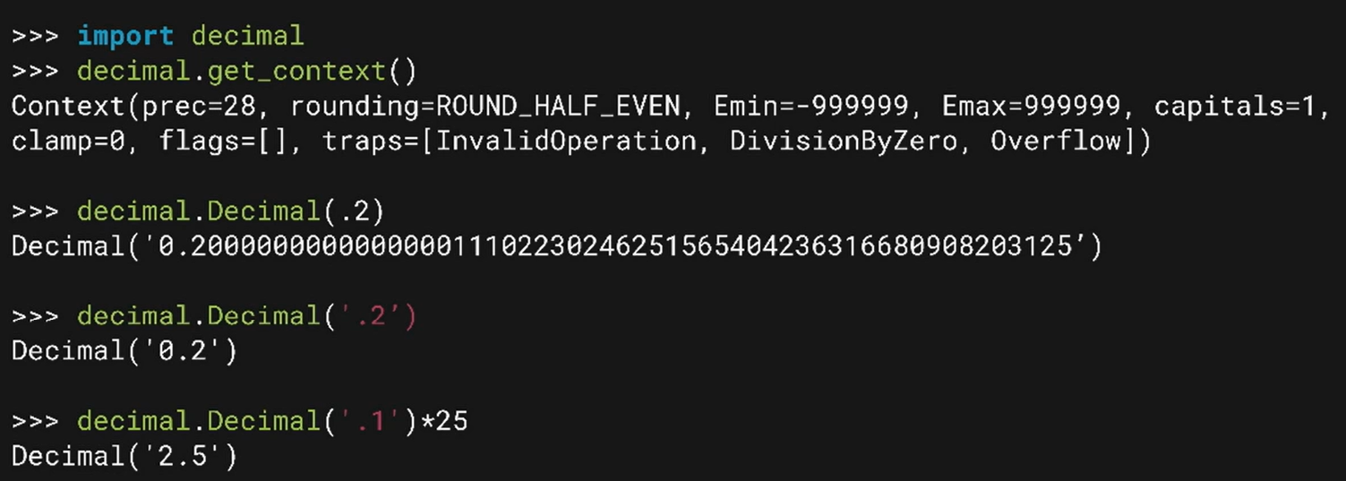

# Core Python: Hashing and More Collections

## Collections by Type

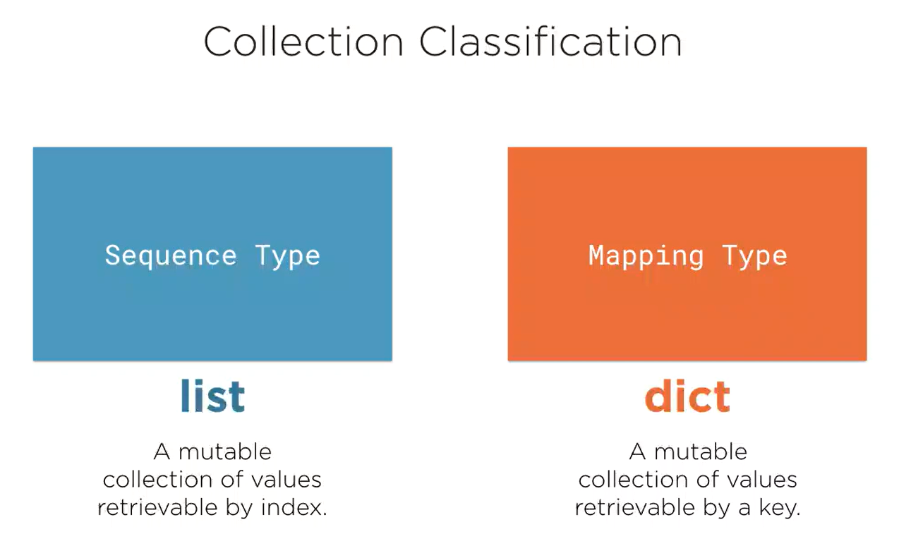

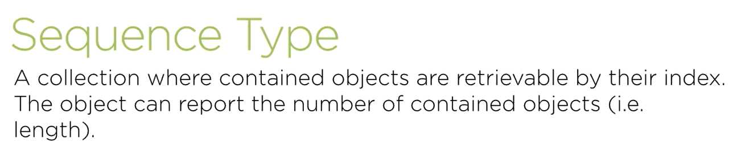

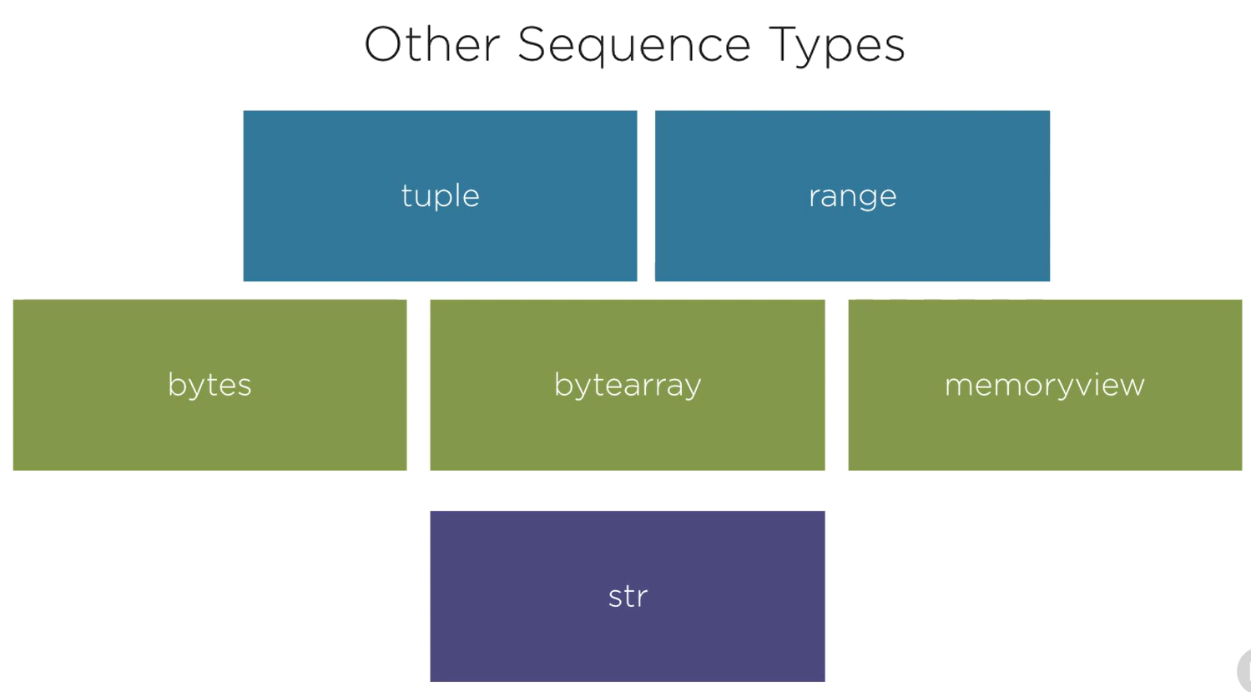

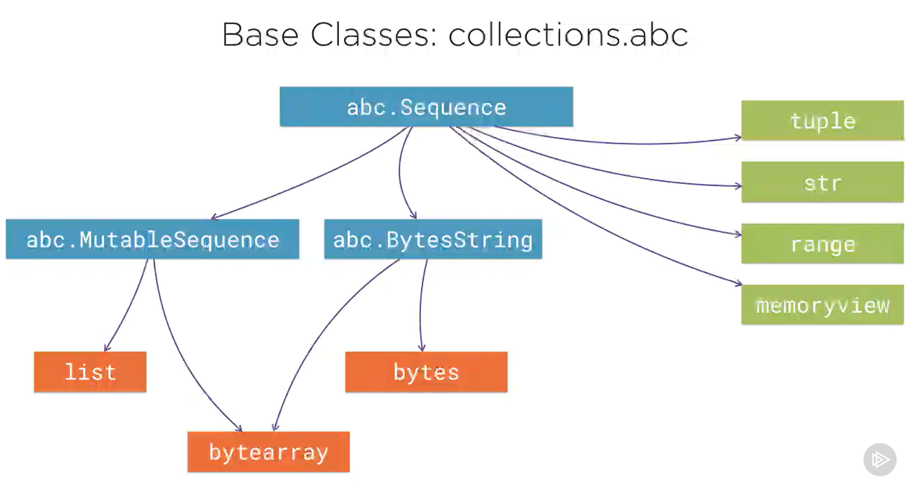

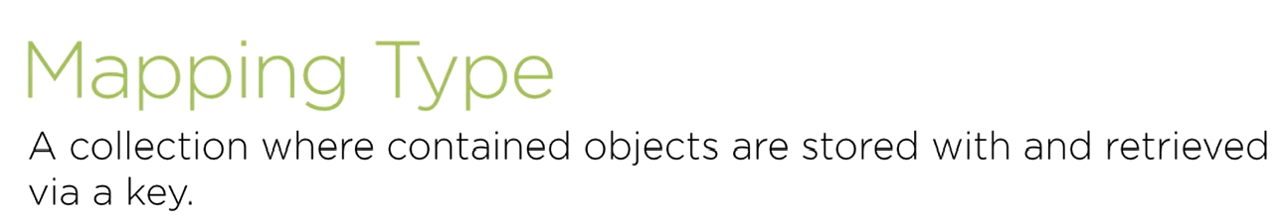

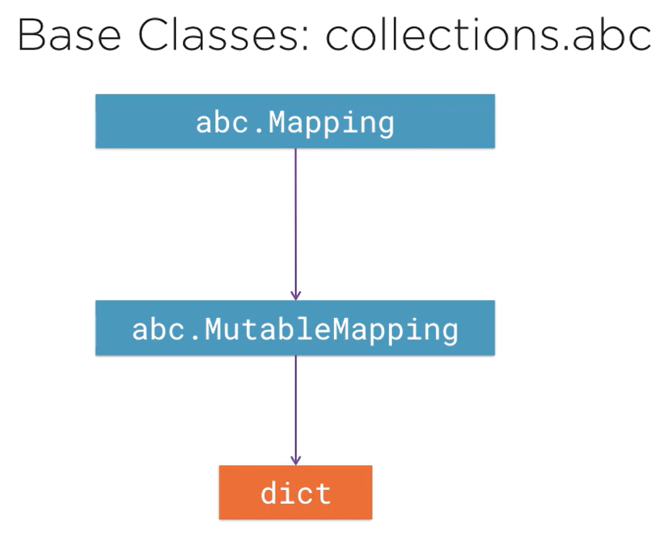

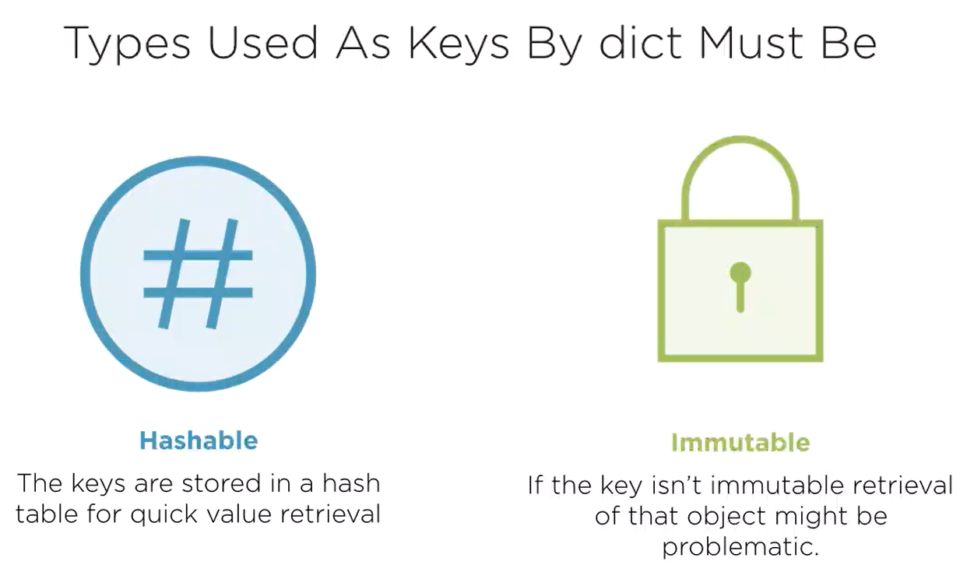

## Custom Object Equality: __hash__ and __eq__

### Hashing

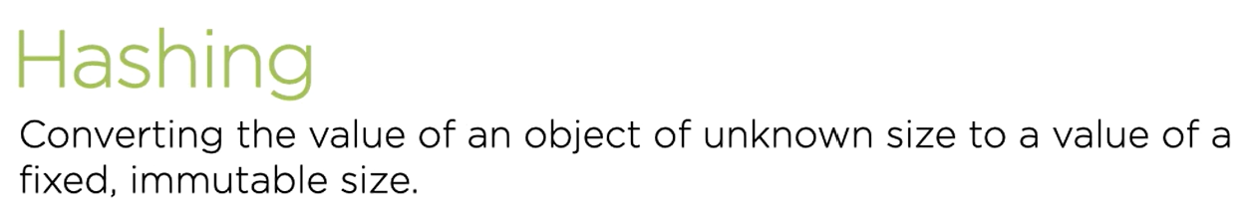

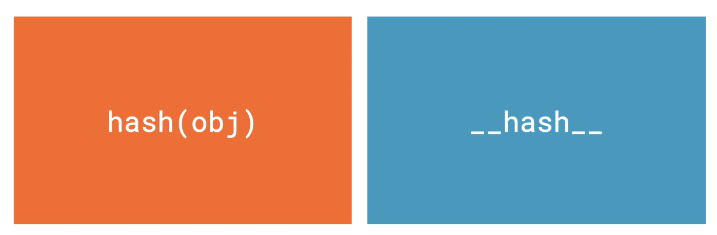

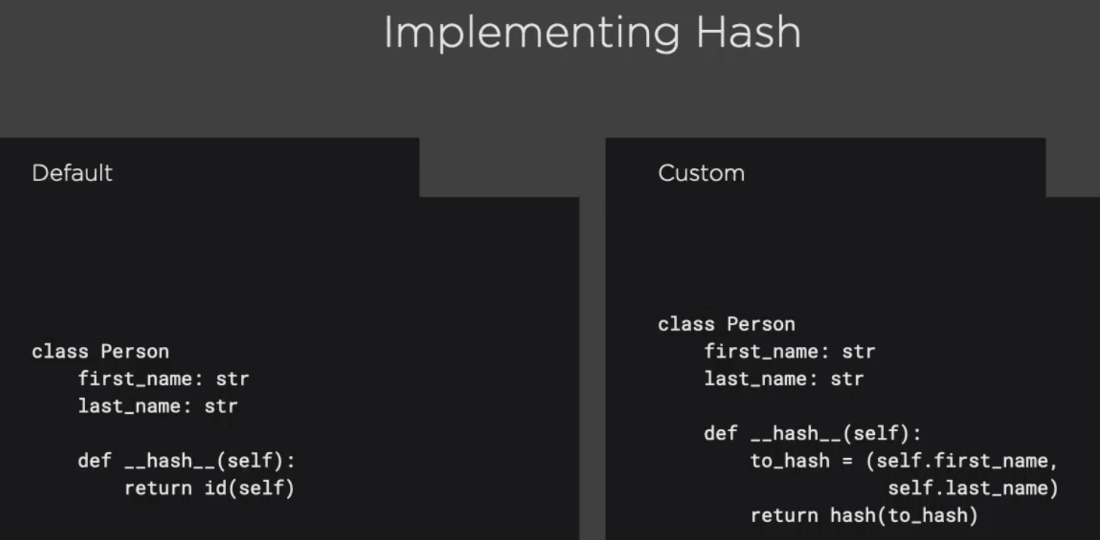

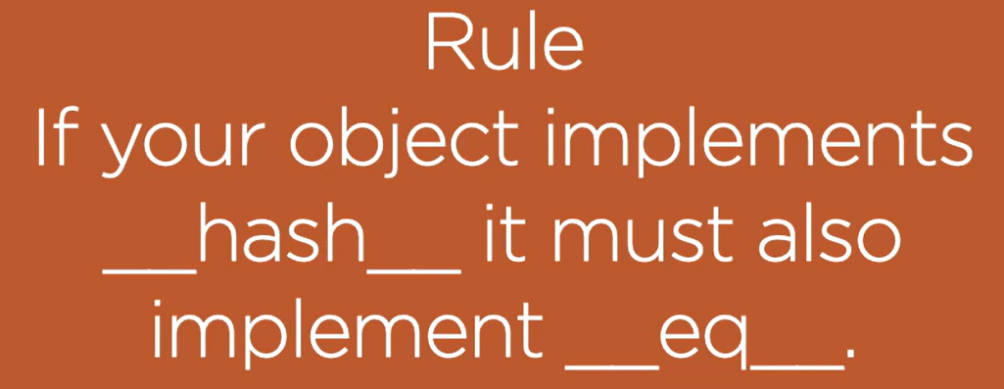

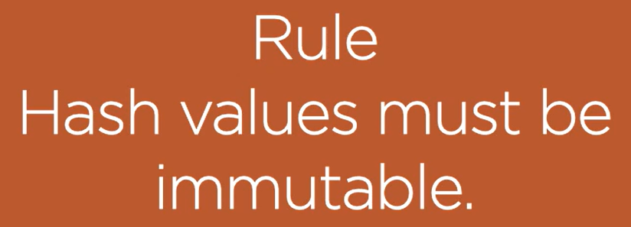

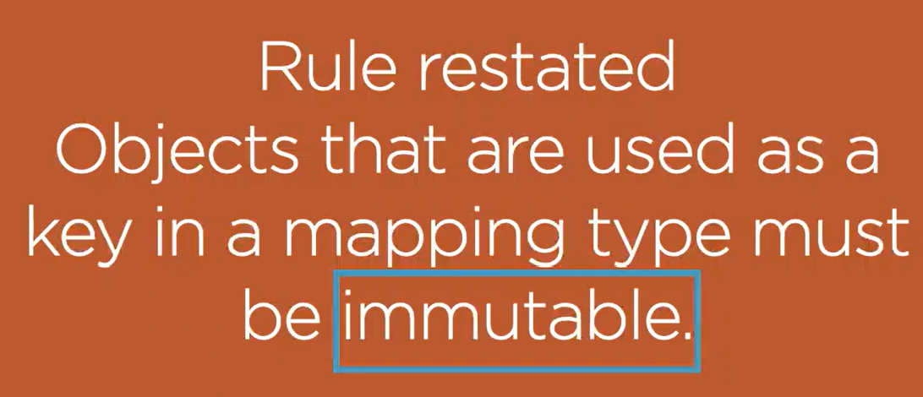

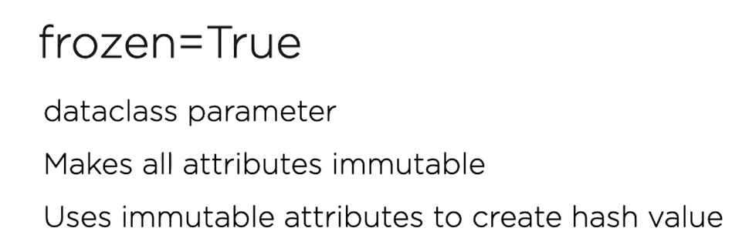

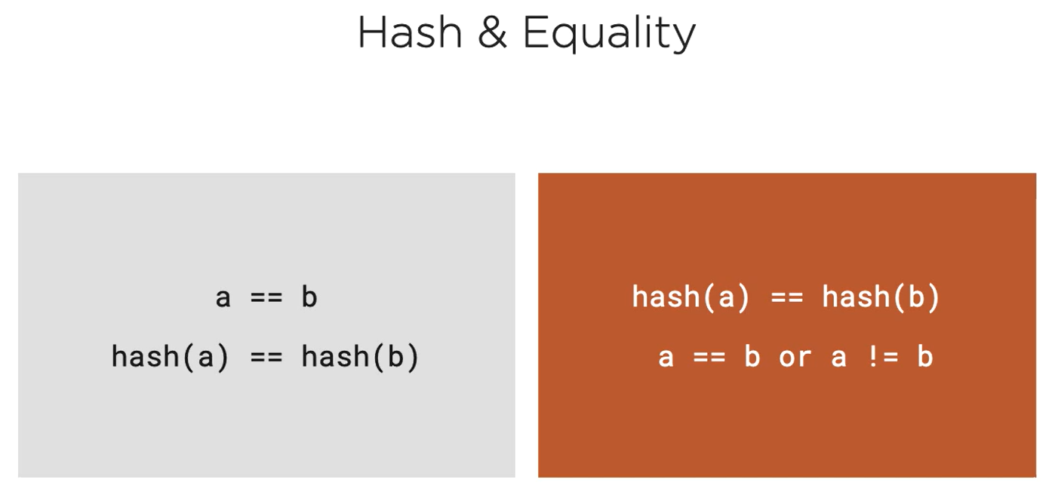

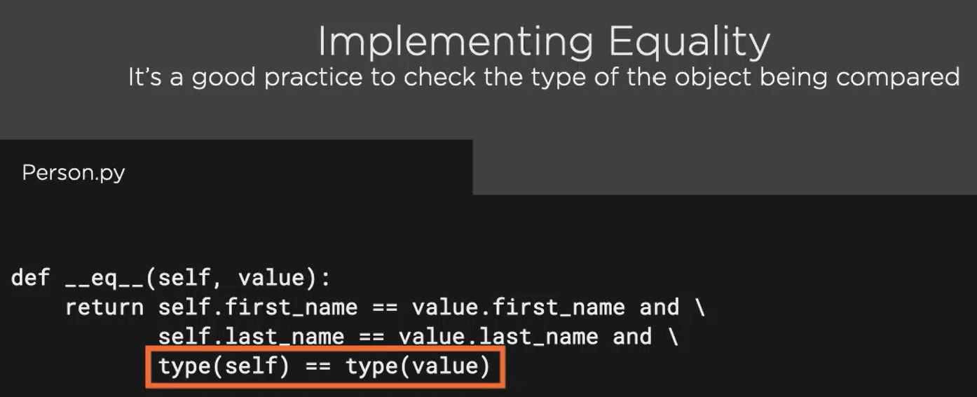

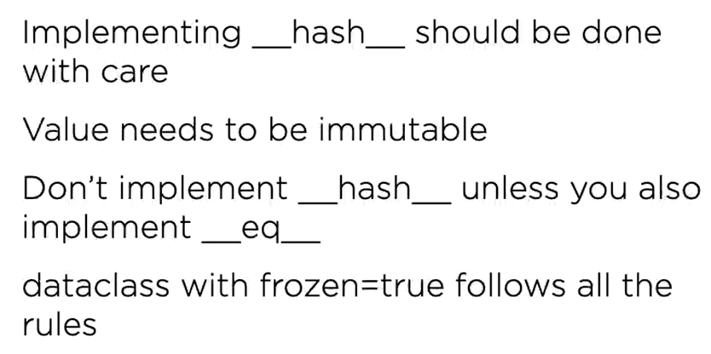

## More Mapping Types

### defaultdict

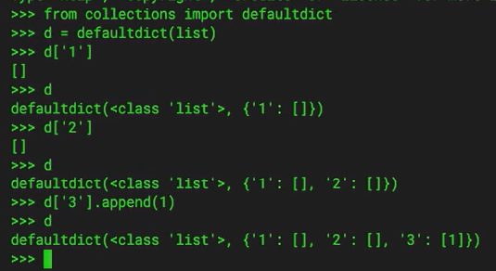

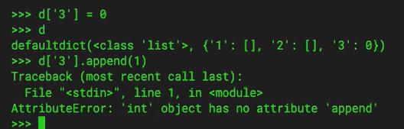

### Counter

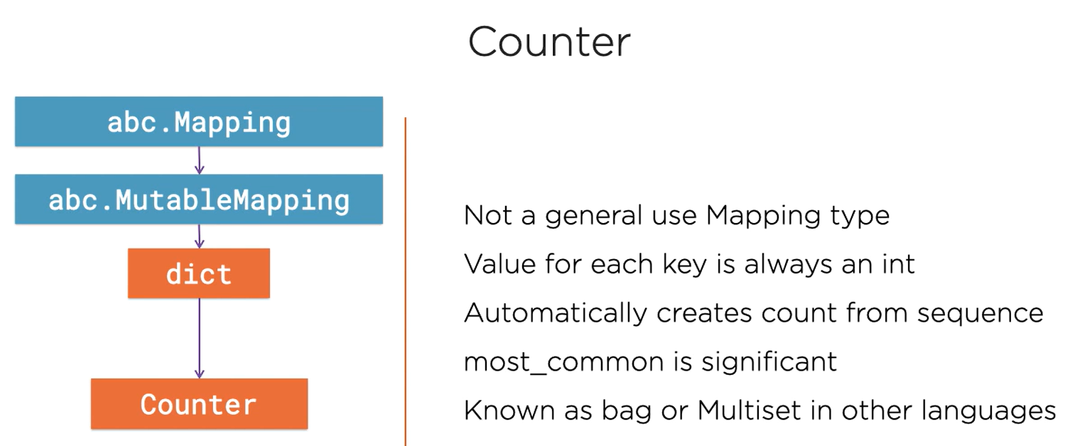

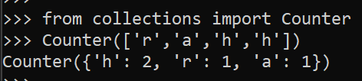

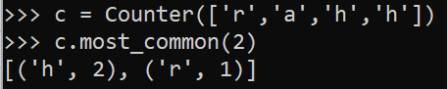

### OrderedDict

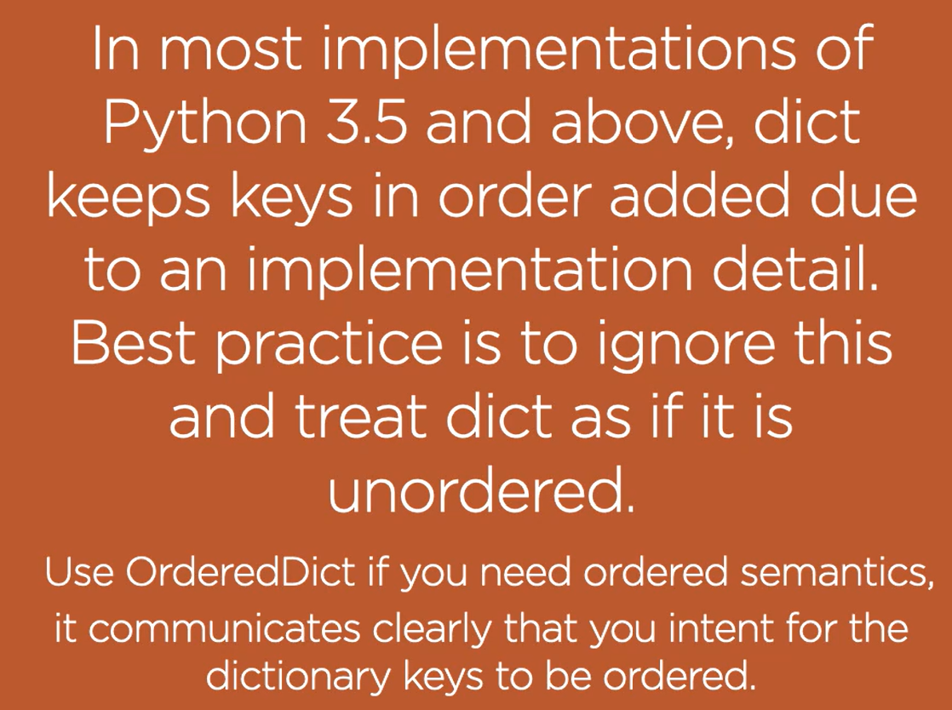

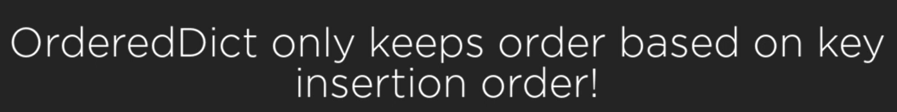

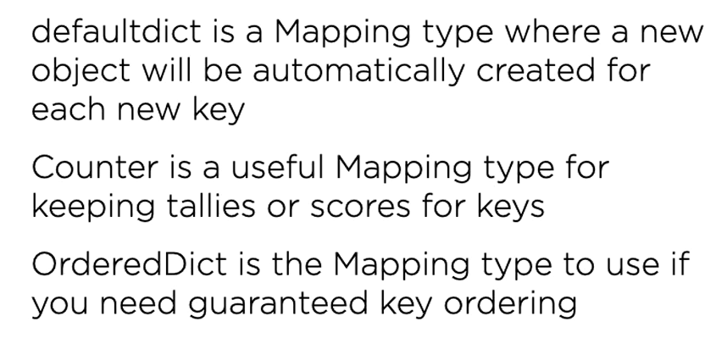

## More Sequence Types

### namedtuple

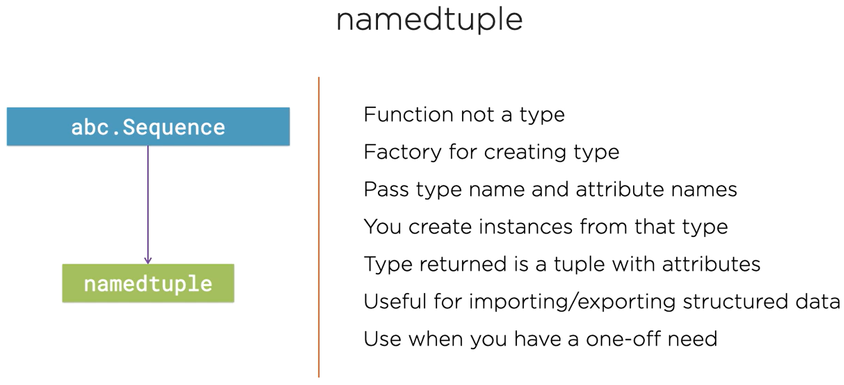

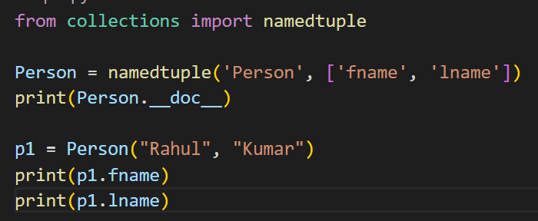

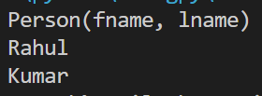

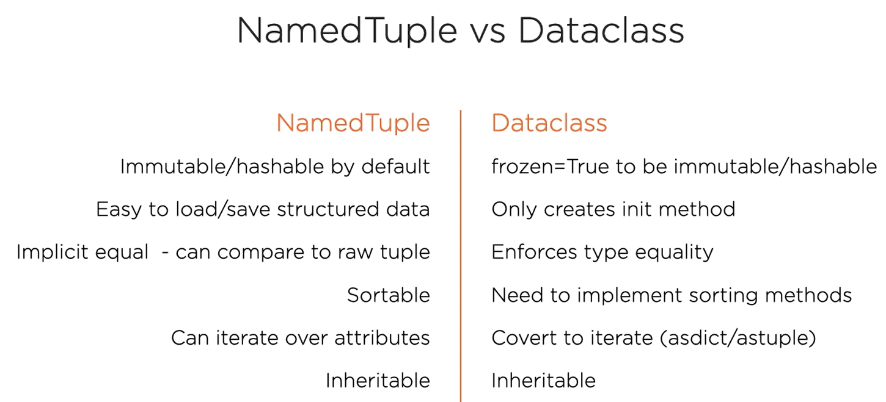

### deque

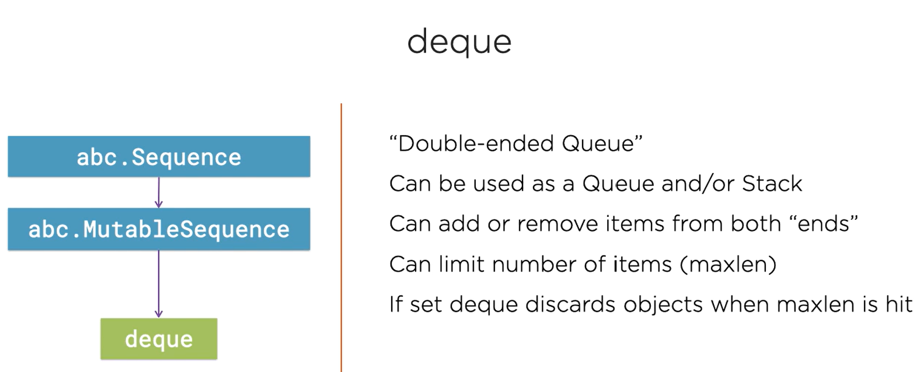

from collections import deque

d = deque()

d.append(1)

d.appendleft(2)

d.pop()

d.popleft()



